Wycliffe C of E Primary School
(with a passion for PE desirable)

Band 8 Scale 16-22, 25 hours per week

Required for September 2026
Recruitment Information Pack:



Timeline

Closing date: Friday the 1st May 2026 (9am)

Interview: Friday the 22nd May 2026

Contents

Welcome letter from the Headteacher Page 3
Wycliffe School Vision and Values Page 4
About BDAT Page 5
BDAT Mission, Vision and Values Page 6
Advert Page 7
Job Description Page 8-16
How to find us Page 17
Selection Process Guidance Page 18-19

Dear Prospective Applicant,

Thank you for your interest in the post of HLTA at Wycliffe Church of England School which will be required for September 2026. This is an exciting opportunity for an outstanding HLTA who is highly motivated and keen to be part of a successful team.

Wycliffe Primary is a pupil-centred place of learning, fully committed to providing all the children in its care with the highest quality of education. Our goal at Wycliffe Primary is to become an outstanding school that delivers educational excellence. You will be fortunate to be part of a team that demands the highest standards of teaching and learning and delivers this with commitment and enthusiasm. We are seeking to appoint an HLTA who, with energy and commitment, can recognise the potential of the staff and children and will strive to develop this.

The school is a mainly two-form entry primary school for ages four to eleven years, based in Shipley, on the very doorstep of the World Heritage Site of Saltaire. We are only a short walk for the train station in Saltaire. The post holder will be employed by BDAT although their main place of work will be at Wycliffe Church of England Primary. We are very lucky to have a team of highly motivated, committed and extremely able professionals on our staff. To match this, our children are inquisitive, hard-working and enjoy their learning. A large part of our school ethos is around involving parents with their children’s learning, and we want parents to feel welcome and valued in and around our school.

I would strongly recommend that you come to visit us to gain insight into the deeply rewarding career that working with our pupils and staff has to offer.

Virtual tour: https://www.youtube.com/watch?v=kZUZOo4urfU&t=369s

Kind regards,

Gavin Hamilton

Interim Executive Headteacher

Wycliffe CE Primary School Vision and Values

Ethos
We recognise that we represent only one of several key stepping stones along a child’s educational journey through life and, therefore, we aim to provide all of our pupils with a sound start to their education, and a smooth transition to subsequent senior schools.
Our ethos is based upon Christian principles. We seek to provide pupils with a clear and solid moral framework, part of which is tolerance of the different beliefs and cultures of others, and equal opportunities for all.
Wycliffe welcomes children of all different beliefs and world faiths. The main Christian festivals will be celebrated in a traditional manner, but important religious festivals of other faiths are also discussed and enjoyed.
Vision Statement – at the core of all we do
“Life in all its fullness” (John 10:10)
“Our vision is to ensure that our school family are happy and fulfilled in a creative learning environment. This is flexible and caters to individual needs while developing a life-long love for learning through which all members can flourish. We nurture an aspirational family of hard-working, respectful individuals who work collaboratively.”
Values Statement
We shall achieve this vision through the promotion and celebration of our six Christian Values.


About BDAT

Wycliffe Primary School is a primary school within Bradford Diocesan Academies Trust. If you are successful in being appointed, the Trust will be your employer.

General Information and Background

Bradford Diocesan Academies Trust (BDAT) is a Multi-Academy Trust (MAT) supporting 21 primary and secondary schools in Bradford. We are a Trust which prides our self in delivering great education outcomes and life opportunities for all our children. We are an inclusive Trust working with children from a rich range of backgrounds who reflect our communities and the city we serve. We are proud to be all about Bradford and developing the future generation of lifelong learners who will go on to achieve incredible things.

BDAT is a Trust which recognises each of our schools is unique. We actively encourage and celebrate difference as we know each of our schools serves very different communities. However, we also know that a key strength of being part of a Trust means together our schools can support each other, learn from each other and share great practice. As importantly we know from working our way through the COVID pandemic, that a problem shared really can be a problem halved, and by working together we can save ourselves time, money and lots of duplication of work.

We are a Trust which is value-led, and we know it is important that we consistently live these values. The Trust’s vision is “We want every child to have a happy and high-quality education enabling them to grow and flourish during their time at school. We will provide schools that develop our young people’s competence, confidence and character, driven by local community context and inclusive Christian values, ensuring everyone achieves their academic and personal potential and leaves our Trust prepared for the next stage of their life journey. We want BDAT schools to be schools of choice for the diverse and special communities we serve.
We will recruit develop, inspire and retain highly skilled staff dedicated to making sure our children and young people have every chance to succeed.”

Our core Trust values are aspiration, inclusion, compassion, resilience and excellence. We seek to model these values in all we do, including how we recruit and develop our staff, how we teach our students and how we liaise with our families, friends and partners. We are a proudly Christian organisation committed to providing high-quality education for all within our ethos. Whilst robust Christian principles underpin the work of the Trust, everyone is encouraged to explore their own spirituality and to recognise and understand that of others. We describe ourselves as having inclusive values believing these are as appropriate and important to staff and students of all faiths (and to those without faith) as they are to those who practice within the Church of England. It is for this reason we choose to support and sponsor Non-Church of England Academies, as well as those within the faith. Therefore, we welcome applications for this role from employees of all faiths if they understand and can promote the values which we share.

BDAT is a large Trust, however we pride ourselves in knowing and understanding our schools. We are all part of the BDAT family, and we all have the same motivation – to see our children succeed. For more information about us follow us on twitter @wearebdat or visit www.bdat-academies.org

BDAT’s Mission, Vision and Values

BDAT’s mission is:

‘To provide high quality education within the context of Christian belief and practice so that every child can fulfil their academic potential and accomplish their individual goals.’

Our vision is:

‘That every student in a BDAT academy gets a happy and high-quality education enabling competence, confidence and character to thrive; and that our Academies become the schools of choice in Bradford.’

Our values are:

Aspiration We set high expectation for ourselves, our children and our staff so that each of us is supported to achieve our own potential. We expect nothing but the best from ourselves and from others.

Inclusion We understand everyone is equal, without exception. We value and encourage diversity and difference. We proactively seek to learn from others.

Excellence We provide rigorous support and challenge to our schools and our students. We strive for excellence in all we do.

Compassion We care for each other. We respect each other and treat our friends and colleagues how they would expect to be treated. We make sure we are safe, feel loved and are actively always supported.

Resilience We are ambitious and reflective. We are determined and brave in making decisions and when facing challenges. We expect our schools to provide us with the skills and knowledge to guide us through our future as life-long learners.







Wycliffe Primary School

Outline Job Description

POST TITLE: HIGHER LEVEL TEACHING ASSISTANT
POST REF: MY NEW TERM REFERENCE
GRADE: BAND 8

GENERIC INTRODUCTION:

The following information is furnished to assist staff joining the school to understand and appreciate the work content of their post and the role they are to play in the organisation. The following points should be noted:

- Whilst every endeavour has been made to outline the main duties and responsibilities of the post, a document such as this does not permit every item to be specified in detail. Broad headings, therefore, may have been used below, in which case all the usual associated routines are naturally included in the job profile.

- Employees should not refuse to undertake work, which is not specified on this form, but they should record any additional duties they are required to perform and these will be taken into account when the post is reviewed.

- BDAT is an Equal Opportunities Employer and requires its employees to comply with all current equality policies both in terms of equal opportunity for employment and access to BDAT Services.

- BDAT is committed, where possible, to making any necessary reasonable adjustments to the job role and the working environment that would enable access to employment opportunities for disabled job applicants or continued employment for any employee who develops a disabling condition.

PRIME OBJECTIVES OF THE POST:

To complement, appreciate and support the role of teachers and other professionals by undertaking work/care/support programmes which enables access to learning in the community as part of a teacher planned approach.

To support the class teacher in the management of pupils in the classroom, and other senior staff on a range of teaching and learning experiences which deliver an appropriately differentiated and suitably challenging creative curriculum for all pupils whilst meeting statutory requirements.

Progressing pupil learning in a range of classroom settings; including working with individuals, groups of pupils or whole classes where the assigned teacher is not present (e.g. during PPA time or covering short term absence). This may involve planning, preparing and delivering learning activities as well as monitoring pupils, assessing, recording and reporting on pupil achievement, progress and development.

To take responsibility for the implementation of learning activities/work programmes under an agreed system of supervision with individuals/groups, in or out of the learning environment. This will include assisting the teacher in the whole planning cycle and the management/preparation of tasks/resources.

Work within school policies and procedures under the direction and guidance of senior staff and within an agreed system of supervision.

May from time to time be required to undertake other duties commensurate with the grade and level of responsibility defined in this job description.

EFFORT DEMANDS:

- Will assist in maintaining the good discipline of pupils throughout school and be expected to use good common sense, develop creative solutions and use initiative in all matters relating to the conduct and behaviour of individual pupils, groups of pupils and whole classes, the safety, mobility (if required), hygiene and well being of the pupils; making decisions both within and often outside established working practices and procedures.

- Will recognise and challenge any incidents of racism, bullying, harassment, victimisation and any form of abuse of equal opportunities, ensuring compliance with the relevant school policy and procedures.

- Will deal with any issues, immediate problems or emergencies that arise in line with school policies and procedures liaising with colleagues where necessary e.g. dealing with a sick, injured or distressed child.

- Acting as a role model, will use specialist skills and training experience to establish productive and constructive working relationships with pupils, setting high expectations, motivating and interacting with them, being aware of their individual needs, supporting difference and ensuring all pupils have equal access to opportunities to learn and develop whilst responding appropriately.

- Will have the ability to cope with the requirements of the post, which may include working with pupils who have emotional/behavioural/physical difficulties.

- Will use specialist learning skills/training/experience to support pupils.

- Use your own initiative and organise your own workload, pay attention to detail, work to deadlines and manage conflicting priorities whilst making decisions where appropriate within established and non established working practices.

- Will contribute to the overall ethos/work/aims of the school.

- Will support, uphold and contribute to the development of the schools Equality policy in respect of both employment issues and the delivery of services to the community.

- Will appreciate and support the role of other professionals.

- Be vigilant and sensitive to any child protection/safeguarding concerns that arise reporting any concerns to the designated officer in line with school policy and procedure.

RESPONSIBILITIES:

- Assist in the management of pupils in the learning environment.

- Assist the teacher in all aspects of lesson planning and planning of other learning activities, participating in all stages of the planning cycle and modify methods to meet individual/group needs; assessing, evaluating and adjusting lessons/work plans as appropriate and in accordance to pupil responses/needs whilst helping pupils to access learning activities through specialist support.

- Perform allocated tasks with limited supervision using professional discretion where required.

- Will transfer work and resources back to the teacher and feedback any issues.

- As agreed, and with limited supervision, deliver a range of teaching and learning experiences which should be appropriately differentiated and suitably challenging, ensuring all children are engaged in appropriate activities; giving support where necessary.

- Will undertake routine marking of pupils' work and accurately record achievement/progress, administer and assess routine tests and invigilate exams/tests as well as working with the teachers to evaluate students progress.

- Support the teacher in establishing, planning, adapting and undertaking structured and agreed learning activities/teaching programmes appropriate to the pupil’s needs to ensure physical, social, emotional and intellectual development, taking into account diversity e.g. language, culture, ability, race and religion.

- Will recognise own strengths and areas of expertise and use these to advise and support colleagues in order to ensure the smooth running of the learning environment and contribute to relevant meetings.

- Will supervise and support pupils consistently at all times including those with special needs; recognising and responding to their individual needs whilst ensuring their safety and education in the learning environment.

- Assess the needs of pupils and use detailed specialist skills in the development and implementation of Individual Education Plans and Personal Care Programmes; attending to the pupils’ personal needs and maintaining related personal programmes with the correct use of care materials including the safety and well being of the pupils, therapy and medical intervention needs of the pupil and first aid, paying attention to social, health, physical and welfare matters as well as high standards of cleanliness and hygiene e.g. washing, dressing, toileting, and, if applicable, mobility.

- For posts working with pupils who are physically less able, it may be necessary to be able to physically assist the pupil in line with school policies and good practice.

- Will teach and supervise whole classes during the short term absence of the teacher and undertake the planning for this supervision within the pre-determined lesson framework; keeping all children engaged, maintaining good order and to keep pupils on task.

- Promote and reinforce the inclusion, acceptance and integration of all pupils, including those with specific and special needs and those from different cultures and/or with a different first language as appropriate.

- Set challenging and demanding expectations, employ strategies to recognise and reward achievement of self-reliance whilst promoting self-esteem. Encourage pupils to act independently, working co-operatively and interacting with others.

- Will develop, organise, prepare, create, safely manage and maintain a purposeful, orderly and supportive learning environment to meet the lesson plans. Take responsibility for the care, preparation, maintenance and use of relevant equipment, assisting pupils in its use, clearing/storage afterwards and sourcing/suggesting new resources where needed.

- Will be aware of pupil progress, monitor/record pupil responses against pre-determined learning objectives as well as provide accurate, constructive and detailed feedback/reports to the teacher and pupils. Make suggestions on developing areas where required.

- In liaison with the class teacher, will establish constructive relationships and communicate with other agencies and professionals to support achievement and progress of pupils.

- Will contribute to the planning of opportunities for students to learn outside of school contexts in line with school policies and procedures.

- Promote positive values, attitudes and good pupil behaviour and encourage pupils to take responsibility for their own actions whilst supporting the teacher in managing this. Deal promptly with conflict and incidents (including those involving restraint) and reporting challenging behaviour where appropriate in line with established policy; developing new solutions where required and contributing to a purposeful learning environment.

- Will gather/report information from/to parents/carers as directed, taking into account parental/carer concerns, dealing with them sensitively, establishing constructive relationships and offering appropriate advice and guidance under the direction of the teacher.

- Will support the teaching staff by reporting pupil progress and achievements at parents evenings which are usually held outside school hours.

- Will be responsible for developing and maintaining manual and computerised records and contributing to the reviews of systems/records as required.

- Will provide clerical/administrative support as directed by the teacher.

- Will implement local and national learning strategies and will support pupils to achieve learning goals e.g. literacy, numeracy, KS3, early years as directed by the teacher whilst making effective use of opportunities provided by other learning activities to support the development of relevant skills.

- Will support pupils in the use of ICT in learning activities as directed by the teacher, develop skills to deliver ICT packages to pupils and develop pupils competence and independence in its use.

- Will participate in own performance development, identify and address any training needs/other learning activities.

- Will assist with the supervision of pupils out of lesson times, including before and after school and at lunchtimes, accompanying teaching staff and pupils on visits, trips and out of school activities; taking responsibility for a group under the supervision of the teacher.

- Will take line management responsibility in the supervision of other Teaching Assistants, students on work experience, trainees and voluntary helpers. Undertake induction, appraisal, training and mentoring as necessary.

ENVIRONMENTAL DEMANDS/WORKING CONDITIONS:

- Will have long periods of sitting or standing.

- Available to work during school hours during term time and a willingness to be flexible as may be required to attend staff meetings/training sessions outside of usual hours.

- Will have contact with members of the public/other professionals e.g. teaching staff, governors, parents/carers, community groups, local education authority, external providers etc.

- This post may include a degree of manual lifting and handling. You are expected to be aware of health and safety policies and procedures and frequently assess your ability to carry out the lifting tasks required of you.

- Report all concerns to an appropriate person.

SPECIAL CONDITIONS OF SERVICE:

- An Enhanced DBS with Children’s Barred List check is required for this post, along with any other relevant safer recruitment checks as outlined in Part 3 of Keeping Children Safe in Education. This is to ensure that there are no contra-indications in personal background or criminal records indicating unsuitability to work with children/young people/vulnerable clients/finance.

Other Considerations

- To contribute to the whole school culture of safeguarding by attending safeguarding training at least annually to keep knowledge up to date; being aware of and complying with policies and procedures relating to safeguarding and child protection; being vigilant for signs that children may be being abused and to report any such concerns to the school’s Designated Safeguarding Lead or the Headteacher.
- To act in accordance with Data Protection Act principles and BDAT’s UK GDPR policy and maintain confidentiality at all times e.g. access to staff/student/parent and carers files.
- Accept and commit to the principles underlying the Schools Equal Rights policies and practices.
- Be able to perform all duties and tasks with reasonable adjustment, where appropriate, in accordance with the Equality Act.
- Must be legally entitled to work in the UK.

PERSONNEL SPECIFICATION:

 | ESSENTIAL
EXPERIENCE: | - Experience of delivering education to pupils in small group or classroom settings.  - Experience of working in a team situation.  - Experience of working with or caring for children of relevant age e.g. voluntary organisation or parental/caring responsibilities.  - Experience of working with pupils with additional educational needs and more able special educational needs.  - Experience of working in a relevant discipline.  - Experience of planning and preparing for lessons.  - Clerical/administrative experience.
QUALIFICATIONS/  TRAINING: | - Minimum of GCSE English and Mathematics at grade C/4 or above (or equivalent)  - Level 4 NVQ/T-Level for Teaching Assistants or equivalent qualification or educated to graduate level.  - Other relevant qualifications relating to the post e.g. Level 4 in Health/Childcare, first aid qualification.  - Evidence of further training/development and/or willingness to participate in further training and development opportunities e.g. relevant learning strategies, literacy and/or particular curriculum or learning area such as sign language, bi-lingual, dyslexia, ICT, math, English et
KNOWLEDGE/ SKILLS: | - Will possess a full and in depth working knowledge of the School’s relevant policies/procedures/codes of practices with an outline understanding of relevant legislation.  - Will have in depth knowledge of the policies covering their service area.  - In depth knowledge of childcare with an understanding/awareness of the principles of child development and learning processes as appropriate.  - Working knowledge of national/foundation stage curriculum and other relevant learning programmes/strategies.  - Excellent organisational and problem-solving skills with the ability to work proactively and independently.  - Excellent communication skills.  - Enhanced advisory, guiding, negotiating and persuasive skills at a developed level.  - Excellent numeracy/literacy skills.  - Excellent ICT skills.  - Ability to use relevant equipment/resources.  - Ability to self-evaluate learning needs and actively seek new learning opportunities.  - Ability to understand classroom roles and responsibilities.  - An understanding of the needs of a multicultural society.  - An understanding of the issues relating to pupils who have additional learning needs, more able and special educational needs.  - In depth knowledge and practical experience of behaviour management.  - Knowledge and commitment to schools' Equality policy.  - In depth knowledge and practical experience of Health and Safety requirements.  - In depth knowledge and practical experience of child protection.  - Ability to relate well to pupils and adults.  - Ability to work constructively as part of a team with a willingness to share knowledge, expertise and experience.  - Ability to remain calm under pressure; prioritising conflicting demands.  - Demonstrate a commitment to working with children of the relevant age.  - Demonstrate good co-operative, interpersonal and effective listening skills.  - In depth knowledge and experience of maintaining confidentiality in matters relating to the school, its pupils, parents or carers.  - Ability to perform all duties and tasks with reasonable adjustments where necessary, working flexibly and willing to accept change.  - Ability to cope with the requirements of the post, which will include working with pupils who have emotional/ behavioural/physical difficulties.

BDAT LEADERSHIP COMPETENCY FRAMEWORK:

At BDAT we believe that it is important we have common expectations of what makes an effective Trust and School leader, supported by a consistent set of deﬁnitions and standards for leadership at different levels. The BDAT Leadership Competency Framework sets out our Trust-wide expectations of what makes a good leader. They inform how we expect our leaders to act and behave and explain what skills and attributes leaders are expected to demonstrate whilst they work in our schools.
They also support the Trust ICARE values on how we work together as colleagues within BDAT.

The framework is applicable to both teaching and support staff working across all roles within our Trust and Academies because at BDAT we believe everyone can be a leader in their role and can continue to develop leadership skills and expertise at each step of their career.

The Leadership Competency Framework is not designed to replace the professional standards to which we must adhere (such as the Headteacher Standards, ISBL Professional Standards and The Nolan Principles of Public Life) but is designed to complement them by setting out those skills and attributes which make a leader in BDAT unique and special.

This role sits within the following areas of the framework.
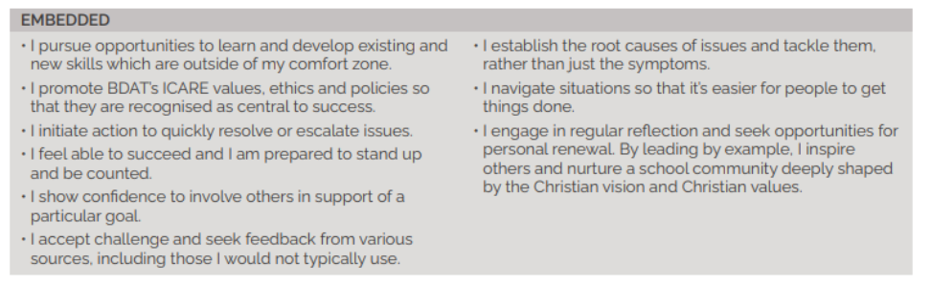
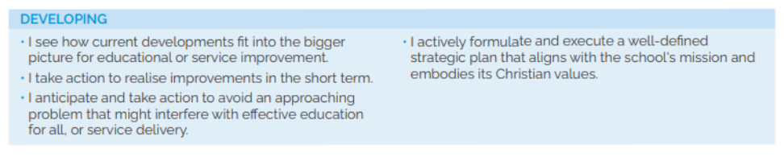
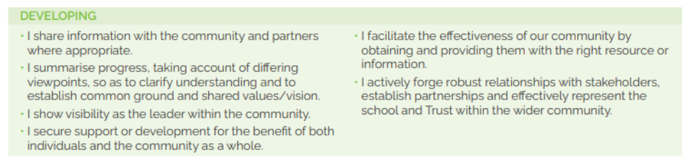

How to Find Us
MAP
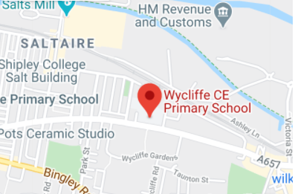

Wycliffe CE Primary School,
Saltaire Road, Shipley, BD18 3HZ
T: 01274 584779
E:office@wycliffe.bdat-academies.org
W: wycliffeprimary.org

BDAT
2nd Floor, Jade Building, Albion Mill,
Albion Road, Bradford, BD10 9TQ
T: 01274 909120
E: info@bdat-academies.org
W: www.bdat-academies.org

Selection Process Guidance
Safeguarding
We are committed to safeguarding our pupils and will assess the candidate’s suitability for working with children as part of the selection process. We will check the accuracy of all information and investigate any perceived anomalies. We take up references prior to interview and use these to verify the information you have given us. Firm offers of employment are never made without satisfactory references. All potential employees are subject to an enhanced disclosure from the Disclosure and Barring Service.

Inclusion
As a Trust we are an inclusive employer. We welcome applications from candidates of all backgrounds, faith, ethnicities or with any protected characteristics. We are simply looking for the very best candidate for the job and will assess your application only on the information in your written application or your performance at interview should you be successfully shortlisted.

We will ensure that the selection process is fair and without discrimination for or against any candidate based on age, ethnicity, gender, religious beliefs, marital status, or sexual orientation. The person specification sets out the criteria used to assess candidates through the selection process.

Visits to the school
Visits to the school are warmly welcomed please call to book a visit on 01274 584779. The visit will give you an opportunity to ask questions about the role and the school to assess if this is somewhere you would like to work.

Applications

Please ensure that all parts of the application are completed. We do not accept CVs as part of the selection process. Please ensure that you demonstrate how your experience and skills make you suitable for the position. Applications should be submitted online: https://mynewterm.com/jobs/146512/EDV-2026-WCPS-59592

Shortlisting
We assess all applications against the person specification criteria using the evidence you provide in your application. This is done by a panel of senior staff and governors. We carefully check all applications for anomalies.

Candidates who best meet the person specification will be invited to an interview. We will notify you by telephone with e-mail confirmation to follow. If you have not heard from us within 3 days of the shortlisting date, you have not been successful at this stage.

References
We request references for all candidates who are invited to interview. Requests will be made at the same time that candidates are invited to interview. Your first referee should be your current or last, employer.

Interview Process

The interview day will consist of a lesson observation and a formal interview. These are designed to allow you to demonstrate your skills and abilities. You will be asked to bring proof of qualifications and identity on the day.

Final Selection
Following the tasks and formal interview, we will use the person specification as a guide to select the most suitable candidate for our school. We will then telephone each candidate to inform them of the outcome. We will give brief feedback during this telephone conversation.

Offer of Employment.
We will make a verbal offer of employment by telephone on the day of the interview, and this will be confirmed in writing. Any offer is made subject to:

- References satisfactory to us.
- A satisfactory DBS check.
- Provision of proof of identity and qualifications.

Timeline
Closing date: Friday the 1st May 2026
Interviews: Friday the 22nd May 2026

