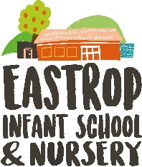

At Eastrop Infant school and Nursery, we are looking for a Learning Support Assistant with a passion for supporting pupils to achieve the highest standard of education, inspiring them to develop life-long learning skills.

It is important for our children to thrive in a school in which they feel safe and valued. Eastrop is a forward-thinking, infant academy nestled in Highworth, on the border of Wiltshire and Oxfordshire, for children aged between 2 and 7. We believe that learning has no limits and do our best to make sure that every day is outstanding for every child who attends our school.

We are part of Grove Learning trust As one organisation, our vision for Grove Learning Trust is unapologetically bold. We are all about creating remarkable futures. For our children, our people, our places of work, we want the very best. We know that strong connections will enable us to achieve our vision, in a world where purposeful collaboration, based on mutual respect and trust, helps us to achieve more together.
You will join our excellent team of professionals who are committed to helping children realise their full potential. Are you the positive, driven and inspirational teacher we are looking for to join our team?

Eastrop Nursery and Infant School is committed to safeguarding and promoting the welfare of all children and expects all staff and volunteers to share this commitment. An enhanced DBS check will be required for this post. To comply with the Asylum and Immigration Act 1998 (as amended by S147 of the Nationality and Immigration and Asylum Act 2002) all prospective employees will be required to supply evidence of eligibility to work in the UK.

