


Candidate Information Pack

Details of the Post
Job Title: | Teacher of English
Start date: | 1st September 2026
Status of post: | Permanent
Closing date for application: | Monday 9th February 2026
Interview Date: | Thursday 12th February 2026

WELCOME – Headteacher
Dear Prospective Candidate,

Thank you for your interest in this important post within our English Department. I hope that after finding out more about Wood Green School, and our English Department in particular, you will want to apply to be part of our dedicated staff team.

Wood Green School is an oversubscribed 11-18 comprehensive in Witney, close to the Cotswolds with excellent links to Oxford and London. We are an extremely supportive school, with staff wellbeing a priority. Our school stands out for its commitment to academic excellence and personal development. Our curriculum approach and teaching principles values subject specialism, giving strong department teams the freedom to share their love of their subject and to light fires. The extensive range of extracurricular activities encourages students to explore their wider talents and build leadership skills. Our dedicated, caring staff are passionate about nurturing each student’s academic and personal potential.

This is a very exciting time for Wood Green. We have created our Wood Green Baccalaureate, that encourages and celebrates everything that a school should develop in young people: engagement in all subjects, learning skills such as research and communication, and personal skills such as thoughtfulness for others. We believe strongly in a culture of mutual respect and strong relationships, demonstrated in our Behaviour Policy built on restorative principles and our Diversity, Equality and Inclusion Policy. Everything is underpinned by our LEARNWell values. Our strong reputation and results improving year-on-year have led to a rapid rise in student applications. This holistic approach ensures that we live out our mission to develop exceptional, well-qualified and well-rounded young people who make a positive contribution to our school, our community and the world.

I believe that investing in staff is crucial to achieving our mission. At Wood Green, we provide a comprehensive programme of staff development, sharing best practice in-school and giving staff the opportunity to work with other schools through our local and national partnerships. All teaching staff work with peer coaches in school and have opportunities for professional development through Trust Peer Reviews, Oxford University Department of Education and National Professional Qualifications.
Wood Green School is part of the Acer Multi-Academy Trust, consisting of nine schools: Wood Green School, Chalgrove Primary School, Stadhampton Primary School, Botley Primary School, Icknield Community College, Watlington Primary School, Glory Farm Primary School, Cooper School and Matthew Arnold School. All nine schools have strong track records of high performance or rapid improvement and share similar values. This partnership adds real benefit to Wood Green School, especially opportunities for staff development. The key values of the Acer Trust are Trust, Big-Heartedness and Ambition.

If this feels like a school where you can flourish, I look forward to hearing from you.

Yours sincerely

Rob Shadbolt, Headteacher

Mission, Values and Vision

Mission Statement

“Our mission is to develop exceptional, well-qualified and well-rounded young people who make a positive contribution to our school, our community and the world.”

Our Values

LEARNING EFFORT ASPIRATION RESPECT NURTURE WELLBEING
Our LEARNWell values reflect our commitment to developing the whole person and underpin everything we do:
- Learning – Wood Green students show curiosity, are creative thinkers, communicate powerfully, respond well to feedback, and find ways to learn that work for them
- Effort – Wood Green students are proud to try hard and to be successful, are not scared to fail, work well with others and by themselves
- Aspiration – Wood Green students achieve highly, believe they can improve, and leave prepared for their next exciting adventure​
- Respect - Wood Green students respect all others, take responsibility for their own actions, develop good relationships with all students and staff, and take care of their environment​
- Nurture - Wood Green students are kind to others and contribute to their community
- Wellbeing - Wood Green students manage themselves well emotionally, and know how to keep themselves healthy and safe.
Department Information

The Department of English consists of eleven specialist teachers who genuinely enjoy working together as a team and who readily collaborate across all Key Stages. The Department teaches in a set of eleven English classrooms, all housed in the same building, along with a department staff room. Each classroom has an interactive touchscreen board, an Ipevo visualiser, and its own PC monitor, and all staff are provided with a laptop.
The Department is well resourced with a range of texts and teaching materials for use across all Key Stages. We seek to work in ways that reduce workload by sharing core resources and approaches, whilst embracing and encouraging the creativity and skills of each classroom teacher.
Ethos
The Department is committed to developing effective learners who can think creatively and independently, as well as being able to reflect on their own practice as readers and writers. We place a significant emphasis on assessment for learning across the curriculum, setting personal targets for individuals to enable them to make progress and aspire to the best outcomes possible.
Students are taught the skills to use both written and spoken language creatively, effectively and precisely for different purposes, audiences and contexts. We encourage students to engage with and appreciate a wide variety of texts, including literary and non-literary texts from both modern and historical contexts.
We are committed to grouping students in ways which will enable staff to focus effectively on the needs of each cohort. This includes teaching mixed ability tutor groups as well as broad ability groups.

Alongside the classroom curriculum, students enter public speaking competitions, the Mock Trial competition, and creative writing competitions. We have also enjoyed theatre trips for all Key Stages to London and Stratford to experience Shakespeare in performance whenever they have been possible.
Curriculum
Key Stage 3
The focus in Years 7-9 is on inspiring learners, as well as teaching students explicitly the core skills of reading, writing, speaking, and listening, through a broad and balanced curriculum that offers continuity and progression to students of all abilities. Careful consideration has been given to the mapping of skills, disciplinary knowledge and powerful concepts across this Key Stage, alongside supporting students to read challenging texts. Our curriculum includes both literary and non-literary prose, poetry, drama, and independent reading.
In Years 7 and 8, we are committed to fortnightly library lessons to promote reading for pleasure and to enable student progress in their independent reading.
Key Stage 4
Students at Wood Green School currently follow the AQA English Language and English Literature specifications at GCSE. The curriculum is sequenced so that students build on the knowledge and skills learned at Key Stage 3, providing plenty of opportunity to make links across their learning and build understanding of literary concepts, as well as practising skills for exams. We aim to inspire an enjoyment of the subject as well as exam success and we are seeking ways to continue to grow the number of students who choose to do English A Level.
Key Stage 5
We offer two different subjects at A Level: English Literature (AQA Spec B) and English Language and Literature (AQA). The teaching of both A Level subjects is structured around the different units and has been planned to enable students to build confidence as they move through the course, enabling them to explore challenging texts and ideas, and providing regular opportunities to consolidate key skills.

Interventions and support
We have established a very effective pathway of interventions and support for KS3 and KS4 led by specialist teachers and a specialist HLTA. We are continuing to develop this pathway.

Department Development and Future Plans
This is an exciting time to join us as we seek to develop our evidence-based work in teaching and learning (a recent focus has been on the effective use of live modelling), to develop effective models of assessment that facilitate both challenge and success, as well as considering how to reduce staff workload.
As a team, we are constantly looking for ways to harness the talent of each member of staff to make us a ‘high-performing team’, rather than just a team of high-performers. We continue to seek the right balance between departmental consistency and freedom in individual classroom practice.
The school use a coaching model for key aspects of CPD. As a department, we look for ways to share and develop the best practice that we see across the school in subject-specific ways.

Job Description
Job Title | Teacher of English
Job Description | This job description forms part of the contract of employment of the successful applicant. The appointment is subject to the conditions of employment of Teachers contained in the School Teachers’ Pay and Conditions document and other current educational and employment legislation.
Review Date of Job Description | January 2020
Establishment | Wood Green School, Woodstock Road, Witney, OX28 1DX
Responsible to: | Head of English
Responsible for: | Teaching and supporting all designated classes in English
Purpose of Post | - To implement and deliver an appropriately broad, balanced, relevant and differentiated curriculum for students and to support a designated curriculum area as appropriate  - To monitor and support the overall progress and development of students as a Teacher/Form Tutor  - To facilitate and encourage a learning experience which provides students with the opportunity to achieve their individual potential.  - To contribute to raising standards of student attainment  - To share and support the school’s responsibility to provide and monitor opportunities for personal and academic growth
Teaching | - To undertake a designated programme of teaching across all key stages  - Teach consistently high-quality lessons  - Plan and deliver schemes of work and lessons that meet the requirements of the KS3, 4 and 5  - Be a role model for students, inspiring them to be actively interested in the subject  - To maintain appropriate records and to provide relevant accurate and up-to-date information for inhouse systems  - To complete the relevant documentation to assist in the tracking of students  - Set expectations for staff and students in relation to standards of achievement and the quality of learning & teaching  - Prioritise and manage time effectively, ensuring continued professional development in line with the role  - To follow the school policies and procedures  - To ensure the effective/efficient deployment of classroom support  - To maintain discipline in accordance with the school procedures, and to encourage good practice with regard to punctuality, behaviour, standards of work and homework  - Follow schemes of work for the subject at all Key stages  - Promote aspects of Personal Development related to the subject  - Updating professional knowledge and expertise as appropriate to keep up to date with developments in teaching practice and methodology, in general, and in the curriculum area of the subject  - Promote the subject learning through out of hour’s activities  - Ensuring a high-quality learning environment throughout the subject area.

Assessment, Feedback and Tracking | - To lead, monitor and evaluate the assessment and feedback to students in line with whole school and department policy  - To follow department monitoring and tracking systems relating to students’ attainment, progress and achievement  - Mark, grade and give written/verbal and diagnostic feedback as required  - Undertake assessment of students as requested by external examination bodies, curriculum areas and school procedures  - Assess, record and report on the attendance, progress, development and attainment of students and to keep such records as are required  - Complete the relevant documentation to assist in the tracking of students  - To follow department policy regarding department tracking of student progress and use information to inform learning and teaching  - Follow setting and co-ordinating assessment arrangements in the subject at all Key Stages, and in all areas as required by school policies, including standardising those assessments.
Staff Development | - To continue personal development in the relevant areas including subject knowledge and teaching methods  - To engage actively in the Performance Management process  - Participate in whole school CPD programmes  - To take part in the staff development programme by participating in arrangements for further training and professional development.
Student Support and Progress | - To be a Form Tutor to an assigned group of students  - To promote the general progress and well-being of individual students and the Tutor Group as a whole  - To liaise with the relevant pastoral leaders to ensure the progress of students  - To register students, accompany them to assemblies, encourage their full attendance at all lessons and their participation in other aspects of school life  - To evaluate and monitor the progress of students and keep up-to-date student records as may be required  - To lead the National Baccalaureate within the tutor group  - To contribute to the preparation of Action Plans and other reports as required  - To alert the appropriate staff to problems experienced by students  - To communicate as appropriate, with the parents of students and with persons or bodies outside the school concerned with the welfare of individual students, after consultation with the appropriate staff.  - To contribute to PSHE and citizenship and enterprise according to school policy  - To apply the Behaviour for Learning policy so that effective learning can take place  - Meet with students over whom there are concerns and contact home where necessary in conjunction with student support team and department heads.
Safeguarding | Be keenly aware of the responsibility for safeguarding children and to help in the application of the Safeguarding and Safe Practices policy within the school.  Comply with the school’s Safeguarding Policy in order to ensure the welfare of children and young persons.

Person Specification
criteria |  | qualities
Qualifications  and training | - Qualified teacher status  - Successful teaching experience  - Evidence of professional development relevant to this role
Skills and knowledge | - Good classroom practice, constantly showing a positive and resilient approach to students and staff  - Excellent communication and organisational skills  - Knowledge of effective teaching and learning strategies  - A good understanding of how children learn  - Ability to adapt teaching to meet students’ needs  - Ability to build effective working relationships with students  - Knowledge of guidance and requirements around safeguarding children  - Knowledge of effective behaviour management strategies  - Effective communication and interpersonal skills  - Ability to build effective working relationships with staff and other stakeholders
Personal qualities | - High expectations for all students and belief in bringing out the best in all  - Commitment to upholding and promoting the ethos and values of the school  - Commitment to always act with integrity, honesty, loyalty and fairness to safeguard the assets, financial integrity and reputation of the school  - Ability to work under pressure and prioritise effectively  - Commitment to maintaining confidentiality at all times  - Commitment to equality

We are not looking for the impossible! If you think that you have at least some of these attributes, we would very much like to hear from you.
Appointment will be subject to enhanced DBS check, qualifications and experience checks and satisfactory references.


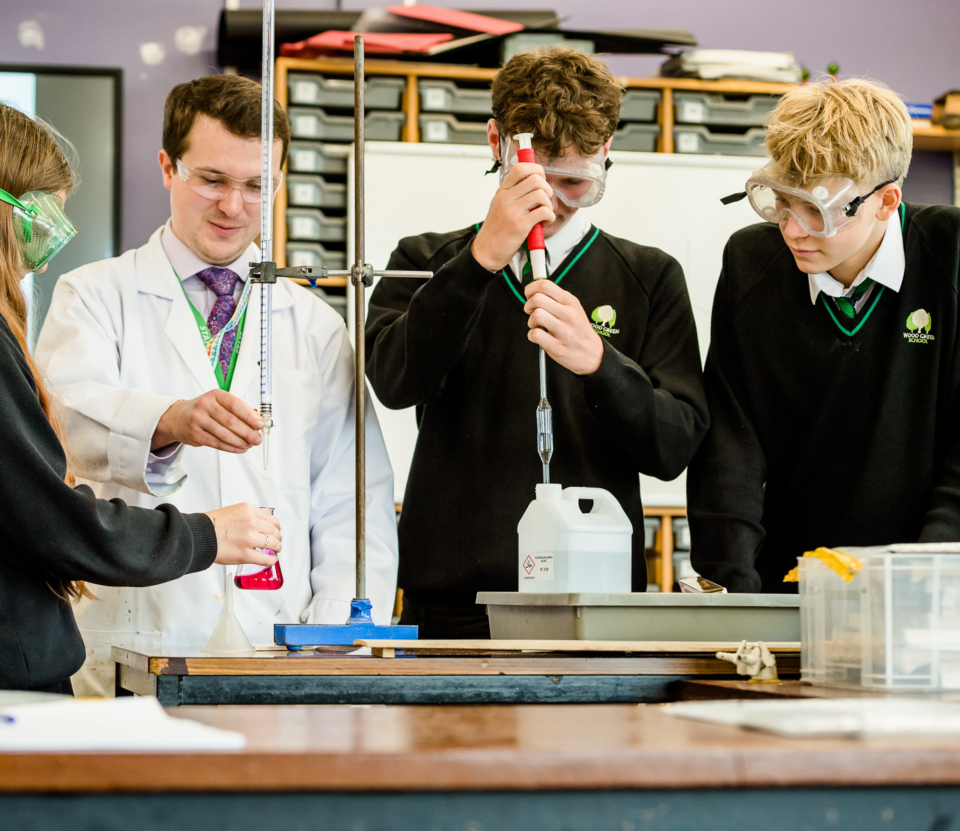

Wood Green School
Woodstock Road
Witney
OX28 1DX

01993 702355
hrwest@acertrust.org.uk
www.wgswitney.org.uk

