
Teacher of Science

Dear Applicant,
Thank you for your interest in the position of Teacher of Science (Chemistry) at Burscough Priory Academy.

The Endeavour Learning Trust board and I are delighted to provide the enclosed information about our School. I hope you find it helpful and on behalf of the whole school community, I would like to take this opportunity to extend a very warm welcome.

Endeavour Learning Trust is a growing Trust in the North West. In our family of schools at this point in our growth, we have four secondary schools and six primary schools formally in the Trust.

Our Trust is a mix of good schools and schools which have been in challenging circumstances. Where there has been work to be done, the impact has been rapid and significant. We are committed to growing our Trust further and we are strengthening our central team to ensure we have the capacity to continue to support where we are needed most. All of our schools and our staff provide us with rich opportunities to learn from and with each other.

We strive to ensure that our family ethos is tangible; that we work as a team; that we want the best for everyone. We are also staunch in our commitment to working in a way which protects the wellbeing of our staff; our commitment to reducing workload is non-negotiable. We seek to thrive; individually, collectively, in our classrooms, staffrooms, schools, our central team and across the Trust.

We hope the enclosed information will give you good insight into our School & Trust.

We look forward to viewing your application.

Yours faithfully,
David Clayton
Chief Executive

Endeavour Learning Trust’s Mission and Values
We will serve our communities to ensure that every child realises their potential
We pledge that our schools will be transformational places of academic excellence that offer a true richness of experience, providing all children with the same opportunities to flourish and develop their unique skills, qualities and talents.
We will work collaboratively with our colleagues, parents and carers and our partners to remove any barriers that place limitations on our children, creating schools that are happy and harmonious places at the centre of their community.
Our Values
Individuality
We are firmly committed to recognising, celebrating and investing in the individuality of all of our children and young people, each of our colleagues and the distinct ethos and identity of each of our schools, whilst remaining united by our core values. We don’t believe in a “one size fits all” approach, and will adapt our provision to meet individual needs.
People centred
Our work is driven by our responsibility to every individual within our Trust community. Every person deserves to be treated with respect, dignity and kindness. We demonstrate empathy and humility in our approach, ensuring that our Trust provides an environment where every individual feels confident to be their true authentic self.
Belonging
Equity of opportunity is central to our practice and we will be relentless in our endeavour to identify and remove barriers that prevent full inclusion. Our culture extends beyond tolerance to one where difference is embraced and every individual is valued and celebrated for their unique contribution to our community. Every individual is a full member in our community.
Transformation
We believe in the promise of each individual across the Trust and will ensure we inspire, support and challenge in proportionate measure, so that we all thrive and are able to achieve our own individual successes. We are bold in our approach, stretching perceived boundaries, to go further for our children, colleagues and communities. We continually develop our approach to respond to changes in the communities we operate within to support every child, colleague and partners to realise their potential.
Togetherness
We are a proud family of schools bonded by our Trust vision, priorities and values. We work as one team in school, across our Trust and with our wider partners for the benefit of the communities we serve. Our collaborative approach inspires us to be bold and brings us together in ways that help us to make a difference. We are better together.

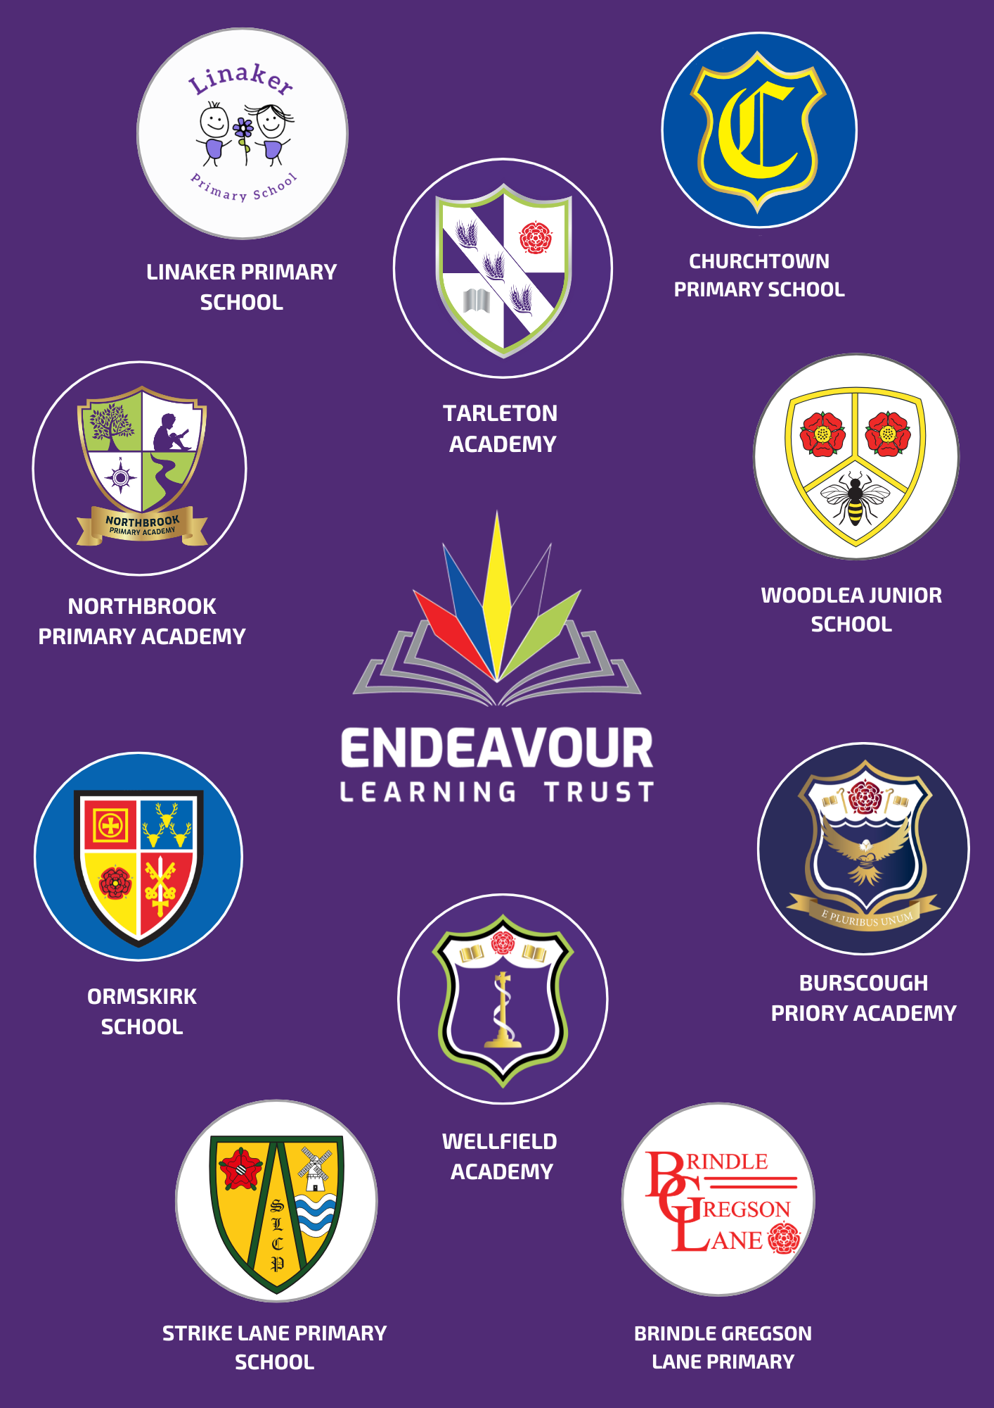


Dear Applicant,

Thank you for your interest in the Teacher of Science (Chemistry) vacancy at Burscough Priory Academy.

We are a small and thriving community school, within the Endeavour Learning Trust family of schools. Since joining the Trust, we have made rapid and sustained progress over the last four years, with the vision of being a ‘Great school at the heart of the community.’

At our school you will find a caring, ambitious and inclusive community; one that is dedicated to celebrating the potential and uniqueness of everyone. To support this commitment, there is a strong curriculum, inspirational and challenging teaching and learning and outstanding pastoral care. In November 2022, this was recognised by Ofsted and we were judged a ‘Good’ school.

The relationships that are fostered in school between the children and staff are exceptional. We are very aware of our responsibility as a school at the heart of our Burscough community and we know that excellent relationships with our parents, staff and within the wider community are crucial to the success of the children. Our motto is, ‘E Pluribus Unum,’ which translates as ‘Out of Many, One.’ You will feel a distinct feeling of togetherness, working as one to make sure our children feel safe, valued and well supported.

Our family ethos is tangible; we work as a team and we want the best for everyone. But we are also staunch in our commitment to doing this in a way which protects the wellbeing of our staff and our students. Our commitment to reducing workload is non-negotiable. We seek to thrive; individually, together, in our classrooms, staffrooms, schools and right across the Trust.

We hope the information in this pack give you a flavour of who we are and what we do. If you have any further questions about the role please get in touch.

We look forward to receiving your application.

Yours faithfully,



Mrs L MacLaren
Headteacher

Teacher of Science - Chemistry
Part time, Maternity Cover – 0.7 or 0.8
Main Pay Range – Upper Pay Range
£32,916 - £51,048 per annum
Required for Easter 2026

Inspire curiosity. Spark discovery. Bring science to life.
Do you have a passion for science, and a talent for inspiring young minds? We are seeking an enthusiastic and dedicated Teacher of Science to join our dynamic Science Department, on a maternity cover basis.
In this exciting role, you will create engaging, hands-on lessons that encourage curiosity, critical thinking, and a deep understanding of the world around us. From exploring the wonders of biology and chemistry to unlocking the principles of physics, you’ll help students become inquisitive, confident, and capable scientists.
Key Responsibilities
- Deliver high-quality, engaging science lessons to students of all abilities.
- Foster curiosity, creativity, and a lifelong love of scientific inquiry.
- Support students in developing practical, analytical, and problem-solving skills.
- Contribute to curriculum development and enrichment activities.
If you’re ready to make the science classroom a place of discovery, exploration, and innovation, we’d love to hear from you!
HOW TO APPLY
To apply, please complete our online application form in full, along with a personal statement to support your application and outline the relevant experience you can bring to Endeavour Learning Trust.
If you require any further information, please contact our Operations Lead, Alexa at a.oldfield@burscoughprioryacademy.org
SAFEGUARDING
Endeavour Learning Trust is committed to safeguarding and promoting the welfare of children, young people and vulnerable adults and expects all staff and volunteers to share this commitment and individually take responsibility for doing so.
Please note that in line with Keeping Children Safe in Education, an online search will be carried out as part of our due diligence on shortlisted candidates.

To carry out the duties of a School Teacher as set out in the School Teachers Pay and Conditions Document.
To plan, develop and deliver high quality lessons and schemes of work, using a variety of approaches, to continually enhance teaching and learning and to maximise individual progress for students
To maintain and build upon the relevant standards achieved in the award for QTS (Secondary) as set out by the Secretary of State
To support the Head of Faculty (HoF) in providing effective leadership and management and to contribute to building and maintaining an effective teaching team which continually strives to enhance the quality of teaching and learning
To contribute as appropriate to a personalised learning agenda to meet the needs of individual students
To contribute to the school’s delivery of engaging and effective teaching and learning strategies
To consistently apply the school’s Behaviour and Rewards Policy
The ability to team Chemistry will be an advantage

Teaching and Learning
Manage student learning through effective teaching in accordance with the Faculty/Department’s schemes of work and policies.
Ensure continuity, progression and cohesiveness in all teaching.
Use a variety of methods and approaches, including differentiation to ensure stretch and challenge for all students and to meet curricular objectives and to ensure equal opportunity for all students.
Set assessments and homework regularly in accordance with the School policies and guidelines, to consolidate and extend learning and encourage students to take responsibility for their own learning.
Work with SEND staff and pastoral support staff (including prior discussion and joint planning) in order to benefit from their specialist knowledge and to maximise their effectiveness within lessons.
Work effectively as a member of the Faculty team to improve the quality of teaching and learning.
Set high expectations for all students, particularly Pupil Premium students, to deepen their knowledge and understanding, to raise aspirations and to maximise their individual achievement.
To plan and execute appropriate intervention strategies within the classroom to address potential underachievement and log as appropriate
Use positive management of behaviour in an environment of mutual respect which allows students to feel safe and secure and promotes their self-esteem.
Inspire creativity, independence and critical thinking
Contribute towards social cohesion

Curricular/Faculty Development
To contribute to the development of comprehensive schemes of work which include a range of teaching and learning methods and activities providing a rich experience for all students, and incorporating a variety of assessment methods at key points to enable accurate judgements to be made on student progress within the Assessment for Learning Agenda.

Subject Knowledge and Understanding
- Have a thorough and up-to-date knowledge and understanding of the National Curriculum requirements and assessment requirements and specifications for examination courses.
- Keep up-to-date with research and developments in subject/pedagogy.

Professional Standards and Development
- Be a role model to students through appropriate personal presentation and professional conduct as in the Guidance for Safer Working Practice for Adults who work with Children and Young People in Education Settings and the school policy and procedures.
- Arrive in class, on or before the start of the lesson, and begin and end lessons on time and be a presence around school and between lessons, ensuring high standards are maintained.
- Cover for absent colleagues in line with agreed school policies.
- Be familiar with and supportive of all the School’s policies and procedures including Safeguarding and Health.
- Establish effective working relationships with professional colleagues.
- Maintain a working knowledge and understanding of teachers’ professional duties as set out in the current School Teachers’ Pay and Conditions document, and teachers’ legal liabilities and responsibilities relating to all current legislation, including the role of the education service in protecting children.
- Liaise effectively with parent/carers and with other agencies with responsibility for students’ education and welfare as directed by the School.
- Be aware of the role of the Trust Board and Local Academy Council of the Academy and support them in performing their duties.
- Be familiar with and implement the relevant requirements of the current SEND Code of Practice, DDA and Access to Work.
- Consider the needs of all students within lessons (and implement specialist advice) especially those who:
- have SEND
- are disadvantaged (including PP, FSM, CLA, Forces Children and EAL)
- are Able, Gifted and Talented
- are mobile students

Liaison/communication
- Meet regularly and work with the HoF (and line manager if different) for professional support and to develop effective Faculty management
- Liaise with other subject teachers in order to utilise effective practice from across the curriculum

Health and Safety
- Be aware of Basic First Aid procedures.
- Be aware of the responsibility for personal Health, Safety and Welfare and that of others who may be affected by your actions or inactions.
- Co-operate with the employer on all issues to do with Health, Safety & Welfare and fire procedures.
- Work to the school’s policies.

Continuing Professional Development - Personal
- In conjunction with the line manager, take responsibility for personal professional development, keeping up-to-date with research and developments in teaching pedagogy and changes in the curriculum, which may lead to improvements in teaching and learning.
- Undertake any necessary professional development as identified in the School or Faculty Improvement Plan and Appraisal processes taking full advantage of any relevant training and development available.
- Maintain a professional portfolio of evidence to support the Appraisal process.
- To work to the school’s policies

Continuing Professional Development – Staff
- Contribute as appropriate to the school’s CPD programme.
- Support trainees and ECTs to ensure they are appropriately monitored and supported if applicable.

Tutor Role
- Every classroom teacher may be expected to be part of House team and to work to the Personal Tutor job description

Safeguarding
- To be responsible for promoting and safeguarding the welfare of children and young persons with whom the post-holder comes into contact with, or is responsible for in line with School Policies.

Section 2 - Additional Duties for this Post
- To teach effectively
- To assist the HoF in ensuring that the Faculty contributes effectively to the attainment of school targets in all Key Stages

To undertake any other duties and tasks as reasonably defined by the Executive Headteacher

This job description may be reviewed annually and may be subject to amendment or modification at any time after consultation with the post holder.

It is not a comprehensive statement of procedures and tasks, but sets out the main expectations of the School in relation to the post holder’s professional responsibilities and duties.

Elements of this job description and changes to it may be negotiated at the request of either the Headteacher or the incumbent of the post.

TEACHER OF SCIENCE
JOB DESCRIPTION


BURSCOUGH PRIORY ACADEMY

To fully engage with Faculty and whole school initiatives for collaborative planning and moderation.

To share in the development of Faculty classroom and intervention strategies for students’ literacy, numeracy and spiritual, moral, social and cultural development.

Monitoring, Assessment, Recording, Reporting, and Accountability

Be immediately responsible for the processes of identification, assessment, recording and reporting for the students in their charge.

Contribute towards the implementation of ‘Pupil Passports’ as detailed in the current Code of Practice and school policies particularly the planning and recording of appropriate actions and outcomes related to set targets and suggested strategies.

Assess students’ work systematically and use the results to inform future planning, teaching, moderation and curricular development and to refine accurate predictions of student outcomes.

Keep up to date with data on student progress and use it effectively in planning and preparation.

Be familiar with statutory assessment and reporting procedures, prepare and present informative, helpful and accurate reports as required.

Keep an accurate register of students for each lesson. Unexplained absences or patterns of absence should be reported immediately in accordance with the School policy.

Subject Knowledge and Understanding
Have a thorough and up-to-date knowledge and understanding of the National Curriculum requirements and assessment requirements and specifications for examination courses.

Keep up-to-date with research and developments in subject/pedagogy.

Professional Standards and Development
Be a role model to students through appropriate personal presentation and professional conduct as in the Guidance for Safer Working Practice for Adults who work with Children and Young People in Education Settings and the school policy and procedures.

Arrive in class, on or before the start of the lesson, and begin and end lessons on time and be a presence around school and between lessons, ensuring high standards are maintained.
Cover for absent colleagues in line with agreed school policies.

Be familiar with and supportive of all the School’s policies and procedures including Safeguarding and Health.

Establish effective working relationships with professional colleagues.

Maintain a working knowledge and understanding of teachers’ professional duties as set out in the current School Teachers’ Pay and Conditions document, and teachers’ legal liabilities and responsibilities relating to all current legislation, including the role of the education service in protecting children.

Liaise effectively with parent/carers and with other agencies with responsibility for students’ education and welfare as directed by the School.

Be aware of the role of the Trust Board and Local Academy Council of the Academy and support them in performing their duties.

Be familiar with and implement the relevant requirements of the current SEND Code of Practice, DDA and Access to Work.

Consider the needs of all students within lessons (and implement specialist advice) especially those who:
- have SEND
- are disadvantaged (including PP, FSM, CLA, Forces Children and EAL)
- are Able, Gifted and Talented
- are mobile students

Liaison/communication

Meet regularly and work with the HoF (and line manager if different) for professional support and to develop effective Faculty management

Liaise with other subject teachers in order to utilise effective practice from across the curriculum

Health and Safety

Be aware of Basic First Aid procedures.

Be aware of the responsibility for personal Health, Safety and Welfare and that of others who may be affected by your actions or inactions.

Co-operate with the employer on all issues to do with Health, Safety & Welfare and fire procedures.

Continuing Professional Development – Personal

In conjunction with the line manager, take responsibility for personal professional development, keeping up-to-date with research and developments in teaching pedagogy and changes in the curriculum, which may lead to improvements in teaching and learning.

Undertake any necessary professional development as identified in the School or Faculty Improvement Plan and Appraisal processes taking full advantage of any relevant training and development available.

Maintain a professional portfolio of evidence to support the Appraisal process.

Continuing Professional Development – Staff

Contribute as appropriate to the school’s CPD programme.

Support trainees and ECTs to ensure they are appropriately monitored and supported if applicable.

Tutor Role
Every classroom teacher may be expected to be part of House team and to work to the Personal Tutor job description

Safeguarding
To be responsible for promoting and safeguarding the welfare of children and young persons with whom the post-holder comes into contact with, or is responsible for in line with School Policies.

Additional Duties for this Post
To teach effectively

To assist the HoF in ensuring that the Faculty contributes effectively to the attainment of school targets in all Key Stages

PERSON SPECIFICATION
 | KEY CRITERIA | Essential (E)/  Desirable (D)
QUALIFICATIONS | Qualified Teacher Status/appropriate Graduate Status | E
QUALIFICATIONS | Effectiveness as a Teacher of Science | E
QUALIFICATIONS | DBS Clearance | E
EXPERIENCE AND KNOWLEDGE | A proven track record of successful teaching with evidence of enhancing student achievement, especially at GCSE level | D
EXPERIENCE AND KNOWLEDGE | A thorough understanding of how data may be used to monitor and improve pupil performance and the effective use of school tracking and reporting systems | D
EXPERIENCE AND KNOWLEDGE | A demonstrable commitment to CPD and a thirst for reviewing and developing teaching and learning strategies | E
EXPERIENCE AND KNOWLEDGE | A commitment to engage in and use educational research for the development of teaching and learning | E
EXPERIENCE AND KNOWLEDGE | An ability to be part of a team | E
EXPERIENCE AND KNOWLEDGE | Infectious enthusiasm in the classroom and around school | E
EXPERIENCE AND KNOWLEDGE | Ability to develop independent learning and enquiry skills in students | E
EXPERIENCE AND KNOWLEDGE | Excellent classroom management and organisation | E
EXPERIENCE AND KNOWLEDGE | Awareness of the principles of Assessment for Learning | E
EXPERIENCE AND KNOWLEDGE | Ability to accurately assess and predict student progress | D
EXPERIENCE AND KNOWLEDGE | An understanding of how data may be used to monitor and improve pupil performance | D
EXPERIENCE AND KNOWLEDGE | Awareness and commitment to a personalised learning agenda | E
EXPERIENCE AND KNOWLEDGE | ICT literate and a willingness to further develop their skills | E
EXPERIENCE AND KNOWLEDGE | Motivation to work with children and young people | E
EXPERIENCE AND KNOWLEDGE | Ability to form effective and appropriate professional working relationships with young people with clear boundaries | E
EXPERIENCE AND KNOWLEDGE | Ability to develop appropriate use of authority within an ethos of mutual respect in accordance with the Behaviour Policy | E
PROFESSIONAL AND PERSONAL ATTRIBUTES | Emotional resilience in dealing with the challenges of the role | E
PROFESSIONAL AND PERSONAL ATTRIBUTES | A genuine passion for education | E
PROFESSIONAL AND PERSONAL ATTRIBUTES | A commitment to the Aims and Vision of the Trust, the School Development Plan and the Faculty Development Plan | E
PROFESSIONAL AND PERSONAL ATTRIBUTES | A willingness to undertake further training and professional development | E
OTHER | Clearance through the Disclosure and Barring Service | E
OTHER | Compliance and adherence to the document ‘Guidance for Safer Working Practice’ & ‘Guidance for Conduct’ | E

