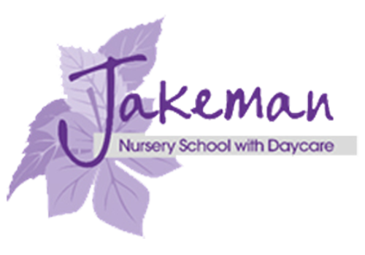
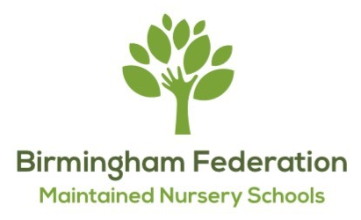
JAKEMAN NURSERY SCHOOL
Jakeman Road, Balsall Heath
Birmingham, B12 9NX
Tel: 0121 4403066
Email: enquiry@jakeman.bham.sch.uk
Executive Head Teacher: Samantha Richards

THE BIRMINGHAM FEDERATION OF MAINTAINED NURSERY SCHOOLS

Allens Croft Nursery School  Shenley Fields Nursery School | Lillian De Lissa Nursery School  Newtown Nursery School
Adderley Nursery School  Highfield Nursery School | Jakeman Nursery School  Gracelands Nursery School
St Thomas Centre Nursery School

Level 2 Qualified Nursery Officer (SEND support) post at Jakeman Nursery School – TERM TIME ONLY
Grade A - Permanent - 34.5hrs per week - Start date 1st September 2026
We are looking for a Level 2 Early Years Nursery Officer to enhance our team to secure outstanding outcomes for all pupils at Jakeman Nursery School. At Jakeman, we pride ourselves on our creative and holistic approach to pre-nursery and nursery education. Our approach empowers children to make their own choices and helps them to be self-motivated individuals. We offer a play-based curriculum, with the children at the centre of everything we do.
Jakeman Nursery School is in a cluster of 2 nursery schools along with Gracelands Nursery School, and cluster leaders, teachers and practitioners work collaboratively to provide high standards of education. The role is supported by a class teacher, a Nursery Manager, and an Executive Head Teacher. The Nursery Officer will support children with SEND, both in our enhanced ratio provision (Oak Room) and across the main provision (2-3 year olds room, 3-4 year olds, outdoors). In our second building, we also have a baby unit for 9x children of 9months-2yr olds. The Nursery Officer will promote and support the vision and direction of the school and the wider Federation of Maintained Nursery Schools.
The Birmingham Federation of Maintained Nursery schools is made up of 9 Nursery Schools delivering inclusive high-quality early education and care to children aged 0-5 years across Birmingham. We have a vibrant and enthusiastic staff of qualified teachers, teaching assistants, nursery officers, play workers, administrators and other support staff who make up our large team. As well as exceptional and inclusive provision for children and families, we are committed to professional development, and provide opportunities for learning and collaboration across the cluster of 2 schools and the wider Federation.
Our settings are culturally diverse with a large number of languages spoken. We have a reputation for supporting children with a range of complex special educational needs and disabilities, as well as support for families who may have additional challenges in their lives.
We are committed to safeguarding and promoting the wellbeing of all children, and expect our staff and volunteers to share this commitment. Suitability checks will be undertaken including background, identity, qualification, work history and two professional references.
Early Years education is undergoing ongoing change and challenge so applicants need to not only be a passionate and committed practitioner but also flexible, resilient and able to contribute innovative ideas.
If you feel you are the right fit to take on the role of Nursery Officer at Jakeman Nursery School, please apply using the MyNewTerm application process. Nursery school visits are most welcome. Please email enquiry@jakeman.bham.sch.uk to arrange an appointment.
Closing date: Monday 13th April 2026 @ 12:00 Interview date: Tuesday 5th May 2026

