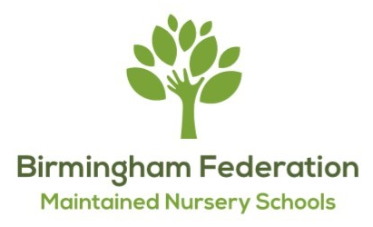
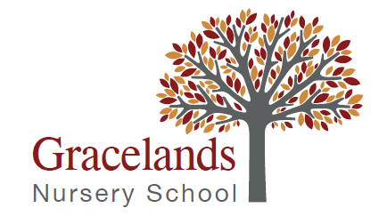

THE BIRMINGHAM FEDERATION OF MAINTAINED NURSERY SCHOOLS

GRACELANDS NURSERY SCHOOL
Grace Road, Sparkbrook
Birmingham, B11 1ED
Tel: 0121 7723124
Email:enquiry@grclands.bham.sch.uk
Executive Head Teacher: Samantha Richards

Allens Croft Nursery School  Shenley Fields Nursery School | Lillian De Lissa Nursery School  Newtown Nursery School
Adderley Nursery School  Highfield Nursery School | Jakeman Nursery School  Gracelands Nursery School
St Thomas Centre Nursery School

Nursery Teacher post at Gracelands Nursery School
MPR/UPS – Term Time Only – Fixed term 12mths maternity cover – 01.09.2026 – 31.08.2027
1 year fixed term maternity leave cover
We are looking for a dedicated and enthusiastic teacher to join our team to secure outstanding outcomes for all pupils at Gracelands Nursery School. At Gracelands, we pride ourselves on our creative and holistic approach to pre-nursery and nursery education. Our approach empowers children to make their own choices and helps them to be self-motivated individuals. We offer a play-based curriculum, with the children at the centre of everything we do.
Gracelands Nursery School in Sparkbrook is in a cluster of 2 Local Authority Maintained Nursery Schools along with Jakeman Nursery School in Balsall Heath, and cluster leaders and teachers work collaboratively to provide high standards of education. The teacher at Gracelands will lead a team of teaching staff across both little nursery (2-3 year olds) and big nursery (3-4 year olds), supported by a Deputy Head Teacher, SENCO and Executive Head Teacher. The teacher will promote and support the vision and direction of the school and the wider Federation of Maintained Nursery Schools.
The Birmingham Federation of Maintained Nursery schools is made up of 9 Nursery Schools delivering inclusive high-quality early education and care to children aged 0-5 years across Birmingham. We have a vibrant and enthusiastic staff of qualified teachers, teaching assistants, nursery officers, play workers, administrators and other support staff who make up our team.
As well as exceptional and inclusive provision for children and families, we are committed to the training and professional development of our staff, and provide opportunities for learning and collaboration across the cluster of 2 schools and the wider Federation.
Our settings are culturally diverse with a large number of languages spoken. We have a reputation for supporting children with a range of complex special educational needs and disabilities, as well as support for families who may have additional challenges in their lives.
We are committed to safeguarding and promoting the wellbeing of all children, and expect our staff and volunteers to share this commitment. Suitability checks will be undertaken including background, identity, qualification, work history and two professional references.
If you are interested in this position, please complete the application via MyNewTerm. Visits are most welcome with prior arrangement. Please contact Samantha Richards (Executive Headteacher) or Harshila Parmar (Deputy Headteacher) on 0121 7723124 or enquiry@grclands.bham.sch.uk to arrange an appointment.
Visit our website for further information about Gracelands Nursery School: https://www.grclands.bham.sch.uk/

Closing date: Friday 17th April 2026 at 09:00 Interview date: Monday 27th April 2026

