

JOB PROFILE
Job Title: | Year Team Support Officer | School/Department: | Harrogate Grammar
Salary Grade: | Band 9 | Working Hours: | 37
Contract Type: | Permanent/Term Time only plus training days (39 weeks per year) | Location: | Harrogate, North Yorkshire
Responsible to: Deputy Headteacher
Role summary:
To support the Year Managers and Pastoral team in first response to student and family need. To ensure exceptional pastoral and academic support is provided for students in order that they are all are able to achieve success. Central to this role will be supporting a team of Year Managers and working effectively with parents, Faculty Leaders and the wider Pastoral team.
Red Kite Learning Trust is committed to safeguarding and promoting the welfare of students and expects all colleagues and volunteers to share this commitment.
Special conditions of service:
No smoking policy, including e-cigarettes.
Role specific responsibilities:
- Working closely with the Year Managers, to support all students including those who are disadvantaged to gain the best outcomes possible.
- Deputise for Year Managers as needed in their absence including running assemblies as needed.
- Work closely with the Year Managers in identifying students and groups of students, who are at risk of underachieving.
- Liaise with appropriate staff and other agencies to effectively support students’ pastoral needs, including social, emotional and mental health needs; behavioural difficulties; improvements to attendance.
- Work with the SENCO to ensure that IEPs are used effectively, targets are matched to individual student needs and also monitoring the progress of particular children including those with EHCPs.
- Support student tracking regarding current progress, behaviour, attendance and punctuality.
- Establish and maintain an ethos of high standards from all students in the year groups you support.
- Keep accurate and timely records.
- Support in managing students in unstructured time by being part of the duty teams at break and lunch and having a high-profile presence around the school.
- Make ‘first day’ contact home when students have not arrived at school or who are late as needed.
- Support Year Managers with administrative and organisational tasks.
- support, as required, alternative and catch-up provision as appropriate.
- Provide first aid support for young people and adults as part of a rota.
Communication
- Liaise effectively with all stakeholders and ensure that the schools’ values and expectations are understood by all.
- Liaise with other postholders as appropriate to ensure efficient running of the school, effective communication and prompt responses to staff and parents in relation to individual students.
Personal development
- Keep up to date with national developments and new ideas in pastoral care in schools so that the best practice can be utilised.
- Engage positively with the school’s CPL programmes and networks both within and beyond the school that support continuous improvement.
Behaviour and attitudes
- Foster a climate of high expectations, excellence and mutual respect across the school, ensuring the positive achievement system is used appropriately, effectively and consistently.
- Support the Year Teams with the management and improvement of behaviour, punctuality, and attendance of students.
Administration
- Be willing to work flexibly in terms of working hours to meet the needs of students and parents.
- Work with the administration services team to ensure that the administration and communication needs of the students are fully met.
- Maintain accurate and up to date records, ensuring they are fully compliant with data management regulations.
RK People responsibilities:
- Contribute to the overall aims and values of our Trust, appreciate and support the roles of other members of the wider team and attend and participate in relevant meetings as required
- Comply with all Trust policies and procedures including child protection, health, safety, welfare, security, confidentiality and data protection, reporting any concerns to the appropriate person
- Contribute to ensuring safeguarding procedures are in place and used effectively at all times
The role holder must demonstrate a flexible approach to the delivery of the role. Consequently, the role holder may be required to perform work not specifically identified in the job profile but which is in line with the general scope, grade and responsibilities of the role.
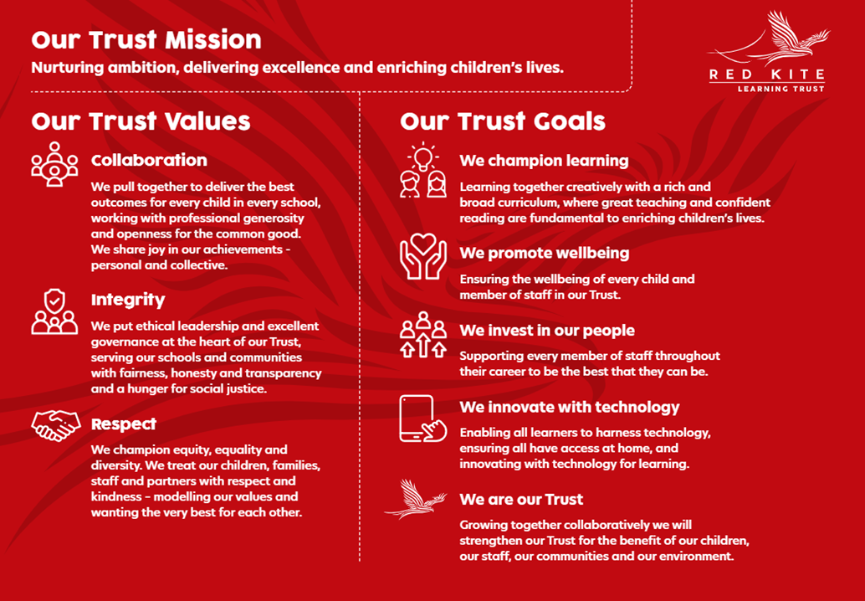
PEOPLE PROFILE
Aptitudes and Characteristics |  |  | Essential | Desirable
Ability to work flexibly and collaboratively as part of a team as well as independently |  |  | *
Ability to communicate well with staff, students and parents/carers and develop positive working relationships |  |  | *
Capacity to evaluate and improve |  |  | *
Ability to deal with sensitive information in a confidential manner |  |  | *
Ability to work under pressure and meet deadlines |  |  | *
Excellent organisation and administrative skills and ability to work to high levels of accuracy |  |  | *
Ability to negotiate challenging situations and work under pressure |  |  | *
Good organisational skills and high levels of self-motivation |  |  | *
Hard-working, well-motivated and positive with the ability to ‘give more’ when the occasion demands it |  |  | *
Qualifications, Knowledge and Experience |  |  | Essential | Desirable
Experience of working with young people and challenging behaviours |  |  | *
High level of ICT skills |  |  | *
Knowledge of strategies relating to intervention to support positive behaviour |  |  | *
Understanding of best practice in raising student attainment |  |  |  | *
Degree level or appropriate qualifications |  |  |  | *
First Aid at Work or Emergency First Aid at Work, or willingness to attend training |  |  | *
Safeguarding and Promoting the Welfare of Students |  |  | Essential | Desirable
An appropriate motivation to work with children and young people |  |  | *
Ability to maintain appropriate relationships and personal boundaries with children and young people |  |  | *
Emotional resilience in working with challenging behaviours and appropriate attitudes to the use of authority and maintaining discipline |  |  | *

