1 to 1 Educational Teaching Assistant
https://mynewterm.com/jobs/147884/EDV-2026-OBA-66566

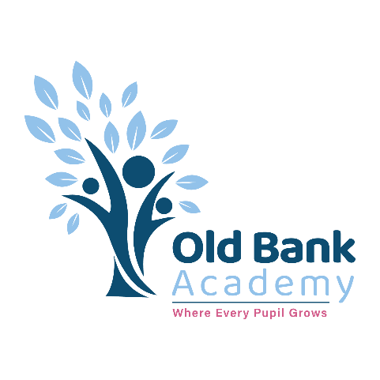




CONTENTS
1. Our Academy
2. Job Description
3. Person Specification
4. Our Trust
Proud member of Impact Education Multi Academy Trust
Recruitment pack

Our Academy

It is with great pleasure that I welcome you, on behalf of the children, staff and governors, to Old Bank Academy.

Old Bank Academy is an inclusive school that caters for the needs of all children aged 4-11 years old. We pride ourselves on the friendly atmosphere of our school community, which enables our children to thrive and reach their potential in all aspects of their life. We are passionate about improving the life chances of young children in our school community and children are encouraged to develop themselves as fully rounded, emotionally intelligent individuals.

As part of Impact Education Multi Academy Trust, we are passionate about making a difference and inspiring children to be resilient and confident learners with a love for learning. Here at Old Bank, we want our children to be excited about learning and to develop their knowledge, skills and understanding across a wide curriculum. We believe in celebrating success and ensuring that children feel valued.

At Old Bank, we work in partnership with parents and carers. We value the contributions of a child’s whole family and are committed to building strong links with the community. We know that the more parents are engaged in their child’s learning, the more they will achieve!

We are an Ofsted good school Where Every Pupil Grows.

Mrs Amy Liddle


Head of School

Job Description

Post: 1 to 1 Educational Teaching Assistant
Salary: Scale 3, Point 5 – 6. Actual salary £19532 - £19842
Contract Type: Permanent Term Time only
Hours: 32.5 hours per week Mon – Fri (8.30am-3.30pm) with 30 mins lunch

Welcome to Old Bank Academy. We provide a nurturing environment for learning and development.
If you would like to request a tour of the school or meet with us informally before applying for the role, please contact our main office on 01924 495790.

Job Description
Post: 1-to-1 Educational Support Assistant

Purpose
To work under the supervision and guidance of teaching staff, providing dedicated 1-to-1 support for a named child to enable access to learning, promote wellbeing, and facilitate inclusion within the classroom and wider school environment.
Duties and Responsibilities
- Constantly uphold and promote our values and vision.
- Work directly with the SENDCO and team to ensure effective provision.
- Develop a strong, trusting relationship with the child, acting as a key adult for their emotional and educational needs.
- Implement and monitor personalised learning and support programmes as directed by the class teacher, SENCO, or external specialists.
- Work with the teacher to ensure that progress is clearly recorded and relates to the learning objectives/goals for students.
- Adapt resources and activities to meet the child’s individual learning style, abilities, and interests.
- Support the child’s social integration with peers, encouraging participation in group activities where appropriate.
- Support the child during transitions (e.g., between activities, at break/lunch times, moving

- around school).
- Work with individuals or small groups to deliver interventions that meet the needs of pupils and comply with the recommendations of their support plans/EHCPs.
- Prepare and organise resources for learning activities, including displays and classroom materials.
- Assist in the supervision of educational visits and local walks, ensuring the safety and wellbeing of pupils.
- Liaise with relevant staff to ensure the child’s needs are met.
- Manage own workload and that of others to allow an appropriate work / life balance.
- Support students throughout the day by fulfilling pastoral responsibilities.
- Communicate effectively with parents and carers as directed by the teacher or school leadership.
- Engage fully in the academy appraisal process to fulfil personal potential and be able to participate effectively in the implementation of the academy’s goals and improvement plan.
- Attend meetings / training and carry out administrative tasks and duties as specified on the academy calendar.
- Consistently implement all academy policies.
- Contribute to decision-making and consultation procedures.
- Report any safeguarding concerns immediately to the Designated Safeguarding Lead.
- Carry out any other reasonable duties as requested by the Headteacher or Head of School.

This job description is not necessarily a comprehensive definition of the post. It will be reviewed annually.

Impact Education Multi Academy Trust is committed to safeguarding staff and students and expects all employees and volunteers to share this commitment. All posts are subject to an enhanced Disclosing and Barring Service DBS check. All interviews will include a question about Safeguarding and any anomalies identified in pre-recruitment checks will be discussed at interview.

Person Specification
Post: 1-1 Educational Support Assistant

Attributes | Essential | Desirable | How Identified
Qualifications | Numeracy and Literacy skills to a level to assist students with their work. (GCSE/O Level Grade C or above) ·  Willingness to undertake training relevant to supporting children in a primary setting (e.g., safeguarding, first aid phonics). | NVQ Level 3 for Teaching Assistants or equivalent qualifications or experience  Training in relevant support strategies  Experience or training in supporting early years or primary-aged children | Application  Certification
Experience | Values driven  Experience of working with young people in relation to social, emotional, behavioural issues  Experience of working 1-1 with children with additional needs  Experience of supporting children’s learning and play in a primary or early years setting | Working in a school with a similar context  Experience working in a primary school or early years environment.  Experience in implementing personalised learning or behaviour support plans. | Application  Interview  References
Knowledge and skills | High expectations which motivate and challenge students  Ability to adapt communication and support strategies to suit the individual child.  Understanding of the primary curriculum including phonics, early maths and play based learning  Understanding of the child’s specific needs (eg, SEND, medical, emotional) and how these may impact learning and behaviour.  Knowledge of safeguarding and child protection procedures | Understanding of the secondary curriculum and other basic learning programmes/strategies  Understanding of Child Development and Learning in the early years and primary phases.  Understanding of the Engagement model and nurture approaches | Application  Interview  References
Character | Strong moral purpose and drive for improvement  Commitment to promoting the child’s independence and self-esteem  Ability to nurture and support young children’s emotional wellbeing.  Ability to work as a team member  Patience, empathy and a caring approach suitable for working with young children.  Excellent interpersonal skills  Ability to receive and act on feedback  Ability to work under pressure  Commitment to the full life of the academy | Ability to liaise with the teachers to plan differentiated work  Ability to think clearly and remain calm in emergency situations  Desire to develop yourself | Application  Interview  References

CEO Welcome
I am proud to welcome you to Impact Education. We are a diverse family of Primary, Secondary, Alternative Provision and All-Through Academies, serving young people and their communities in Calderdale and Kirklees, West Yorkshire.

Our vision is to be a Trust where hearts and minds connect; values-driven partners who work collaboratively to provide a high-quality whole education that impacts positively on our young people. We are on a mission to improve their life chances, challenging social disadvantage and championing inclusion. We believe in student agency and equipping our young people with the knowledge, skills and qualities to be successful in learning, life and work.

Our people are empowered to create, explore, share and learn from each other and the wider system. They have access to high quality continued professional development and learning. We work hard, but not at the expense of wellbeing, and we want all our people to feel valued, respected and happy in their work.

Our values of Heart, Mind and Connect underpin everything we do and our core principles articulate how we will live these out.

If you are interested in learning more about our Trust, please make contact, there is so much to share.

Best Wishes,

Mick Kay
Chief Executive Officer

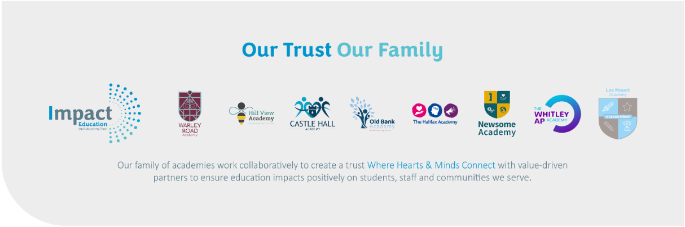

Benefits of Joining
All colleagues receive a planned induction to ensure the best start possible. We are also very proud of the professional learning opportunities across our Trust which are part of our Canopy offering. Canopy means professional learning for everybody across Impact trust – whatever your school, whatever your role and whatever your interest. A place which inspires us all to grow and develop and pushes us all to be our professional best. These opportunities vary from ITT Training, NPQ’s, HLTA, SEND TA , Wellbeing Champion Apprenticeships and many more. Early Career teachers are supported through a range of networks and have access to fully trained mentors and coaching opportunities. ​

You will also have opportunities to develop your skills and knowledge by working across the Trust on school improvement workstreams.
Staff wellbeing is important to us and colleagues new to the Trust will be automatically enrolled into our employee benefits platform ‘Smart Hive’, which gives access to a range of benefits:
- Car Benefit Scheme
- Cycle to Work Scheme
- Employee Assistance Programme (Including LifeWorks health & wellbeing portal & App
- Face-to-face or telephone counselling (also available for immediate family members)
- Online Cognitive Behaviour Therapy (CBT) (also available for immediate family members)
- Gym Discounts
- Mobile phone deals
- Retail Discounts Scheme
Colleague Voice and wellbeing is really important to us. Colleagues new to the Trust will be automatically enrolled into our employee benefits platform ‘Smart Hive’, which provides access to a range of benefits outlined below. We also complete an annual Trust listening survey and our Colleague Ambassadors support the development of action plans to help us work towards our goal of being a Great Place to Work.​

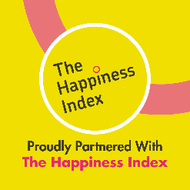
We listen to our colleagues and measure the health of our culture through our partnership with The Happiness Index. We use their employee engagement and happiness platform to gather feedback anonymously and help drive a happier, healthier and higher-performing organisation.
For further information about working for Impact Education MAT, please visit our website:
www.i-mat.org.uk/working-for-us/

