
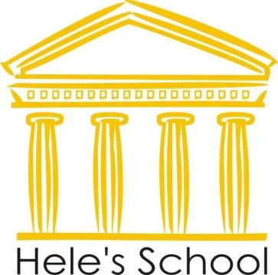

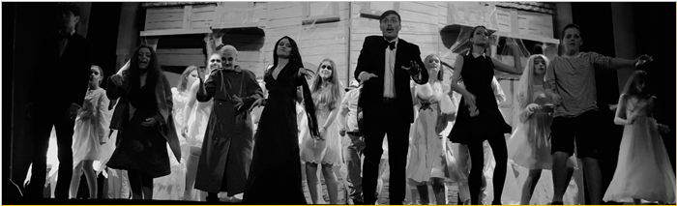
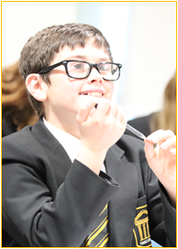
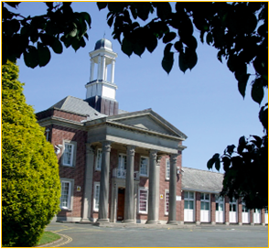

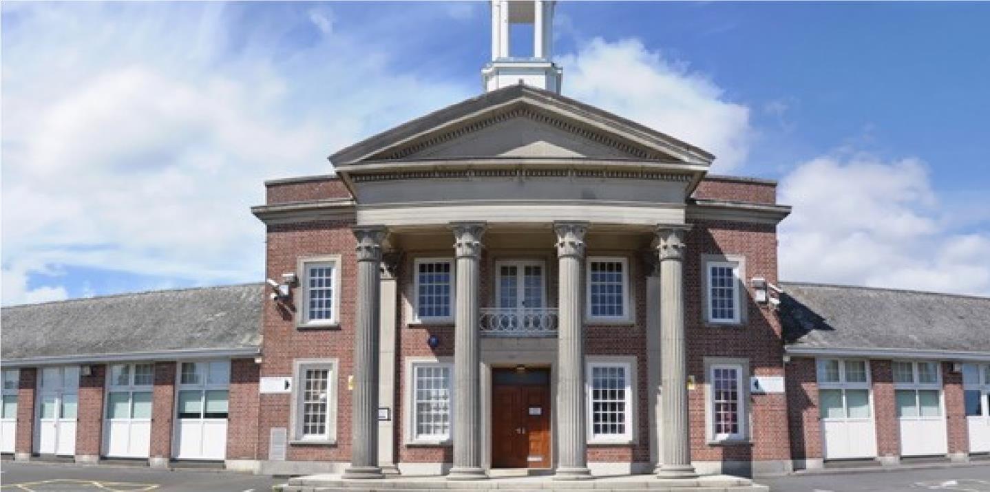

Teacher of Social Sciences
(With ability to offer a second subject)
Candidate Pack

Seymour Road, Plympton, Plymouth, Devon PL7 4LT
Phone: 01752 337193
Email: heles.school@plymouth.gov.uk
Web: www.heles.plymouth.sch.ukd us on

Principal: Emma Clapham

Application Procedure
Teacher of Social Sciences – with ability to offer a second subject
Salary: MPS/UPS
Basis: Permanent
Hours: Full Time
Location: Across the Trust (based at Hele’s School currently).
Required to start on: 1st September 2026

This is an exciting opportunity to join Hele’s School and Westcountry Schools Trust. Hele’s is a supportive, friendly and oversubscribed learning community with a very good reputation. We wish to appoint an exceptional candidate, who possesses energy and creativity. If you are motivated by the prospect of being part of ‘Team Hele’s’ and by working alongside others who share a passion and determination to provide the very best opportunities of our young people, then we would very much welcome your application.

If you would like to join us and feel you could thrive in a collegiate and positive atmosphere, then we’d love to hear from you!
Please click the link to submit your application form. Please note – we do not accept CVs. Completed applications should be submitted prior to the closing date.

The closing date for this application is Monday 1st June 2026
Shortlisting will take place on Monday 1st and Tuesday 2nd June 2026
Interview date is Tuesday 9th June 2026. If you have not heard from us by this date, you should assume that your application has been unsuccessful. Prospective candidates are welcome to telephone the school for additional clarification if they wish.

With 31- strong cross-phase MAT we are regularly looking for passionate people to join our teams. If there are no vacancies currently, but you would like to register your interest for future vacancies, please join our talent pool and we will be in touch as soon as we have a suitable position.
Equality Statement
Hele’s School affirms its opposition to unfair discrimination and commits itself to a comprehensive policy of equal opportunity. At Hele’s we regard all members of our school as being of equal value and that each person has the right to equality of opportunity. We aim to create an atmosphere, which actively explores and counters myths, fears and prejudices that can work against equality of opportunity. No individual or group should be discriminated against on the grounds of their racial group, religion, sexual orientation, disability, ethnicity, nationality, age, gender, gender identity or political affiliation. Bullying and harassment will not be tolerated. Sexual and racial harassment, including persecution on the grounds of sexual orientation (i.e. homophobic bullying), are disciplinary offences and relevant policies will be followed in such circumstances.

Hele’s School is committed to safeguarding and promoting welfare of children and young people and expect all staff and volunteers to share this commitment; therefore, all posts will be subject to a satisfactory DBS Enhanced Disclosure.


Welcome to Westcountry Schools Trust (WeST) and thank you for considering a career with Westcountry Schools Trust (WeST). This is an exciting time to join us. Our Trust brings together 31 schools across South Devon, Plymouth and Cornwall, with plans for further growth in the years ahead.

Each school proudly retains its local identity, yet we are united by one mission: Empowering ALL children to make a positive impact on society. Our vision is simple but powerful: Every child achieving in a great school.

Why Work With Us?
At WeST, we strive for academic excellence because we know that great outcomes create life chances and opportunities for young people. High expectations are at the heart of our work, and inclusivity remains central to everything we do.

We are moving towards a clustering model, enabling schools to retain their autonomy and distinctiveness while benefiting from the collective strength and support of a wider family. This interconnectedness is the backbone of how we work: quietly providing essential support so schools can focus on what matters most—enabling teachers to be excellent in the classroom.

Our Values
What binds us together is not uniformity, but a shared set of values:
Collaboration, Aspiration, Integrity, Compassion, and Respect — showing due consideration for the thoughts, feelings and beliefs of others.

What We Offer
- A strong central school improvement team to support colleagues at the chalk face.
- Shared services that lift the heavy load of background activity, allowing schools to focus on teaching and learning.
- Opportunities for collaboration across teaching, curriculum design, staff development, finance, HR, estates, governance, and wider school improvement.
- Partnerships beyond our boundaries with the South West Regions Group Director, Teaching School Hub Council, Higher Education Institutions, Local Authorities, and employers.

Join Our Community
As part of WeST, you will help shape the Trust’s future direction, work alongside expert colleagues, and join a cross-phase family committed to giving children the very best start in life. There can be no greater privilege than working with such wonderful pupils and dedicated staff, whose passion drives everything we do.

This post presents a fantastic opportunity to work at Hele’s School; a dynamic, ambitious school and a tight-knit team of dedicated staff, governors and trustees committed to providing the very best experiences and support for the young people in our care. The Pupil Admission Number at Hele’s increased from 210 to 240 students in September 2019, and each intake since has been over-subscribed at that number with a waiting list, such is the popularity of the school. Nat Parnell
Chief Executive Officer, WeST
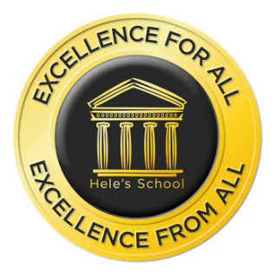
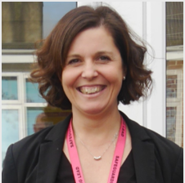

A message from
Emma Clapham, Principal

I take great pleasure in welcoming you to Hele’s School! We are a school with a tradition of academic excellence, high aspirations and a big heart. A school that students and staff are proud to attend. A school where we never compromise our insistence that everyone is valued, learns, enjoys and achieves. Expectations for staff and students are unapologetically high, and very simple; be kind and work hard, both to do things right and to do the right thing…even when no one is looking!

Our mission is to support and challenge everyone, adult or child, to continually get better. We have a ‘no excuses’ philosophy which reinforces our belief that all of us can improve, and nothing is impossible. Quite simply, it isn’t about being ‘the best’ at something, as being ‘the best’ is temporary. Instead, we seek to ensure we get better each day – that’s permanent growth and ensures we never stop aspiring. It is for this reason that recognising and celebrating endeavour, as well as achievement, is something we hold dear, for staff and students alike.

We work hard at providing an inclusive, calm, and purposeful learning environment, with students committed to excellence, and aim to ensure all students have opportunities to enrich their learning and discover new skills and interests through a breadth of curricular and extra-curricular opportunities to excite and engage young people. In short, we are what we believe school should be.

Having been a Senior Leader at Hele’s for the past decade, I am extremely proud to now lead the dedicated and enthusiastic team of staff who are passionate about working with young people and are committed to ensuring that those entrusted in our care get the best life chances possible. Everything we do is shaped by our determination to ensure that each and every child has a positive and memorable experience of school and leaves with every opportunity open to them to ensure they can choose their path through life. We look to shape young people who thrive, flourish and, crucially, are happy.

In terms of curriculum, we offer a traditional and broad offer across Key Stages 3, 4 and 5. We focus on opportunities to develop teaching and learning at every turn and, importantly, teachers at Hele’s have a resolve to be the best they can be in the classroom. Our extended pastoral team ensure our core purpose to keep children safe and remove barriers to learning is fulfilled so that young people can be inspired, can aspire and can achieve. In return we expect a buy in to our belief that we all have an active role to play in making our school a great place to be, which manifests itself in every child displaying the highest standards of commitment to learning, pride and care.

Hele’s is a community committed to personal and professional growth of all, with dedicated staff, supportive families and committed students. I have no doubt that the right candidate will be happy, supported and fulfilled being part of Team Hele’s and will take great pride in what we can achieve together for our community and for each other. I do hope you are inspired to apply for this post, and I look forward to reading your application.

Thank you in advance for the time and emotional investment that I know you will commit to this process.

With very best wishes,
Emma Clapham
Principal

About Hele’s School

Hele’s School is a larger than average 11-18 comprehensive school in Plympton, Plymouth. Plympton sits at the northeastern edge of the city, bordering the South Hams area of outstanding natural beauty.

The school makes use of the closeness of Devon’s countryside and moors and Plymouth’s waterfront with a thriving Cadet Corps and Duke of Edinburgh Scheme. Our Combined Cadet Force (CCF), incorporating Army, Royal Navy and Royal Air Force corps, is one of our unique selling points, providing a visible presence both in the school and the wider community and opening countless opportunities for our students around leadership, teamwork and personal presentation, outdoor pursuits, to name just a few.

In recent years, the Pupil Admission Number has increased to 240 in each year group and a period of capital investment to meet this growth is being planned. There are 1350 students in the school, which includes a thriving Sixth Form of 210, based in specialist accommodation.

Hele’s has a proud and long history as a caring school with a strong reputation for excellence and providing opportunity. It enjoys the support of an active parent body, who share our determination to provide the highest quality of education and pastoral care for their children. Students’ attitudes to learning are good; they are well behaved, and attendance and punctuality are excellent. In short, the young people entrusted to our care want to learn and are delightful to teach.

Our pastoral system is organised around year groups with an 8-form entry and leadership from a teaching Head of Year and a non-teaching Pastoral Support Manager for each year group. There is a 30-minute tutor period each morning with a Guided Reading Programme and a strong programme of Personal Development in this time, supported by weekly assemblies. The pastoral leadership team and tutors remain with the tutor group and take them through from Year 8 to Year 11 so that the relationship between tutor and students is deep and sustained, and family connections with school become trusted and embedded. Year 7 remains as a separate year team of specialist tutors and Head of Year so that we can ensure an exceptional start to secondary school for every child.

Post-16 has a mix of Year 12 and Year 13 students in each Tutor group. We use every opportunity to harness the expertise and interest of our Post-16 learners to act as leaders and mentors to younger students in all manner of ways, including having a visible Junior Leadership Team (JLT) to act as an important conduit for student voice and school improvement.

An excellent professional body of teachers and a hardworking and effective team of associate staff is a hallmark of the school and Hele’s is fully staffed in all areas with specialist teachers. Middle Leaders form an active and effective Joint Leadership Group (JLG) with Senior Leaders, and the JLG is the driving force behind school improvement.

The curriculum structure is currently based around a 2-year KS4, with GCSE options ordinarily taken in the spring term of Year 9. We operate a 2-week timetable with 50 lessons a fortnight, each of 1-hour duration. The school day runs from 8.40am to 3.10pm, allowing plenty of time for the well-developed and rich extra-curricular provision, which includes a mix of academic, sporting, performance and personal development opportunities, as well as a newly-implemented Guided Reading Programme that runs for all year groups (except for Year 11 and Year, which have an intervention programme) in Tutor time.

Hele’s plays its part fully in the Westcountry Schools Trust, in Plymouth and beyond; the Principal has a passion and commitment for Hele’s to be outward-facing, and the school and trust regularly contribute to national, regional and city-wide initiatives on a range of fronts, maintaining a strong relationship with the Local Authority, the Regional Directors, and other organisations across the country.

History of Hele’s School

Elize Hele was born in Brixton in about 1560 and although he lived most of his life at Fardell, Cornwood, on the outskirts of Plympton, his final resting place is in St Andrew’s Chapel in Exeter Cathedral. Having no heirs, Elize left his wealth to be used for “pious uses”. A number of schools in the South West were founded out of his estate by his trustees, including the grammar school at Plympton, which was, until its temporary closure at the end of last century, known as Hele’s School, Plympton.

The old grammar school building, which still stands in Plympton St. Maurice, was completed in 1671. Next to it stood the Schoolmaster’s house in which Sir Joshua Reynolds was born. It is a surprising fact that the old grammar school produced four distinguished artists: Sir Joshua Reynolds, the first President of the Royal Academy; James Northcote; Benjamin Haydon and Sir Charles Eastlake, President of the Royal Academy and the first Director of the National Gallery.

The school faced many difficulties in the latter part of the nineteenth century and was eventually forced to close in 1903, before it was reconstituted by Devon County Council as a co-educational grammar school in 1921 called Plympton Grammar. The school grew and prospered and moved to its present site on Seymour Road in 1937.

New extensions were opened from 1970, and in 1983 refurbishment took place in preparation for reorganisation into an 11 – 18 mixed comprehensive school and it reverted to its old name of Hele’s School.

In the decade from 2000, Hele’s benefited from three specialisms - Languages, Maths & Computing and Applied Learning - and enjoyed national acclaim as a Language College. This strength continues, despite the change to national policy and the subsequent removal of funding, and international links and internationalism remain important.

The school became a Converter Academy in April 2011 and operated as a Stand-Alone Academy Trust for the following 7 years. In September 2018, Hele’s joined a Multi Academy Trust, the Westcountry Schools Trust (WeST), which it played a key part in co-constructing.

Stronger Together

A now 31- strong cross-phase MAT of 23 Primaries, 8 Secondaries, plus an Adult Training Provider, the Westcountry Schools Trust is geographically tight but spans Devon, Plymouth and Cornwall. With the strength of collaboration and ambition, the capacity for shared school improvement, leadership development and collaboration is limitless. The WeST aspiration of ‘Every child in a great school’ sits well with the Hele’s vision (and vice-versa) and the strap line ‘Stronger together’ articulates our shared ambition to ensure that this aspiration becomes a reality.

There remains a strong commitment, professionalism and moral imperative amongst the Hele’s staff and Local Governing Body to ensure we provide the young people in our care with an educational and pastoral support experience that is first class in every aspect. This is very much supported by the WeST Trust Board and strategic direction of the MAT. We have a burning ambition and determination to put Hele’s firmly on the map locally, regionally and nationally and to be recognised as an outward-facing, aspirational and collegiate centre of excellence, which remains committed to continuous improvement.

Hele’s School Ambition

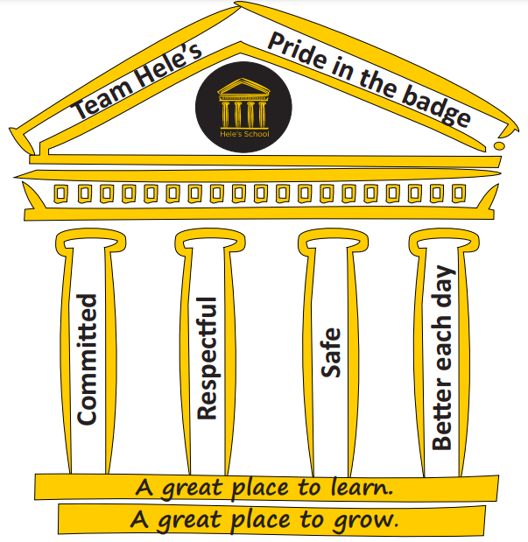
Our school’s purpose:
To warm hearts and to light fires in minds. Our ambition is to inspire confident learners who will thrive in a changing world, never fearful of taking risks and learning from mistakes made as part of their growth. We hold dear the belief that ‘people matter’, and the quality of personal relationships at all levels is central to ensuring a safe, happy, caring, inclusive environment.

Vision:
We pride ourselves on being an outward-facing school community that delivers outstanding academic and personal outcomes for all.

Mission:
We instil a passion for learning - for child and adult alike.
We allow everyone a chance to shine.
We provide a safe, happy community, where we are all supported and challenged to be the best we can be.
We believe there is no ceiling to aspiration.
We ensure a growth mindset culture pervades all we do.
We celebrate endeavour at every opportunity.
We grow ‘future fit’ young people.
We are a school in the heart of the community and with the community in our heart.
We develop and maintain a reputation for excellence - locally, regionally and nationally.
We remain restless for continuous improvement, always striving to be better.

Values:
We dream big, aim high and work hard.
We have pride in all we do and all we are.
We respect each other, our environment, and ourselves.
We ensure outstanding learning is at the core of our provision.
We do things right, and we do the right things.
We have high expectations of and for every person.
We strive to be better each day – as adults and as young people.
There are no excuses – all can achieve no matter their starting point.
We ’walk the talk’ and all play our part in ensuring Hele’s is a great school to be part of.

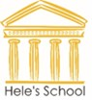


WESTCOUNTRY SCHOOLS TRUST

JOB DESCRIPTION

Job Title: Teacher of Social Sciences – with ability to offer a second subject

Location: Across the Trust (based at Hele’s School currently)

Grade/Salary: Main Scale (MPS/UPS)

Reports to: Head of Department

Job Purpose

To support, develop and maintain high standards of teaching and learning, as well as the wellbeing of students in Social Sciences across the School.

Duties and Responsibilities
- Support pupils towards achieving the national expectation for progress by the end of KS3, KS4 & KS5 by setting high expectations.
- A careful and astute approach to the analysis of assessment data at key points during the monitoring cycle, ensuring that any barrier to learning is swiftly identified.
- Take appropriate action to facilitate learning and evaluate the impact of any (significant early) intervention undertaken.
- Record all actions and outcomes relating to pupil performance and wellbeing on the appropriate school systems and prepare reports for subject leaders as necessary.

- Support students so that the quality of learning over time in lesson is at least good or better.
- Display high expectations which inspire, motivate and challenge pupils.
- Facilitate and monitor the progress of specific target groups of students to ensure they make progress in line with national expectations, specifically using the SEN Code of Practice and acknowledging that all teachers are teachers of SEN pupils.
- Ensure consistently high standards of teaching and learning in line with the Hele’s Model of Learning.
- Attend regular team meetings to discuss teaching and learning, and to share good practice.
- Maintain a culture of self-evaluation, seeking and engaging in continuing professional development as a reflective practitioner.
- Provide regular feedback for students in a way which recognises good practice and supports their progress over time and moves learning on, resulting in a tangible impact in student learning.
- Keep abreast of contemporary ideas of teaching the subject by attending courses and meetings.

- To create and maintain a teaching and learning experience that is appropriate for all abilities to make progress that is at least good.
- Resource effectively and differentiate an appropriate scheme(s) of learning for each class.
- Use assessment for learning strategies to provide formative feedback to students and their parents/carers on how to improve learning in line with school policy.
- Attend parents' evenings as necessary.
- Ensuring health and safety is managed to ensure the wellbeing of pupils and staff.
- Integrate literacy, numeracy, oracy and communication skills into teaching and learning so that they are explicitly taught.
- Communicate class/set lists and amendments in a timely manner to Head of Department/Key Stage Coordinator.

- To extend and enrich the curriculum experience so that many pupils make better than expected progress.
- Promote the subject to engender excitement and interest in pupils wanting to follow it for further study within or beyond the school.
- Taking responsibility for teaching rooms; originating displays of work, posters etc. connected with the subject.
- Support opportunities for learning beyond the classroom to deepen learning for all abilities.
- Ensure regular home learning tasks are set and used to deepen and consolidate learning in line with school policy.
- Ensuring that all the necessary administration connected with offsite/outdoor learning are completed two weeks before any visit takes place. This includes informing parents of the arrangements by letter, obtaining parental consent where appropriate, making sure that pupils are adequately supervised and correctly dressed and, in some cases, taking out insurance.

- To promote and secure good behaviour and standards consistent with policy guidelines.
- Promoting good behaviour in the classroom, both for learning and more generally, consistently applying Standard Operating Procedures or management of behaviour.
- Promoting pride in standards of presentation in classwork and home learning tasks; encouraging displays of work, posters etc. connected with the subject and take actions to ensure the classroom is well looked after.
- Develop experience in the classroom through good teaching that is stimulating and engaging for all pupils.
- Dealing with enquiries and complaints from parents which relate to the work of students in your charge in line with school policy, referring on to Head of Department as necessary.

- Fulfil safeguarding and pastoral obligations in the role designated.
- Follow guidelines given in the pastoral/tutor job purpose document.
- Promote well-being and safeguard pupils, in line with professional duty of care.
- Promote the holistic development of pupils.

- Fulfil wider professional responsibilities (especially those on UPS or seeking to move to UPS).
- make a positive contribution to the wider life of the school.
- develop effective professional relationships with colleagues, knowing when and how to draw on advice and specialist support.
- Deploy support staff effectively.
- Take responsibility for improving teaching through appropriate professional development, responding to advice and feedback from colleagues.
- Communicate effectively with parents and carers with regard to pupils' achievement and wellbeing.

General
- To act in accordance with, and actively promote, all Trust policies, including Safeguarding, Health and Safety and Equality & Diversity.
- To participate in Continuing Professional Development (CPD relevant to the role and to engage in Performance Development Reviews (PDRs).
- Preparing and contributing to Trust wide development by sharing best practice and delivering/receiving professional feedback.
- To retain confidentiality and maintain data and/or files in accordance with Trust policies for data governance, as appropriate for the role.

This job description provides a general reflection of the main duties and responsibilities of the post at the date of production. You may be expected to take on other reasonable activities deemed to be within the character of the post to assist in efficient service delivery. The duties may change over time as requirements and circumstances evolve without changing the general character of the post or level of responsibility.

PERSON SPECIFICATION
E = Essential, D = Desirable

Method of Assessment  The table indicates the possible method/s by which the skills/knowledge/level of competence in each area will be assessed. | Essential or Desirable | Application Form | Interview (or other selection activity)
Qualifications:
Qualified Teacher Status | E | X
Good honours degree or equivalent | E | X
Evidence of continuing professional development | D | X
Evidence of keeping up to date with educational thinking and knowledge | D | X
Experience:
Teaching within the subject area in relevant Key Stages | E | X | X
The ability to teach Social Sciences to KS5 | E | X | X
The ability to offer/teach a second subject | E | X | X
Evidence of appropriate professional development | E | X | X
Involvement in department self-evaluation and development planning | E | X | X
Proven record as a teacher whose students reach high standards of learning and achievement | D | X | X
Knowledge, Skills and Abilities:
Knowledge of the National Curriculum for Social Sciences | E | X | X
Willingness to keep up to date in subject knowledge and national developments. | E | X | X
Ability to plan and teach effectively using a variety of strategies. | E | X | X
Competence in the use of Information and Communication Technology. | E | X | X
Excellent interpersonal skills with both adults and children. | E | X | X
Willingness and ability to work as part of a team. | E | X | X
Ability to communicate effectively both verbally and in writing. | E | X | X
Ability to prioritise and organise own work. | E | X | X
Ability to work effectively to a high standard, on occasion, under pressure, meeting deadlines. | E | X | X
Knowledge of Health and Safety procedures and their application. | E | X | X
To have a ‘can do’ philosophy | E | X | X
Committed to personal development. | E | X | X
To enjoy working with young people. | E | X | X
Willingness to contribute to other areas of school life. | D | X | X
To be flexible, energetic, adaptable and have the ability to use initiative. | E | X | X
To identify and develop opportunities. | E | X | X
To carry out professional duties in a positive, helpful and courteous manner. | E | X | X
To have high aspirations and expectations for their students and themselves. | E | X | X
Committed to raising standards and continuous improvement. | E | X | X
To be dedicated to the success of the students, their teams, the school and themselves. | E | X | X
Commitment to implement whole school/staff policies relating to the safeguarding of children. | E | X | X
VALUES-BASED BEHAVIOURS - It is important to us that your values align with ours:
Compassion:
Recognising need in others and acting with positive intention to promote well-being and improve outcomes | X |  | X
Aspiration:
Works to high expectations, modelling the delivery of high-quality outcomes | X |  | X
Showing passion, persistence and resilience in seeking creative solutions to strive for continuous improvement and excellence | X |  | X
Integrity:
Acting always in the interests of children and young people, | X |  | X
Acting with a consistent and uncompromising adherence to strong moral and ethical principles | X |  | X
Communicating with transparency and respect, creating a working environment based on trust and honesty | X |  | X
Collaboration:
Creating a shared vision and working effectively across boundaries in an equitable and inclusive way to skilfully influence and engage others | X |  | X

