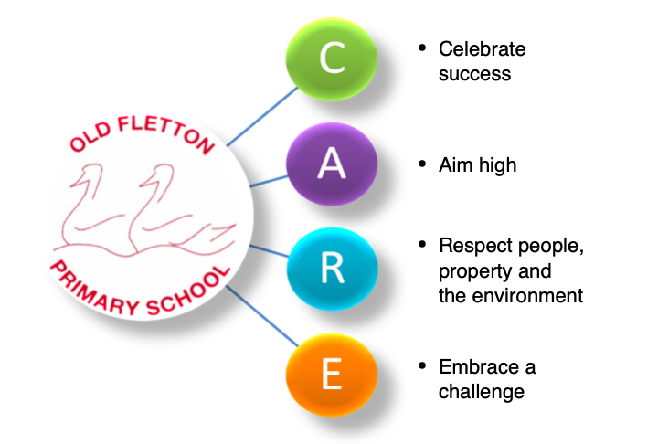
Old Fletton Primary School
Job Description

Post title: Class Teacher
Grade: Main Scale
Responsible to: Headteacher / Deputy Head
Responsible for: TAs providing classroom support

This job description is not a comprehensive description of the post. Discussions will take place on a regular basis to clarify individual responsibilities within the general framework and character of the post as identified below. All class teachers should meet the core element of the Framework of Professional Standards. (STPCD)

Purpose of the post:
To have the main responsibility for the education and welfare of a class, having due regard to the requirements of the National Curriculum, the School’s aims and values, policies and scheme of work. To maintain good health and safety practices and report those which can cause risk, accident or ill-health. To promote the well-being of staff and pupils in the school. To work collaboratively with colleagues in school to secure best outcomes.

Main responsibilities:
In accordance with the school’s policies and under the direction of the headteacher:

Teach
Having regard to the curriculum of the school, and with a view to promoting the development of the abilities and aptitudes of the pupils in any class or group assigned to you;
- plan and prepare lessons and courses;
- teach the pupils assigned to you, according to their educational needs;
- set and mark work to be carried out by the pupil in school and elsewhere;
- assess, record and report on the development, progress and attainment of pupils;

Other activities
- promote the general progress and well-being of individual pupils and of any class or group of pupils assigned to you;
- make records of and reports on the personal and social needs of pupils;
- communicate and consult with the parents of pupils;
- communicate and co-operate with persons or bodies outside the school;
- participate in meetings arranged for any of the purposes described above;
- contribute to extra-curricular activities.

Assessments and reports
- provide or contribute to oral and written assessments, reports and references relating to individual pupils and groups of pupils;

Appraisal or review of performance
- participate in arrangements made in accordance with the most recent regulations for the appraisal or review of your performance and that of other teachers;

Review, induction, further train and development
- review from time to time your methods of teaching and programmes of work;
- participate in arrangements for your further training and professional development as a teacher, including undertaking training and professional development which aims to meet needs identified in planning and review statements.

Educational methods
- advise and co-operate with the head teacher and other teachers on the preparation and development of courses of study, teaching materials, teaching programmes, methods of teaching and assessment and pastoral arrangements;

Discipline, health and safety
- maintain good order and discipline among the pupils and safeguard their health and safety, both when they are on school premises or when they are engaged in authorised school activities elsewhere;
- To be aware of the health and safety policy, reporting concerns promptly on Every (online reporting) or to the Office Manager or Headteacher.

Staff meetings
- participate in meetings at the school which relate to the curriculum for the school or the administration or organisation of the school, including pastoral arrangements;

Cover
- to supervise and, so far as is practical, teach any pupils whose teacher is not available to teach them (you will not be required to provide such cover for more than 38 hours in any school year).

External examinations
- participate in arrangements for preparing pupils for external examinations, assess pupils for the purposes of such examinations and record and report such assessments; and participate in arrangements for pupils’ presentation for and conduct such examinations; (you are not required routinely to participate in any arrangements that do not call for the exercise of a teacher’s professional judgement, such as invigilation).

Management
- contribute to the selection for appointment and professional development of other teachers and support staff, including the induction and assessment of new teachers and teachers serving induction periods;
- co-ordinate or manage the work of other staff; and
- take such part as may be required of you in the review, development and management of activities relating to the curriculum, organisation and pastoral functions of the school;

Administration
- participate in administrative and organisational tasks related to such duties as are described above, including the direction or supervision of persons providing support for the teachers in the school;
- attend assemblies, register the attendance of pupils and supervise pupils, whether these duties are to be performed before, during or after school sessions.
- You are not required routinely to undertake tasks of a clerical or administrative nature which do not call for a teacher’s professional skills and judgement.

This job description will be reviewed annually for the formation of a yearly job plan and may be amended according to changing job requirements.

