


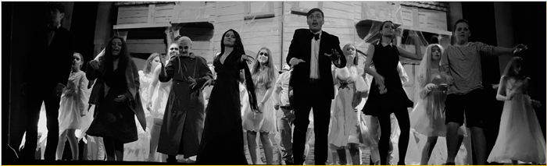

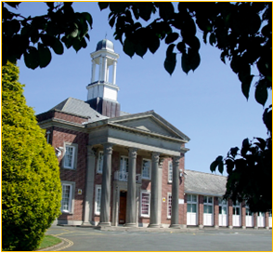

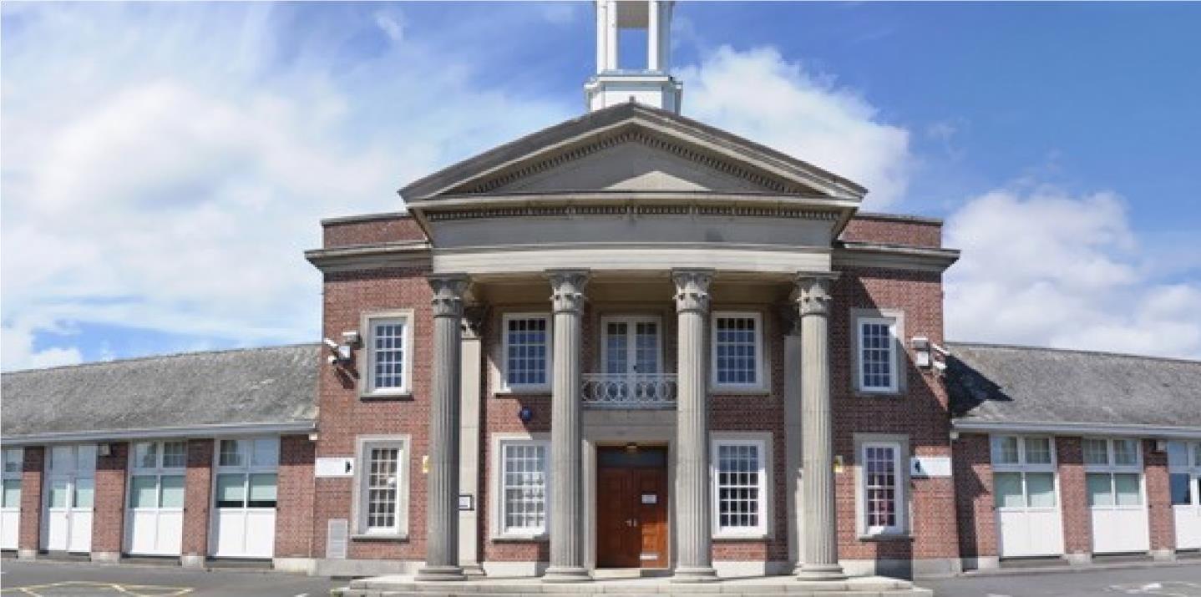

PART TIME CLEANING SUPERVISOR
Candidate Pack

Seymour Road, Plympton, Plymouth, Devon PL7 4LT
Phone: 01752 337193
Email: heles.school@plymouth.gov.uk
Web: www.heles.plymouth.sch.ukd us on

Principal: Emma Clapham

Application Procedure
Part time Cleaning Supervisor

Salary: NJC Grade C (Scp 5-7 ) Starting salary £25583 FTE, actual salary £10272
Hours: 16.5 hours per week x 41 weeks per annum ( 38 weeks Term time & 3 weeks Deep Clean in School Holidays )
Required to start as soon as possible

This is an exciting opportunity to join Hele’s School and Westcountry Schools Trust. Hele’s is a supportive, friendly and oversubscribed learning community with a very good reputation. We wish to appoint an exceptional candidate, who possesses energy and creativity and can provide effective and efficient cover to support colleagues. If you are motivated by the prospect of being part of ‘Team Hele’s’ and by working alongside others who share a passion and determination to provide the very best opportunities of our young people, then we would very much welcome your application.

If you would like to join us and feel you could thrive in a collegiate and positive atmosphere, then we’d love to hear from you!
Please click the link to submit your application form. Please note – we do not accept CVs. Completed applications should be submitted prior to the closing date.

The closing date for this application is 9.00am on Tuesday 20th January 2026
Shortlisting will take place on Tuesday 20th January 2026
Interviews will be held on Friday 23rd January 2026 If you have not heard from us by this date, you should assume that your application has been unsuccessful. Prospective candidates are welcome to telephone the school for additional clarification if they wish.

With 31- strong cross-phase MAT we are regularly looking for passionate people to join our teams. If there are no vacancies currently, but you would like to register your interest for future vacancies, please join our talent pool and we will be in touch as soon as we have a suitable position.

Equality Statement
Hele’s School affirms its opposition to unfair discrimination and commits itself to a comprehensive policy of equal opportunity. At Hele’s we regard all members of our school as being of equal value and that each person has the right to equality of opportunity. We aim to create an atmosphere, which actively explores and counters myths, fears and prejudices that can work against equality of opportunity. No individual or group should be discriminated against on the grounds of their racial group, religion, sexual orientation, disability, ethnicity, nationality, age, gender, gender identity or political affiliation. Bullying and harassment will not be tolerated. Sexual and racial harassment, including persecution on the grounds of sexual orientation (i.e. homophobic bullying), are disciplinary offences and relevant policies will be followed in such circumstances.

Hele’s School is committed to safeguarding and promoting welfare of children and young people and expect all staff and volunteers to share this commitment; therefore, all posts will be subject to a satisfactory DBS Enhanced Disclosure.




Welcome to Westcountry Schools Trust (WeST), and thank you for your interest in this exciting position at Hele’s School.

This post presents a fantastic opportunity to work in a dynamic, ambitious school and a tight-knit team of dedicated staff, governors and trustees committed to providing the very best experiences and support for the young people in our care. The Pupil Admission Number at Hele’s increased from 210 to 240 students in September 2019, and each intake since has been over-subscribed at that number with a waiting list, such is the popularity of the school.

Beyond the boundaries of Hele’s School, you will have the opportunity to work and contribute to the development of a cross-phase family of twenty-seven schools. We are passionate about our children benefiting from the blend of education in which we believe and know that we can only achieve this by creating the right climate for our staff to excel and feel professionally rewarded. As such, you will work amongst a wide team of colleagues who are mutually supportive and value high quality professional development.

If you share our passion for children succeeding, regardless of their starting points, and believe you have the skills and energy to make a difference to the lives of our young people, we very much look forward to you joining our team. We actively appoint people with a strong sense of moral purpose and a desire to help all students – we firmly believe that education can make a difference to the life chances of all young people.

Our promise to you as a colleague working in a Westcountry Schools Trust establishment is that you will be valued, empowered, invested in and grown in this role, supported to move on to the next stage in your career, whatever and wherever that may be.

Rob Haring
Chief Executive Officer, WeST




A message from
Emma Clapham, Principal

I take great pleasure in welcoming you to Hele’s School! We are a school with a tradition of academic excellence, high aspirations and a big heart. A school that students and staff are proud to attend. A school where we never compromise our insistence that everyone is valued, learns, enjoys and achieves. Expectations for staff and students are unapologetically high, and very simple; be kind and work hard, both to do things right and to do the right thing…even when no one is looking!

Our mission is to support and challenge everyone, adult or child, to continually get better. We have a ‘no excuses’ philosophy which reinforces our belief that all of us can improve and nothing is impossible. Quite simply, it isn’t about being ‘the best’ at something, as being ‘the best’ is temporary. Instead, we seek to ensure we get better each day – that’s permanent growth and ensures we never stop aspiring. It is for this reason that recognising and celebrating endeavour, as well as achievement, is something we hold dear, for staff and students alike.

We work hard at providing an inclusive, calm, and purposeful learning environment, with students committed to excellence, and aim to ensure all students have opportunities to enrich their learning and discover new skills and interests through a breadth of curricular and extra-curricular opportunities to excite and engage young people. In short, we are what we believe school should be.

Having been a Senior Leader at Hele’s for the past decade, I am extremely proud to now lead the dedicated and enthusiastic team of staff who are passionate about working with young people and are committed to ensuring that those entrusted in our care get the best life chances possible. Everything we do is shaped by our determination to ensure that each and every child has a positive and memorable experience of school and leaves with every opportunity open to them to ensure they can choose their path through life. We look to shape young people who thrive, flourish and, crucially, are happy.

In terms of curriculum, we offer a traditional and broad offer across Key Stages 3, 4 and 5. We focus on opportunities to develop teaching and learning at every turn and, importantly, teachers at Hele’s have a resolve to be the best they can be in the classroom. Our extended pastoral team ensure our core purpose to keep children safe and remove barriers to learning is fulfilled so that young people can be inspired, can aspire and can achieve. In return we expect a buy in to our belief that we all have an active role to play in making our school a great place to be, which manifests itself in every child displaying the highest standards of commitment to learning, pride and care.

Hele’s is a community committed to personal and professional growth of all, with dedicated staff, supportive families and committed students. I have no doubt that the right candidate will be happy, supported and fulfilled being part of Team Hele’s and will take great pride in what we can achieve together for our community and for each other. I do hope you are inspired to apply for this post and I look forward to reading your application.

Thank you in advance for the time and emotional investment that I know you will commit to this process.

With very best wishes,
Emma Clapham
Principal

About Hele’s School

Hele’s School is a larger than average 11-18 comprehensive school in Plympton, Plymouth. Plympton sits at the northeastern edge of the city, bordering the South Hams area of outstanding natural beauty.

The school makes use of the closeness of Devon’s countryside and moors and Plymouth’s waterfront with a thriving Cadet Corps and Duke of Edinburgh Scheme. Our Combined Cadet Force (CCF), incorporating Army, Royal Navy and Royal Air Force corps, is one of our unique selling points, providing a visible presence both in the school and the wider community and opening countless opportunities for our students around leadership, teamwork and personal presentation, outdoor pursuits, to name just a few.

In recent years, the Pupil Admission Number has increased to 240 in each year group and a period of capital investment to meet this growth is being planned. There are 1350 students in the school, which includes a thriving Sixth Form of 210, based in specialist accommodation.

Hele’s has a proud and long history as a caring school with a strong reputation for excellence and providing opportunity. It enjoys the support of an active parent body, who share our determination to provide the highest quality of education and pastoral care for their children. Students’ attitudes to learning are good; they are well behaved, and attendance and punctuality are excellent. In short, the young people entrusted to our care want to learn and are delightful to teach.

Our pastoral system is organised around year groups with an 8-form entry and leadership from a teaching Head of Year and a non-teaching Pastoral Support Manager for each year group. There is a 30-minute tutor period each morning with a Guided Reading Programme and a strong programme of Personal Development in this time, supported by weekly assemblies. The pastoral leadership team and tutors remain with the tutor group and take them through from Year 8 to Year 11 so that the relationship between tutor and students is deep and sustained, and family connections with school become trusted and embedded. Year 7 remains as a separate year team of specialist tutors and Head of Year so that we can ensure an exceptional start to secondary school for every child.

Post-16 has a mix of Year 12 and Year 13 students in each Tutor group. We use every opportunity to harness the expertise and interest of our Post-16 learners to act as leaders and mentors to younger students in all manner of ways, including having a visible Junior Leadership Team (JLT) to act as an important conduit for student voice and school improvement.

An excellent professional body of teachers and a hardworking and effective team of associate staff is a hallmark of the school and Hele’s is fully staffed in all areas with specialist teachers. Middle Leaders form an active and effective Joint Leadership Group (JLG) with Senior Leaders, and the JLG is the driving force behind school improvement.

The curriculum structure is currently based around a 2-year KS4, with GCSE options ordinarily taken in the spring term of Year 9. We operate a 2-week timetable with 50 lessons a fortnight, each of 1-hour duration. The school day runs from 8.40am to 3.10pm, allowing plenty of time for the well-developed and rich extra-curricular provision, which includes a mix of academic, sporting, performance and personal development opportunities, as well as a newly-implemented Guided Reading Programme that runs for all year groups (except for Year 11 and Year, which have an intervention programme) in Tutor time.

Hele’s plays its part fully in the Westcountry Schools Trust, in Plymouth and beyond; the Principal has a passion and commitment for Hele’s to be outward-facing, and the school and trust regularly contribute to national, regional and city-wide initiatives on a range of fronts, maintaining a strong relationship with the Local Authority, the Regional Directors, and other organisations across the country.

History of Hele’s School

Elize Hele was born in Brixton in about 1560 and although he lived most of his life at Fardell, Cornwood, on the outskirts of Plympton, his final resting place is in St Andrew’s Chapel in Exeter Cathedral. Having no heirs, Elize left his wealth to be used for “pious uses”. A number of schools in the South West were founded out of his estate by his trustees, including the grammar school at Plympton, which was, until its temporary closure at the end of last century, known as Hele’s School, Plympton.

The old grammar school building, which still stands in Plympton St. Maurice, was completed in 1671. Next to it stood the Schoolmaster’s house in which Sir Joshua Reynolds was born. It is a surprising fact that the old grammar school produced four distinguished artists: Sir Joshua Reynolds, the first President of the Royal Academy; James Northcote; Benjamin Haydon and Sir Charles Eastlake, President of the Royal Academy and the first Director of the National Gallery.

The school faced many difficulties in the latter part of the nineteenth century and was eventually forced to close in 1903, before it was reconstituted by Devon County Council as a co-educational grammar school in 1921 called Plympton Grammar. The school grew and prospered and moved to its present site on Seymour Road in 1937.

New extensions were opened from 1970, and in 1983 refurbishment took place in preparation for reorganisation into an 11 – 18 mixed comprehensive school and it reverted to its old name of Hele’s School.

In the decade from 2000, Hele’s benefited from three specialisms - Languages, Maths & Computing and Applied Learning - and enjoyed national acclaim as a Language College. This strength continues, despite the change to national policy and the subsequent removal of funding, and international links and internationalism remain important.

The school became a Converter Academy in April 2011 and operated as a Stand-Alone Academy Trust for the following 7 years. In September 2018, Hele’s joined a Multi Academy Trust, the Westcountry Schools Trust (WeST), which it played a key part in co-constructing.

Stronger Together

A now 31- strong cross-phase MAT of 23 Primaries, 8 Secondaries, plus an Adult Training Provider, the Westcountry Schools Trust is geographically tight but spans Devon, Plymouth and Cornwall. With the strength of collaboration and ambition, the capacity for shared school improvement, leadership development and collaboration is limitless. The WeST aspiration of ‘Every child in a great school’ sits well with the Hele’s vision (and vice-versa) and the strap line ‘Stronger together’ articulates our shared ambition to ensure that this aspiration becomes a reality.

There remains a strong commitment, professionalism and moral imperative amongst the Hele’s staff and Local Governing Body to ensure we provide the young people in our care with an educational and pastoral support experience that is first class in every aspect. This is very much supported by the WeST Trust Board and strategic direction of the MAT. We have a burning ambition and determination to put Hele’s firmly on the map locally, regionally and nationally and to be recognised as an outward-facing, aspirational and collegiate centre of excellence, which remains committed to continuous improvement.

Hele’s School Ambition


Our school’s purpose:
To warm hearts and to light fires in minds. Our ambition is to inspire confident learners who will thrive in a changing world, never fearful of taking risks and learning from mistakes made as part of their growth. We hold dear the belief that ‘people matter’, and the quality of personal relationships at all levels is central to ensuring a safe, happy, caring, inclusive environment.

Vision:
We pride ourselves on being an outward-facing school community that delivers outstanding academic and personal outcomes for all.

Mission:
We instil a passion for learning - for child and adult alike.
We allow everyone a chance to shine.
We provide a safe, happy community, where we are all supported and challenged to be the best we can be.
We believe there is no ceiling to aspiration.
We ensure a growth mindset culture pervades all we do.
We celebrate endeavour at every opportunity.
We grow ‘future fit’ young people.
We are a school in the heart of the community and with the community in our heart.
We develop and maintain a reputation for excellence - locally, regionally and nationally.
We remain restless for continuous improvement, always striving to be better.

Values:
We dream big, aim high and work hard.
We have pride in all we do and all we are.
We respect each other, our environment, and ourselves.
We ensure outstanding learning is at the core of our provision.
We do things right, and we do the right things.
We have high expectations of and for every person.
We strive to be better each day – as adults and as young people.
There are no excuses – all can achieve no matter their starting point.
We ’walk the talk’ and all play our part in ensuring Hele’s is a great school to be part of.



WESTCOUNTRY SCHOOLS TRUST

JOB DESCRIPTION

Post title: CLEANING SUPERVISOR

Hours/Weeks per annum: 16.5 hours per week: Monday 14.45-18.15 and Tuesday to Fridays 15.00- 18.15 for 41 weeks per annum ( 38 weeks term time plus 3 weeks Deep Cleaning 1 week at Easter and 2 weeks at the end of the summer holidays ).

Responsible to: Premises Manager & Operations Manager leads all Support staff

STATEMENT OF PURPOSE:
To Lead and manage a team of cleaners daily to ensure the premises are cleaned in accordance with the specified standards and to the satisfaction of the Premises and Operations manager.
The post holder is expected to be sympathetic towards the busy demands of the school, and must have a flexible attitude, being able to re-adjust work schedules around after school events, including cover for planned staff absence( sickness cover is the responsibility of the Premises Manager) , which will include actual cleaning of areas when staff are off and demonstrating how to clean / mentor new staff. The post holder should act as an ambassador, taking pride in high standards of cleanliness. A strong leadership ability and excellent communication and motivational skills are a must. The postholder should always be able to follow advice and solve problems and conflicts effectively allowing the school to operate smoothly.

PRINCIPAL ACCOUNTABILITIES:
1 At the start of each shift, check emails for messages, daily bulletins, and School event information such as parents’ evenings and after school lettings that may impact on cleaning routines, so that work can be organized accordingly. Occasional photocopying of information for the team. Keep an online diary. Organize and authorize casual claims for cover staff working in conjunction with Finance to ensure payments are made by payroll deadlines .
2 Organise, supervise, and monitor the cleaning team, ensuring that the appropriate standards are delivered throughout the school, including the allocation/ change of cleaners to different areas. Attend update meetings with the Premises manager/ Operations Manager. Manage all communications with cleaners who meet daily in the staff room before the start of the shift.
3 Carry out a rotation of monthly checks on each area, using a checklist/ score system and identify areas for improvement for each cleaner setting targets and clarifying expectations if they do not meet the standard required.
4 This position includes 1.5 hours a day of actual cleaning in a designated area as directed by the Premises Manager and cover for staff absences, when no cover can be found.
5 Assist with moving furniture and moveable fittings to aid cleaners with manual handling when required. Be confident operating Floor machines / Ride on Cleaner ( Training will be provided ) .
6 Each zone has a cleaning cupboard for each cleaner, check that cleaners have opened these at the start of the shift and have fully secured them upon completion at the end of the shift. Ensure that all cleaning cupboards, equipment etc. are kept in a clean tidy and safe condition in accordance with Coshh regulations.
7 Monitor levels of cleaning materials and consumables and pass on orders to the premises manager in a timely fashion so that stocks do not run out.
8 Ensure all staff wear uniforms and the correct PPE /and identity badges whilst on site and behave in an acceptable manner. Report any uniform requirements to the Premises Manager
9 Be willing to Promote good ‘housekeeping’ practices by demonstrating the cleaning of a problem area as an example as and when needed and standards fall and be able to resolve conflict within the team
10 Monitor safety of cleaning equipment and report any faults observed by yourself/cleaners to the caretaking staff so that repairs can be made.
11 Ensure the cleaning team are signing in to the InVentry system & signing out at the end of shift.
12 Ensure all Health and Safety requirements are observed by the cleaning staff.
13 Take part in training, where deemed necessary by the Premises & Operations Manager, to carry out your duties effectively and keep your training up to date with refreshers.
14 Any other duties that are relevant to the role.

This job description outlines the duties of the post as required at present to indicate the level of responsibility of the role It is not a comprehensive or exclusive list and duties may be varied from time to time which do not change the general character of the job or the level of responsibility.

The contents of this job description have been made known to the members of staff in question.

PERSON SPECIFICATION

E = Essential, D = Desirable

Method of Assessment  The table indicates the possible method/s by which the skills/knowledge/level of competence in each area will be assessed. | Essential or Desirable | Application Form | Interview
Knowledge, Skills and Experience
Cleaning Experience in a similar role | Essential
Understand the schools cleaning standards | Essential
Able to communicate & work effectively with other team members and take direction from Line manager | Essential
Ability to ensure that all cleaning tasks are carried out with due regard to health and safety. | Essential
Carry out the various periodic cleaning processes e.g., vacuum cleaning, carpet cleaning, toilet cleaning, sweeping, and polishing, removal of graffiti, cleaning off all marks on wall and doors. | Essential
Understand the appropriate use of different cleaning materials, preferably Coshh Trained, but training is given. | Essential
Attention to detail and observation of high standards regarding infection control, cleaning all touch points daily | Essential
Ability to carry out instructions and work with the minimum of supervision and equally to work under pressure should flexibility be needed if an after-school event is on after School and routine needs to be changed. | Essential
Ability to work as part of a team, form good relationships with other colleagues | Essential
Ability to adhere to and implement the Trust’s Equal Opportunities Policy. | Essential
Honest and trustworthy and an ambassador for the school | Essential
Able to demonstrate a commitment to professional development through further training. | Essential
Have a DBS check and clearance | Essential
Knowledge / or Training in Manual handling and Health and Safety at Work Act | Desirable

