What does “Term Time Only” (TTO) mean?

Many support staff in schools are employed on a term time only basis. This means they are contracted to work for a proportion of the school year rather than all 52.143 weeks.

A standard school year includes 38 working weeks (190 days). Most TTO contracts also include additional weeks worked during school closure periods (5 days often for INSET or training days). These extra weeks vary by role.

These additional weeks are known as “plus weeks.”

Example:
• 38 + 2 means the employee works the 38 term weeks plus 2 additional weeks, totalling 40
working weeks per academic year.

Do TTO staff get holidays and holiday pay?

TTO staff cannot take annual leave during term time, but they are still entitled to paid holiday, just like any other employee.

Holiday entitlement is:
• Pro‑rated, based on the number of weeks worked
• Dependent on length of service

Example:
• A TTO employee working 38 + 1 weeks (39 total) in their second year of service is entitled to 5.8488 weeks of paid leave, which includes statutory holiday entitlement.

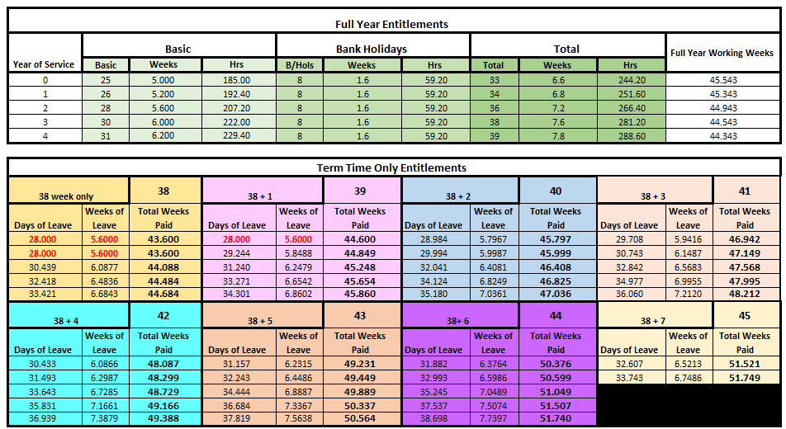





How will I get paid?

Because TTO staff work fewer weeks than a full-year employee, their salary is a pro-rated proportion of the full-time equivalent (FTE) salary. A full time working week is 37hrs and a full year is 52.143.

How do TTO staff get paid?

Step 1: Calculate the proportion of the year worked.
(Please note that the following example is based on a full time working week of 37hrs).

Term Weeks | + | +Weeks | + | Weeks Leave | = | Weeks Paid | / | FTE Weeks | = | FTE
38 | + | 1 | + | 5.8488 | = | 44.849 | / | 52.143 | = | 0.86

Step 2: Apply the FTE proportion to the full-time salary

FTE Salary | x | +Weeks | = | Actual Salary
£25,989 | x | 0.86 | = | £22,350

Step 3: Convert to monthly pay

FTE Salary | / | +Weeks | = | Actual Salary
£22,350 | / | 12 | = | £1,862.55

Calculating TTO, part time salary requires additional considerations, calculated as follows;

Using the same example but reducing weekly hrs to 25

FTE Salary | / | FTE Weeks | / | FTE Hrs | x | Part Time Hrs | x | Weeks Paid | = | Actual Salary
£25,989 | / | 52.143 | / | 37 | x | 25 | x | 44.849 | = | £15,103.74

FTE Salary |  | / | +Weeks | = | Actual Salary
 | £15,10.74 | / | 12 | = | £1,258.65

Splitting the actual annual salary ensures you receive a consistent monthly salary even during months when you do not work, such as August.

What does this mean in practice?

Although TTO staff are paid monthly across the whole year, they are only paid for the weeks they are contracted to work plus their holiday entitlement.

On average:
- TTO staff are paid for around 44 weeks per year
- This means approximately 8 weeks per year are unpaid
- The annual salary is simply spread evenly over 12 months for budgeting convenience

