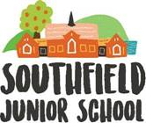

Class teacher
Recruitment Pack

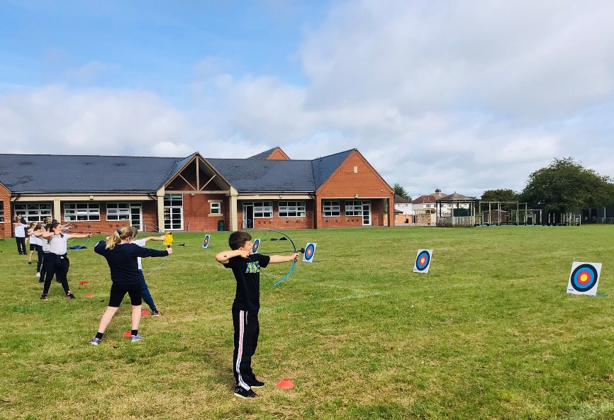

Advert Opens: 17.12.25 Advert Closes: 19.01.26



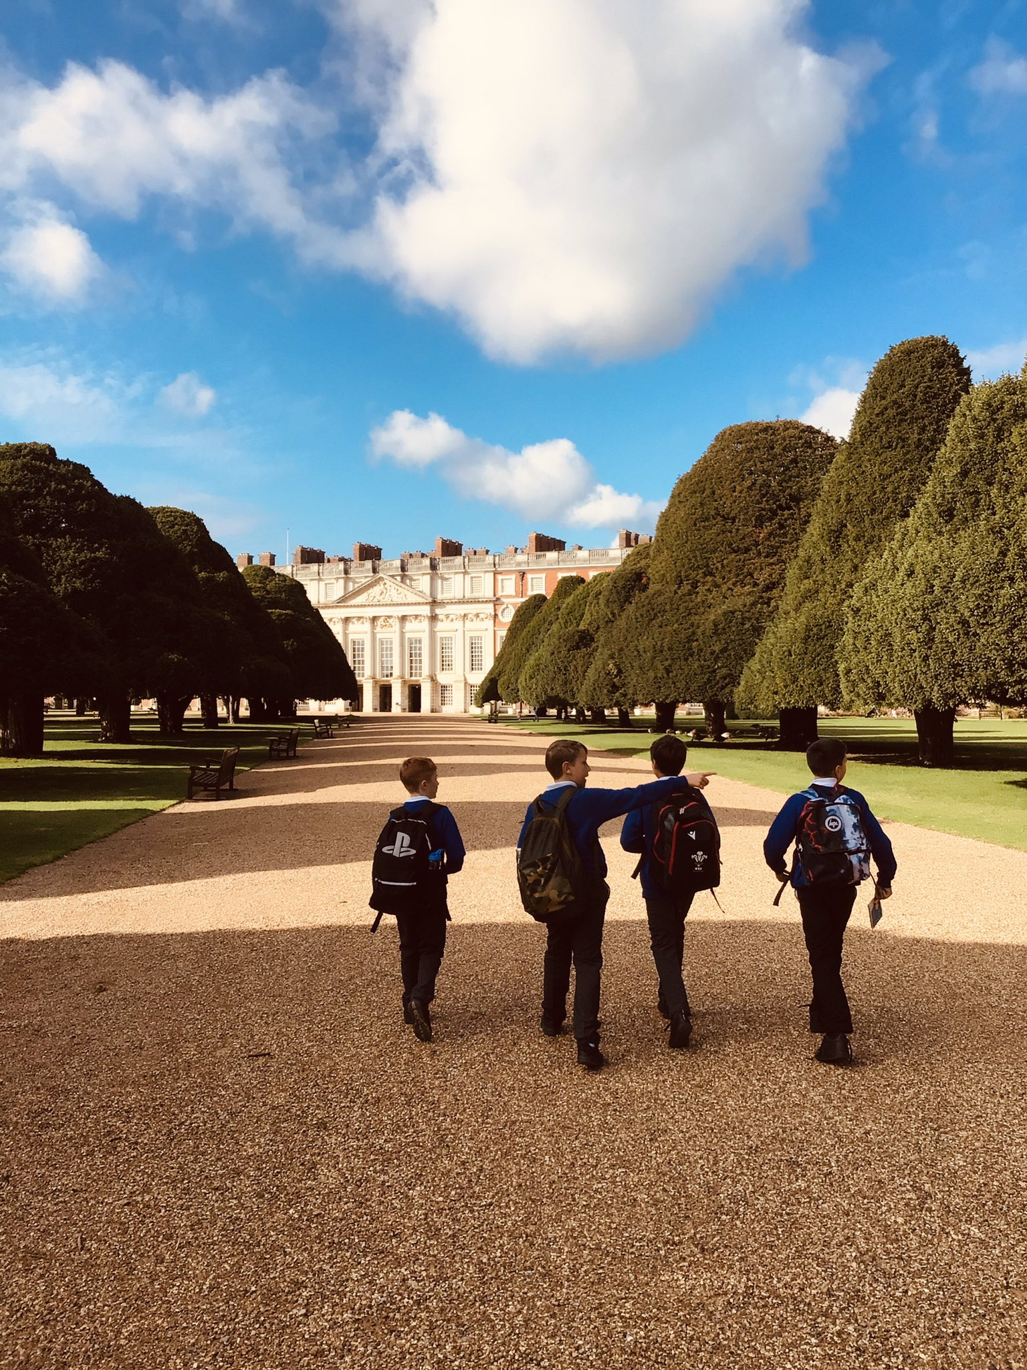
Contents

Grove Learning Trust (GLT) Vision 2
A snapshot of Southfield Junior School 3
Our school values 3
Welcome 4
Person Specification 6
Recruitment Process 7
Safeguarding, Equal Opportunities and Data Protection 8

Grove Learning Trust (GLT) Vision
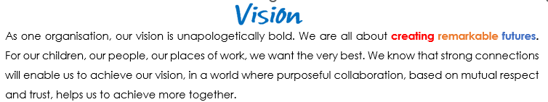
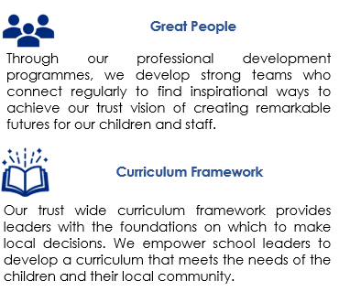
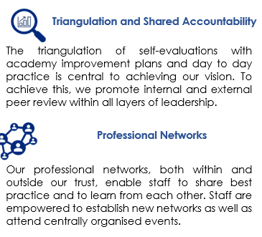

A snapshot of Southfield Junior School



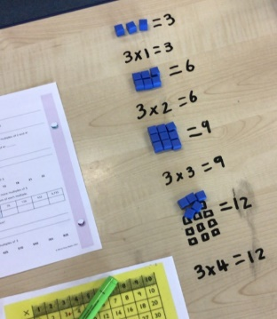

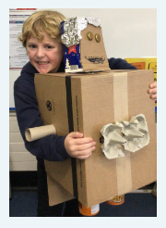
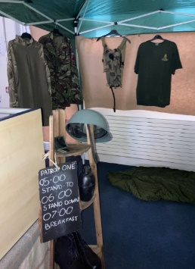


See more at: https://www.southfieldjuniorsch.co.uk/ or on our Instagram page https://www.instagram.com/southfieldjunior/ - we are sure you’ll be impressed!

Our school values

Our School Council worked collaboratively to decide on our six school values.



The children, with our School Council leader and pupil voice governor, also worked with the designers from our website design company, Greenhouse Schools Online, to design the characters below.






Welcome

Thank you for your interest in our vacancy: Southfield is a great school to work in! We are a school brimming with excitement. We believe strongly that learning has no limits and do our best to make sure that each day is great for every child as an individual and as part of our wider school community.

Our school is an academy situated in Highworth, just north of Swindon and we 175 wonderful pupils. We work with our local area and staff and children can often be found using the local church for religious education lessons; litter picking in the community; or sometimes in the Highstreet to study our local history.
Southfield is recognised as a good school by Ofsted (March 2025). We strive to progress and enhance children’s education. At Southfield, we are reflective practitioners and make improvements based on the needs of our children and community.
We are proud of the learning environment we’ve created and strongly believe that prospective candidates will see that Southfield is a very welcoming and inclusive school which benefits from a supportive staff team, families and governors. We encourage learning in a variety of ways and we are proud to have the facilities to run outdoor sessions; we also run nurture sessions weekly and mental health and well-being sessions! We immerse the children in their topics and plan ‘hook’ days, trips, events and experiences to aid their learning. Our whole school use the ‘zones of regulation’ to aid the children’s personal development and we have weekly circle time sessions.
We feel privileged to work with a team of open-minded and dedicated professionals who are focused on the children’s learning, wellbeing and development. We welcome creative thinkers, inspirational team players, flexible leaders and people who are committed to making sure that the children who attend Southfield Junior School get the very best, all-round experience which enables them to grow into talented young people.
If we sound like a good match for your way of working, please get in touch to arrange a visit… come and see all that our school has to offer you.
If we, or any other member of the academy team here at Southfield, can be of any help, please do not hesitate to get in touch at your earliest convenience.
With best wishes and good luck,

Kimberley O’Sullivan - Head of School Julie Warburton - Executive Head
Job Description
Post: Upper key stage 2 Class Teacher (fixed term contract to 31.08.2026)
Part-time (Thursdays and Fridays only).

Start date: February 23rd 2026

Reports to: Head of School

Grade: Teachers’ Main Pay Scale (MPS 1 – 6)

KEY PURPOSE OF THE JOB

To take responsibility for the education and welfare of a designated class of children in accordance with the current School Teachers’ Pay and Conditions and Teachers’ Standards documents. Adhere to the requirements of national, statutory guidance as well as policies and procedures agreed by the Governing Body of Southfield Junior School.

MAIN ACTIVITIES

- Take responsibility for planning and implementing agreed schemes of work for all children in the designated class, within the framework of statutory and recommended national and school policies.

- Maintain assessment records and to report on children’s progress to senior staff and parents/carers, in accordance with national and school policy.

- Manage additional adults who are deployed to work with the class and/or specific children with identified special needs and/or disabilities (SEND).

- Safeguard children, adhering to the school’s agreed staff handbook and safeguarding/child protection policies at all times.

PRINCIPAL ACCOUNTABILITIES

- Plan, differentiate and provide feedback on children’s work in accordance with national and school policies.

- Ensure that all children experience a broad, balanced and stimulating curriculum offer, in line with the agreed curriculum maps and statutory guidance.

- Actively adapt teaching and learning experiences so that each child has the opportunity to make excellent progress and achieve standards that meet his/her full capability.

- Ensure that all children, including those in identified contextual groups, make at least good academic progress and outstanding progress wherever possible.

- Make appropriate educational provision for children with Special Educational Needs and Disabilities (SEND) and those learning English as an Additional Language (EAL), with support, where needed, from the SENDCo and support staff where necessary.

- Provide children with opportunities to manage their own learning (e.g. Assessment for Learning) and become independent learners.

- Create a secure, safe and stimulating classroom environment and maintain the highest standards of organisation, behaviour and discipline.

- Maintain high standards of displays / working walls both in the classroom and in other areas of the school, in collaboration with teaching assistants and support staff.

- Arrange for resources, equipment and materials to be available in such a way that they are properly cared for, easily accessible and encourage children to become responsible for their own learning.

- Work collaboratively with colleagues to undertake medium and short-term planning and the implementation of agreed schemes of work.

- Assess children’s progress, maintain records and provide written reports to parents/carers in accordance with school and national policies.

- Communicate openly and clearly with parents, carers and outside agencies about children’s wellbeing & safety and their progress & attainment.

- Ensure that school aims and objectives, in relation to the curriculum, equal opportunities, safeguarding and discipline are promoted in everyday classroom organisation and practice.

- Liaise with school-based and other external professionals and support staff as required.

- Take responsibility for the management of other adults as described in the purpose of this post.

- Proactively research and undertake continuous professional development (CPD) opportunities through and participate actively in the school’s arrangements for appraisal and performance management.

- Undertake any other reasonable and relevant duties in accordance with the changing needs of the school.

KEY ORGANISATIONAL OBJECTIVES

The post holder will contribute to the school’s objectives in service delivery by:
• Enacting the agreed Health and Safety requirements deemed appropriate to the post and workplace
• Ensuring compliance with Data Protection legislation
• Operating within the school’s Equal Opportunities framework
• Following to the agreed framework for safeguarding children
• Contributing to the maintenance of a caring and stimulating environment for pupils

Person Specification
 | Essential | Desirable
Qualifications | Qualified Teacher Status (QTS) and evidence of continuous professional development (CDP) | Safeguarding training (level 1)
Experience | The Class Teacher must have:  - A track record of at least ‘good’ teaching  - Previous experience of working in key stage 2  - Understanding planning for, monitoring and evaluating children’s progress  - Support children with their behaviour / choices | In addition, the Class Teacher might have:  - Evidence of consistently ‘good’ teaching across the curriculum. This is through feedback and monitoring.  - Experience of teaching in year 5 / 6.
Knowledge and understanding | The Class Teacher must have knowledge and understanding of:  - Teaching and learning strategies that can be used to facilitate excellent progress for all children.  - Effective behaviour management techniques.  - The monitoring, assessment, recording and reporting of children’s progress.  - The National Curriculum.  - The statutory requirements concerning safeguarding and child protection. | In addition, the Class Teacher might also have knowledge and understanding of:  - End of Key Stage 2 assessments.
Skills | The Class Teacher will be able to share evidence about how they:  - Establish and develop close relationships with parents, governors and the community.  - Communicate effectively (both verbally and in writing) to a variety of audiences, including colleagues and children alike.  - Create a happy, challenging and effective learning environment.  - Ability to lead the coordination of a curriculum subject | In addition, the Class Teacher might also be able to:  - Provide support and guidance to colleagues leading other curriculum areas.  - Provide an extra-curriculum activity for a group of children.
School Specific Needs | - Fully committed to the vision and values of Southfield Junior School as an inclusive school  - Work flexibly to provide support to staff and children | - Committed to developing the school at the heart of the community; strengthening links within the local area.  - Aid promotion of the school at school based and community-based events.

Recruitment Process

Applications and Visits

We’d really like to meet you, show you around and introduce you to the children and staff. Visits can be arranged by contacting our school office team on 01793 762210 or by e-mailing admin@southfield-jun.swindon.sch.uk

Download an application pack for this position by:

- Accessing e-Teach and searching Swindon vacancies for Southfield Junior School
- Accessing our school website
- Speaking to a member of our school office team

School Website

https://www.southfieldjuniorsch.co.uk/

Key Dates:

Advert opens : 17.12.25
Advert closes: 19.01.26
Shortlisting: 20.01.26
Interviews: w/c 26.01.26

** We reserve the right to close the advert early and interview prior to the closing date.

Candidates who are successful at the shortlisting stage will be notified shortly after the closing date. Candidates who have not heard from us by this point should presume that their applications have not been successful on this occasion.

We will seek references for all shortlisted candidates prior to interview and, in line with guidance in ‘Keeping Children Safe in Education’, online checks will also be made of shortlisted candidates.

Safeguarding, Equal Opportunities and Data Protection

Safeguarding

We are committed to safeguarding and promoting the welfare of all children. We expect all candidates to share this commitment. The successful candidate will be expected to undertake an enhanced Disclosure & Barring Service (DBS) and relevant identity, qualification and disqualification by association checks before a formal offer is made, contracting is undertaken and induction commences within our school.

For further details about safeguarding, please visit our school website.

Equal Opportunities

We are an equal opportunities employer and welcome applications from all suitably qualified persons regardless of their race, sex, disability, religion/belief, sexual orientation or age.

Data Protection Privacy Notice

As part of the recruitment process, we collect and process personal data relating to job applicants. We are committed to being transparent about how we collect and use that data and to meeting data protection obligations. For further information on how we collect and process data, please refer to the Data Protection Policy & Privacy Notice found on www.grovelearningtrust.co.uk

