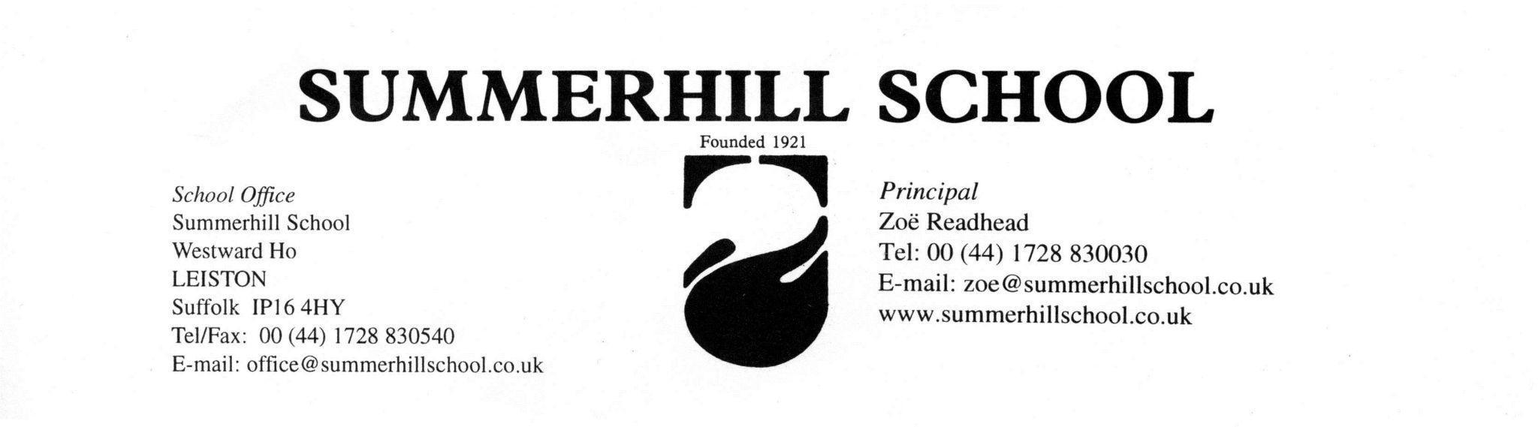
Primary Teacher Job description

Summerhill School- General Information for Applicants

Summerhill School is a multinational boarding school community with between 50 to 90 students aged 5-17 and a full-time team of teachers and house parents supported by part-time teachers and ancillary staff.

You probably know something about the school as the founder, A.S. Neill is internationally renowned for his achievement in setting up this free democratic school as well as for his books about his life as a teacher and educator. The school is still run as he started it: by a democratic meeting where everyone’s vote counts equally; and with the children having the freedom to attend lessons or not as they see fit.

The Principal, Zoë Readhead, is Neill’s daughter and an ex-Summerhillian and thus a continuity of traditions is maintained at the school.

Working at Summerhill can be a life-changing experience as it is founded on principles of optimism, trust and cooperation that are rare. It is hard work during the term for full-time staff as there is no set knocking off time and the unique character of the social environment can lead to intense activity well into the evening. However, the setting in 11 acres of wood and field is peaceful and there are opportunities to escape to the beach or the town, whilst the holidays are exceptionally long by any standard!

We are careful not to behave like ‘adult carers’ as the kids do not like it. The important thing about our relationships with the kids here is that we are all equal and we have no more right to snoop around their problems than they have ours. Having said that, we are responsible for them - this is a school after all! - so we try to work it so that we are aware but not intrusive, available but not pushy.

This is a residential post. Summerhill is a boarding school and a close-knit community. A full engagement with the broader life of the community is deeply enriching and satisfying and is not to be seen as an extra round of duties and responsibilities. Indeed, as a self-governing school many of the traditional roles of the teacher, such as discipline and order, bedtimes, are taken care of by the children. However, as a member of the community you will be expected to become involved in school activities of one kind or another. We are all equal members of a community and as such we are expected to take our turn when needed, be part of a social event committee or be a beddies officer, "litter-pick-up" amongst others.

A week in Summerhill is structured like this: Wake up on weekdays is at 8.00am and classes begin at 9.00am. There are seven 40m lessons, there is a 20-minute break at 11am and 1 hour for lunch at 12.40pm. Lessons finish at 3.00pm and we have a 15-minute tea break. Afterwards on Monday and Friday there are school meetings at 3.15pm and on Tuesdays a staff meeting. On Fridays the staff meeting is immediately after the school meeting. There could be other meetings added to these ones depending on the needs of the community. Supper also varies but at the moment is set for 5.30pm.

Accommodation and Pay

There is a variety of accommodation for staff including rooms in outlying buildings and rooms next to children’s dormitories.

Terms are eleven weeks long on average and you have three complete weekends off per term. These begin at 3.00pm on Friday afternoon and end on Sunday evening. The holidays are long (4+ weeks, 4+ weeks and 8+ weeks). It is alright to have a friend down to visit in term time from time to time, but it has to go through management first and then the general meeting.

Other time taken, for example going for walks along the coast, must be negotiated with the other staff to ensure there are always enough adults in the school. You are expected to cover for a houseparent for one day and night on a rota sharing the duty with another member of staff, approximately 11 days in a term, participate on school party rotas, invigilate exams and write some articles for the Summerhill newsletter amongst other duties.

The pay includes all accommodation, bills and food during term time and is currently set at £18,200 per annum. Additional duties, such as airport trips attract small extra sums of money.

If you are serious about working at Summerhill you will probably not be principally attracted by financial gain, but you might like to consider that the experience you gain could not be bought and is certainly unique.

Primary Teacher Position at Summerhill

The Primary department is a group of children aged 7-12 years. The primary teacher’s job at Summerhill School offers the right candidate the opportunity to work imaginatively in a free environment where children are encouraged to grow at their own pace. You will be in charge of a multiple-room suite, some set as an open space for arts, crafts and projects, playroom/library, other set up for boardgames, reading and lessons. This structure is flexible and can be changed according to the teacher. You will have a great deal of freedom to discover the best way to teach free children, with the support and advice of other experienced staff with regular staff meetings and practice meetings with other teachers as well you will be appointed a staff mentor.

The job as a primary teacher in Summerhill is complex as the ability of the students is wide: teaching reading from beginners to advanced readers. However, the overall lessons are delivered in small groups. The outgoing teacher managed these mixed abilities by providing a mixture of activities that could be shared by everyone and/or focused sessions for smaller groups.

A primary teacher at Summerhill is responsible for teaching lessons (English, Maths, Science, amongst others depending on kids and teacher interests) to approximately 20 students. The timetable consists of seven, forty-minute, lessons each weekday, beginning at 9.00am and ending at 3.00pm.

Other teachers provided specific subjects such as Woodwork, Art, Music, EAL (English as Additional Language), ITDT (Information Technology Design Technology) and some other House parents may want to offer projects or other interests.

The ideal candidate will find the challenges and opportunities provided by this free education exciting. You will be free of the incessant rounds of bureaucracy and testing you may have experienced elsewhere but you will be faced with the challenge of providing stimulating and structured lessons for children who are under no compulsion to attend.

There will be literacy and numeracy meetings you will have to attend, these are set to talk about practices, record keeping, new ideas or specific concerns in the classroom, as well as to support other teachers.

Primary teacher: qualities we are looking for
- A dedicated primary teacher with imagination and flair.
- An organised and self-motivated; able to work without supervision.
- Able to offer lessons to students of different ages and mixed ability levels.
- Possess the appropriate academic qualifications and the relevant teaching experience and the confidence and ability to be in sole charge of this crucial stage of learning
- Capable of keeping up to date regarding appropriate syllabuses, new methods, etc.
- Able to maintain a safe and attractive classroom environment, organising and managing the space and the materials in the classroom
- Someone happy to live and work in a multi-national community where many children’s first language is not English.
- Sensitive to the reasons that children may not want to attend classes.
- Tolerant of differences and willing to work cooperatively with other staff.
- Up to create a Curriculum Outline and a yearly Self-Evaluation.
- Enthusiastic- willing to take a full and active part in the life of the school.
- Good sense of humour- essential!
- The courage to live in a community of children as an equal member whilst retaining a responsible attitude towards the children, staff and community in general
- Aware of the unique philosophy of Summerhill School and sympathetic to the aims of the school.
You are recommended to read Barefoot in November by Zoë Readhead and Summerhill and A.S. Neill Book which is available in the school shop online. It will help you understand Summerhill and the philosophy behind it.

