
Our Vision:
To develop aspirational learners who strive for excellence academically, creatively and culturally, benefitting from a wide range of opportunities led by inspirational educators.

Shirley High School
Performing Arts College

“Striving for Excellence”

Job Description:

Post: Seclusion Unit Manager
Line Manager: SLT member responsible for Seclusion

The Seclusion Unit Manager will oversee the day-to-day management of the Seclusion Room, working with pupils who have been secluded for a fixed period and working alongside staff for pupil support.

Areas of responsibility and guidance:

Core Duties:

- Day-to-day management of the Seclusion Room.
- Working with pupils excluded for a fixed period.
- Working alongside staff responsible for pupil support.

Seclusion Unit:

- To be the identified person with responsibility for pupils referred to the unit;
- Liaising with the DoFs / HoDs / HoYs and other teaching staff regarding the work to be covered in lessons;
- Collecting all work at the end of the day and returning it to the relevant member of staff;
- Supervising the pupils during seclusion, ensuring that they behave well and complete the work set;
- Completing registers and all necessary forms, as appropriate, in line with school procedures;
- Working with children at risk of suspension as directed;
- To undertake mentoring with the pupils in Seclusion to prepare for their reintegration meetings and for return to mainstream lessons;
- To complete daily reports on the pupils in Seclusion and copy them to the Head of Year prior to the pupil’s reintegration meeting and return to mainstream lessons;
- To report on matters relating to Seclusion at Pastoral Team meetings;
- To complete Seclusion data on request from the Member of the Senior Leadership Team (SLT) with responsibility for Seclusion.

Support:

- To implement and monitor the progress of pupils and their individual learning programmes;
- To support pupils enabling them to access the curriculum, achieve their full potential, work independently and collaboratively, and participate fully in school life;
- To set targets and use performance and other relevant data to monitor the performance and progress of targeted pupils;
- To attend meetings with tutors, outside agencies, parents / carers, Heads of Years and members of the Pupil Support team to share information concerning targeted pupils, as required;
- To assist the Heads of Years in the identification of pupils who require additional intervention;
- Providing support and help to facilitate the pupil’s learning; for example, by undertaking some additional research such as speaking to teachers, reading through textbooks, and using the internet.

Responsibilities:

- Being aware of and complying with policies and procedures relating to child protection, health, safety and security, confidentiality and data protection, reporting all concerns to an appropriate person;
- Being responsible for your own Health & Safety, as well as that of colleagues, pupils, parents / carers and visitors.
- Understanding, complying and enforcing equal opportunity within the workplace. Undertaking any appropriate training and challenging racism, prejudice and discrimination or any unacceptable behaviour.
- Contributing to the overall ethos/work/aims of the school;
- Appreciating and supporting the role of other professionals;
- Attending and participating in relevant meetings as required;
- Participating in training and other learning activities and performance development as required;
- To enrich personal knowledge by consulting up-to-date resources;
- Promote and ensure the health and safety and good behaviour of pupils at all times.

Other:

- When supervising pupils at any time (including lunchtime), ensuring that pupils abide by school rules;
- Supervising other school activities, e.g. lunch / detention;
- When invigilating examinations, ensuring that examination rules and regulations are adhered to under the direction of the Lead Invigilator / Examination Officer;
- To work as part of a flexible and supportive team to further the ethos of the school;
- To undertake relevant training to enhance personal development and use the knowledge to the benefit of the school and its pupils;
- Any other appropriate tasks as directed by the Member of the Senior Leadership Team (SLT) with responsibility for Seclusion;
- To liaise with and contact parents / carers as required.

Personal Qualities:

- Accurate record-keeping.
- Demonstrate great communication skills with all within the school community;
- Neat appearance in line with the school policy and Code of Conduct;
- Ability to work as part of a successful team and work effectively under pressure;
- Have the determination and resilience to ensure that all pupils are challenged in all aspects of school life.
- Ability to liaise effectively with parents / carers / teachers / outside agencies.

Think Green:

- Support the school in demonstrating good environmental practices (such as energy efficiency, use of sustainable materials, recycling and waste reduction) wherever possible in day-to-day work.

Safeguarding and Child Protection:

- To reinforce and enforce the school’s commitment to safeguarding and promoting the welfare of children and young people.
- Uphold the duty of care to ensure that if there are any concerns relating to the welfare or safety of a child they are immediately relayed to the Designated Person(s) with responsibility for safeguarding children.

Person Specification:

Essential | Desirable
Effective behaviour management | Organised and reliable
Good communication and interpersonal skills skills | Working knowledge of relevant polices/codes of practice and awareness of relevant legislation
Effective use of ICT and other specialist equipment/resources | Very good organisational skills
Very good numeracy/literacy skills | Ability to relate well to children and adults
Demonstrable attention to detail | Ability to work constructively as part of a team, understanding school roles and responsibilities and your own position within these
Experience of development, management and operation of administrative systems | Ability to self-evaluate learning needs and actively seek learning opportunities

We want all at SHS to believe in and maintain the values of our school:

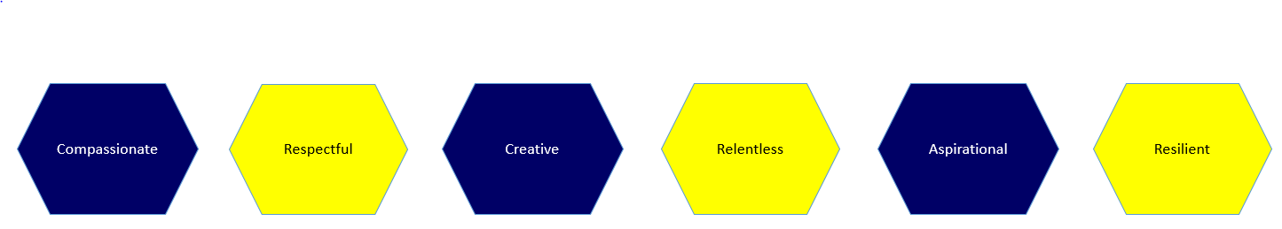

Signature: ……………………………………………………………………… Date: …………………………..……………………………………….

