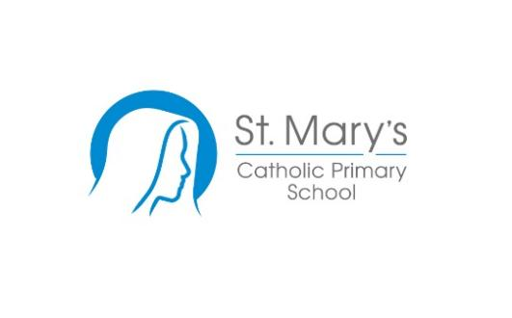 JOB DESCRIPTION

Post Title: Whole School Assistant Date June 2024

Summary of Role

Supporting teachers, pupils with various activities and administrative tasks that facilitate the effective running of the school and benefit all stakeholders, ensuring that our children are safe and well.

Main Duties

Classroom support for teachers

- Preparing and maintaining teaching materials, resources and equipment. Storing and retrieving this equipment as required.
- Mounting pupil work and assisting with displays.
- Undertaking routine clerical duties eg completion of records and reproduction of letters, photo- copying and producing class lists.
- Setting up and maintaining equipment and software.

Pupil Support

- Supervising and assisting with cloakroom duties.
- Assisting pupils with personal care and hygiene including toileting.
- Accompanying unwell pupils’ home or to hospital.
- Attending to unwell and injured pupils as necessary.
- Receiving and caring for pupils arriving before school and caring for pupils left under the supervision and guidance of a teacher.
- Assisting with the supervision of individuals or groups of pupils under the supervision and guidance of a teacher during lessons, break periods, in the dining room and on school outings.

School support

- Ordering, receiving, cataloging, issuing, and maintaining equipment and materials.
- Assist with the collection and balance of school monies as appropriate.
- Investigating pupil absence.
- Data input of pupil records into computerised systems.
- Collating pupil reports.
- Producing analyses of attendance figures.
- Producing analyses of test results.
- Administration related to work experience.
- Administration of statutory tests or school assessments.
- Administration support of cover of absence teachers.
- Taking notes of meetings as required.
- Contribute to the protection of children from abuse (in accordance with the Sheffield LEA Child Protection Procedure).

- Contribute to the health and safety of pupils and other staff in accordance with Health and Safety regulations and school policy.

- Any other duties that are appropriate to the role.

General

- The post holder will be required to complete mandatory training from time to time. This may be in person or online covering subjects like safeguarding, data protection, cyber security and health and safety.

- All Trust staff are required to follow the Trusts Policies and Procedures, and these can be found on the Trust’s intranet.

- Postholders will be required to assist with taking unwell children home or to hospital

- To participate in and undertake an annual appraisal process and complete any necessary training and development.

- All staff are required to respect, the Trust’s distinctive ethos as a Catholic Trust and not to do anything that is detrimental or prejudicial to the interests of this.

Pay and benefits.

The Trust broadly follows the NJC green book terms and conditions of employment.

Salary scale (Sheffield NJC Grade 3) Scale point 5 - 6 (pro rata £26,428 – £26,847).
Hourly rate: £13.69 - £13.91.

NJC occupational sick pay.

LGPS Pension Scheme.

September 2026

