Welcome to the Marlborough Science Academy Science Department
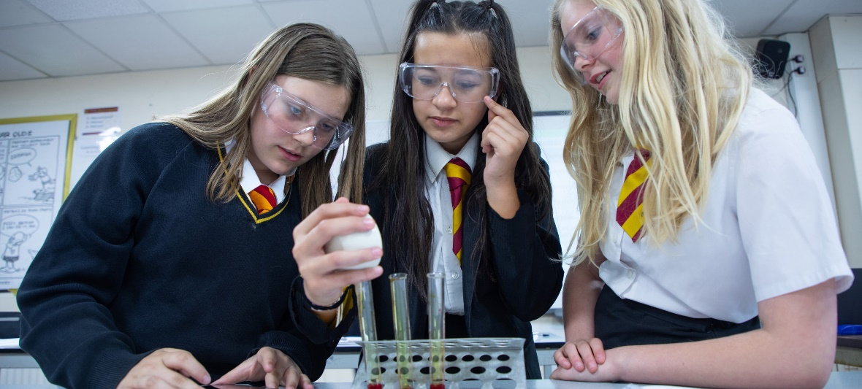
Are you passionate about sharing your knowledge and guiding the next generation of scientists? If so, the Science Faculty at The Marlborough Science Academy will be the perfect fit!

We are a close-knit and supportive team of staff, united by a shared commitment to excellence in teaching, and student success. We are more than just colleagues, we are mentors, supporters, and friends. We foster an environment where open communication and a shared sense of purpose propel us all forward.

Join us and:

- Make a real impact: Shape young minds and inspire a lifelong love of science in our diverse student body.
- Collaborate with passionate colleagues: we love to share best practice and learn from each other's expertise.
- Contribute to our extra-curricular science and STEM clubs, helping students work towards goals such as CREST awards.
- Enjoy a work-life balance: We are passionate about working hard, but also working smart so that we can thrive in a challenging career.
- Contribute to an outstanding community: Be part of a dynamic school known for its development of students’ character as well as academic skills and knowledge.
The curriculum caters for all of our students, providing rigour and depth for those students aspiring to scientific careers and interest, knowledge and scientific literacy for students whose ambitions lie in other curriculum areas.
All of our students have the opportunity to study a combined Science course (AQA) in KS4 with selected students able to study the separate 3 GCSEs. We also have a thriving sixth form, and through the whole curriculum we aim to inspire curiosity and confidence in our students, through using a selection of:
• Retrieval practice, with a focus on pre-requisite knowledge needed to access each lesson.
• Formative and summative assessments leading to student reflection and progression.
• Modelling concepts and skills.

Are you ready to take the next step in your career in science teaching? We invite you to visit us and join our dynamic Science Faculty. Together, we can ignite the passion for science and empower the next generation of scientific leaders.

We look forward to hearing from you! Graham Spiller, Head of Science and the team.



