

ROLE PROFILE

*Red Kite Learning Trust is committed to supporting work–life balance and recognise the benefits of flexible working. We welcome requests for flexible working arrangements as part of the recruitment process. While flexibility may be possible for many roles, each request will be considered on an individual basis.
Job Title: | Headteacher | School: | Templenewsam Halton Primary School
Salary Grade: | L21-L25 | Working Hours: | Full time
Contract Type: | Permanent | Location: | Leeds
Responsible to: CEO of Red Kite Learning Trust and Director of Primary Education
Role summary: To lead and manage the school and continue positively to the wider work of our Trust and a shared mission for education. We are committed to continuing to work with the School Teachers’ Pay & Conditions Document and associated conditions of service.
Special conditions of service:
No smoking policy, including e-cigarettes/vaping.
Role specific responsibilities:

Key Responsibilities - Leading and Managing Teaching & Learning
- To foster an inclusive culture and effectively communicate a vision of excellence for the school, which involves continuously improving the quality of teaching and learning
- Ensure teaching & learning is led in accordance with the School and our Trust’s vision and goals
- Ensure a consistent and continuous school-wide focus on pupils’ achievement, using data and appropriate benchmarks to monitor progress in every child’s learning
- Ensure that learning is at the centre of strategic planning and resource management
- Ensure a culture and ethos of challenge and support where all pupils can achieve success and be engaged in their own learning
- Use a range of evidence, including national data and own schools’ performance data, to support, monitor and evaluate and improve aspects of school life, including challenging under performance
- Demonstrate and articulate high expectations and set challenging targets for the whole school community
- Ensure individual staff accountabilities are clearly defined, understood, and agreed and are subject to rigorous review and evaluation in accordance with managing performance excellence
- Utilise our shared Trust quality assurance systems including school review, self-evaluation and performance management to present a coherent and accurate account of the school’s performance to a range of audiences including governors, trustees, parents, and carers
- Ensure a culture of professional curiosity as the Designated Safeguarding Lead (DSL) and whole school adherence to all Trust and statutory requirements, currently provided through Keeping Children Safe in Education
- Implement strategies that secure high standards of behaviour and attendance
- Monitor, evaluate and review classroom practice and promote improvement strategies
- Determine, organise, and implement a rich curriculum that exceeds the requirements of the National Curriculum and reflects our Trust values
- Take a strategic role in the development of new and emerging technologies to enhance and extend the learning experience of pupils
- Maximise the contribution of staff to improve the quality of education provided and standards achieved and ensure that constructive working relationships are formed between staff and pupils
- Build and develop the team to work as effectively and efficiently as possible whilst also securing the highest levels of staff engagement
- Work as a key partner within our Trust, via the Executive Headteacher Board and other Trust and Alliance wide activities
- Arrange for a Deputy or other suitable person to assume responsibility at any time when the Headteacher is absent from the school
- Work closely with the Business Manager and wider Trust Finance team to manage the school’s financial and human resources, ensuring effectiveness and efficiency in achieving the vision and goals of the school within the parameters of the budget
- Manage and organise the school environment efficiently and effectively to ensure it meets the needs of the curriculum and health and safety regulations
- Support and uphold the school and Trust policies
- Work to the Seven Principles of Public Life
Key Responsibilities – Shaping the Future
- Work closely with the local governing body and others to ensure the school vision and strategic plan are effective and relevant to the school’s development
- Work within the school community to translate the School/Trust vision into agreed objectives and operational plans
- Demonstrate the vision and values in everyday work and practice
- Motivate and work with others to create a shared culture and positive climate
- Ensure creativity, innovation and the use of appropriate new technologies and initiatives to achieve excellence
- Ensure the strategic planning takes account of the diversity, values and experience of the school and its community
- Demonstrate a commitment to our Red Kite Learning Trust Inclusion Pledge
Key Responsibilities – Strengthening Community
- Develop and secure trust amongst the community and all stakeholders
- Create a wholly inclusive environment
- Create and maintain an effective partnership with parents and carers, to support and improve pupils’ achievement and personal development
- Seek opportunities to invite parents, careers and community figures, business, or other organisations into the school to enhance and enrich the school and its value in the wider community
- Contribute to the development of the school-led, self-improving education system through the work of our Trust and Alliance
- Work with partners and agencies to ensure every child feels they belong, can achieve and look forward to a brighter future
Key Responsibilities - Developing Self and Working with Others
- Treat people fairly, equitably and with dignity and respect to create and maintain a positive school culture.
- Build a collaborative learning culture within the school and actively engage with other schools, within and beyond our Trust, to build effective learning communities
- Ensure effective planning, allocation, support and evaluation of work undertaken by teams and individuals, ensuring clear delegation of tasks
- Acknowledge responsibilities, celebrate achievements of individuals and teams
- Regularly review own practice, set personal targets and take responsibility for personal development
- Manage own workload and support others in doing the same, to provide for good levels of work/life balance
- Create a safe learning environment where colleagues feel able to contribute to ideas and practice
All colleagues, regardless of career stage, will make a positive contribution to the wider life and community of our school, for example through sport, music, hobbies etc.
RK People responsibilities:
- Contribute to the overall aims and values of our Trust, appreciate and support the roles of other members of the wider team and attend and participate in relevant meetings as required
- Comply with all Trust policies and procedures including child protection, health, safety, welfare, security, confidentiality and data protection etc., reporting any concerns to the appropriate person
- Contribute to ensuring safeguarding procedures are in place and used effectively at all times.
The role holder must demonstrate a flexible approach to the delivery of the role. Consequently, the role holder may be required to perform work not specifically identified in the role profile but which is in line with the general scope, grade and responsibilities of the role.
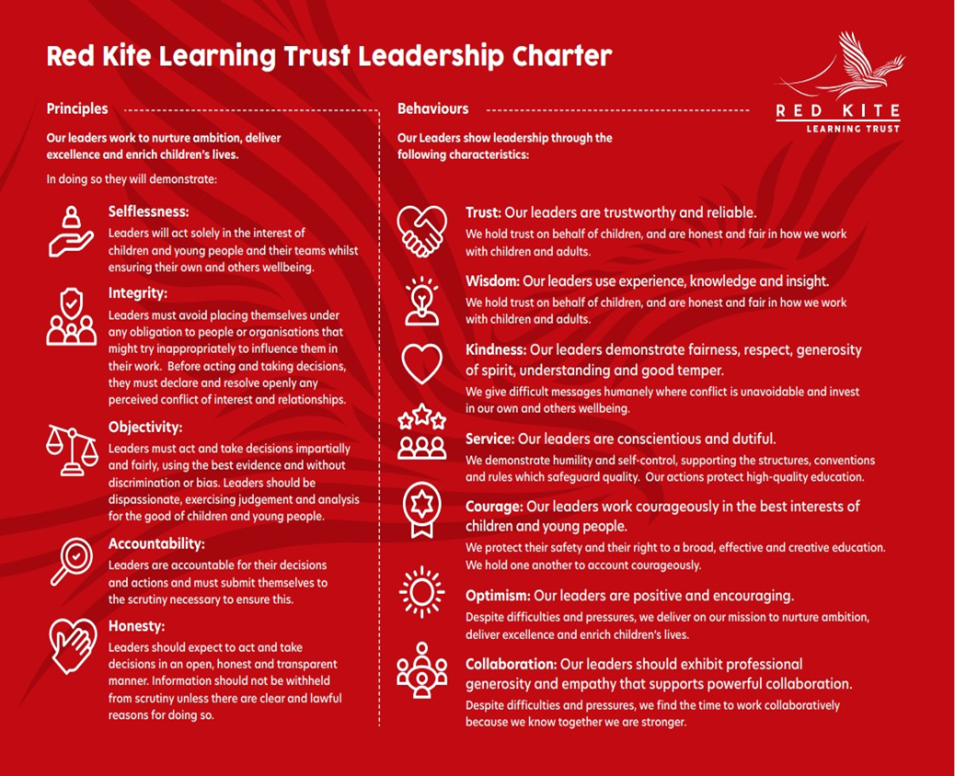
PEOPLE PROFILE
Aptitudes and Characteristics |  |  | Essential | Desirable
Demonstrable ability to work effectively in a wide range of partnerships |  |  | *
Ability to lead and manage significant whole school initiatives |  |  | *
Ability to monitor and evaluate the work of others; to offer support and intervention where necessary |  |  | *
Ability to articulate, share and translate a vision of education within the context of a primary school |  |  | *
Ability to ensure effective strategic financial planning and budgetary management to achieve best value |  |  | *
Can collaborate and communicate strategically with a wide range of audiences including parents, pupils, colleagues, governors, other schools and colleges |  |  | *
Commitment to the promotion of an inclusive school community |  |  | *
Ability to give and receive effective feedback and act to improve personal performance |  |  | *
Can challenge, influence, motivate and support others to attain high standards |  |  | *
Ability to develop and sustain a safe, secure and healthy school environment, ensuring an understanding of the legal issues related to managing a school |  |  | *
Ability to apply the principles and practice of quality assurance systems including school review, self-evaluation, performance management and stakeholder and community involvement |  |  | *
An ethical leader who exercises confidentiality and a high level of emotional intelligence |  |  | *
Willingness to be flexible and work to meet the best interests of the school and our Trust |  |  | *
Committed to delivering the schools vision, values and policies |  |  | *
Self-motivated, resilient, and hard-working |  |  | *
Sense of humour and optimism |  |  | *
Proven commitment to inclusion for all |  |  | *
Commitment to excellent and respectful behaviour from the whole academy community |  |  | *
Ability to manage the school efficiently and effectively including HR, Finance and Accommodation |  |  | *
Qualifications and Knowledge |  |  | Essential | Desirable
Graduate with Qualified Teacher Status |  |  | *
Achieved NPQH |  |  |  | *
Proven experience of developing good working relationships with all stakeholders |  |  | *
Sound knowledge of Early Years Foundation Stage education |  |  | *
Up to date knowledge in subject, national policy, pedagogy, classroom management strategies, research/inspection findings and statutory requirements |  |  | *
Understand what constitutes quality in educational provision, the characteristics of effective school development, and effective strategies for raising standards and the achievement of all pupils |  |  | *
Thorough understanding of curriculum development |  |  | *
Comprehensive knowledge of performance management requirements in an educational context |  |  | *
Understanding of the characteristics of an effective learning environment and the key elements of successful behaviour and attendance management |  |  | *
Skills and Experience |  |  | Essential | Desirable
Experience in a primary phase leadership role, e.g. Headteacher, Interim Headteacher, or Deputy Headteacher |  |  | *
Experience of applying a range of successful teaching and learning strategies to meet the needs of all pupils |  |  | *
Experienced of managing a school efficiently and effectively on a day-to-day basis including HR, Finance and Accommodation |  |  | *
Excellent management, motivational and communication skills |  |  | *
Experience of developing good working relationships with all stakeholders |  |  | *
Experience of leading, managing and co-ordinating staff through an effective team based approach |  |  | *
Experience of monitoring and improving the quality of teaching and learning |  |  | *
Experience of meeting the needs of all learners; raising standards |  |  | *
Experience of strategic planning |  |  | *
Experienced in analysing data, developing strategic plans, setting targets and monitoring/evaluating progress to lead school improvement |  |  | *
Experience of whole school self-evaluation and improvement strategies |  |  | *
Safeguarding and Promoting the Welfare of Pupils |  |  | Essential | Desirable
An appropriate motivation to work with children and young people |  |  | *
Ability to maintain appropriate relationships and personal boundaries with children and young people |  |  | *
Emotional resilience in working with challenging behaviours and appropriate attitudes to the use of authority and maintaining discipline |  |  | *

