

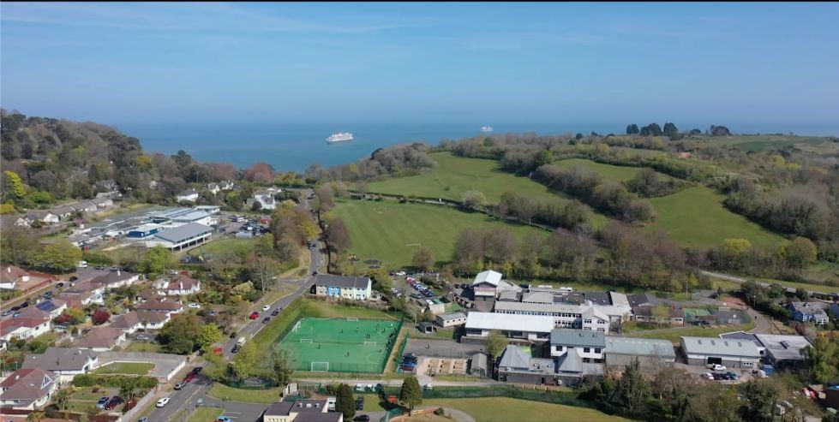

TEACHING ASSISTANT
VACANCY INFORMATION

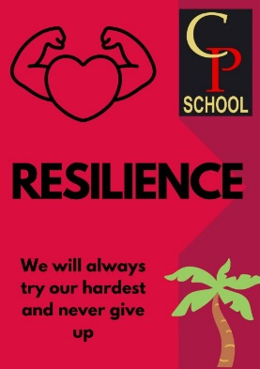




Welcome to
Combe Pafford School

Sally Banfield, Headteacher

Thank you for your interest in joining Combe Pafford School. We are a vibrant, nurturing, and inclusive community where children and young people feel safe, valued, and inspired to learn. As Headteacher, it is a privilege to lead a school where our students’ individuality, achievements, and resilience are celebrated every day.

Since joining the school in September 2024, I have been consistently impressed by the incredible talent and resilience of our young people and the dedication and expertise of our staff team. Together, we are committed to providing exceptional education and personalised support that enables every student to thrive.

About Our School

Combe Pafford School currently provides specialist education for students aged 9–19 (Years 4–14) with:
- Autistic Spectrum Condition (ASC)
- Moderate learning difficulties
- Physical difficulties
- Complex needs

We combine high-quality academic teaching with a strong vocational pathway that continues into our Post-16 provision. Some students study GCSEs; others follow Entry Level or Functional Skills qualifications. Our belief is simple: there are no ceilings to what our young people can achieve.

Our aim is for every student to leave us with meaningful qualifications, confidence in themselves, and the skills they need for independence, work-based employment and adulthood.

Future Development

At the request of Torbay Local Authority, from September 2026 the school will move to a formal designation for Autistic Spectrum Condition (ASC). From this point forward, new admissions will require a formal ASC diagnosis. This shift strengthens and focuses on our commitment to delivering high-quality specialist provision for autistic learners. Our first cohort under this designation will join us in Years 4–7 from September 2026 and we are excited to welcome them to the school.

In line with our new designation, the school is having a capital build project completed over the summer. This includes new outside learning spaces, a new sensory zone with associated spaces, new toilets, outside playground equipment and a new OT space. All our current young people with MLD will continue their journey at Combe Pafford as we build our new ASC cohorts up from the lower end of the school. The school will be fully ASC by September 2030.

Our Values and Vision

Personal development is at the heart of everything we do. We prioritise communication, social understanding, problem solving, resilience, and life skills so that our students can approach the wider world with confidence.

Our school culture is guided by our core values of:
- Compassion
- Resilience
- Respect

The Role of Teaching Assistant

A Teaching Assistant at Combe Pafford supports pupils with special educational needs in lessons and social times, working closely with teachers to promote learning, positive behaviour, personal development, and preparation for adulthood within a phased school setting. 1:1 Teaching Assistants support a specific named pupil during their time at our school.

Why Join Us?

We are proudly oversubscribed and recognised as a school of choice within Torbay and the surrounding community. Staff benefit from a supportive team ethos, clear routines, strong leadership, and a culture that values professional growth and wellbeing.

If you believe in the potential of every young person and want to make a meaningful difference in the shaping of their lives, we would be delighted to receive your application.

Come and Visit

The best way to understand our ethos and culture is to come and see it in action. We warmly welcome prospective applicants to visit us and experience our community firsthand.

Thank you for reading our application pack and for the time you invest, if you choose to apply. I look forward to reading any application you submit. Please do not hesitate to contact me at school if you have any questions about the role.

Kind regards,

Sally Banfield
Headteacher


About the Role
Combe Pafford is a successful and popular 8-19 single academy special school situated on the coast in Torbay within easy reach of Dartmoor National Park. The school is a very popular school and always oversubscribed and has an excellent reputation locally for catering for the needs of pupils who have moderate learning difficulties, many of whom have additional needs of ASC or PD. We have 205 pre 16 pupils and a thriving sixth form of 60 students.

We are fortunate in that the school has been extensively remodelled and refurbished in recent years and we have invested heavily and created a wide range of first-class vocational facilities on-site which includes a construction hall, fully operational garage, a horticulture centre, animal care centre, hair salon and café which opens to the public. The outcome of this is that on average, at least 50% of our students leave us to undertake suitable and appropriate employment.

Besides a wide-ranging academic offer, we are also extremely keen to help youngsters develop their personal and social skills through wide-ranging enrichment and residential opportunities, which has included visits to Europe, China and Costa Rica. This year we will are offering residential trips for all our students from Year 7-Year 14 visiting, Kenya, Grand Canaria, France, Belgium, Germany, Wales and other parts of the UK.
Our vision is to develop a successful school that delivers the very best educational experience with a clear focus on raising standards and having high aspirations for all pupils and students whilst celebrating each individuals’ uniqueness.

The school is now looking to appoint a Teaching Assistant, someone who will work with our young people in lessons and also when they are in social times in school. Our teaching assistants support both the quality of education and learning and behaviour and attitudes across our school.

Teaching Assistant are phased based either in our lower, middle and upper school and will be based in with teachers and classes in this phase.

If you are innovative, creative, forward thinking, and have a passion for working with staff and communities to ensure children with special educational needs get the education they deserve, this is your opportunity to make a real difference.

The successful candidate will need to be someone who:
- Has the ability to build effective working relationships with pupils and adults
- Is kind and has a passion for working with young people
- Has good literacy and numeracy skills and organisational skills
- Has the ability to work as part of a team and to be flexible in their approach to daily routines
- Has great listening skills and is able to remain calm in stressful situations

We strongly believe that every child should go to school excited about the day ahead and experience a sense of achievement when they go home. We strive to provide a curriculum that both motivates our pupils and encourages them to continue learning each and every day and prepare them for the world of work.

Our pupils are encouraged to develop the knowledge, skills, attitudes, confidence and self-esteem necessary to overcome their barriers to learning and meet the challenge of adult life.

Further information about the school can be found on our school website: www.combepaffordschool.co.uk

JOB DESCRIPTION
Salary range | NJC Grade C/D (£24,796 - £25,989) FTE  Actual Salary £18,013 - £18,880
Contract | Permanent, Temporary and Fixed Term Contracts Available
Start Date | September 2026
Hours | Monday–Friday 8.45am - 3.40pm term time  (+ an additional 1 week) 31.25 hours per week

KEY DUTIES:

To work under the instruction/guidance of teaching/senior staff, to undertake work/care/support programmes, to enable access to learning for pupils and to assist the teacher in the management of pupils and the classroom. Work may be carried out in the classroom or outside the main teaching area.

ROLE PURPOSE
- Support for Pupils

- To attend to the children’s general welfare, personal needs and personal hygiene to include lifting and positioning, toileting and feeding
- Assist with the development and implementation of Individual Education/Behaviour Plans and Personal Care programmes
- Establish constructive relationships with pupils and interact with them according to individual needs
- Promote the inclusion and acceptance of all pupils
- Encourage pupils to interact with others and engage in activities led by the teacher
- Set challenging and demanding expectations and promote self-esteem and independence
- Provide feedback to pupils in relation to progress and achievement under guidance of the teacher
- Deliver intervention sessions as directed by the class teacher

- Support for the Teacher

- Create and maintain a purposeful, orderly and supportive environment, in accordance with lesson plans and assist with the display of pupils’ work
- Use strategies, in liaison with the teacher, to support pupils to achieve learning goals
- Assist with the planning of learning activities
- Monitor pupils’ responses to learning activities and accurately record achievement/progress as directed
- Provide detailed and regular feedback to teachers on pupils’ achievement, progress, problems etc.
- Promote good pupil behaviour, dealing promptly with conflict and incidents in line with established policy and encourage pupils to take responsibility for their own behaviour
- Establish constructive relationships with parents/carers
- Administer routine tests and invigilate exams and undertake routine marking of pupils’ work
- Provide clerical/administrative support e.g. photocopying, typing, filing, money, administer coursework etc.
- Assist with collation of assessment evidence and pupils’ work

- Support for the Curriculum

- Undertake structured and agreed learning activities/teaching programmes, adjusting activities according to pupil responses
- Undertake programmes linked to local and national learning strategies e.g. literacy, numeracy, KS3, early years recording achievement and progress and feeding back to the teacher
- Support the use of ICT in learning activities and develop pupils’ competence and independence in its use
- Prepare, maintain and use equipment/resources required to meet the lesson plans/relevant learning activity and assist pupils in their use
- Attend relevant training in-school LSA training as required

- Support for the School

• Be aware of and comply with policies and procedures relating to child protection, health, safety and security, confidentiality and data protection, reporting all concerns to an appropriate person

Expectations of Applicants:
1. Treat people fairly, equitably and with dignity and respect to create and maintain a positive culture.
2. Work as a positive team player, demonstrating mutual respect and integrity for others whilst maintaining open and effective communication at all levels in the School.
3. Develop and maintain a culture of high expectations for self and others and take appropriate action where necessary.
4. Regularly review own practice.
5. Maintain high standards of professional conduct and personal appearance.

Notes: This job description may be amended at any time in consultation with the postholder

PERSON SPECIFICATION

 | Essential | Desirable
Qualifications | GCSE or equivalent level, including at least a Grade 4 (previously Grade C) in English and Maths. | Relevant qualification in education, tutoring, SEND or child development.
Experience | Experience working with children or young people. | Experience working with pupils with Autism and/or Moderate Learning Difficulties.  Teaching, tutoring, learning support, mentoring, or intervention experience.
Knowledge | Understanding of inclusive educational practice.  Knowledge of guidance and requirements around the safeguarding of children. | Knowledge of how to help adapt and deliver support to meet individual needs.  Subject and curriculum knowledge relevant to the role, and ability to apply this effectively in supporting teachers and pupils.  Good ICT skills, particularly using ICT to support learning.  Understanding of EHCPs and SEND legislation.
Qualities and Skills | Good organisation skills.  Ability to build effective working relationships with pupils and adults.  Excellent verbal communication skills.  Ability to work as part of a team and to be flexible in approach to daily routines. | Skills and expertise in understanding the needs of all pupils.

Additional Information
Applicants should hold GCSEs (or equivalent qualifications) in English and Maths at Grade 4/C or above and have experience of working within a school environment. If you do not have experience, we may be able to offer an Apprenticeship role. Further details will be provided to shortlisted candidates at interview.

HOW TO APPLY

Please apply via the link on My New Term. This link will also be on the school website. Applications will only be considered on the school application form with an optional covering letter.

All candidates are advised to refer to the job description and person specification before making an application.

In fulfilling its aims and objectives, Combe Pafford actively seeks to achieve equality of opportunity and treatment for all members of the school community. We will continuously strive to ensure that everyone is treated with respect and dignity. Each person in our school will be given fair and equal opportunities to develop their full potential regardless of their gender, ethnicity, cultural and religious background, sexuality, disability or special educational needs and ability. The school works actively to promote equality and foster positive attitudes.
Combe Pafford is committed to combatting all forms of discrimination by implementing positive policies and practices in compliance with the Equality Act 2010.
Any offer of employment to this role will be subject to receipt of a satisfactory enhanced disclosure from the Disclosure Barring Service, Children and Adult Barred List Checks, Section 128, identity checks, medical clearance, proof of relevant qualifications, satisfactory references and eligibility to work in the UK checks. Shortlisted candidates will be subject to an online search and required to complete a self-declaration of their criminal record at their interview.

All members of staff are expected to promote and safeguard the welfare of students in accordance with Keeping Children Safe in Education, including maintaining clear professional boundaries in all relationships.
We strive for excellence and encourage our staff to aim high, making positive impacts through their clear focus and professionalism.

If you believe you are the right person for our role then we would love to hear from you.
If you have any further questions about this role, please liaise with the Deputy Headteacher on jmcveigh@combepafford.torbay.sch.uk or by telephone on 01803 327902

