
Apprentice IT Technician



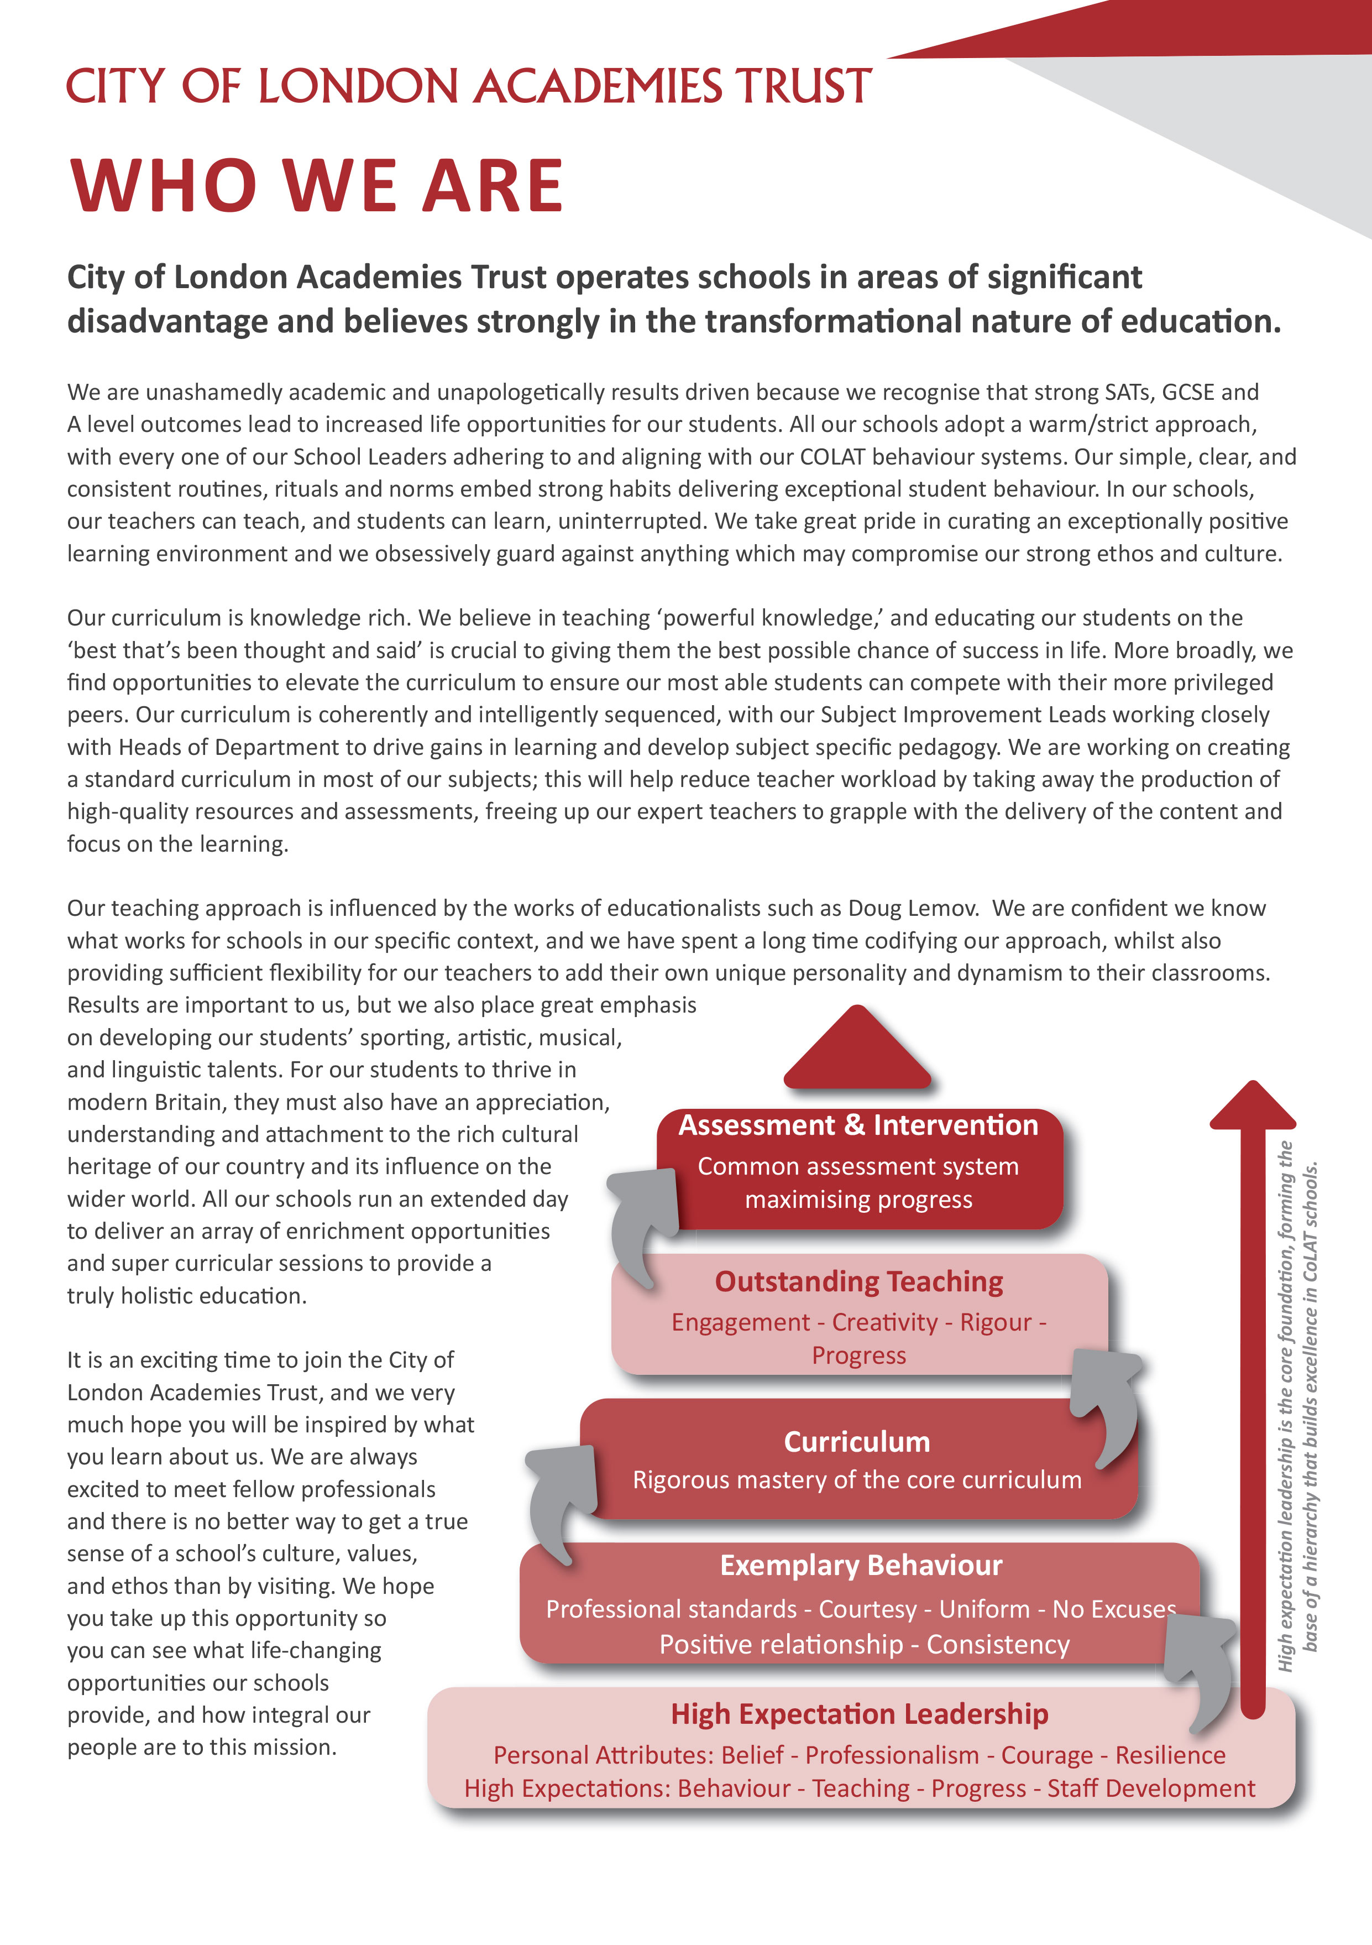



Apprentice IT Technician - Job Description

Post: Apprentice IT Technician

Reporting to: Apprentice(s) in line with the Trust’s Apprenticeship Programme headed by the
Service Manager

Salary: £22,260 FTE

Working Pattern: Full time, 35 hours per week, 52 weeks per year

Location: Based within the Central IT Team, with the expectation to be deployed to any Trust
Academy within London that requires relevant support as needed

Disclosure level: Enhanced

Role Purpose

As a Apprentice ICT Technician, your role is to support the in house COLA IT Services team in delivering, maintaining and supporting technology in City of London Academy Trust.

Your application should explain your suitability, the reason you would like to complete an apprenticeship with us and why you want to work within the City of London Academy Trust, as well as how your qualities will support the team.

Opportunities to gain wider technical knowledge and experience across the Trust are expected and will be beneficial to you.

Key Responsibilities

- Provide high quality, first and second line technical support for the ICT service desk; answering and recording all calls and activities within the service desk and adhering to COLA IT services SLA guidelines
- Supporting users, setting up user accounts, implementing password changes, and resolving user problems as and when they occur e.g. logging on access, password changes, software problems, internet access, advice on using software, etc.
- Keeping records of IT assets, including the management of user equipment loans
- Stock control of consumables, hardware ordering, distribution and paperwork
- Maintenance of IT hardware and software including installing, upgrading, troubleshooting, routine checking, fault finding and rectifying IT related items
- Recording details of faults through the service desk
- Working within legislation and best practices not limited to: Data Protection, GDPR, Safeguarding, Health & Safety, Copyright, Cyber Security
- Any other reasonable task as directed

Apprenticeship Information

Training provider: Firebrand (https://firebrand.training/uk/apprenticeships)

You will be enrolled on the Infrastructure Technician level 3 apprenticeship program which covers mandatory knowledge and skills outlined in the apprenticeship standard. As an IT Apprentice technician you will attend a suite of market-leading training program and you will be offered the chance to gain industry recognised qualifications.

You will receive full training and support from the Firebrand Apprenticeship team to increase your skills. Your training will provide an opportunity to gain qualifications through either BCS or vendor specific exams where applicable. These qualifications will provide a pathway to a professional career in IT and can be used to help move seamlessly between roles in the IT industry.

Apprenticeship Training is funded by the Education & Skills Funding Agency (ESFA), an executive agency of the Department for Education and is undertaken through the apprenticeship training provider.

To be eligible for a Government funded apprenticeship you must have lived in the UK or European Economic Area (EEA) for the last 3 consecutive year.+

Safeguarding Children
COLAT is committed to safeguarding and promoting the welfare of children and young people. We expect all staff to share this commitment and to undergo appropriate checks, including enhanced DBS checks.

The above responsibilities are subject to the general duties and responsibilities contained in the Statement of Conditions of Employment. The duties of this post may vary from time to time without changing the general character of the post or level of responsibility entailed.

The person undertaking this role is expected to work within the policies, ethos and aims of the Trust and to carry out such other duties as may reasonably be assigned. The post holder will be expected to have an agreed flexible working pattern to ensure that all relevant functions are fulfilled through direct dialogue with employees, contractors and community members.

English Duty
This role is covered under part 7 of the Immigration Act 2016 and therefore the ability to speak fluent spoken English is an essential requirement for this role.

Person Specification

Our Values and Vision
The City of London Academies Trust, sponsored by the City of London Corporation, aims to provide high-quality education for students and pioneer educational innovation. We are driven by the ambition to provide world-class experiences and deliver exceptional educational outcomes for the young people we serve.

All City of London academies draw upon the traditions, institutions, heritage and historical successes of London to furnish each of their diverse communities with life-transforming learning experiences. In doing so, we believe that the young people we serve develop into successful, compassionate young adults, who make a positive contribution to their local, national and global communities.

Our schools are characterised by a common understanding of what makes outstanding schools, based on five key principles which are known as our 'Foundations of Excellence'​.

Our Staff
Our staff have high expectations, are consistent and driven to provide the best teaching and opportunities for our students. Teachers work in a well-disciplined environment where they are able to teach creative and engaging lessons, and all staff are given exciting opportunities to develop and learn from exceptional practitioners.

Equal Opportunities
The postholder will be expected to carry out all duties in the context of and in compliance with the COLAT Equalities policies

 | Essential | Desirable
Qualifications and Training
5 GCSE’s in the grade A*-D range, including English and Maths | ✓
Experience, Skills and Knowledge
Ability to communicate clearly and sensitively in writing and orally to a variety of audiences | ✓
Analytical and problem solving skills |  | ✓
Willingness to undertake off site/residential training workshops as required by the program | ✓
Working knowledge of Internet services, including cloud, web and E-Mail |  | ✓
Someone who is looking to widen their skill-set and open up their learning towards a solid career in Education IT | ✓
Personal Qualities
Strong relationship-building skills with the ability to inspire trust and commitment across the organisation | ✓
Good organisational skills; able to manage own time effectively |  | ✓
Willingness and ability to travel around London to support other sites as required | ✓
Excellent communication skills, verbal and written – able to deal with a variety of people sensitively and empathetically including staff and students | ✓
Ability to work under pressure while maintain a positive professional attitude, and work on own initiative | ✓
A commitment and dedication to succeed | ✓
Flexible and willing to contribute to the success of the team | ✓
Other
Commitment to safeguarding and promoting the welfare of children and young people | ✓
Willingness to undergo appropriate checks, including enhanced DBS Checks | ✓
Motivation to work with children and young people | ✓
Ability to form and maintain appropriate relationships and personal boundaries with children and young people | ✓

Apprentice IT Technician
erer

Full time, 35 hours per week, all year round

Central IT Team, London and other Trust academies as required

Applications are to be submitted through the My New Term portal
9.00am, Monday 03 August 2026



