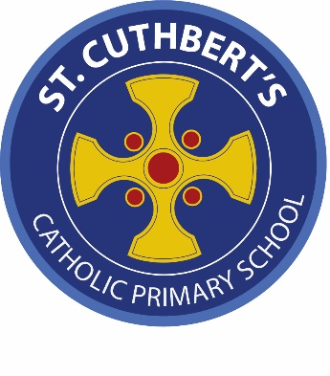

Position: 0.5 Permanent Teacher of children with SEMH needs
Contract Type: Part Time, Permanent from January 2026
Salary: M1-U3

At St. Cuthbert’s Catholic Primary School, we have high aspirations for all our children and work hard to help them improve. We focus on trauma informed practice, nurture and care first and foremost so that our children have the opportunities to learn.

An opportunity has arisen to join our team, and the governors are looking for a teacher who can help us to deliver an excellent education to all pupils in our Resourced Provision. We are looking to recruit a determined and passionate qualified teacher who will help us serve our local community by offering excellent provision, developing strong relationships with parents, and contributing to the wider life of the school.

You will be joining a Catholic school with an inclusive ethos, working hard to provide an outstanding education for all. Our community includes pupils and staff from a range of different backgrounds – all are equally welcome. We work together to form children who are compassionate, respectful, tolerant and collaborative, as well as academically successful. This is a permanent part time role to start in January 2026.

We are looking for a teacher who:

- Demonstrates optimism about children and expects the highest possible standards
- Nurtures pupils’ emotional wellbeing and develops social skills
- Has a passion and the enthusiasm to work with children with social, emotional and mental health needs.
- Will lead teaching assistants with support and guidance and support children with EHCP’s.
We can offer you:

- A positive, warm and welcoming working environment
- Experienced, intelligent, supportive colleagues
- An opportunity to be part of an aspirational community committed to good quality teaching and learning.

Closing date for applications: 12 noon, 15th December 2025
Interviews: 19th December 2025

Candidates should be aware that the school is part of the Mater-Christi Multi Academy Trust. Successful candidates will be employees of the Mater-Christi Multi Academy Trust.
Visits to the school are encouraged. Please contact the school office on 01228 818201 if you would like to arrange a visit. For any further information on the role, please contact the Head, Mrs S Hutchinson, on 01228 818201.

