

Candidate information pack



Welcome from Ewan McPherson, Principal, Deeplish Primary Academy

Dear applicant,
‘Growing great learners’

Thank you for your interest in the post of Teaching Assistant at Deeplish Primary Academy. I am extremely proud to be the Principal of such a warm and friendly school as Deeplish.

Whatever the needs of our children we aim to ensure they thrive at Deeplish, feeling safe, having fun and enjoying success. We want our pupils’ time in our school to be memorable, build on what they know and can do and help them become lifelong learners.

We value highly the partnership between home and school and encourage all parents to take an active part in the education of their children. The partnership between school staff, parents, governors and other stakeholders is an essential one. Children are at the heart of all we do and their social and emotional well-being, as well as their academic achievements are very important.

We are looking for a teaching assistant to start as soon as possible. The successful candidate must be a good communicator, team player, child centred, able to meet deadlines and reliable.

Prospective candidates are welcome to visit the Academy, please contact Mrs Minton to arrange a suitable date and time.

Closing date for applications: Monday 2nd March 2026 at midday
Interview and Assessment Day: Tuesday 10th March 2026

Post to commence – ASAP

Academy details

Address | Derby St, Rochdale, Lancs. OL11 1LT
Telephone | 01706 392480
Email | deeplish@focus-trust.co.uk
Website | www.deeplishprimaryacademy.co.uk

Welcome from David Roberts, Chair of Governors

Dear applicant,

Thank you for taking the time to consider applying for the role of Teaching Assistant at Deeplish Primary Academy. As Chair of the Governing Board, I would like to take this opportunity to tell you a little bit about the context of our school.

Deeplish is an academy right at the heart of the Deeplish community and we work really hard to do everything that we can to support our children and families. We joined Focus Trust in December 2014 and have not stopped improving.

When you visit us, you will find a very inclusive culture where everyone is valued and listened to. Our children and staff are fantastic and have a real love for learning. We have a reputation for being a friendly, caring and successful school, something that I know you will see if you come to visit us.

I hope I have given you a flavour of Deeplish and I have every confidence that we will successfully recruit a teaching assistant who can work with us in order to develop school further. We will offer you a very supportive governing body with high expectations for our children and staff. I hope that you feel encouraged to apply for the post.

Job Description

Academy | Deeplish Primary Academy
Job title | Learning Support Assistant/ Teaching Assistant
Grade | Grade 3 (NJC POINT 9 – 13)
Accountable to | Principal
Line manager | Class teacher / EYFS Lead / Assistant Principal

Purpose of the role
To work under the direct instruction of teaching/senior staff, usually in the classroom with the teacher, to support access to learning for pupils and provide general support to the teacher/s in the management of pupils and the classroom.

Main Duties
Support for Pupils
- Establish rapport and respectful, trusting relationships with pupils, acting as a role model and setting high expectations.
- Supervise and support pupils to undertake agreed learning activities / programmes linked to local and national curriculum and learning strategies, e.g., literacy, numeracy, KS1 or KS 2 or early years.
- Adjusting activities according to pupil responses and needs, including for those with special educational needs.
- The role may include supporting and implementing pupils’ personal programme, including social, health, physical, hygiene, and welfare matters. The pupil may also need assistance to access different areas of the school. Following appropriate training and in line with school procedures, to administer basic first aid and/or medication as required.
- Promote inclusion and acceptance of all pupils by encouraging them to interact with each other and to engage in activities led by the teacher.
- Promote self-esteem and independence amongst pupils.
- Support the implementation of Individual Education Plans and Behaviour Plans
- Provide feedback to pupils on their progress and achievement under the guidance of a teacher, in line with school policy.

Support for teachers
- Promote good pupil behaviour, dealing promptly with conflicts in line with school behaviour policies.
- Establish constructive relationships with parents and carers, promoting the School’s home/school liaison policy
- Assist the teacher with the preparation of teaching and learning materials and resources.
- Provide detailed feedback to teachers on pupils’ achievement, progress, problems etc. as requested.
- Undertake pupil record keeping as requested and assist with the collation of pupil reports as requested by the teacher, which may involve data inputting.
- Maintain a purposeful, orderly and supportive environment, in accordance with lesson plans.
- Assist with the display of pupils’ work.
- Prepare, maintain and use equipment/resources required to meet the lesson plans/learning activity and assist pupils in their use.
- Administer and mark straightforward routine tests, e.g. spelling or mental arithmetic, and invigilate tests as required
- Provide clerical support for teachers, e.g. photocopying, filing, collecting money, checking deliveries and placing goods in stock and maintaining records of stock, administering coursework, production of work sheets for agreed activities

Support for school
- To support others within the classroom and the School, contributing to the achievement of School objectives by working as part of a team
- Assist with activities outside the classroom, working as part of a team to oversee pupils and support Activity Leaders, e.g. Breakfast Club or accompanying to swimming lessons. (If this is an agreed part of the working pattern)
- Accompany teaching staff and pupils on visits, trips and out-of-school activities as required and take responsibility for a group under the supervision of a teacher

Fulfill wider professional responsibilities
- Make a positive contribution to the wider life and ethos of the Academy and the Trust.
- Develop effective professional relationships with colleagues, knowing how and when to draw on advice and specialist support.
- Liaise with external agencies with regard to pupil progress, safety and welfare.
- Work with other staff across the Trust and in other maintained schools or other academies.
- Communicate effectively with parents with regard to pupils’ achievements and well-being.
- To attend relevant meetings as required.
- To participate in training and other learning activities and performance development as required.
- To be aware of and comply with policies and procedures relating to child protection, health, safety and security, confidentiality and data protection, reporting all concerns to an appropriate person.
Personal and professional conduct
A Teaching Assistant is expected to demonstrate consistently high standards of personal and professional conduct. The following statements define the behaviour and attitudes which set the required standard for conduct throughout a Teaching Assistant's career.

Teaching Assistants uphold public trust in the profession and maintain high standards of ethics and behaviour, within and outside the Academy, by:
- treating pupils, staff, parents and visitors with dignity, building relationships rooted in mutual respect, and at all times observing proper boundaries appropriate to an adult working in an Academy environment;
- having regard for the need to safeguard pupils’ well-being, in accordance with statutory provisions;
- showing tolerance of and respect for the rights of others;
- not undermining fundamental British values, including democracy, the rule of law, individual liberty and mutual respect, and tolerance of those with different faiths and beliefs; and
- ensuring that personal beliefs are not expressed in ways which exploit pupils’ vulnerability or might lead them to break the law.

Professionals working in the Focus-Trust must have proper and professional regard for the ethos, policies and practices of the Academy and the Trust, and maintain high standards in their own attendance and punctuality.

Professionals must have an understanding of, and always act within, the statutory frameworks which set out their professional duties and responsibilities; and within the policies, handbooks and guidelines of the Academy and of the Focus-Trust.

General
The post holder will:
- Be expected to actively support work and ethos of the Focus-Trust.
- Be expected to undertake such additional duties as may reasonably be requested by the Principal or their representative.
- Respect confidentiality of staff, pupils, families and visitors and not breach this trust. Any breaches of confidentiality must be reported to the Principal immediately.
- Participate in arrangements for appraisal and in the identification of areas in which s/he would benefit from training and undergo such training.
- Proactively keep abreast of developments in relation to the post, and whenever possible and appropriate, attend professional development opportunities.
- Comply with and support all policies related to equal opportunities, child protection and safeguarding of children and colleagues.

This job description is neither exhaustive nor exclusive, and it may, after consultation with the post holder be subject to modification and amendment in accordance with the needs of the academy.

Signed …………………………………………………………… Post holder

Signed ……………………………………………………………… Principal/Line manager

Dated ………………………………………………………………

Person Specification for Teaching Assistant Level 1

Essential Criteria | How Identified | Desirable Criteria | How Identified
Skills:  Interpersonal skills to build effective working relationships with pupils and colleagues  Communication skills to liaise sensitively and effectively with parents and carers  Working with or caring for children of a relevant age to those in the school  Experience of working with learning resources and helping with their preparation to support learning programmes  Experience of effectively using ICT and other technology such as digital recorders and photocopiers and resolving straightforward problems in their operation  Able to promote a positive ethos and good role model  Able to continually improve own practice/knowledge through self evaluation and learning from others  Team-work skills to work collaboratively with colleagues, understanding classroom roles and responsibilities and your own position within these | Application form and selection process.  Application form and selection process.  Application form and selection process. |  | Provide evidence by producing certificate.
Knowledge and Understanding  Basic understanding of a child’s development and learning.  Understanding of the relevant policies/codes of practice/ and awareness of relevant legislation in the context of your role  General understanding of national/foundation stage curriculum and other relevant learning programmes/strategies  Understanding of equal opportunities and an awareness of potential barriers children may have around learning | Application form and selection process.  Application form and selection process. | Appropriate knowledge of first aid.  To be aware of policies and procedures relating to child protection, health, safety and security, confidentiality and data protection. | Application form  Application form and selection process.
Qualifications / Training  NVQ 2 for Teaching Assistants or equivalent qualification or experience  Literacy and Numeracy skills equivalent to Level 1 of the National Qualification & Credit Framework  Completion of Department for Education Teacher Assistant Induction Programme  (or to complete within first term)  Willingness to undertake training in relevant learning strategies e.g. literacy/ Key Stage 3  Pediatric First Aid certificate (where appropriate) | Application form and selection process. | GCSE Maths and / or English grades D-G  CSE Level 2 | Application form and certificate.
Other conditions | Enhanced CRB Disclosure clearance

About our Academy

Academy vision, ethos and values
Our vision is ‘Growing Great Learners’.

At Deeplish we aim to create a quality environment where everyone involved with the school has respect for themselves, for others and for their community.

By constantly encouraging and emphasising positive aspects of work and behaviour we seek to promote the high standards we strive to achieve.

We believe that the goals and targets we set should be high but realistic so every child has equal opportunity to achieve their maximum potential.

We actively promote healthy life-styles and give children the knowledge and understanding they need to make informed decisions about their health, safety and well-being as they grow.

Everyone at Deeplish, be they child or adult, has a role to play and a contribution to make to the life of the school and its place in the community.

We believe that the teaching/learning environment we provide should reflect the fact that everyone’s contribution will be recognised and their views will be listened to.

We aim to have a school which provides stimulating, enriching and fulfilling experiences - a place which people enjoy coming to.

Our children are our future. At Deeplish we work together to give children the academic and life skills they will need for a happy and successful future.

Our pupils

The children at Deeplish are a real strength of the school. Pupils’ behaviour, their relationships with all people and their eagerness to learn makes the school a great place to be. Pupils get on well together and their relationships with each other and their teachers are characterised by warmth and mutual respect. We have a very active School Council who play a key role in how school runs and how we will take the school forward in the future.

Our staff

The staff at Deeplish are committed to providing the best possible education for all children. They work extremely hard to nurture and develop children so they achieve their full potential in a supportive environment.

Our facilities

Deeplish is a modern school (completed in December 2011) and is a two-form entry. The classrooms are light and spacious and well equipped to ensure the children have a learning environment conducive to the 21st century. We are extremely fortunate to have large grounds which have been designed and developed to support childrens’ learning.

Our school organisation

Our pupil admission number is 60 and there are two classes for each year group, from Reception to Year 6. In addition to class teachers, learning is supported in classes by teaching assistants – the number of these depends on needs within classes and year groups.

Our curriculum

We offer a broad and balanced curriculum which gives the children a wide range of experiences to develop the whole child. Our curriculum is geared to giving children a firm grounding in the necessary knowledge and skills to succeed in an ever-changing world as well as providing them with the solid foundations of reading, writing and maths.

Our extra-curricular activities

A range of extra-curricular activities usually operates in the autumn and summer terms, during which staff generally run an after-school club once a week. Examples of clubs offered include basketball, choir and debating.

School Quick Facts

Type of school | Primary
Age range | 3 - 11
Location/LA | Rochdale
Number of children | 457
Number of teaching staff | 20
Number of support staff | 27
% FSM | 37%
% SEN | 20%
% EAL | 78%

Our geographical area

Deeplish Primary Academy is right at the heart of the community it serves. The school is situated in the middle of Deeplish, very close to Rochdale train station.

In addition to our partner academies within Focus-Trust, we work collaboratively with schools in our local partnership and with a range of secondary schools in the Rochdale area to which our pupils transfer at the end of Year 6.
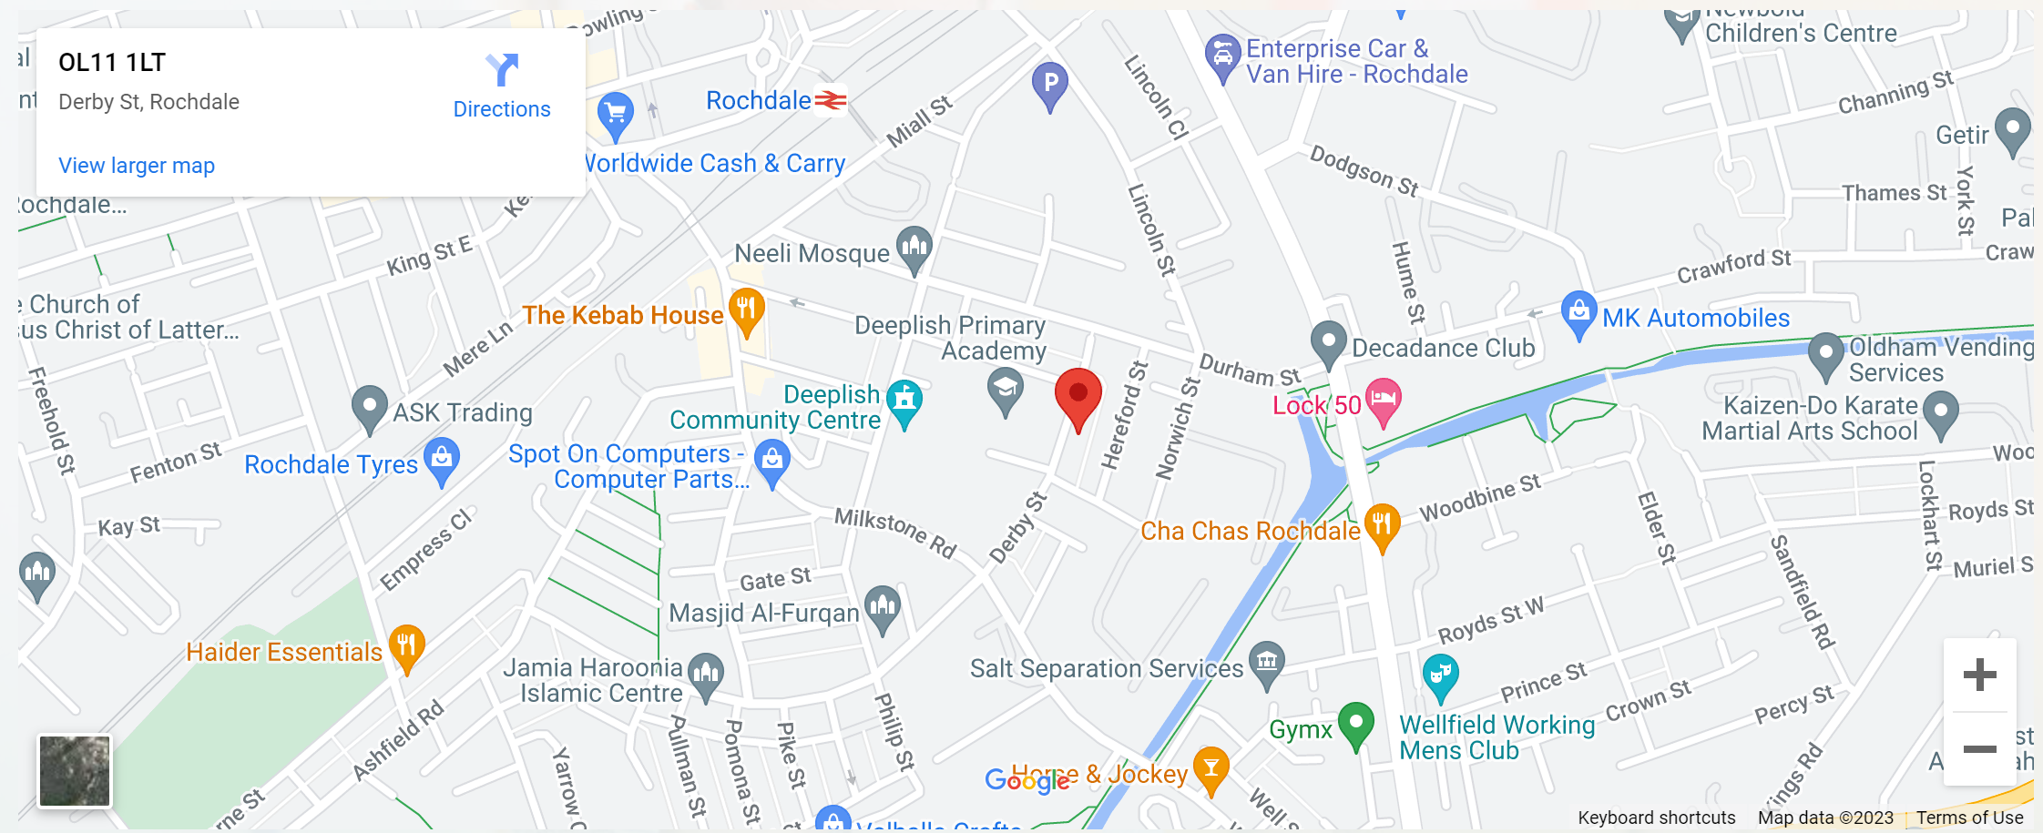

What you might want to know about Focus Trust

Who are we?
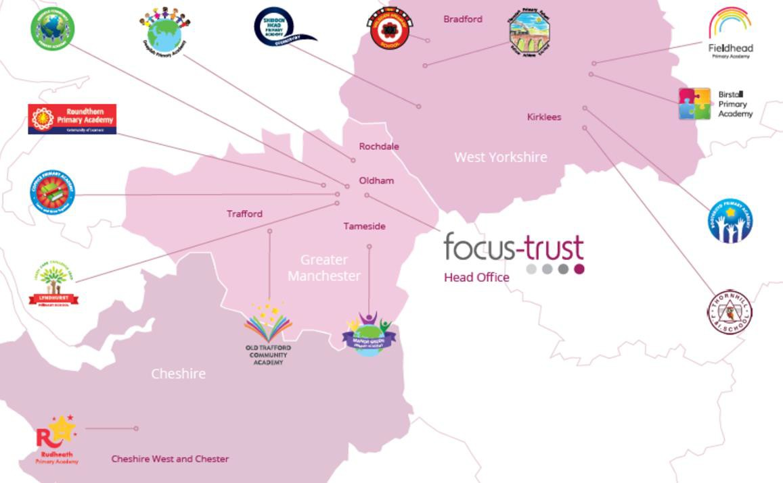
Focus-Trust was incorporated in May 2012 as a primary trust. The Trust has links with the sponsor, Focus Education, but is an entirely separate legal entity. As with all academy trusts, the Trust is a company limited by guarantee and an exempt charity. The Trust’s offices are situated in a newly converted historic mill conversion in Chadderton, Oldham with excellent motorway networks to access our schools.

The defining feature of Focus-Trust is that it is a specialist primary phase trust. This means that the work of the Trust is driven by the distinctive needs of primary schools. Whilst the Trust has robust systems for accountability, each school has their own distinctive identity, ethos and culture, and this is a commitment to every school when they convert and join the Trust.
Focus-Trust currently has a small centrally employed team. The members of the team are highly skilled and committed to the vision, culture and values of the Trust.
All the schools within the Trust are willing partners who have actively chosen to join Focus-Trust and there is a very high degree of consensus, cooperation and commitment from within the group.
The Trust has robust policies and systems in place to govern and guide its work. These have been gradually implemented as the Trust has grown. The Trust has well-established productive relationships with trade unions and meets half termly with a group of national trade union representatives to discuss policy development. This has enabled us to introduce and change a range of policies in a streamlined and cooperative way.

Additional information.
Equality of opportunity
Focus-Trust is an equal opportunity employer, dedicated to a policy of non-discrimination in employment on any basis including age, gender, race, colour, nationality, ethnic origin, disability, gender, religion, age, marital status, sexual orientation and/or medical condition.

Safeguarding
Focus-Trust is committed to safeguarding and promoting the welfare of all children and young people. There is an explicit expectation that all employees share this commitment and adhere to all safeguarding policies and procedures. Applicants should be aware that the recruitment process will include an assessment of your suitability to work with children.

Right to work in the UK
Under the Asylum and Immigration Act 1996, it is a criminal offence to employ anyone who is not entitled to live or work in the United Kingdom. Applicants can expect us to ask for proof of this at interview stage, where you will be asked to provide some original documentation to confirm that you are eligible to work within the UK. Photographic proof of identity will also be required.

Validation of qualifications and identity
All shortlisted candidates will be asked to bring original certificates or relevant qualifications and identity documents to interview. These will be photocopied and kept on file and, if appropriate, may be confirmed as genuine with the relevant awarding bodies. The copies of the successful candidate will be retained on their personnel file. The copies of unsuccessful candidates will be treated as confidential waste and disposed of appropriately.

References and Social Media Checks
If you are shortlisted, we will take up references before the interview date, unless you state otherwise on your application form. However, two satisfactory references must be received before we can confirm any offer of an appointment One of your referees must be your current or most recent employer. The information we request will relate to salary, length of service, skills and abilities, suitability for the job, disciplinary record and suitability to work with children. Copies of references or open references will not be accepted. On receipt of references, your referees may be contacted to verify any discrepancies, anomalies or relevant issues as part of the recruitment verification process.
In line with our safer recruitment policy, on-line presence checks will be undertaken if you are shortlisted. This check is designed to complement the range of standard recruitment checks and allows us to identify a candidate’s online presence which potentially could damage the organisation’s reputation.

Disability
To comply with the Equality Act 2010, we are legally required to consider making reasonable adjustments to ensure that disabled people are not disadvantaged in the recruitment and selection process. We are therefore committed to meeting, wherever possible, any needs you specify on the application form. Please contact the named person on the advert, if you need to discuss this in any detail. We will consider any reasonable adjustment under the terms of the Act to enable an applicant with a disability (as defined under the Act) to meet the requirements of the post.

Disclosure of a criminal record
Employment in this role is subject to an enhanced check with the Disclosure and Barring Service (DBS). Checks will also be made against the lists showing people barred from working with children. All checks must be satisfactory before any offer of employment can be confirmed and before commencement of work can take place.

Dress code
We expect all staff to dress professionally and appropriately for the roles undertaken. We pride ourselves on the high standards of dress of both our pupils and staff; these standards are led by our staff who we expect to set an example.

Knowledge and skills profile
This is an important part of your application and is your opportunity to explain how you meet the person specification for the post. You should demonstrate, using no more than 2000 characters, your skills, knowledge and experience and give short examples. Describe how you match the requirement of the job; include experience gained from previous jobs, community or voluntary work. Ensure that the information you give is well organised, relevant and brief. You may find it helpful to use sub-headings in order to keep your statement well focused. If you do not submit this profile, you will not be considered for short listing.

Policies
Focus-Trust and the schools have a range of policies and handbooks that help to make clear our expectations and ways of working. These are always shared openly with staff and are accessible to everyone. There are several policies that prospective employees should be aware of when making an application. These can be found on the Trust website www.focus-trust.co.uk and school websites. All members of staff will be asked to sign a declaration as part of the induction process to acknowledge that they have read and understand the Code of Conduct and some of the key policies, e.g. Safeguarding and Child Protection, Health and Safety, Acceptable use of IT.

Pensions
Focus-Trust contributes to Teachers’ Pensions and Local Government pensions in the same way and with the same level of contribution as local authorities.

Employer Relations
Focus-Trust has a Trade Union agreement which recognises the teacher and support staff unions. This is further supported by an ongoing and productive relationship with key trade union officials.
Thank you for taking the time to read this information pack. We wish you every
success in any application you may make.

