

Robert Smyth Academy
Market Harborough

Teacher of Food & Nutrition
Applicant Information Pack



Dear Applicant,

Thank you for your interest in Robert Smyth Academy. I suspect that if you are anything like me, the first thing you may be interested to learn will be about our climate for learning and the expectations of students. It would be fair to suggest that we are an institution that has a commitment to structure, predictability, and routine. These are important foundations for a calm and purposeful learning environment that benefits all students and the staff who work alongside them. Our students are courteous, kind and have high aspirations for their futures. This would have been the school of my dreams when I was teaching a fuller timetable earlier in my career particularly with the ability to teach to A-Level and retain that connection with my degree (I still love the opportunity of teaching, and this remains a privilege).
Students and staff feel safe and sense a belonging in our school. This is reflected in excellent behaviour, oversubscription in all year groups, above national average attendance and excellent exam results. We prioritise staff wellness through regular forums, consultations and by promoting a culture of mutual respect for all.
We also offer students a formidable package of enrichment opportunities and the magic of this offer is that we are not just the sporty, artistic, creative, musical or academic school but we are a truly comprehensive provider, and we have strength and high-quality provision in each and every one of those specialist areas. It is little wonder that we have seen a significant increase in admissions as we become the provider of choice in Market Harborough.
We have an excellent track record of supporting teachers. If you ask experienced colleagues or more recently qualified teachers, you will find that this is a welcoming, supportive, and warm environment. Members of staff work hard together toward a common aim of giving our students an excellent experience and they do this through mutual support. Senior leaders are visible around the site at all stages of the day to support teachers, associate staff members and students whenever we can. Much of the time that our leadership team invests in being present comes back to proactive, positive supervision so that students benefit from structure and enjoy their learning. We are all part of the same team, and this is truly a place of work where the right team player will thrive and develop very quickly.
Every day my experience of working with students, staff and parents reinforces my conviction that this is a very special place to work. My aspirations for students are limitless and this is an exciting time to join us.
I don't expect perfection, but I do expect you to be passionate about your subject, our students and your own professional development. I am always happy to speak to prospective teachers and if you would like to find out more then please let me know and I will give you a call.


Yours faithfully

Dan Cleary
Principal

Teacher of Food & Nutrition

Closing Date: Please refer to My New Term
Start date: | 24 August 2026 | Contract type: | Full Time
Salary: | M1 | Contract term: | Permanent
Suitable for ECTs: | Yes

Our staff are our most valued asset. The Academy has access to a wealth of support provided by outstanding practitioners, giving opportunities for staff to flourish and develop.

The Role
An outstanding Teacher of Food & Nutrition is required to join a committed and hard-working department.

Additionally, you will benefit from:
- Working in a subject area with improving outcomes
- Teaching in a forward thinking department with excellent resources and facilities for teachers who love their subject
- The opportunity to develop and deliver examination courses to GCSE level
The Academy
The Robert Smyth Academy developed from Market Harborough’s oldest school and was founded in 1607. It is now a vibrant, fast growing 11 – 19 Academy with nearly over 1300 students and well over 300 students in the sixth form. The area around Market Harborough, which is an attractive and a growing market town, is increasing in its diversity and offering significant potential for the Academy to grow.

In 2022 the Academy’s Key Stage 4 and 5 results were excellent and underpin the progress that has been made. Ofsted inspected the school in November 2022 and found it to be ‘Good’ in all areas. The inspection report is worth reading as it represents a snapshot of a happy, cohesive school with fantastic behaviour and hardworking students

If you join us, you will benefit from:
- Teaching pupils who are well behaved and courteous
- Teaching pupils who are motivated as the school enjoys strong parental support
- Working in a Trust with structured professional development opportunities
- A real chance to develop in a forward thinking, highly successful academy
- Developing yourself in our ‘can do’ culture and positive ‘want to’ climate

Staff Wellbeing

We actively place staff wellbeing at the centre of everything we do. Our staff are our single biggest asset, and the success of our students depends on them. So we take care of and invest in them properly.

A few of the things we offer are:
- A supportive, open and approachable management team who are visible leaders
- A comprehensive CPD programme for all staff whether ECTs or aspiring leaders
- Friendly colleagues who are always happy to help each other
We really value our staff and will do whatever we can to meaningfully demonstrate that

Staff Incentives
Free tea, coffee, fruit and biscuits
Staff wellbeing forums
Weekly Yoga classes
Many social events (pot luck parties, nights out, annual car rally…)
Employee Assist Programme
Weekly running group
On-site parking for staff
The Academy participates in the childcare voucher scheme
Informal visits and conversations about the post are most welcome

The recruitment process is robust in seeking to establish the commitment of candidates to support the school’s measures to safeguard children and to identify, deter or reject people who might pose a risk of harm to children or are otherwise unsuited to work with them. The successful applicant will be required to undertake an Enhanced DBS check. All applications will be considered on their merit and the post will be offered subject to the usual health, criminal record and reference clearance. We are committed to safeguarding and promoting.
FOOD & NUTRITION AT THE ROBERT SMYTH ACADEMY
The Faculty
Our pupils love both the theory and practical elements of the Food and Nutrition curriculum. This is something that is a real highlight of their curriculum time and they are keen to learn. The Faculty is housed in a large, well-lit and well-resourced building. There are a range of subject specific classrooms along with specialist equipment and a computer suite.

The Faculty places emphasis on high quality teaching and learning, teamwork and encouraging participation in the continuing review of curriculum and assessment. We are a relatively new team with a vision for making the design, food and art related subjects of the highest standard. The teaching staff are supported by a team of experienced technicians.

In Year 7 and 8 we aim to instill a love of cooking that will help students develop their essential food preparation skills and facilitate some as they go on to choose the GCSE Food Preparation and Nutrition course. GCSE studies start in Year 10 and go through to Year 11. We follow the Eduqas GCSE course.

A variety of teaching strategies are used, taking into account individual and group targets. At GCSE the students develop their skills in a range of techniques and processes in all subject areas.

The Academy aims to emphasise the importance of the personal development of each student as an individual, and subject teachers are expected to play their part as form tutors in the broader life of the Academy.

The Academy has a commitment to professional development and the successful candidate can expect valuable experience, the support of experienced staff and a pleasant working atmosphere leading to considerable job satisfaction. We are a friendly team and we are looking forward to welcoming a new member to our faculty.

Current Developments
We are part of the Tudor Grange Academies Trust and this has led to exciting changes across the Academy and in terms of the wealth of support and expertise the Trust can offer to the faculty as part of collaborative working including shared resources.

Robert Smyth Academy are very positive about education and the opportunities that we are able to offer to all of our students. We have strong relationships with our feeder schools and have offered Primary KS2 days for the last few years.

General Information
The successful candidate will be expected to play a full and active part in developments in Food & Nutrition subject area and a readiness to become involved in the extra-curricular life of the school.

HOW TO APPLY
If you would like to join our outstanding team and apply for this post, please complete the application form on My New Term in full. Please note that incomplete applications may result in possible rejection from the shortlisting process.

Section 1: Work Eligibility
Please state QTS status.

Sections 2: Current/Most Recent Employment and Full Chronological History
Please ensure that this section is completed fully. If you have gaps in your employment please indicate the reasons for this. This may be explored further in an interview.

Section 3,4,5 and 6: Education, Training and Qualifications
Please complete this fully and ensure that you have proof available of your qualifications. If you are not in possession of this proof, please be aware that we will require your permission to contact the relevant awarding bodies prior to a firm offer of appointment, should you be successful.

Section 7: Supporting Personal Statement
Please include your letter of application and use this opportunity to show your suitability for this post as outlined in the job description and person specification and tell us why you want to join us at Tudor Grange.

Section 8: References
Please provide two referees and their details. A telephone number or email address often makes this process easier and would be much appreciated. The references MUST include your current or most recent employer and will ask about your suitability to work with children. Open references or testimonials will not be considered. Please be aware that we may approach previous employers to verify particular experience or qualifications.

Section 9: Personal Information
Please ensure that all details are completed including your date of birth. This is to ensure that appropriate identity checks can be made. Ensure your NI number, email address and contact numbers are also included. For Teaching staff please make sure you include your Teacher Reference Number (TRN) number.

Section 11: Declaration
Please be aware that by signing the declaration you are declaring that you are not on List 99, disqualified from work with children or subject to sanctions imposed by a regulatory body e.g. the General Teaching Council (GTC) and that you either have no convictions, cautions or bind-overs or that you have attached details of these in a sealed envelope. You are also aware that you will be subject to a DBS Disclosure appropriate to the level of the post should you be successful.

Please be aware that providing false information is an offence and could result in the application being rejected or summary dismissal if you are appointed on the strength of this, with possible referral to the police.

ABOUT ROBERT SMYTH ACADEMY

When Robert Smyth founded the original Market Harborough Grammar School in 1607 he would not have known that, over 400 years later, his school would become the Robert Smyth Academy, a thriving and successful school at the heart of the local community. Today, the spirit of Robert Smyth lives on through the ambition, excellence and opportunity which are central to our ethos. We have a reputation for academic success, extensive curricular and extra-curricular provision and the personalised support and care that we offer to our students. We are proud to serve the young people of Market Harborough and look forward to working with you as you join our Academy.

We are looking forward to working with all of our students during their secondary school experience and being able to follow, nurture and support them on their journey to adulthood. We have high expectations and set high standards. We will continue to inspire our students to reach their potential, achieve their goals and make a difference.

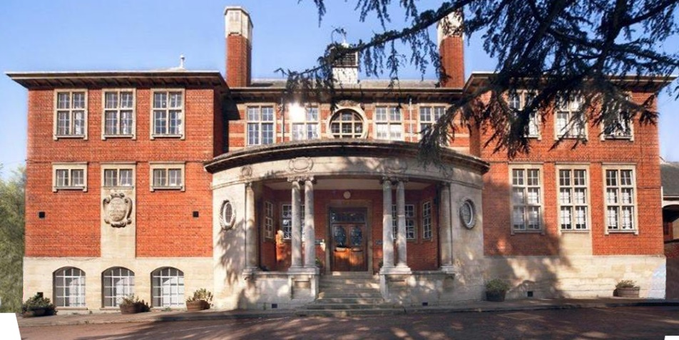

The Trust, as of September 2025, is a Trust of thirteen schools: five secondary, one all through academy and seven primary academies. Restlessness characterises all our academies: we are not afraid to challenge complacency and weaknesses identified are seen as opportunities to improve, the energy and drive for the ceaseless journey comes from our key ambition: ‘Every child deserves an outstanding education.’
This movement as a Trust offers a huge opportunity for up to date training, cross curricular working, bespoke professional development pathways and allows all staff to be at the cutting edge of national and international educational movement. All staff are encouraged to better themselves and we collectively celebrate success in a vibrant and healthy working community.

LEADERSHIP TEAM AND GOVERNORS
Principal
Mr D Cleary

Senior Leadership Team
Miss K Nicholson - Associate Principal
Mrs V McNair
Mr M Payne
Ms L Kirk
Miss D Paterson

Head of Sixth Form
Mr G Luhrs

Chair of Governors
Mrs Kay Goddard

OUR VISION

Students who attend Robert Smyth Academy will benefit from an outstanding education, which will enable them to live happy and fulfilling lives. We are committed to becoming a centre of excellence in the East Midlands and as we move to the next stage in this journey to outstanding, we are committed to the following principles:

- We put students at the centre of what we do

- We are a truly comprehensive school, inclusive in the fullest sense

- We are committed to providing an environment that is academically special. We will maintain a climate where students learn, and teachers enjoy teaching and developing their practice

- We expect all members of our community to enjoy and to be excited by learning

- We are committed to securing student outcomes that consistently exceed national comparison

- We aim to develop a sense of enquiry in all

- We listen to all stakeholders

- We will ensure that all stakeholders are proud of their relationship with the Academy

We believe in success in its most broad and complex form for all students and we are committed to:

- Empowering students with knowledge

- Enabling students to attain excellent qualifications

- Stimulating students to make excellent progress in all areas

- Encouraging students to develop a sense of social responsibility

- Supporting students to become economically literate

- Inspiring students to find their passion for learning

- Equipping students with the confidence to take their next steps

OUR VALUES
It is vitally important that all students understand three basic, daily expectations of their approach to Academy life. We believe that all students, irrespective of background require structure to achieve their best. These values apply in every facet of Academy life and they are as relevant to a new student in Year 12 as they are to a new student joining in Year 7. At the core of these three expectations is a belief that discipline equals freedom.

Respect
All students are expected to be immaculately dressed, on time and ready to learn every day. These routines apply like clockwork and allow students to make the most from the curriculum by being in a state of preparation. Every student is expected to demonstrate this mindset so that no time is wasted and they are able to learn and make exceptional progress across the curriculum. The expectation for students to be punctual, organised and well-presented is a consistent feature of Academy life and there are no exceptions.
All students are expected to be kind and show compassion toward one another. We embrace traditional values and expect students to say “Please” and “Thank you” as well as to hold doors for one another around the Academy site. We encourage students to express gratitude to their peers and other members of the community and to pick each other up when they face times of difficulty. We explicitly reinforce the importance of kindness and ensure that students know that how they treat others really matters.
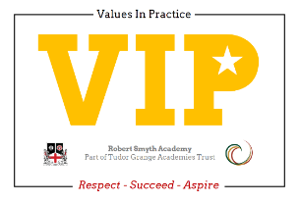

Succeed
All students are expected to work hard. We encourage students to take responsibility for their performance and reject excuses or quick fixes. We believe that all students will exceed expectations through a commitment to discipline in their concentration, thought and work. We know that learning is a change to long term memory and that for learning to take place there must be focus, repetition, checking and retrieval. We expect all students to demonstrate a strong work ethic that will enable them to be empowered with significant advantages in knowledge acquisition.

Aspire
All students benefit from a sense of purpose and will be encouraged to identify the ways in which they wish to progress. Staff will strive to understand individual goals and aspirations so they can help students to build confidence and resilience in order to maximise achievement.


OUR FACILITIES
Robert Smyth Academy was opened in 1607 as a single classroom school in the centre of the town. It then moved up to its current site in 1909. It occupies a site just outside the centre of the market town. The Academy is made up of a variety of buildings including specialist buildings for Sport, Music, Art & Design and a newly built Communication, Interaction, Resource Base for children with autism.

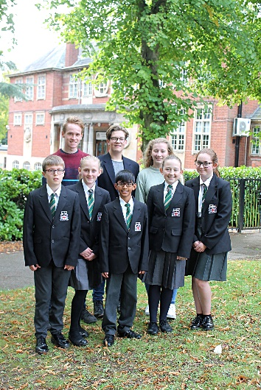
• Eight Science Laboratories
• Specialist building for Design & Technology and Art
• Specialist building for Music with rehearsal rooms
• Five ICT suites on the Windows platform
• Whole school network of over 200 PCs
• Media Studies suite
• Large Sports Centre with two Sports Halls and Changing Rooms
• Extensive sports fields surrounding the site including 3 new all-weather hockey pitches

• Two cafeteria style dining areas with additional Food Bar in playground
• Sixth Form Centre with 4 classrooms and study areas
• Sixth Form only Café with study area
• Sixth Form Quiet Study Area
- Sixth Form Wi-Fi
- October 2025 saw the opening of the new double-height extension consisting of 5 Science Laboratories and preparation room, 11 general purpose classrooms, an additional canteen and kitchen and additional student toilets.

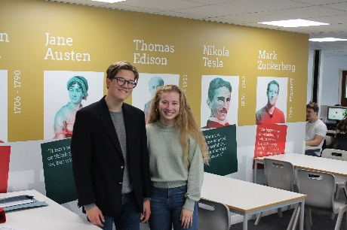
ACADEMIC ORGANISATION
At Robert Smyth we operate a two week timetable, with 25 60 minute lessons in each week. We have a split break and lunch system with Years 7 and 8 having an earlier lunch than the rest of the school.
There are no bells to signify when lessons begin and end which we feel makes for a more pleasant environment and helps prepare students for life after school which, in most cases, will not be controlled by bells.
The philosophy of Robert Smyth is that each student is entitled to a curriculum that prepares them for life’s opportunities, responsibilities and experiences. Statutory requirements of the national curriculum are supplemented by the Academy’s broader curricular provision.
At Key Stage Three, students follow a common curriculum. In Years 10 and 11 students are offered greater choice, enabling a more personalised curriculum that meets the needs of each individual learner.
Key Stage Three
All students in their first three years at the Academy study the core curriculum which includes English, mathematics, science, physical education, PSHE and religious studies. Their curriculum is enriched by studies in humanities, art, three design subjects, performing arts, digital literacy and a modern foreign language.
During Year 9, full consultation takes place between staff, students and parents to support curriculum choices at key stage four.
Key Stage Four
The Key Stage Four curriculum is designed to give students every opportunity to achieve their full potential and to maximise the choices available at Post-16.
All students in Years 10 and 11 study English language, English literature, mathematics, science, physical education and PSHE. Religious studies is taught as part of the PSHE programme.
Key Stage Five
The curriculum in the Sixth Form is designed to prepare students for both university and the world of work. Each Sixth Form student has their own specific goal and ambition and we ensure that each student has a personalised curriculum that meets their individual requirements. Students choose from a diverse range of subjects so that they are able to participate in challenging and enjoyable courses. Extra qualifications such as the Extended Project are also available.
We provide a variety of opportunities within the Academy, and are proud that our students have been able to succeed as Student Leaders, peer mentors, sports coaches, book buddies and much, much more.
PASTORAL ORGANISATION
KS3 and 4 Students are looked after in one of four Colleges; Bragg, Hammond, Logan and Moseley, each led by a College Leader and an Assistant College Leader
Assemblies are held weekly to reinforce key values and to celebrate achievement.

EXTRA CURRICULAR ACTIVITIES
As an Academy we feel strongly that the development of team and interpersonal skills is enhanced by the opportunities and experiences students have outside of the classroom. Hence, we provide a diverse breadth of activities that are part of a weekly timetable for students to opt into. These activities usually run after school and are delivered by willing and specialist staff who want to relay their knowledge and passion.
The list below shows just a small selection of the programme on offer:
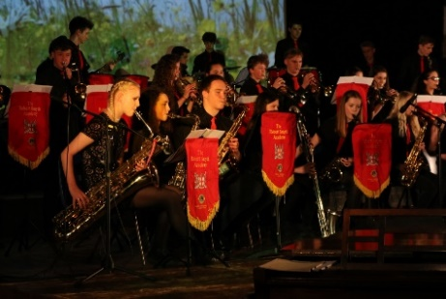
• Sports Teams including Football, Rugby, Netball, Hockey, Cricket, Basketball, and Trampolining
• Choirs, Orchestras and ensembles
• Drama
• Dance
• STEM Club

• Duke of Edinburgh
• Warhammer club


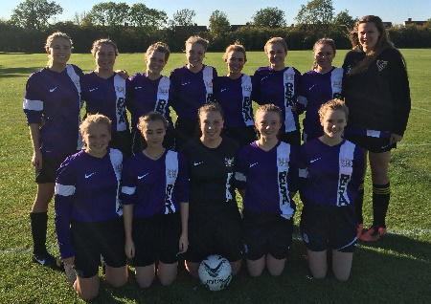

Our Students

“There’s a great range of sports and extracurricular activities that you can get involved in, either after school or at lunch.”

“Big shout-outs to the PE department especially and the variety of sports that are offered to students. Jewellery club and board game club also get a mention.”

“Teachers are helpful in lessons, and they are supportive of the students.”

“I feel safe in school and enjoy coming here.”

“The school setting is safe.”

“We are proud of how clean it is and feel the community in school is positive and I would recommend the school to others.”

“Teachers care about what happens here, and so do the students.”

“Staff go the extra mile by giving up their free time to go on trips with them, attending fixtures, putting on interventions after school and in the holidays for those doing GCSE’s. The teachers work hard to support learning e.g. staying late after school to get resources ready – this is really picked up by the students, I wonder if the teachers know how much we value those bits?”

Our Staff

“Working at RSA so far has been great. The level of support, feedback and professional development is excellent. In my department, with a well-structured Scheme of Work and great resources and an experienced mentor, my first year has been manageable and enjoyable too. Here, I feel valued, supported and nurtured. Any issues, talk to senior leads, the well-being team or other teachers and it is dealt with promptly and efficiently” Teacher of Languages

"Working at Robert Smyth Academy is a breath of fresh air. You can really feel the positivity as you walk round the school, with staff and students alike smiling and greeting you. There is a family-like mentality to staff, with cross-curricular support making you always feel welcome. As an ECT, I have been fantastically supported and always have someone to turn to for advice, either with planning, standardisation or behaviour strategies. It's a genuinely lovely place to work.' Teacher of English

“I enjoy working at Robert Smyth Academy as there is a real community feel which is made possible by the attitudes of the students and staff. Students are respectful and want to do well which makes the job very rewarding. The Academy has a great reputation in the local area and there is a sense of pride in working here.” Administrator

I joined RSA in the summer as an ECT and have been overwhelmed with the support I have received. Everyone is really friendly and I've been able to develop my teaching and style with the help and support of my department. Our students are so keen and willing to learn, they are the highlight of my day and really make my job feel worthwhile. Teacher of Geography

