 | 
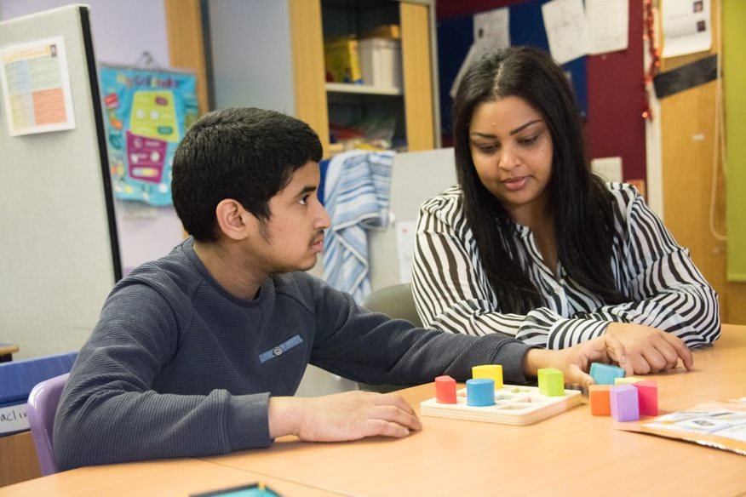 | 

Moorcroft School is a bridge between childhood and adulthood.
It creates a journey we proudly accompany our students on.

Welcome to Moorcroft School

We are a secondary school for students between 11 and 19 years old with severe learning disabilities (SLD), profound and multiple learning disabilities (PMLD) and autistic spectrum disorders (ASD). Some of the students may also have additional sensory or physical impairments or challenging behaviour.
At Moorcroft School we aim to provide the best possible education outcomes for our students.
All our students have a personalised learning programme to help them achieve their best. We use this to adapt our curriculum to meet their individual needs.
As staff, we are all committed to ensuring that our students become independent learners and grow up confident and able to take their place in society.

- Moorcroft is a Secondary School for pupils with severe learning difficulties and complex needs in the London Borough of Hillingdon
- We cater for pupils from 11-19, with SLD, including autism, PMLD and MSI
- All pupils have an EHCP plan.
- There are currently 147 pupils on roll. 30 pupils are educated at a satellite provision and sixteen pupils with complex needs are educated at Sunshine House Specialist setting. Pupils at Sunshine House will move to the new free school due to open in January 2026.
- There are 102 boys and 45 girls. 39 pupils are PMLD. Most pupils have Severe Learning Difficulties with a small number of pupils with more moderate needs. In addition, 32 pupils are diagnosed with an autistic spectrum disorder.
- 45 pupils are in receipt of pupil premium. 69 pupils are eligible for FSM.
- 77 pupils are EAL, although most pupils are at an early stage of language development.
- Apart from English the most widely spoken community languages are Somali, Panjabi and Tamil.
- There is a high staff to pupil ratio.
- Integrated physical and creative therapies for pupils, extensive therapy input including Occupational Therapy, Speech and Language Therapy, Physiotherapy, Drama, Music, and Dance Therapy.
- The NHS provides a school nurse.
- High quality specialist provision – hydrotherapy pool, Food Technology room, dedicated sixth form area.
- Specialist ASD classes.

Our Vision
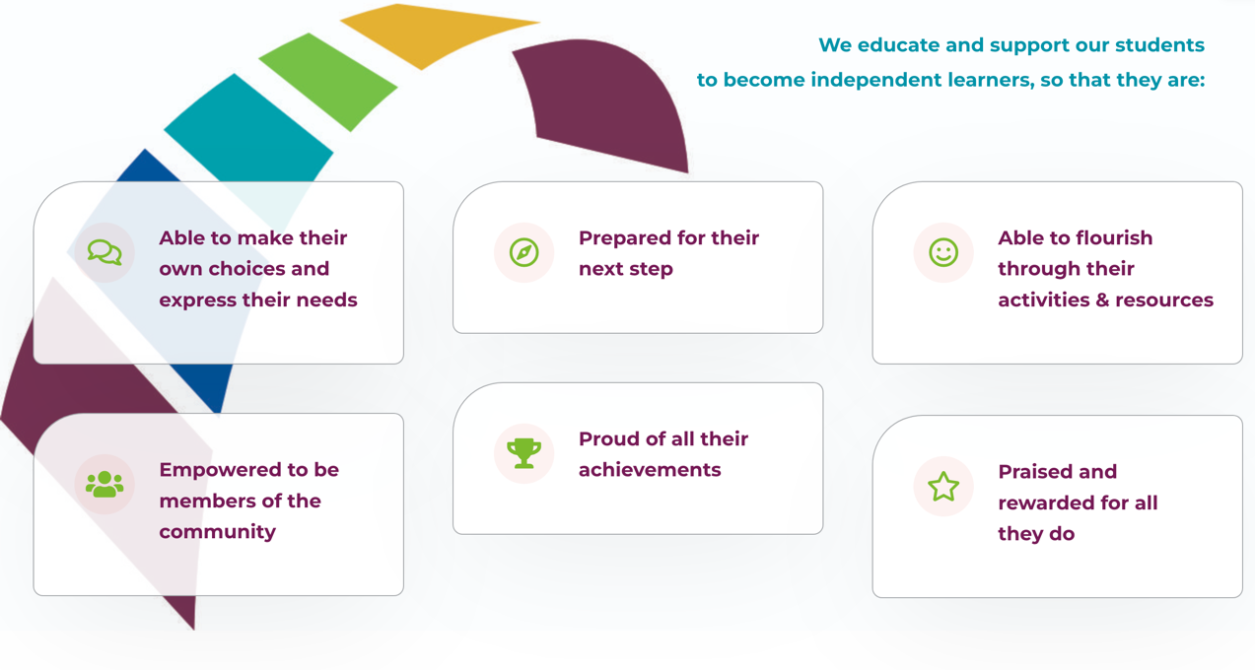

How we learn

At Moorcroft we have diverse ways of teaching students to help them to learn to the best of their ability. We adapt our pathways with specialist strategies, activities, and resources, and we can individualise timetables and organise classes in different ways to suit our individual students’ needs.
Our students are taught in small class groups with the average class size being 8.
Every class is staffed by a teacher and an average of three qualified and experienced teaching assistants.
This ratio makes sure each student receives a mix of whole class, small-group, and individual teaching.
ASD classes
We have specialist ASD classes. Students in these classes use the TEACCH approach to access learning as independently as possible. Each student has an individual learning station to reduce visual distractions. The day is highly structured, so students become familiar with their routine.
Students also receive intensive therapeutic support, as we believe that to achieve outstanding learning, the communication, physical, sensory and socio-emotional needs of our students must be met. Opportunities to address these needs are incorporated across the curriculum for all the students.
Professionals working with our ASD pupils include Speech and Language Therapists, Occupational Therapists, Creative Therapists and an educational psychologist.
Students who may have challenging behaviour work with familiar and experienced staff who are able to help them achieve their very best.

Multi-Sensory Learners
Students in our specialist provision benefit from a high staff-to-student ratio. We make it our priority to ensure that our students are in a stimulating, nurturing and safe environment, and all of their needs, including physical and medical needs are met, to enable them to access learning, achieve and thrive.
Staff members are experienced in working with students with PMLD. Students are monitored and receive input from therapists, such as physiotherapists, rebound therapists, speech and language therapists, creative therapists, occupational therapists and physiotherapists; we incorporate therapy programmes into all of the activities throughout the day.
Classrooms in this department are physically separate from other parts of the school to accommodate for the most vulnerable students and has a curtained area for visual stimulation as well as another adjacent room for individual work. We have direct access to a fenced patio area and an on-site hydrotherapy pool.

Our Progress

Our progress at Moorcroft School is summarised below with recent improvements in multiple areas.

- In January 2021, a satellite site to accommodate Key Stage 3 pupils.
- The school curriculum ensures that each learner follows a curriculum pathway tailored to their needs ensuring that they do exceptionally well.
- A new PSHEC curriculum means that the school can nurture pupils' personal development and welfare to great effect.
- Greater collaboration between teachers and therapists ensure that pupils communication, sensory and physical needs are met in the classroom through increased readiness to learn.
- Mentoring of new teachers, including NQTs has led to the standard of teaching and learning to remain high.
- We have a strong and dynamic leadership team and phase leads. ensure teachers are held to account for pupil performance across the school.
- Training in teaching of writing and phonics has led to an improvement in literacy skills for the most able pupils in the school.
- Ofsted confirmed in October 2024 that Moorcroft remains an outstanding provision.

