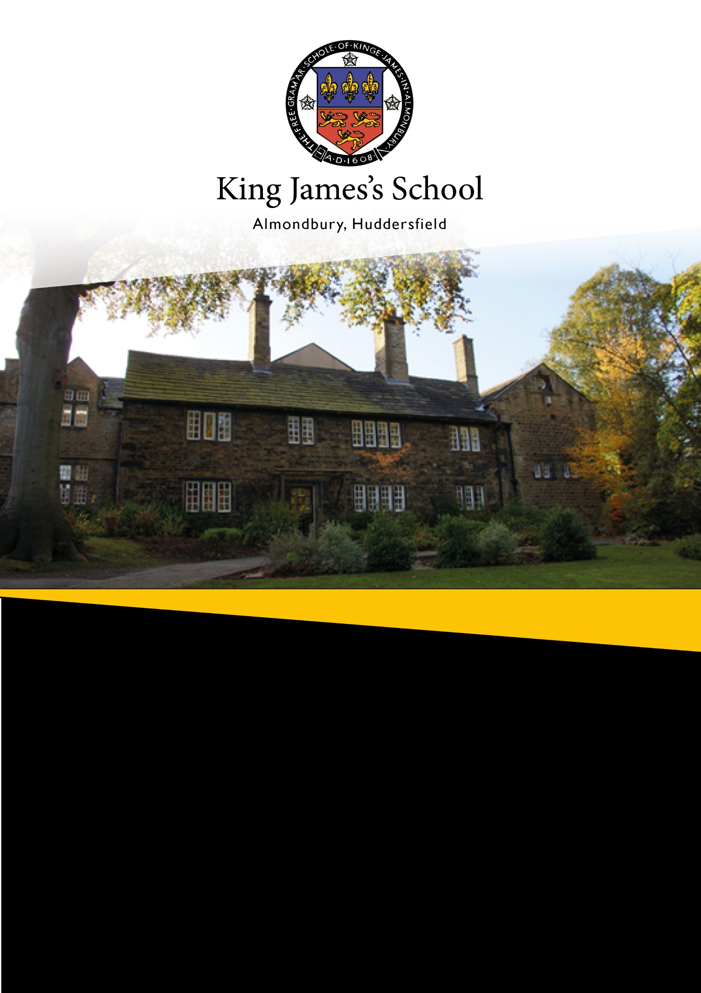

Assistant Principal
Applicant Information Pack

St Helen’s Gate
Almondbury, Huddersfield, HD4 6SG
01484 412990
Welcome to King James's School

Thank you for taking an interest in joining our school. King James's School is an extremely popular & successful 11-16 mixed comprehensive, serving south-eastern Huddersfield and surrounding villages.
The essence of our school is built around three Hs:
- our distinguished History;
- our Holistic provision, which develops students both academically and pastorally;
- our High expectations and aspirations.
Our ethos, summarised in the King James’s Way, demands the best from everyone through key values:
- Kindness and compassion
- Inclusion and tolerance
- Nurture and innovation
- Greatness and aspiration
We pride ourselves on being a superb staff team who are highly professional. We all have a passion for learning and are committed to inspire and support all our students to be successful and to develop into confident young adults ready for life after King James's School.
We are committed to safeguarding our students and this is evident in our recruitment processes. We ask all applicants to provide us with two references, which will be obtained prior to any interview. In addition to this, we will also carry out online searches for all shortlisted candidates as part of our due diligence. Any successful candidate will be required to undertake an enhanced Disclosure and Barring Service (DBS) check.

I really hope that once you have read through this information pack that you apply to lead our team. Please note the deadline an application is 08:00 on Tuesday 5 May 2026. If you have any queries please contact my PA, Tracey Brook, via email staff.tbrook@kingjames.school.

Comment from the Principal

Thank you for taking an interest in our amazing school. It has been my greatest pleasure to have been part of our incredible journey over recent years. Having joined the school as an Assistant Headteacher in 2004, I became Vice Principal in 2010 and then became the 28th Principal in 2015. I am therefore leaving King James’s after having spent 22 years in senior management, 11 of those as headteacher.

During this time, our school has undergone substantial transformation; we have had a significant period of success and remain a highly successful and popular school, with enviable traditions dating back more than 400 years.
It is therefore fair to say that King James’s is a unique school, and this is a unique opportunity.
Comment from the Principal Designate

I arrived at King James's School in 2023 as the Vice Principal in charge of Quality of Education, having completed many years in school leadership in London the move to Yorkshire was for family reasons.


I am honoured and excited to be taking over as Principal in September and I can honestly say King James’s is a special school and this is an exciting time to join us.

Special because we are a community, we are ambitious for the best outcomes but we are also invested in people and in the values of a holistic experience for our students. Exciting because after a very successful Ofsted visit in 2025, the school is very well placed to build on and push forward from very strong foundations.

The leadership team at King James's is very settled, but there is currently opportunity to strengthen and expand our team as well as reshape due to a retirement, we are excited by that opportunity.

This post is an ideal springboard for someone looking to make their mark in a supportive and collaborative school that is ambitious to progress.
Meet the Senior Team
Ian Rimmer –
Principal
Rebecca Walton –  Vice Principal - Pastoral and Safeguarding   |  | Ben Streets –  Vice Principal - Quality of Education
Stephen McNamara –  Senior Assistant Principal - Achievement   | Kirsty Roden –  Director of Finance and Operations   |  | Abbi Terry –  Assistant Principal - Personal Development  
Our Ethos and Values—The King James's Way

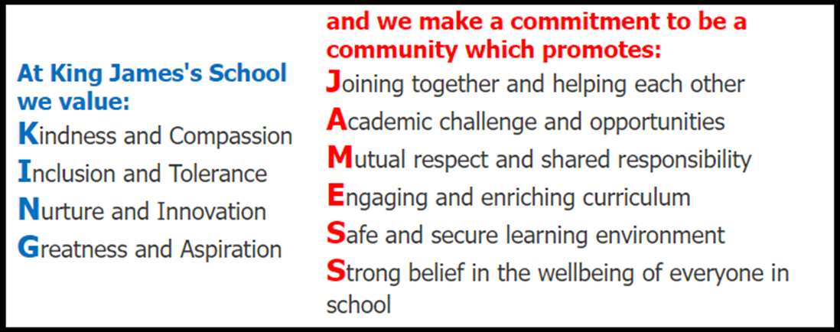

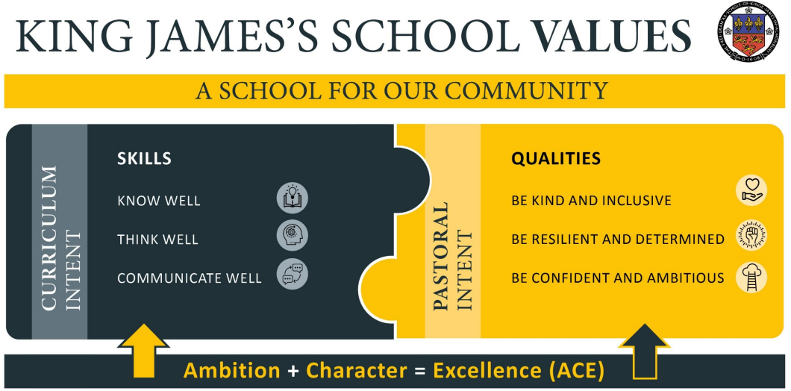

Our Culture - ACE

Recent times have provided significant challenges for students. The fallout from the pandemic stretches far beyond lost learning. The very fabric of what students are used to, and their confidence in the structures on which they routinely depend, has been severely shaken, leading to significant impact on emotional wellbeing. In order to address these emotional and learning deficits, we have devised our ACE strategy.

Ambition
By providing high-quality experience/opportunity for all, we aim to create an environment in which all students are encouraged to “think big” in order to raise the level of ambition and establish a schoolwide sense of “why not me?"

Character
Also, in setting clear standards/routines/behaviour norms expected of all students (and staff) around school during lessons/social times, we aim to make explicit “how we do things around here” in order to raise standards in a fair and supportive way.

This vision will be achieved through the delivery of our Ambition and Character curriculums.
Ambition – provide high-quality experience/opportunity for all:
- Create an environment in which all students are encouraged to ’think big’, establishing a schoolwide sense of ’why not me’
- Expose students to new experiences in a variety of contexts
- Provide students with opportunities which will enable them to become future leaders
- Encourage reflection upon options for life after King James’s and setting themselves aspirational goals which match their potential
Character – establish clear standards/routines/behaviour norms expected of all (staff and students) around school during lessons/social times:
- Reflect our core values and ethos, so all stakeholders are clear as to ‘how we do things around here.’
- Outline the offer we provide to each of our key stakeholders in order to deliver our expectations, routines and the King James’s Way.
- Set out the standards, routines, behaviour and character ‘norms’ we expect of all our staff and students inside and outside of the classroom.
- Set out the standards and routines we expect from the school community during social times i.e. break and lunches.
Our Community and Location

Our school is situated approximately 2 miles from the centre of Huddersfield, in a semi-rural position overlooking the Farnley Valley, serving a suburban area and a scatter of villages to the east and south of Huddersfield. We are in an excellent location within easy access to a number of places. This map shows all areas within a 45-minute commute of our school.

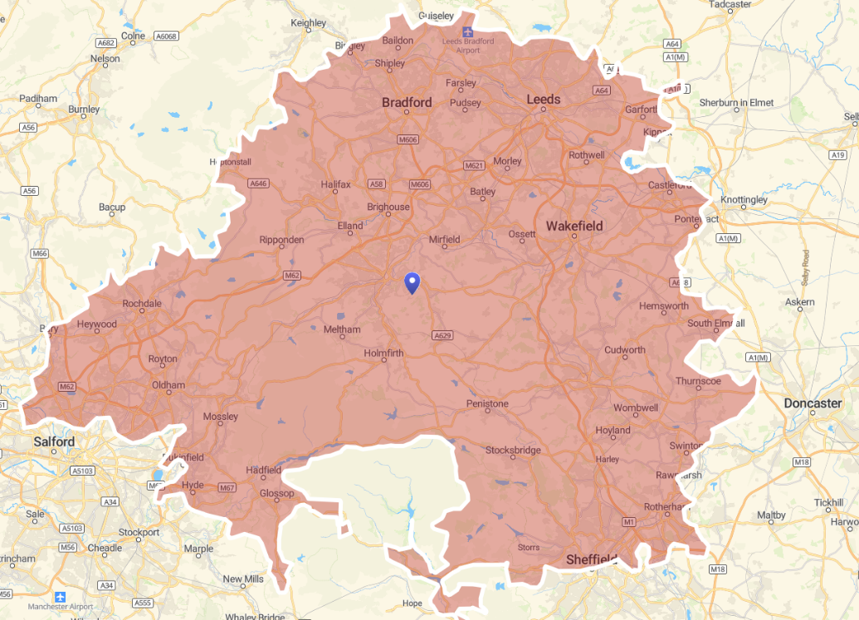

Our intake comes predominantly from the priority admission area of Almondbury, Grange Moor, Kirkheaton and Lepton.

We play an important role in our local community from year group charity efforts to promoting local initiatives.






Our School in Numbers

Type of School | Converter Academy
Age Range | 11 - 16
Number of Students | 1065
Number of Staff | 113
Percentage of students eligible for Pupil Premium | 30%
Percentage of students who are children looked after | 1%
Percentage of students who require SEND Support | 15%
Percentage of students who have an EHCP | 2%
Percentage of students with English as an Additional Language | 7%
Last Ofsted report | February 2025 ‘Good’



Why Choose King James's School?

There are many benefits to working at our school including:
Pay
- Terms and conditions of employment and salaries at least match national pay and conditions within the education sector.
- Our approach to sick pay and maternity/paternity leave meet or exceed national standards.
- Auto-enrolment into a generous pension scheme – helping you plan for the future
Flexible working
- Term-time only, part-time and other flexible working patterns are available for a significant proportion of roles.
PPA
- A minimum of 12½ % PPA for teaching staff - giving you more time for planning and marking
Refreshments
- Complementary refreshments for those attending evening events
- Breaktime refreshments on INSET days
- Access to a canteen
Wellbeing
- Up to 3 days paid compassionate leave
Health
- Onsite counselling service – free and confidential
- Free flu vaccines – helping you to try and stay well
- Free eye tests and contribution to your glasses (if this is appropriate)
Finance
- Access to discount sites through vivup – making your money go further
- Parking
- Free onsite parking, with some car charging ports

What do our staff say about working at KJS?
CPD is available on a wide range of topics to undertake as and when needed
A lovely environment to work in
The staff are amazing
It is a superb school with so many positive things going for it

King James's School – A Great Place to Work

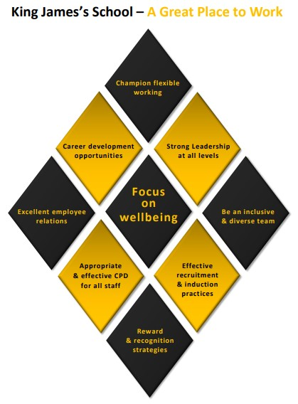

What You Can Expect from KJS
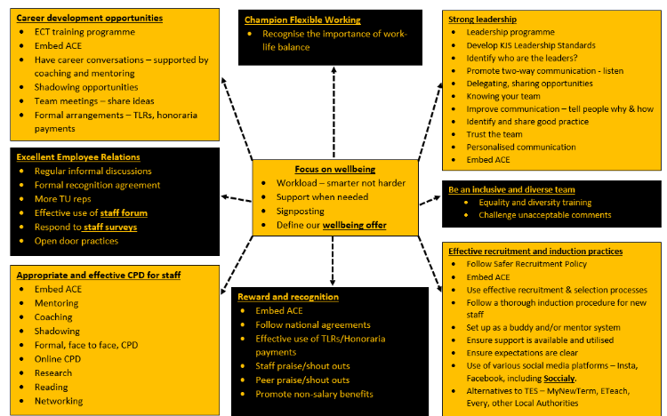

Our Team

Our staff really make our school a special place to work and learn. We value the contribution of each and every individual in school who help us to provide our students with a safe and stimulating learning environment.


We currently have approximately 113 members of staff. We also regularly have student teachers in school, training with our partner organisations such as C&K SCITT and Manchester Nexus SCITT; all of these people play an important role in our success.

We are split into 8 faculties; Business and Computing, Design and Technology, English, Humanities, Maths, Modern Foreign Languages, Performance and Science. We work hard to share best practice within our teams and to provide opportunities for staff to grow and develop whatever their role or career aspirations.

Our Curriculum and Pastoral System

We have a three-year KS3 which provides a broad and balanced curriculum for all our students. All students take courses in English, Mathematics, Science, Art, Design Technology (including Food and Textile Technology), French, Spanish, History, Geography, Religious Education, Music, Drama, Physical Education, Integrated Studies (personal, social and citizenship education) and Computing.

Students at KS4 will typically be entered for up to 9 GCSEs depending on their 'pathway'.

All students follow GCSE courses in English Language, English Literature, Mathematics and Science. The Science course is worth 2 GCSEs.

Students who have demonstrated flair and aptitude in Science also have the opportunity to take Science as an option, allowing them to gain individual GCSE qualifications in Physics, Chemistry and Biology.

Students choose further subjects from a range of other GCSE or vocational courses. Some students may require a more personalised learning and may follow fewer subjects dependant on their personalised needs. The full set of courses currently offered this academic year at KS4 are:

- Art (Fine Art, Textiles, Graphics)
- Business Studies
- Computer Science
- Food Nutrition
- Geography
- History
- Health and Social Care
- Creative iMedia
- Modern Foreign Languages (French, Spanish)
- Music
- PE
- Performing Arts (Drama)
- Science (Triple)
- Statistics

In addition to the above examination courses, all students follow non-examinable courses in Physical Education, Personal and Social Education, Careers and Religious Education.

As a school we offer a wide variety of extra-curricular activities and some of these are designed to support our students in their studies.

At King James’s School we provide a strong network of pastoral care with the core purpose of ensuring that students feel happy, safe and able to achieve. The fostering of respectful relationships between students, their peers and staff allows everyone to feel a sense of pride in their school community and how it develops.

Student support begins with the form tutors who provide the all-important daily contact with the students. They monitor attendance, punctuality and behaviour and generally ensure students are happy and progressing. They are the first point of contact for parents.

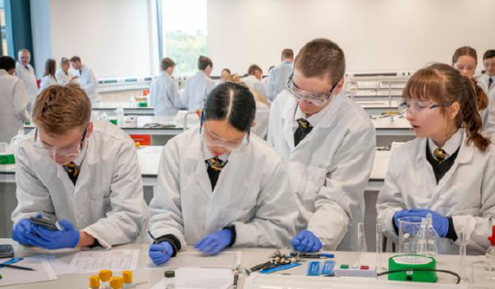

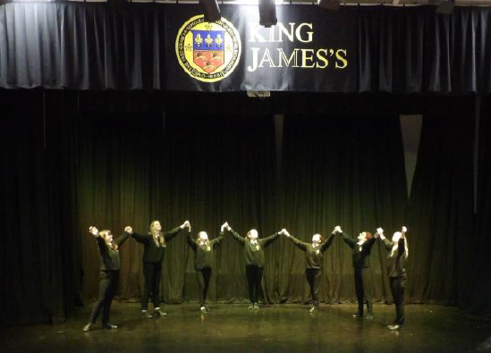

Job Advert
The role
We are looking to appoint a senior leader to deliver on an area of the school development plan, which will be chosen in consultation with the Principal and Vice Principal from the list below:
- Curriculum and Teaching
- Inclusion
- Achievement
We are committed to appointing the best leader and any area above can work within our strong, effective and growing senior leadership team. This post will involve leading a team of staff and whole school responsibilities.

Us
At King James’s School, we are ambitious for the very best outcomes for every one of our students, and we believe that education is more than just examinations and lessons. Our school focuses on providing a holistic experience that inspires curiosity, builds confidence and character in our young people and prepares them for their future by giving them strong foundations and happy memories.

We are a community-focused school built on respect, inclusion and the belief in valuing and developing people. We had a highly successful Ofsted in 2025 that highlighted we are a very good school that should now strive to be a great school, that is our ambition in all senses. This is an opportunity to be a key part of our special school and our journey.

You
We are more interested in your leadership qualities and your professional character than in specific experiences or knowledge. You need to be a leader who understands how to set a strategic vision, how to inspire others at all levels to develop and implement that vision, how to see change and development through to completion and impact. You will be able to demonstrate a track record of impact in your leadership journey to this point. This post will suit someone who is professionally ambitious.

You will be a team player, who believes in leadership setting the example, you will be professionally reflective, collaborative and enjoy challenge. A hands-on leader who is solution focused and wants to be involved in the life of our community is important; a good sense of humour is also something we value. Finally, someone who believes in the potential of people, whether staff or student and wants to be a key part of shaping that culture in our school community.

Safeguarding
We are committed to safeguarding and promoting the welfare and safety of children and young people and expect all staff to share this commitment. We ask all applicants to provide us with two references, which will be obtained prior to any interview. We will also carry out online searches for all candidates who are shortlisted for interview as part of our due diligence. Any successful candidate will be required to undertake an enhanced Disclosure and Barring Service
(DBS) check. This post involves direct contact with children and is considered to be a regulated activity. This role is exempt for the Rehabilitation of Offenders Act 1974, so most criminal convictions must be disclosed to us.

Job Description
Purpose of Post
- To undertake the professional responsibilities for teachers and assistant heads as outlined in the School Teachers’ Pay and Conditions Document
- To work and contribute as a key part of the Senior Leadership Group to drive and evaluate school improvement.
- To set a clear vision and ensure strong whole school implementation and impact in one area of the HMI framework.
- To Lead and Line Manage others, offering constructive challenge and developing the practice of others in a positive leadership manner.
- To lead on the development, implementation and evaluation of strategies, policies and practices to ensure an inclusive curriculum is in place across the school
- To ensure own teaching practice models the best standards and reflects the school QOE framework.

Key Areas
- Leadership and Management
- Staffing
- Students
- Safeguarding
- Administration
- Resources and Budget
- Premises
- Governing Body, Parents and Community
- General

Duties and responsibilities
Leadership and Management
- Be a visible, approachable and consistent presence in school to support and inspire staff and students
- Promote collaborative working, both internally and externally, to help achieve the highest possible outcomes for students
- Lead effectively to achieve the highest possible outcomes for students
- Support staff members to manage their workload and manage own workload effectively.
- Oversee a faculty area, providing support, challenge and guidance as needed
- Provide clear vision and leadership that supports the well-being of staff and students
- Provide regular strategic and operational updates to relevant stakeholders including the Principal, governors, staff, students, parents/carers and outside agencies
- To promote and embed the ethos and values of the school
- To contribute fully to the agenda of all meetings attended.

Staffing
- To foster good working relationships with staff including offering leadership, guidance and support especially in relation to behaviour management, inclusion and pastoral issues
- To support with the recruitment of staff
- To lead by example and address any behaviour observed that does not reflect school standards.
- To be positive about school development to all members of the school staffing structure.

Students
- Set the highest possible standards of classroom practice and management as an exemplar to other colleagues
- Work as part of the SLG team to develop, implement and monitor relevant strategies, policies and practices to secure the highest possible outcomes for students
- Promote a restorative approach to behaviour across the school.
- Take SLG detentions and complete On Call as part of the SLG rota.

Whole School area to be added once appointment made + HMI area agreed with successful candidate.

Safeguarding
- As part of your wider duties and responsibilities you are required to promote and actively support the school’s responsibilities towards safeguarding. Safeguarding is about keeping people safe and protecting people from harm, neglect, abuse and injury. It is about creating safe places, being vigilant and doing something about any concerns you might have. It isn’t just about the very old and the very young, it is about everyone who may be vulnerable

Administration
- Manage a varied workload
- Ensure school data entries are completed on time.
- Ensure own workload is managed so deadlines are met, communicate any issues promptly with Line Manager if any task is problematic in any aspect.

Resources and Budget
- To manage any budget given responsibly, ensuring spending has a clear rationale and plan for measurable impact.

The Site and Premises
- To be aware of, and assist, in implementing the Health and Safety policy of the school, and to advise the Principal of any known concerns regarding security

The Governing Body, Parents and the Community
- To attend, and contribute to, Governor Meetings and committee meetings as required
- To represent the school on behalf of the Principal
- To ensure promotion of positive, effective relationships between the school and parents, Governors and the local community

General
- Undertake duties in school as required.
- Promote equality and diversity within school
- Participate in any appropriate training and development
- Carry out other reasonable tasks when required
- Be a reflective leader who welcomes and accepts challenge and development as a professional expectation.
- Work in a manner that reflects the Nolan principles and set that example as a senior leader.

RESPONSIBLE TO: TBC Principal or Vice Principal.

Person Specification
Requirement | Essential | Desirable
Qualifications
A good honours degree
Qualified Teacher Status
National Professional Qualification
Post graduate study
Experience
Proven record of outstanding practice as a classroom teacher in a secondary setting
Successful record of supporting students to secure the highest possible outcomes
Evidence of supporting students with a variety of additional needs including SEND to secure the highest possible outcomes
Proven success in developing, implementing and evaluating strategies to support whole school improvement
Building strong relationships with key stakeholders including staff, students, governors, parents/carers and external agencies
Managing a team
Managing budget responsibility
Teaching in a challenging setting
Teaching in a high performing school
Leading change to support school improvement
Evidence of impact as a Middle Leader in secondary setting

Requirement | Essential | Desirable
Skills and knowledge
Excellent subject, curriculum, pedagogical and assessment knowledge
Excellent behaviour management knowledge

Understanding of, and commitment to, safeguarding

Excellent communication skills, including ability to communicate difficult information to a variety of stakeholders
Ability to devise and implement creative solutions to complex problems
Comprehensive understanding of the performance measures for schools and in OFSTED education inspection framework
Personal attributes
Committed to the Nolan Principles

Motivated, enthusiastic and reliable

Ability to give, and respond to, feedback from stakeholders

Strong attention to detail

Clarity of vision

Commitment to the full life of the school

Resilience – ability to work effectively under pressure and manage a varied workload
Approachable character and ability to get on with others

Ability to make difficult decisions

Responsive to change and fully open to professional challenge

Strong commitment to continued professional development and self-evaluation

