What Our Staff Say

What Our People Say

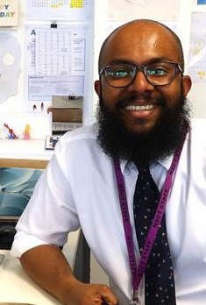
Troy

“I’m an Art Teacher and Deputy Head of Year 10 at Heron Hall Academy. My journey started at Cuckoo Hall Academy, where I worked as a Teaching Assistant, primarily with KS3 students. I supported higher-ability students with SATs and assisted SEN students with reading, writing, and creativity through art clubs. Outside of work, I pursued my passion for art, freelancing for private clients.

Transitioning to Heron Hall Academy, I took on a mixed role supporting both the SEN and Art Departments. Later, I assumed the role of an unqualified teacher, aiding Year 11 students with their Art GCSE alongside another art teacher. In 2018–2019, I pursued my PGCE at the University of Warwick, specializing in Art and Design. While training nationwide, I continued teaching at Heron Hall Academy, applying newfound pedagogy with the support of my mentors. Since obtaining my QTS, I’ve continued teaching art at Heron Hall Academy, taking on pastoral responsibilities and improving the art curriculum. In 2023, I became the Deputy Head of Year 10, working closely with the Head of Year. Additionally, I began teaching A-level art in the newly opened Sixth Form, attending targeted CPD sessions to enhance my KS5 teaching skills.”

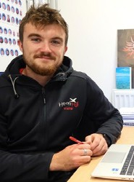
Aidan

“I joined Heron Hall Academy in September 2018, straight after completing my A’ Levels in Physical Education (PE), Biology, and Art at an Enfield secondary school. Despite not enjoying school much, I persevered and passed all three A’ Levels. This experience fuels my passion for working in education, as I want to provide a positive experience for students and show them the benefits of hard work.

When a vacancy for an Apprentice Teaching Assistant at Heron Hall was advertised, I jumped at the opportunity and started in September 2018. North Star Community Trust has continuously supported my development. After completing my first apprenticeship in 2019, I became a PE Technician for two years. In 2021, I began a Degree Apprenticeship, which I will complete in the summer of 2024.

What I love most about working in education is the variety and the motivation I get from seeing students’ progress. The Trust, SLT, and my colleagues have been incredibly supportive throughout my training. I have now moved into an unqualified PE Teacher role, where I teach my own classes and plan and deliver the curriculum to secondary students. Once I complete my degree, I aim to obtain QTS and become a Qualified PE Teacher at Heron Hall Academy.”
le Sa

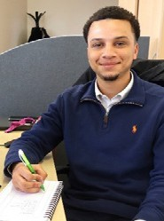
Xavier
“My name is Xavier Cumberbatch, and I currently hold the position of Business Operations Officer at North Star Community Trust. Beginning as a Social Media and Marketing Assistant in 2019, my journey within the Trust has been dynamic. I’ve had the opportunity to explore various business roles, including a 12-month placement in our HR department, customer-facing roles in two of our school offices, collaboration with senior management in strategic planning teams, and involvement in health and safety compliance within the estates and facilities department. The degree apprenticeship has been a pivotal steppingstone, providing me with invaluable skills and insights essential for my professional growth. I am deeply appreciative of the Trust’s unwavering support, which has been instrumental in propelling my career forward.

Contributing to the Trust’s mission goes beyond mere employment; it’s a source of pride. Knowing that my contributions contribute to creating optimal learning environments for schools and students fills me with immense satisfaction.”

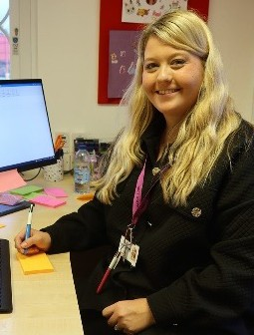
Amy
“I am currently a Deputy Headteacher at Woodpecker Hall Academy. I first joined the trust as a trainee teacher, straight after finishing my degree. I embarked on my PGCE course with Buckingham University as part of the Graduate Teacher Programme, meaning that I trained alongside my class-based role.
I have always enjoyed having a challenge, so I always looked for the next opportunity to progress in my career. Fortunately, there has always been an opportunity for me within the Trust, so I became a subject leader for various subjects, as well as a Year Group Leader.
In 2017, I applied for my first Senior Leadership position and became an Assistant Headteacher, before progressing to my current role as Deputy Head in 2023. Throughout this time, I have been given opportunities for further professional development, including studying for a master’s with Warwick and an NPQSL with the IOE. I thoroughly enjoy working here and giving back to our local community.

