Bentley West Primary School
Part of Leigh Trust

Job Advert: Grade 3 – Family Support Worker (FSW)
Position: Family Support Worker (FSW)
Hours: Full-time 32.5 hours per week, Term Time including the expectation to work up to 2 weeks in the holidays and be paid overtime - to be negotiated
Contract: Permanent.
Start Date: As soon as possible.
Salary: Grade 3 (Scale Point 9-22), £27,254-£33,699 FTW (full time equivalent), salary will be worked out pro-rata, term time only and according to experience
Location: Bentley West Primary School, Monmouth Road, Bentley, Walsall WS2 0EQ.

The Role
Bentley West Primary School (Part of Leigh Trust) is a vibrant and inclusive school continually striving for excellence and committed to ensuring the well-being and academic success of every child. It is an exciting time for Bentley West, as we embark on a new ambitious framework of support for children and their families, ensuring a greater sense of belonging, improved attainment and resilience.
We are seeking a dedicated and relational individual for the role of Family Support Worker at our school to support our families.
Job Purpose
To work under the guidance of the Pastoral Lead, Hub Lead family support officer and Trust Director for Wellbeing & Family Services and, to implement agreed work programmes with individuals/groups/families. The Family Support Worker will be predominantly education / school based, but will have a wider remit including working with families and the local community through the use of the Early Help Assessment (EHA) and Leigh Flourish Framework (see attached).

The (FSW) will develop relationships and strategies for engaging parents within the communities the school serves. Communicating and promoting school programs and in school sessions, including engaging in the delivery of sessions as per The Leigh Flourish framework.
The FSW will work with a range of vulnerable pupils and their families, but give priority to those who need the most help, especially those experiencing multiple disadvantages including:
- Looked After Children
- Children who have social care involvement - CIN, CP or who are receiving Early Help Services (EHA)
- Children with emotional, medical or special needs
- Children with a statement of special educational needs (Education, Health Care Plan)

Summary of Main Duties and Responsibilities (For more detail please see the job description and person specification)
- Collaborate with outside agencies and the Leadership Team to maintain the highest levels of pupil behaviour and wellbeing for vulnerable pupils.
- Initiate contact with parents and carers for safeguarding, behaviour, health/medical, and wellbeing concerns.
- Coordinate multi-agency working to support pupils at risk of falling behind.
- Maintain effective record-keeping using CPOMS.
- Undertake home visits and welfare checks with identified families.
- Deliver intervention programs within school to support children and families.
- Comply with policies and procedures relating to child protection, health, safety and security.
- Develop communication between school and family for pupils who are at risk of falling behind.
- To complete ‘Keep in touch calls’ with children and families during school holiday periods and organise targeted support where required.
- To be available to support children and families during the school holidays on a rota basis.

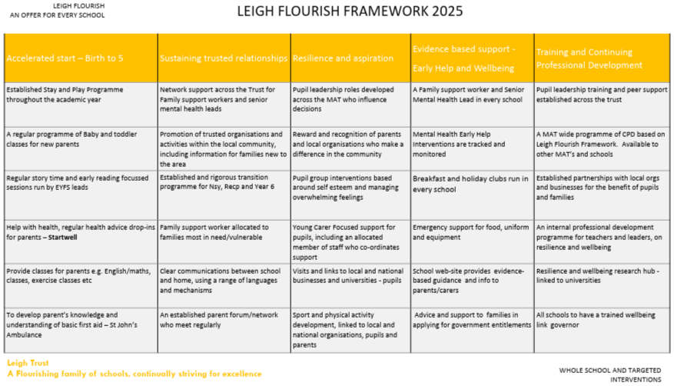
Qualifications
Essential
- NVQ Level 3 or equivalent in a relevant area
- GCSE in English and Math’s at Grade C or equivalent
Desirable
- Additional qualifications as evidence of supporting children and / or their families with additional needs

Join Our Team at Bentley West
If you are a dedicated and compassionate individual with a drive to support vulnerable children and families, we want to hear from you. This role offers a unique opportunity to make a positive impact within our school community and beyond.

To apply: Please apply through ‘My New Term’, only applications submitted on the support staff application form on ‘My New Term’ will be considered.

Closing Date: Midnight Sunday 17th May 2026
Shortlisting: W/C 18th May 2026
Interviews: Shortly afterwards

Informal visits to the school are welcome, please call Mrs Cath Keats on 01922 720792 or email cath.keats@bwp.leightrust.co.uk to make an appointment.

Safer Recruitment

In line with our commitment to safeguarding, the successful candidate will be required to provide their original birth certificate as part of our comprehensive pre-employment identity and vetting checks.

Equal Opportunities, Safeguarding & Child Protection

Bentley West Primary believes that its workforce should reflect the local community and that all groups within the community should have equal access to the Trust’s employment opportunities. We are an equal opportunities employer and welcome applications from all suitably qualified persons regardless of their race, sex, disability, religion/belief, sexual orientation or age.

Safeguarding Commitment

Safeguarding is our top priority. We encourage all applicants to review our Safeguarding and Child Protection Policy, which outlines our commitment to the safety and wellbeing of students.

This school is committed to safeguarding and promoting the welfare of children and expect all staff to share this commitment.

The successful candidate will be subject to all necessary pre-employment checks, including: enhanced DBS; Prohibition check; Childcare Disqualification (where applicable); qualifications (where applicable); medical fitness; identity and right to work.

References

All applicants will be required to provide two suitable references.

Short-listed Candidates

An online search will also be carried out as part of due diligence on all short-listed candidates.

Rehabilitation of Offenders

This post is exempt from the Rehabilitation of Offenders Act 1974 and the amendments to the Exceptions Order 1975, 2013 and 2020. Which means that when applying for certain jobs and activities certain spent convictions and cautions are ‘protected’, so they do not need to be disclosed to employers, and if they are disclosed, employers cannot take them into account.

Further information about filtering offences can be found in the DBS filtering guide.

Immigration Act

This post is covered by Part 7 of the Immigration Act (2016). Therefore, the ability to speak fluent and spoken English is an essential requirement for this role.

