 Appointment 
Information Pack
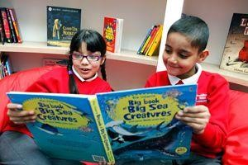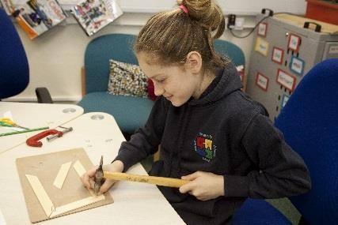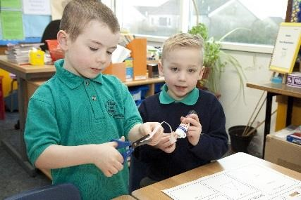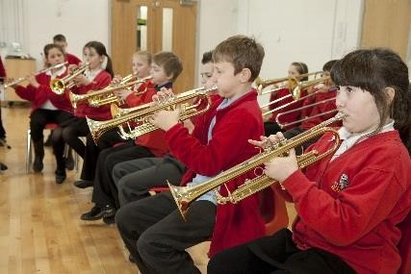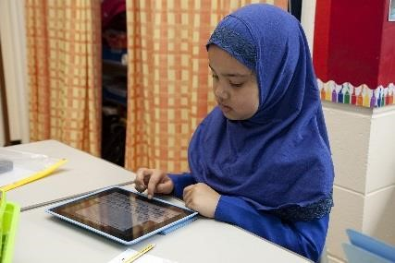

Vacancy | Learning Support Assistant
Location | Lyndhurst Primary and Nursery School
Start date | ASAP
Closing date | 09.01.2026
Salary | Grade 3 (NJC point 9-13)
Contract | Maternity Leave Cover
Return application to | lyndhurst@focus-trust.co.uk

Welcome from Mr J Chadwick, Lyndhurst Primary and Nursery School
Dear applicant,
Thank you for taking an interest in the Learning Support Assistant vacancy at Lyndhurst Primary and Nursery School.
Our popular School is situated in the Hollins area of Oldham, Greater Manchester, serving a large residential area of private and local authority housing. The school's planned admission number is 472 and the school’s admission limit in Reception to Year 6 is 60 per year group. With the exception of Nursery where we have a PAN of 52. This includes part time and full time attendees. The number of children on roll currently stands at 460. Approximately 25% of our children are entitled to free school meals, 11.28% have Special Educational Needs and 33% come from homes where English is not their first language.
Our school is popular with local families and has a reputation for being friendly and welcoming. There are good links with the local community through various activities and we enjoy positive relationships with neighbouring schools and the local authority.
Key messages from our most recent Ofsted report in 2019:
- This is a calm and caring school where pupils get on well together. Leaders’ vision of a school where pupils ‘learn, care, challenge and lead’ is central to Lyndhurst Primary School. Leaders and teachers have high expectations of pupils. They make sure that all pupils are able to take part in school life. For example, pupils learn sign language so they can communicate with their peers.
- Pupils enjoy taking part in wide range of extra-curricular activities across the school. These include the well-attended breakfast reading club, robotics competitions and trips which enhance the curriculum.
- Pupils enjoy school. They feel happy, safe and well looked after. Pupils’ behaviour is typically good. The pupils that we spoke to told us that poor behaviour and bullying does happen occasionally but that is rare. When it does happen, pupils said that adults sort it out quickly and fairly.
- School leaders are passionate about making sure that all pupils are learning well. Pupils told us that they enjoy the many opportunities that they have to learn new things.
I am extremely proud to be the Headteacher at Lyndhurst Primary and Nursery School and believe it is a rich and vibrant place to learn and work; where we embrace our vision: shaping the future, making memories, ready for life. I would be very happy to answer any questions that you may have.
We hope that you will find this information pack helpful in finding out more about this post.
If you would like a further conversation about any aspect of this post or about working as part of Focus-Trust, please do not hesitate to email lyndhurst@focus-trust.co.uk or contact the school office who will arrange a telephone call.
Please contact us if you require any further information.
Please return all completed documents via the My New Term Platform by 12noon on the 09.01.2026

Welcome from Sheila Garara, Chair of Governors

Dear applicant,

Thank you for taking the time to consider applying for the post of Class Teacher with Early Years responsibility at Lyndhurst Primary and Nursery School. As Chair of the Governing Body, I would like to take this opportunity to tell you a little bit about the context of our school.

Lyndhurst Primary and Nursery School is a two-form entry school, situated in Hollins in Oldham, Greater Manchester. We have PAN of 472 primary aged pupils with an admission limit of 60 pupils per year group. A number of pupils come from homes where English may not be the first language.

We are proud to be part of the Focus Academy Trust and recognise the value of support, ethos, challenge, and collective efficacy embodied within the trust.

This is a very friendly school where children are happy, and staff work exceptionally hard as part of a team. The large staff of teachers and teaching assistants are led by a dedicated, skilled Senior Leadership Team; all working together to drive the school vision: shaping the future, making memories, ready for life.

There are 15 spacious and well-equipped classrooms. The school has a large hall which is used for PE and other events, dining room and assembly hall. Our school is surrounded by secure playgrounds and a large, grassed area which includes a Forest School space. The building is relatively new, and we are co-located with Springbrook School.

We offer a wide range of extra-curricular activities and clubs, ranging from a variety of sports to robotics.
Families are made very welcome in the school, and we try to involve them as much as we can.
Our school is popular with local families and has a reputation for being friendly and welcoming. There are good links with the local community through various activities and positive relationships with neighbouring schools, including the local High Schools.

I hope I have given you a flavour of Lyndhurst Primary and Nursery School; and that it makes you feel that you would like to become a part of our school community.

Yours faithfully

Sheila Garara
Chair of the Governing Body

Academy details
Address | Heron Street, Hollins, Oldham, OL8 4JD
Telephone | 0161 770 7260
Email | Lyndhurst@focus-trust.co.uk
Website | Lyndhurst Primary Academy - Home (lyndhurstprimaryschool.co.uk)

About our school

Lyndhurst Primary and Nursery School

Shaping the Future Making Memories Ready for Life
Lyndhurst Primary and Nursery school aims to nurture: happy, confident, inquisitive, responsible citizens with high aspirations for themselves and others.
We seek to achieve this through:
- A culture of that is expectation driven linked to the fundamental British Values
- Working together to create a happy, cohesive school, where individual contributions and opinions are valued.
- Promoting each pupil’s self-esteem by building and developing individual strengths and talents so that children feel able to take risks within a safe, positive environment.
- Providing opportunities to explore, investigate and question the world around them through a broad and balanced curriculum enabling children to develop their natural inquisitiveness.
- Creating a stimulating environment, with high quality teaching, where children are encouraged to think for themselves, express their opinions and take responsibility for their learning.
- Supporting children to make the right choices for themselves and others, enabling them to make a valuable contribution to society and become responsible citizens.

Our pupils
The majority of our pupils are of Asian, Asian British, Pakistani and Bangladeshi heritage.
The proportion of pupils known to be eligible for free school meals is above average. The proportion of disabled pupils or who are supported at school action plus or with a statement of special educational needs is above average. Attainment on entry is below age expected levels.

Our staff
Our leadership team comprises the Headteacher, Deputy Headteacher, two Assistant Headteachers and a School Business Manager. In addition to teachers and teaching assistants, we have safeguarding & pastoral leads who work with children and families, staff and outside agencies to offer support for wellbeing and develop parental engagement. The running of the school is also supported by admin, site, kitchen and lunchtime teams.

Our facilities
Lyndhurst is a two-form entry school. The classrooms are light and spacious and well equipped to ensure the children have a learning environment conducive to the 21st century. We are extremely fortunate to have large grounds which have been designed and developed to support children’s learning, including Forest School.

Our school organisation
Our pupil admission number is 472 and there are two classes for each year group, from Reception to Year 6. Currently Nursery consists of a morning and afternoon class with a total PAN of 52. Learning of children is also supported and facilitated by our team of skilled HLTAs and LSAs.

Our curriculum
We offer a broad and balanced curriculum which gives the children a wide range of experiences to develop the whole child. Our curriculum is geared to giving children a firm grounding and the necessary skills to succeed in an ever-changing world as well as providing them with the solid foundations of reading, writing and maths. We are very proud to be an Arts Mark School as well as having achieved the Platinum PE Award, and the Bronze Travel Mark.

Our extra-curricular activities
We have a range of activities, including non-competitive and competitive sports, children’s fundraising groups, robotics and arts clubs. We have a well-attended free breakfast club and love to get involved in community events such as Young Voices.

Academy Quick Facts
Type of school | Primary and Nursery
Age range | 3-11
Location/LA | Oldham
Number of children | 467
Number of teaching staff | 17
Number of support staff | 44
% FSM | 25%
% SEN | 11.28%
% EAL | 33%

Job Description

Academy
Job title | Learning Support Assistant/ Teaching Assistant
Grade | Grade 3 (NJC POINT 9 – 13)
Accountable to | Principal
Line manager | Class teacher / teachers, or Inclusion Manager, or SLT.

Purpose of the role
To work under the direct instruction of teaching/senior staff, usually in the classroom with the teacher, to support access to learning for pupils and provide general support to the teacher/s in the management of pupils and the classroom.

Main Duties

Support for Pupils
- Establish rapport and respectful, trusting relationships with pupils, acting as a role model and setting high expectations.
- Supervise and support pupils to undertake agreed learning activities / programmes linked to local and national curriculum and learning strategies, e.g. literacy, numeracy, KS1 or KS 2 or early years.
- Adjusting activities according to pupil responses and needs, including for those with special educational needs.
- The role may include supporting and implementing pupils’ personal programme, including social, health, physical, hygiene, and welfare matters. The pupil may also need assistance to access different areas of the school. Following appropriate training and in line with school procedures, to administer basic first aid and/or medication as required.
- Promote inclusion and acceptance of all pupils by encouraging them to interact with each other and to engage in activities led by the teacher.
- Promote self-esteem and independence amongst pupils.
- Support the implementation of Individual Education Plans and Behaviour Plans
- Provide feedback to pupils on their progress and achievement under the guidance of a teacher, in line with school policy.
Support for teachers
- Promote good pupil behaviour, dealing promptly with conflicts in line with school behaviour policies.
- Establish constructive relationships with parents and carers, promoting the School’s home/school liaison policy
- Assist the teacher with the preparation of teaching and learning materials and resources.
- Provide detailed feedback to teachers on pupils’ achievement, progress, problems etc. as requested.
- Undertake pupil record keeping as requested and assist with the collation of pupil reports as requested by the teacher, which may involve data inputting.
- Maintain a purposeful, orderly and supportive environment, in accordance with lesson plans.
- Assist with the display of pupils’ work.
- Prepare, maintain and use equipment/resources required to meet the lesson plans/learning activity and assist pupils in their use.
- Administer and mark straightforward routine tests, e.g. spelling or mental arithmetic, and invigilate tests as required
- Provide clerical support for teachers, e.g. photocopying, filing, collecting money, checking deliveries and placing goods in stock and maintaining records of stock, administering coursework, production of work sheets for agreed activities

Support for school
- To support others within the classroom and the School, contributing to the achievement of School objectives by working as part of a team
- Assist with activities outside the classroom, working as part of a team to oversee pupils and support Activity Leaders, e.g. Breakfast Club or accompanying to swimming lessons. (If this is an agreed part of the working pattern)
- Accompany teaching staff and pupils on visits, trips and out-of-school activities as required and take responsibility for a group under the supervision of a teacher

Fulfill wider professional responsibilities
- Make a positive contribution to the wider life and ethos of the Academy and the Trust.
- Develop effective professional relationships with colleagues, knowing how and when to draw on advice and specialist support.
- Liaise with external agencies with regard to pupil progress, safety and welfare.
- Work with other staff across the Trust and in other maintained schools or other academies.
- Communicate effectively with parents with regard to pupils’ achievements and well-being.
- To attend relevant meetings as required.
- To participate in training and other learning activities and performance development as required.
- To be aware of and comply with policies and procedures relating to child protection, health, safety and security, confidentiality and data protection, reporting all concerns to an appropriate person.
Personal and professional conduct
A Teaching Assistant is expected to demonstrate consistently high standards of personal and professional conduct. The following statements define the behaviour and attitudes which set the required standard for conduct throughout a Teaching Assistant's career.

Teaching Assistants uphold public trust in the profession and maintain high standards of ethics and behaviour, within and outside the Academy, by:
- treating pupils, staff, parents and visitors with dignity, building relationships rooted in mutual respect, and at all times observing proper boundaries appropriate to an adult working in an Academy environment;
- having regard for the need to safeguard pupils’ well-being, in accordance with statutory provisions;
- showing tolerance of and respect for the rights of others;
- not undermining fundamental British values, including democracy, the rule of law, individual liberty and mutual respect, and tolerance of those with different faiths and beliefs; and
- ensuring that personal beliefs are not expressed in ways which exploit pupils’ vulnerability or might lead them to break the law.

Professionals working in the Focus-Trust must have proper and professional regard for the ethos, policies and practices of the Academy and the Trust, and maintain high standards in their own attendance and punctuality.

Professionals must have an understanding of, and always act within, the statutory frameworks which set out their professional duties and responsibilities; and within the policies, handbooks and guidelines of the Academy and of the Focus-Trust.

General
The post holder will:
- Be expected to actively support work and ethos of the Focus-Trust.
- Be expected to undertake such additional duties as may reasonably be requested by the Principal or their representative.
- Respect confidentiality of staff, pupils, families and visitors and not breach this trust. Any breaches of confidentiality must be reported to the Principal immediately.
- Participate in arrangements for appraisal and in the identification of areas in which s/he would benefit from training and undergo such training.
- Proactively keep abreast of developments in relation to the post, and whenever possible and appropriate, attend professional development opportunities.
- Comply with and support all policies related to equal opportunities, child protection and safeguarding of children and colleagues.

This job description is neither exhaustive nor exclusive, and it may, after consultation with the post holder be subject to modification and amendment in accordance with the needs of the academy.

Signed …………………………………………………………… Post holder

Signed ……………………………………………………………… Principal/Line manager

Dated ………………………………………………………………

Person Specification for Teaching Assistant Level 1

Essential Criteria | How Identified | Desirable Criteria | How Identified
Skills:  Interpersonal skills to build effective working relationships with pupils and colleagues  Communication skills to liaise sensitively and effectively with parents and carers  Working with or caring for children of a relevant age to those in the school  Experience of working with learning resources and helping with their preparation to support learning programmes  Experience of effectively using ICT and other technology such as digital recorders and photocopiers and resolving straightforward problems in their operation  Able to promote a positive ethos and good role model  Able to continually improve own practice/knowledge through self evaluation and learning from others  Team-work skills to work collaboratively with colleagues, understanding classroom roles and responsibilities and your own position within these | Application form and selection process.  Application form and selection process.  Application form and selection process. |  | Provide evidence by producing certificate.
Knowledge and Understanding  Basic understanding of a child’s development and learning.  Understanding of the relevant policies/codes of practice/ and awareness of relevant legislation in the context of your role  General understanding of national/foundation stage curriculum and other relevant learning programmes/strategies  Understanding of equal opportunities and an awareness of potential barriers children may have around learning | Application form and selection process.  Application form and selection process. | Appropriate knowledge of first aid.  To be aware of policies and procedures relating to child protection, health, safety and security, confidentiality and data protection. | Application form  Application form and selection process.
Qualifications / Training  NVQ 2 for Teaching Assistants or equivalent qualification or experience  Literacy and Numeracy skills equivalent to Level 1 of the National Qualification & Credit Framework  Completion of Department for Education Teacher Assistant Induction Programme  (or to complete within first term)  Willingness to undertake training in relevant learning strategies e.g. literacy/ Key Stage 3  Pediatric First Aid certificate (where appropriate) | Application form and selection process. | GCSE Maths and / or English grades D-G  CSE Level 2 | Application form and certificate.
Other conditions | Enhanced CRB Disclosure clearance

Background to the Trust

Focus-Trust was incorporated in May 2012 as a primary trust. The Trust has links with the sponsor, Focus Education, but is an entirely separate legal entity. As with all academy trusts, the Trust is a company limited by guarantee and an exempt charity. The Trust’s offices are situated in a newly converted historic mill conversion in Chadderton, Oldham with excellent motorway networks to access our schools.
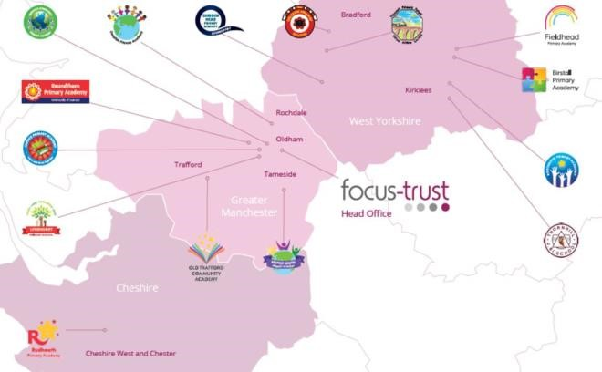

The defining feature of Focus-Trust is that it is a specialist primary phase trust. This means that the work of the Trust is driven by the distinctive needs of primary schools. Whilst the Trust has robust systems for accountability, each school has their own distinctive identity, ethos and culture, and this is a commitment to every school when they convert and join the Trust.
Focus-Trust currently has a small centrally employed team. The members of the team are highly skilled and committed to the vision, culture and values of the Trust.
All the schools within the Trust are willing partners who have actively chosen to join Focus-Trust and there is a very high degree of consensus, cooperation and commitment from within the group.
The Trust has robust policies and systems in place to govern and guide its work. These have been gradually implemented as the Trust has grown. The Trust has well-established productive relationships with trade unions and meets half termly with a group of national trade union representatives to discuss policy development. This has enabled us to introduce and change a range of policies in a streamlined and cooperative way.
Vision
‘Great schools at the heart of our communities’ - with our Community Champions and colleagues, we strive to ensure we are being civic leaders making a difference in the local and national communities and the community is supporting us.
Commitment
‘Learning together, making the difference’
Collective Efficacy
We have a well-developed and securely embedded culture of Collective Efficacy. By this we mean we have, ‘A shared commitment to work together on the things that matter to improve outcomes for all.’
The Focus-Trust Values
Professional honesty is at the heart of everything we do. The Trust knows the schools well because of the strong working partnership between academy leaders and the Trust Central Team. It is only by being honest and transparent with a balance of credible challenge and effective support, that we can move forward and get the best for all children and staff. Our work is underpinned by our values:

Care for children, adults and the learning environment
Dare to do things differently and have a go
Be fair, honest and inclusive – demonstrating integrity
Share expertise and best practice for the benefit of all learners

What you might want to know about Focus Trust

Pensions
Focus-Trust contributes to Teachers’ Pensions and Local Government pensions in the same way and with the same level of contribution as local authorities.
Employer Relations
Focus-Trust has a Trade Union agreement which recognises the teacher and support staff unions. This is further supported by an ongoing and productive relationship with key trade union officials.
Equality of opportunity
Focus-Trust is an equal opportunity employer, dedicated to a policy of non-discrimination in employment on any basis including age, gender, race, colour, nationality, ethnic origin, disability, gender, religion, age, marital status, sexual orientation and/or medical condition.
Safeguarding
Focus-Trust is committed to safeguarding and promoting the welfare of all children and young people. There is an explicit expectation that all employees share this commitment and adhere to all safeguarding policies and procedures. Applicants should be aware that the recruitment process will include an assessment of your suitability to work with children.
Dress code
We expect all staff to dress professionally and appropriately for the roles undertaken. We pride ourselves on the high standards of dress of both our pupils and staff; these standards are led by our staff who we expect to set an example.

Policies
Focus-Trust and the schools have a range of policies and handbooks that help to make clear our expectations and ways of working. These are always shared openly with staff and are accessible to everyone. There are several policies that prospective employees should be aware of when making an application. These can be found on the Trust website www.focustrust.co.uk and school websites. All members of staff will be asked to sign a declaration as part of the induction process to acknowledge that they have read and understand the Code of Conduct and some of the key policies, e.g. Safeguarding and Child Protection, Health and Safety, Acceptable use of IT.
Right to work in the UK
Under the Asylum and Immigration Act 1996, it is a criminal offence to employ anyone who is not entitled to live or work in the United Kingdom. Applicants can expect us to ask for proof of this at interview stage, where you will be asked to provide some original documentation to confirm that you are eligible to work within the UK. Photographic proof of identity will also be required.
Validation of qualifications and identity
All shortlisted candidates will be asked to bring original certificates or relevant qualifications and identity documents to interview. These will be photocopied and kept on file and, if appropriate, may be confirmed as genuine with the relevant awarding bodies. The copies of the successful candidate will be retained on their personnel file. The copies of unsuccessful candidates will be treated as confidential waste and disposed of appropriately.
References and Social Media Checks
If you are shortlisted, we will take up references before the interview date. One of your referees must be your current or most recent employer. Two satisfactory references must be received before we can confirm any offer of an appointment. The information we request will relate to salary, length of service, skills and abilities, suitability for the job, disciplinary record and suitability to work with children. Copies of references or open references will not be accepted. On receipt of references, your referees may be contacted to verify any discrepancies, anomalies or relevant issues as part of the recruitment verification process.
In line with our safer recruitment policy, social media checks will be undertaken if you are shortlisted. This social media check is designed to complement the range of standard recruitment checks and allows us to identify a candidate’s online presence which potentially could damage the organisation’s reputation.
Knowledge and skills profile
This is an important part of your application and is your opportunity to explain how you meet the person speciation for the post. You should demonstrate your skills, knowledge and experience and give short examples. Describe how you match the requirement of the job; include experience gained from previous jobs, community or voluntary work. Ensure that the information you give is well organised, relevant and brief. You may find it helpful to use subheadings in order to keep your statement well focused. If you do not submit this profile, you will not be considered for short listing.
Disability
To comply with the Equality Act 2010, we are legally required to consider making reasonable adjustments to ensure that disabled people are not disadvantaged in the recruitment and selection process. We are therefore committed to meeting, wherever possible, any needs you specify on the application form. Please contact Natalie Harris if you need to discuss this in any detail. We will consider any reasonable adjustment under the terms of the Act to enable an applicant with a disability (as defined under the Act) to meet the requirements of the post.
Disclosure of a criminal record
Employment in this role is subject to an enhanced check with the Disclosure and Barring Service (DBS). Checks will also be made against the lists showing people barred from working with children. All checks must be satisfactory before any offer of employment can be confirmed and before commencement of work can take place.
Please return all completed documents to lyndurst@focus-trust.co.uk by 12 noon on the 09.01.2026

Thank you for taking the time to read this information pack. We wish you every success in any application you may make.

