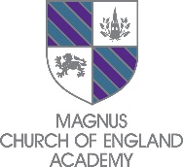

Magnus Church of England Academy, an academy within the Diocese of Southwell and Nottingham Multi Academy Trust, is seeking to appoint to the following role to start ASAP:

Reading Tutor
Contract: Permanent, Term Time Only
Salary: £21,980 (pro rata at 37hrs per week)
Hours: 37 hours per week, Term Time Only

Support students to develop their reading skills and confidence through high-quality 1:1 and small group tutoring.

Improve reading fluency, comprehension, vocabulary, decoding and phonics skills where appropriate, helping students make measurable progress and develop a positive attitude towards reading.

Be a calm, supportive and adaptable individual who can respond flexibly to different learning styles and student needs.

Application Deadline: Friday 5th June 2026 – 9am

The Diocese of Southwell & Nottingham Multi Academy Trust is committed to safeguarding and promoting the welfare of young people and expects all employees to share this commitment. The successful applicant will be subject to appropriate child protection screening including checks with previous employers and undertake an enhanced DBS with barred check.

