


Assistant Teacher
Alkborough Primary Academy
Candidate
Information Pack
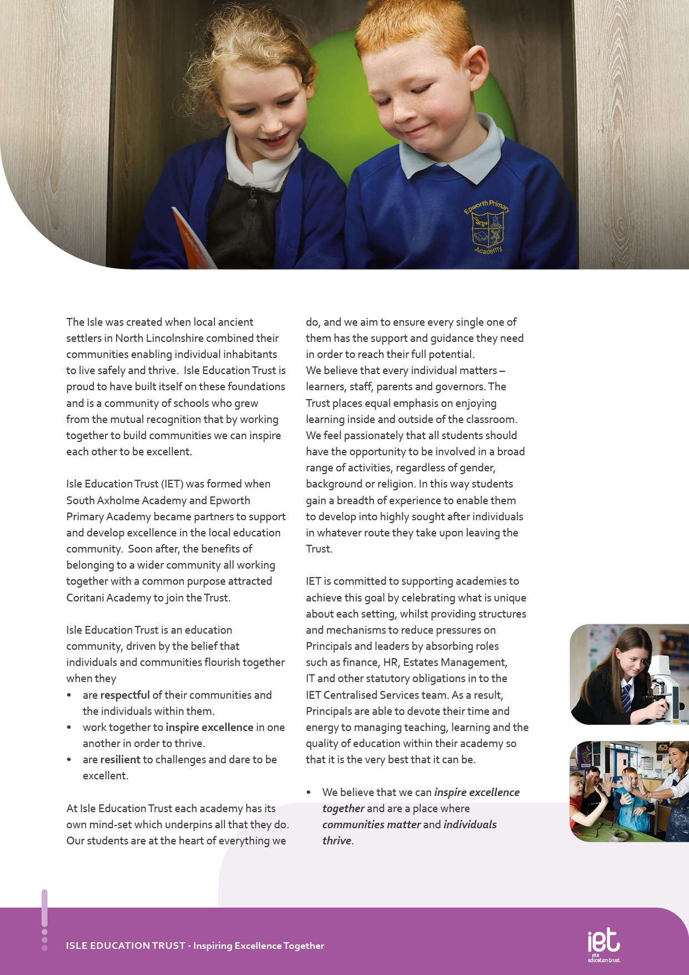
About IET

Dear Prospective Colleague,

Thank you for your interest in joining Isle Education Trust. I’m delighted that you're considering becoming part of our team—whether you’re looking to support students directly or contribute to the vital work that happens behind the scenes, your role matters deeply to us.
At Isle Education Trust, our vision is clear: Inspiring Excellence Together. Across our family of academies, we recognise that excellence doesn’t happen by chance—it’s built by a committed, skilled, and diverse team working together with shared purpose.
Our non-teaching colleagues are the backbone of our success. From safeguarding and administration to site management, finance, pastoral support, and everything in between, you help shape the culture and daily experience of our schools. Your expertise keeps our academies running smoothly, our environments safe and welcoming, and our pupils supported every step of the way.
We are proud to uphold values that guide our Trust:
- Respect – shown through honesty, consistency, and care.
- Resilience – demonstrated in our commitment to excellence, even in the face of challenge.
- Inspiration – sparked by individuals who lead by example and empower others to thrive.
When you join our team, you’ll find a community where your contributions are valued, your development is supported, and your wellbeing is prioritised. We offer professional learning opportunities, a culture of collaboration, and a genuine commitment to making our academies great places to work.
If you share our belief that every role within education is a chance to make a difference, I warmly invite you to explore opportunities across the Trust. We’d be thrilled to welcome you into our mission of inspiring excellence—together.
Warm regards,



Sarah Sprack
CEO, Isle Education Trust

Welcome from the CEO

Welcome from the Chair of Governors
Dear Applicant

Thank you for your interest in joining our vibrant school community here at Alkborough Primary Academy. We are a small team where passion for learning, creativity, and genuine care for children is at the heart of everything we do.

Alkborough is a small, nurturing school nestled in a beautiful village setting. We pride ourselves on our warm, inclusive atmosphere where every child is known, valued, and supported to thrive. Our pupils are curious, enthusiastic, and full of character—and our dedicated staff work tirelessly to ensure they experience an education that is both broad and enriching.

We believe in fostering a culture of collaboration, kindness, and high expectations. Our staff are not only committed professionals but also supportive colleagues who share a collective goal: to help each child flourish academically and personally. Whether you’re leading learning in the classroom or shaping the wider school experience, Alkborough is a place where your ideas, talents, and values truly matter.

If you’re seeking a role where you can make a meaningful difference while being part of a caring and ambitious team, we’d love to hear from you.

Warm regards,

M Garlick

Michelle Garlick
Chair of Governors


Nestled in the historic village of Alkborough—where the ancient landscapes of Julian’s Bower and sweeping views of the Trent, Ouse, and Humber converge—our school stands as a proud steward of tradition and progress. The village’s rich tapestry, from its Anglo-Saxon roots to its role in England’s early Christian history, inspires a sense of identity and wonder that we lovingly pass on to our pupils.
At Alkborough Primary, we blend this deep local heritage with a forward-thinking ethos. We are a small but vibrant community where children are known, nurtured, and celebrated as individuals. Our values—kindness, curiosity, resilience, and respect—shape the way we learn, the way we grow, and the way we connect with one another and the wider world.
We believe that education flourishes in a warm, inclusive environment. Here, learning is not just academic—it’s personal, creative, and rooted in real life. Staff, children, and families work together to ensure every child flourishes not only as a learner, but as a thoughtful, confident member of society.
Alkborough Primary School is more than a place of learning—it's a place to belong.


About the Academy

Job Purpose
The successful candidate will work as an Assistant Teacher, lead interventions with learners and step up to lead teaching and learning in the classroom when cover is required within the Academy. The role requires management of pupil behaviour and ensuring a safe environment for learning.

The Assistant Teacher will report to the Principal.
Job Title Assistant Teacher

Salary | £32,544 fte
Job Details | 32.5 hours  Term Time Only  Permanent
Location | Alkborough Primary Academy
Required | September 2026
Application Close | 09:00 Monday 22nd June 26
Interview Date | tbc

Job Description

Job Description

To work to the National standards for Teaching Assistants including:
- In the absence of a teacher, to be solely responsible for a class of students, ensuring they are engaged in learning activity.
- Plan, teach and assess individual or small groups of students within the classroom
- Be aware of and support differentiation and ensure that pupils have equality of access to opportunities to learn and develop.
- Effectively manage student behaviour and any other immediate issues or emergencies that arise in accordance with academy policy.
- To support students to engage with the work provided, including providing support where necessary with literacy, numeracy and organizational skills.
- To liaise with teachers/other relevant staff with regard to work set for a class and ensure you are suitably equipped and informed to be able to effectively supervise the assigned lesson.
- To feedback to the class teacher on student engagement in the set work and also any other issues that may have arisen.
- To help prepare, monitor and maintain a safe and secure learning environment.
- To undertake student registration of a class as required.
- To undertake administrative duties relevant to the role
- To act as invigilator for both internal and external exams under formal conditions
- When not required to undertake any responsibility falling within the above, you may be directed to provide additional support in the academy with duties of a different nature.

Any other reasonable duties as requested by the Principal or SLT

Key Responsibilities and Accountabilities


INTERVIEWS:
Thursday 13th June 2024
CLOSING DATE:
Tuesday 11th June 2024 at 9:00am
- Work with all students ensuring equality of opportunity for all.
- Take responsibility for Safety and Welfare of all students, raising any concerns following the Academy/Trust protocols and procedures.
- Work proactively and effectively in partnership with all stakeholders.
- Carry out a share of statutory supervisory duties.
- Treat students with dignity and build relationships rooted in mutual respect and at all times observing proper boundaries appropriate to the professional position.
- Participate in CPD relevant to the role.
- Accompany teaching staff and students on visits, trips and out of school activities as required.
- Demonstrate an understanding of and take responsibility for promoting high standards of literacy including the correct use of spoken English and numeracy.
- Participate in arrangements for examinations and assessments.
- Take an active role in promoting good behaviour in and around the Academy/Trust.
- Ensure that students adhere to the uniform code and apply sanctions when this code is breached.
- Develop an academy learner mind-set – the attitudes, skills and learning habits needed to become an inspired, confident and independent learner.
- Be a positive role model and demonstrate consistently and effectively the positive attitudes, values and behaviour which are expected of students.
- Work as a team member and identify opportunities for working with colleagues and sharing the development of effective practice with them.
- Regularly review the impact of their work and its impact on students’ progress, attainment and well-being, refining approaches where necessary and responding to advice and feedback from colleagues.
- Proactively participate with arrangements made in accordance with the Appraisal Policy.
- Have professional regard for the practice, ethos and policies of the Academy/Trust and maintain high standards in your own attendance and punctuality.
- Operate at all times within the stated policies and practices of the Academy/Trust.
- Contribute positively and effectively to the whole Academy/Trust ethos.
- Cooperate with other staff members to ensure a sharing and effective use of resources to the benefit of the Academy, individual departments and students.
- Attend and participate in appropriate calendared meetings.
- Take responsibility for own professional development and duties in relation to Academy policies and practices.
- Liaise effectively with staff, students, parents and governors.
- Ensure compliance with Health and Safety at Work Act 1974 and all other policies related to health and safety, and to ensure compliance with the Data Protection Act 1988.
- Ensure compliance with data protection laws and safeguarding procedures.
- Carry out any other duties as directed by your Line Manager as may from time to time be agreed in accordance with the nature of the job described above.

We expect all Trust staff to:

This is not an exhaustive list of tasks and job descriptions will be continually reviewed and changed according to the needs of the Trust.

Post holders will be expected to be flexible in undertaking duties and responsibilities attached to their post and may be asked to perform duties, which reasonably correspond to the general character of the post and are commensurate with its level of responsibility. This job description is provided for guidance only and does not form part of the contract of employment.


Qualifications |  | Essential |  | Desirable
Good literacy & numeracy skills (Level 3) |  | A
Further academic qualifications relevant to post |  |  |  | A
First Aid Qualification |  |  |  | A
Experience | Essential |  | Desirable
Experience of working in an educational setting or similar environment |  |  | A
Experience of working with young people aged 11 to 18 |  |  | A
General understanding of school policies and procedures relating to health and safety, behaviour, attendance, equal opportunities and child protection |  |  | I
Knowledge of School Management Information Systems |  |  | A
Experience of Microsoft software packages (Word, Excel, Publisher) |  |  | AI
Basic understanding of child development and learning |  |  | A I
Practical Skills | Essential |  | Desirable
Ability to manage the behaviour of students to promote a calm working environment | A I
Ability to motivate students | I
Ability to work collaboratively and effectively within a team | A I
Ability to work independently and to show initiative | A I
Ability to work under pressure, prioritise and meet deadlines | A I
Friendly, approachable and non-confrontational manner combined with the ability to be firm | I
Ability to build and maintain successful relationships with students; treat them consistently, with respect and consideration, and demonstrate concern for their development as learners | I
The capacity to inspire and motivate others – both adults and students |  |  | I
Ability to use ICT effectively to support learning |  |  | A
A desire to work with young people and to support their education and achievements | A I
A professional approach in both manner and physical appearance | I
Able to demonstrate discretion, confidentiality and commitment | I R
Able to liaise sensitively with parents/carers recognising their role in the student’s learning | I R
Enthusiasm, determination and insistence on high standards | I
Flexible and good humoured approach | I
A proven track record of excellent attendance and punctuality | R
An understanding classroom roles and own position with the school hierarchy | I
High expectations of self and others | Essential |  | Desirable
A flexible and adaptable approach | A I
An innovator with the desire to continue to learn | A I
Resilience and the determination to be successful within this role and ambitious for the Academy and its students | I
Safeguarding Students | Essential |  | Desirable
Committed to safeguarding and promoting the welfare of children and young people | I
Equal Opportunity | Essential |  | Desirable
The ability to ensure that there is equality of access to educational attainment and that all aspects of equal opportunities are adhered to | I

Person Specification:

Personal Qualities and Essential Attributes | Essential | Desirable
A desire to work with young people and to support their education and achievements | A I
A professional approach in both manner and physical appearance | I
Able to demonstrate discretion, confidentiality and commitment | I
Able to liaise sensitively with parents/carers recognising their role in the student’s learning | I
Enthusiasm, determination and insistence on high standards | I
Flexible and good-humoured approach | I
A proven track record of excellent attendance and punctuality | I
An understanding classroom roles and own position with the school hierarchy | I
High expectations of self and others | Essential | Desirable
A flexible and adaptable approach | A I
An innovator with the desire to continue to learn | A I
Resilience and the determination to be successful within this role and ambitious for the Academy and its students | I
Safeguarding Students | Essential | Desirable
Committed to safeguarding and promoting the welfare of children and young people | I
Equal Opportunity | Essential | Desirable
The ability to ensure that there is equality of access to educational attainment and that all aspects of equal opportunities are adhered to | I

KEY
A = assessed through the application process
I = assessed through the interview process


c
 Pension Scheme
All staff are enrolled in either the Teachers’ Pension Scheme or Local Government Pension Scheme, whichever is relevant.
 Continuous Professional Development
IET offers numerous opportunities for continued CPD for all staff including NPQs and apprenticeships

 Cycle to Work Scheme
Eligible staff may apply to purchase a new bike, e-bike or cycling accessories through this salary sacrifice scheme, making significant savings.

 Staff Wellbeing
This is a priority for the Trust. All staff have access to a free Employee Support Package, including 24/7, 365 days a year online and telephone support covering areas such as mental health, bereavement, financial advice and counselling.

 Healthcare
All staff have free access, 24/7, 365 days a year to an online doctor.

 Flu Vaccinations
All staff are able to request a free voucher for a flu vaccination in the Autumn term.

 Discounts
Through our employee benefits platform, staff can make significant savings through discounts and vouchers in a range of areas including restaurants, supermarkets, retail and holidays.

Trust Benefits:


Appointment Process
How to apply
To apply for this post, visit the IET website:

Isle Education Trust - Vacancies

Receipt of early applications from candidates with the appropriate experience, qualifications and personal qualities may result in an early interview being offered.

Isle Education Trust promotes equality of opportunity and welcomes applications from all sectors of society.

Isle Education Trust is committed to safeguarding and promoting the welfare of children and expects all staff and volunteers to share this commitment. All posts at Isle Education Trust are subject to an Enhanced Disclosure and Barring check.

