

Cleaner
Recruitment Pack

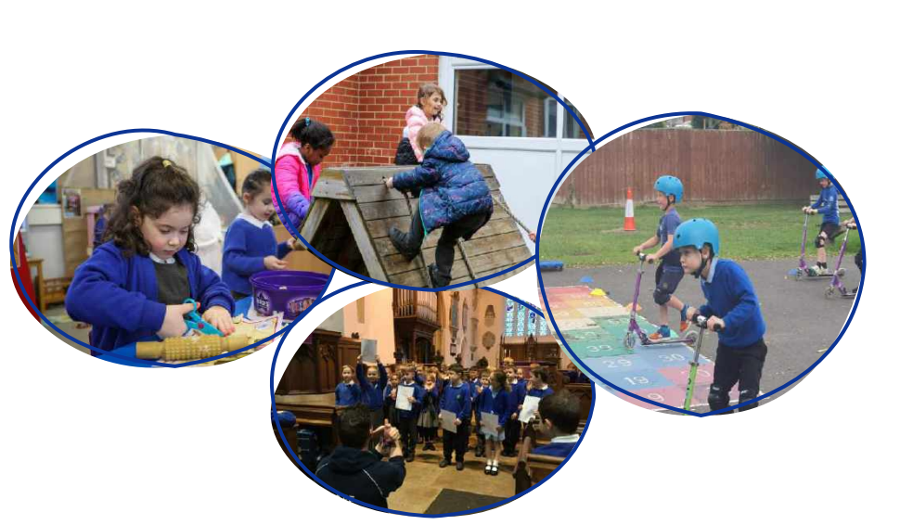

Advert Opens: 16.01.2026 Advert Closes: 23.01.26

Contents

Grove Learning Trust (GLT) Vision 2
A snapshot of Wroughton Infant School… 3
Our school values 3
Welcome 4
Person Specification 7
Recruitment Process 8
Safeguarding, Equal Opportunities and Data Protection 8

Grove Learning Trust (GLT) Vision

GLT Vision

As one organisation, our vision for Grove Learning Trust is unapologetically bold.
We are all about creating remarkable futures. For our children, our people, our places of work, we want the very best. We know that strong connections will enable us to achieve our vision, in a world where purposeful collaboration, based on mutual respect and trust, helps us to achieve more together.

Trust >> Connect >> Collaborate

A snapshot of Wroughton Infant School…


See more at: https://www.wroughton-infants.co.uk/

Our school values

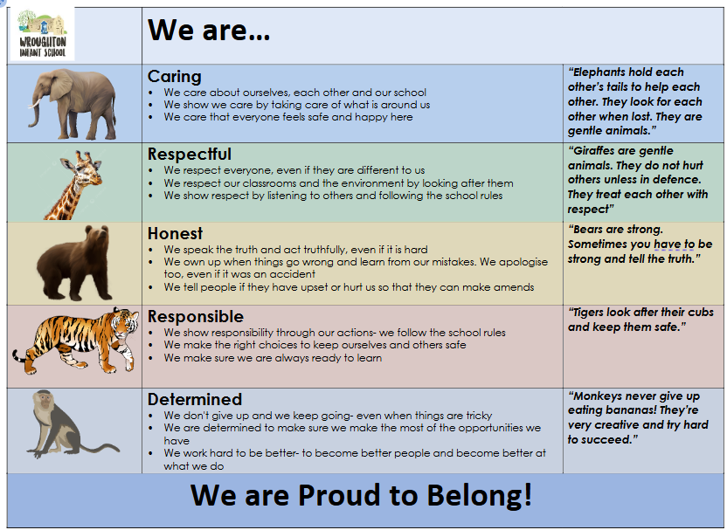

Welcome
Thank you for your interest in our Cleaner position. Wroughton Infant School is a great place to work and I’m excited that you’re thinking about joining us. We are looking for an enthusiastic and dedicated person to join our school until the end of this academic year.
Wroughton Infant School is a two-form entry Infant School which is part of Grove Learning Trust. Since joining the trust we have come together to share resources, expertise and our mutual vision and commitments for the children within our community. At Wroughton Infants, we are ‘Proud to Belong’ and this is shown through all aspects of the school. We work hard to ensure that no child is left behind and that the unique identity of the school is protected, celebrated and valued for the contribution they make to ensuring children have the best educational experiences. We passionately believe, that by working together, the children will receive a higher quality of education.
We are proud of the learning environment we have created and strongly believe that prospective candidates will see that Wroughton Infants is a welcoming and inclusive school which benefits from a supportive staff team, families and governors.
With best wishes,
Melanie James | Headteacher
Job Description
Job details Salary: J2, £12.67 p/hr.
Contract type: Fixed Term contract until the end of the academic year 2025-26. 5 hrs per week (1 hr per day, Mon to Fri), term time only.
Reporting to: Headteacher and Caretaker
Responsible for: Cleaning of the school hall including its toilet, computer room and kitchenette
Main purpose
Under the direction of the Headteacher/Caretaker to fully contribute to site cleanliness ensuring all facilities are clean and available for use. Attaining high standards of cleaning and hygiene throughout the school environment.

Main Activities
To undertake cleaning duties to maintain a high standard of cleanliness at Wroughton
Infant School, primarily the school hall, as directed.

Cleaning:
• Ensure the cleanliness of the school hall including toilets, kitchen and computer
suite areas, as well as any other areas as directed, inclusive of, but not limited to
hoovering, polishing, wiping down surfaces, mopping floors.
• Carry out emergency cleaning measures following storms, break-ins, vandalism,
graffiti etc. as directed
• Ensure all litter bins are regularly emptied and cleaned.
• Ensure all refuse is properly always placed in the waste contractor’s bins.
• Ensure that equipment is in a clean, safe tidy condition.
• Carry out periodic, deep cleaning such as light fittings- after suitable training

Security during cleaning
• Ensure that the grounds and buildings are secure.
• Ensure that all windows and doors are secured at the end of the day. • Ensure lights and other equipment are switched off as appropriate

Health and Safety
• Immediately report to the line manager and/or site caretaker any hazards that have been discovered. Ensure that work undertaken do not present a hazard to you or others.
• Ensure that all fire exits are clear.
• Provide safe handling of cleaning materials,
• In accordance with the provisions of the Health and Safety Act, take reasonable care for yourself and others who may be affected by your acts or omissions at work and co-operate with the school so far as necessary to enable it to perform or comply within its duties under any statutory health and safety provisions.

Organisation
• Maintain and arrange orderly and secure storage of supplies
• Ensure cleanliness of equipment, check for quality/safety- reporting any faults
• Be aware of and comply with policies and procedures relating to child protection, health, safety and security and confidentiality, reporting all concerns to an appropriate person.
• Appreciate and support the role of other professionals. Resources
• Ensure the maintenance of a clean and orderly working environment.
• Undertake basic record keeping as directed.
• Refill and replace consumables.

Resources
• Ensure the maintenance of a clean and orderly working environment.
• Undertake basic record keeping as directed.
• Refill and replace consumables.

Physical Effort:
• The postholder will be expected to undertake bending, lifting, rubbing, scrubbing
and stretching in the course of their duties: eg, Cleaning, receiving deliveries of
goods and equipment setting out and putting away furniture, including high level
cleaning.
• Due to the nature of cleaning there will be an expectation that the postholder will
be exposed to dirt and dust which on occasion, for example, adverse weather
conditions may be higher than normal.

Additional duties and responsibilities:
• The post holder may be required to perform duties other than those given in the
job description for the post. The duties and responsibilities attached to posts may
vary from time to time without changing the general character of the duties or the
level of responsibility entailed. Such variations are a common occurrence and
would not of themselves justify the revaluation of a post. In cases, however, where
a permanent and substantial change in duties and responsibilities of a post occurs, consistent with a higher level of responsibility, then the post would be eligible
for re-evaluation.
• In fulfilling the requirements set out in this job description, the post holder will apply
Grove Learning Trust’s commitment to equality by treating all employees fairly and
without discrimination on the grounds of colour, race and ethnic or national origin,
sexual orientation, age, marital status, disability, trade union association or religious
beliefs.
• In addition, the job holder will always respect the need for confidentiality, whilst
performing the duties of the role.

Safeguarding
Grove Learning Trust is committed to safeguarding and promoting the welfare of children and young people at all times. The post holder will be responsible for promoting and safeguarding the welfare of all children with whom they come into contact, in accordance with the trust’s safeguarding policies. The post holder is required to obtain a satisfactory Enhanced Disclosure from the Disclosure and Barring Service (DBS). Safeguarding training is included in the induction of all GLT staff and annual refresher

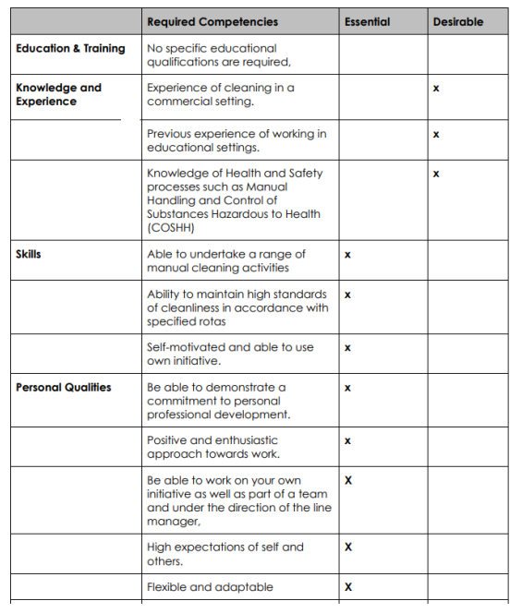

Recruitment Process
Applications and Visits

We’d really like to meet you, show you around and introduce you to the children and staff. Visits can be arranged by contacting our school office team on 01793 8123040 or by e-mailing admin@wroughton-infants.co.uk

Key Dates:

Advert opens : 16.01.2026
Advert closes: 23.01.2026, noon
Shortlisting: 23.01.2026
Interviews: 27.01.2026

Candidates who are successful at the shortlisting stage will be notified shortly after the closing date. Candidates who have not heard from us by this point should presume that their applications have not been successful on this occasion.

We reserve the right to interview prior to the closing date.

We will seek references for all shortlisted candidates prior to interview and, in line with guidance in ‘Keeping Children Safe in Education’, online checks will also be made of shortlisted candidates.

Safeguarding, Equal Opportunities and Data Protection

Safeguarding

We are committed to safeguarding and promoting the welfare of all children. We expect all candidates to share this commitment. The successful candidate will be expected to undertake an enhanced Disclosure & Barring Service (DBS) and relevant identity, qualification and disqualification by association checks before a formal offer is made, contracting is undertaken and induction commences within our school.

For further details about safeguarding, please visit our school website.

Equal Opportunities

We are an equal opportunities employer and welcome applications from all suitably qualified persons regardless of their race, sex, disability, religion/belief, sexual orientation or age.

Data Protection Privacy Notice

As part of the recruitment process, we collect and process personal data relating to job applicants. We are committed to being transparent about how we collect and use that data and to meeting data protection obligations. For further information on how we collect and process data, please refer to the Data Protection Policy & Privacy Notice found on www.grovelearningtrust.co.uk

