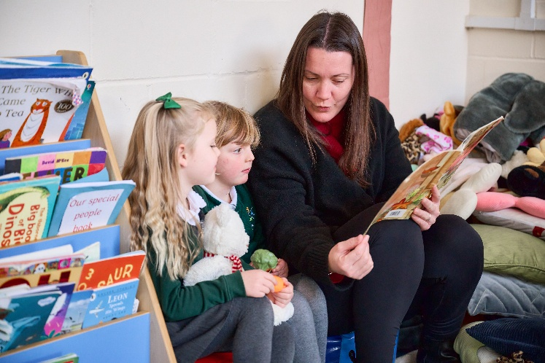




Warboys Primary Academy
Application Information Pack
Casual Teaching Assistant
Principal’s Welcome

Dear Applicant,
Thank you for considering a position with us at Warboys Primary Academy.
At Warboys, we place a strong focus on building a learning community, and our vision is to ensure that every child is happy, feels valued and experiences success.

Working at Warboys Primary Academy means being part of our dedicated team, contributing to a stimulating and challenging environment where students feel confident and eager to learn. Every role at our academy is vital in helping our pupils realise their potential and achieve great things.
As a valued member of our school community, you'll work closely with parents and carers, ensuring that every child receives the support they need. This partnership enhances the children’s educational experience and helps build a supportive network for both the pupil and their families. This collaborative approach helps to create a positive atmosphere where everyone feels valued and heard.
Our academy is part of Thomas Deacon Education Trust (TDET), which offers valuable opportunities for collaboration with its other academies and partnerships throughout Cambridgeshire. You’ll be able to share expertise and best practice with a network of professionals, exchanging ideas and supporting each other’s growth. As well as providing enriched education for our pupils, this integrated approach offers opportunities for your own development.
As well as opportunities for professional growth, as part of our team you can expect an aspirational atmosphere with dedicated colleagues, and supportive leadership which values your input. We are excited to welcome you to Warboys Primary Academy. Together, we can provide the best possible start to every child’s education and lifelong learning journey.
If you have any questions or would like to arrange a visit, please don’t hesitate to contact me.

Warm regards,
Mr Stuart Mallott | Principal

www.wpa.education |  Find us on Facebook

Job Description
Job Title | Casual Teaching Assistant
Reports to | Deputy Principal
Working Hours | As and when required
Salary/Grade | Pathway 1
Core Purpose | To assist the classroom teacher in the support and inclusion of all pupils as well as vulnerable pupils (with Education Health Care Plans) and encourage interaction and independence.

Key Responsibilities
Supporting the Pupil (under the guidance of the class teacher)
• Support individual to access learning at an appropriate level to assist their progression.
• Provide specialist learning support to enable pupils to meet individual targets.
• Establish and maintain supportive relationships with individual pupils or small groups to ensure they understand and can achieve the tasks.
• Promote the inclusion and acceptance of all pupils.
• Adapt activities and tasks for individual pupils to make them more accessible.
• Understand the specific needs of individual pupils and adopt effective strategies to support them.
Supporting the Teacher
• Prepare the classroom for lessons as directed.
• Prepare materials and resources for lessons as directed.
• Undertake support activities as required, e.g. photocopying, mounting displays, filing, etc.
• Undertake pupil record keeping as requested.
• Promote good pupil behaviour, dealing with pupils in line with the established policies encouraging pupils to take responsibility for their own behaviour.
Supporting the Curriculum
• Support pupils to understand instructions.
• Support pupils in respect of local and national learning strategies e.g. literacy, numeracy, early years, as directed by the teacher.
• Support the use of ICT in the curriculum.
Supporting the Academy
• Set a personal example that contributes to the positive ethos of the Academy.
• Be aware of, and comply with, policies and procedures, e.g. child protection, health, safety and security, confidentiality and data protection, reporting all concerns to an appropriate person.
• Assist with the supervision of pupils out of lessons, including before and after school and at lunch times.
• Accompany staff and pupils on visits, trips and out-of-school activities as required and take responsibility for small groups.
• Develop and maintain professional and effective working relationships with parents/carers, external partners and other colleagues.
• Attend meetings as required.
• Engage actively in the Academy Performance Management Process.
• Undertake professional development as required or identified through the Performance Management process.
• To undertake First Aid training and use this to assist as required during the day.

General Responsibilities

- Comply with any reasonable request from a manager to undertake work of a similar level that is not specified in this job description.
- Create and maintain positive and supportive relationships with staff, parents, business, community and other stakeholders.
- Be aware of the School’s duty of care in relation to staff, students and visitors and to comply with all health and safety policies at all times.
- To engage with appropriate training opportunities to promote professional effectiveness in this role.
- Participate in the ongoing development, implementation and monitoring of the Trust and Academy Improvement Plans.
- To treat all information acquired through employment, both formally and informally, in strict confidence.
- To be aware of the school’s responsibilities under the General Data Protection regulations (GDPR) for the security, accuracy and relevance of personal data held on such systems and ensure that all processes comply with this.
- Be aware of and comply with policies and procedures relating to child protection, reporting all concerns to the Designated Safeguarding Lead.
- Be aware of and comply with the codes of conduct, regulations and policies of the Trust and Academy and its commitment to equal opportunities.
The duties and responsibilities listed above describe the post as it is at present. It cannot be read as an exhaustive list of duties and may be altered at any time with Academy approval.
Note: Every job description in the organisation will be subject to a review either:
- On an annual basis at the time of the annual appraisal meeting, or
- As a result of a change in strategic direction, or
- As a result of a team/operational requirements, or

It is the shared responsibility of the post holder and their manager to ensure that the job description is kept up to date.

Person Specification

Attribute | Essential  or Desirable | Assessment
Qualifications
Level 2 qualification in Maths/Numeracy and English/Literacy | E | A
Willingness to undertake appropriate first aid training | E | A
Training in relevant learning strategies e.g. literacy/numeracy/EAL | D | A
Teaching Assistant qualification | E | A
Knowledge & Understanding
Ability to provide support for pupils, including those with special needs and EAL, ensuring their safety and access to learning activities | E | I
Promote good pupil behaviour, and deal promptly with conflict and incidents | E | I
Ability to undertake student record keeping as requested | E | I
Ability to provide support for structured and agreed learning activities/learning programmes, taking into consideration pupils’ learning needs | E | I
Awareness of procedures relating to child protection, health, safety and security, confidentiality and data protection | E | I
Ability to utilise strategies to support students in achieving learning goals | D | I
Understanding of how to support Literacy/Numeracy/EAL programmes, record achievements and progress and providing appropriate reports and feedback for the teacher | D | I
Skills & Abilities
Establish good working relationships with pupils acting as a role model | E | I
Encourage pupils to interact with others and engage in activities led by the teacher | E | I
Assist with the development and implementation of Individual Learning Plans and Education Health Care Plans | E | I
Provide detailed and regular feedback to teachers on pupils’ achievements and progress | E | I
Support the use of ICT in learning activities and develop pupils’ competence and independence in its use | E | I
Work as part of a team appreciating and supporting the role of other people in the team | E | I
Experience
General understanding of national curriculum and other basic learning programmes/techniques | E | I
Basic understanding of child development and learning | E | I
Ability to relate well to children and adults | E | I
General awareness of inclusion, especially within a school setting | E | I
Previous experience of working with primary aged children | D | I
Personal Commitment
Demonstrate and adhere to TDET and Academy’s Core Values. | E | A/I
Commitment to equality and diversity in the workplace. | E | A
Adhere to GDPR guidelines and the Academy’s internal procedures. | E | A
Adhere to the Academy’s Safeguarding and Prevent policy and procedures. | E | A/I
Adhere to TDET’s Health and Safety policy and procedures. | E | A

Assessment methods
A – Application I – Interview T – Task/Activity L – Lesson Observation
R – References

