


Welcome
Trent College is an independent co-educational boarding and day school, located in Long Eaton, Nottinghamshire. Founded in 1868, we have been providing a first-class education for over 150 years.
Set in a beautiful 45-acre campus we enjoy state-of-the-art facilities, including modern classrooms, sports facilities, and boarding houses. With traditional foundations and a modern outlook, Trent College is renowned for providing an excellent education for its 1,200 pupils.
The Elms is our Nursery and Junior School which provides a stimulating and nurturing environment to our youngest children, aged 6 weeks to 11 years. The two schools work closely together and share the same vision, aims and ethos. Together, we give the highest priority to the quality of our academic provision. Alongside a strong focus on sports, music, drama and a wide range of co-curricular activities to develop our pupils’ character and resilience, to prepare them for the modern world.
Rated ‘Excellent’ across the whole school by the Independent Schools Inspectorate in 2021, Trent College has a strong academic record, with a high percentage of students achieving top grades in their examinations and going on to study at some of the best universities in the UK and abroad.
We have highly qualified and experienced teaching staff who are committed to providing an excellent standard of education. We also have a large population of support staff, ensuring that our friendly school and beautiful campus operate to the very highest standards.

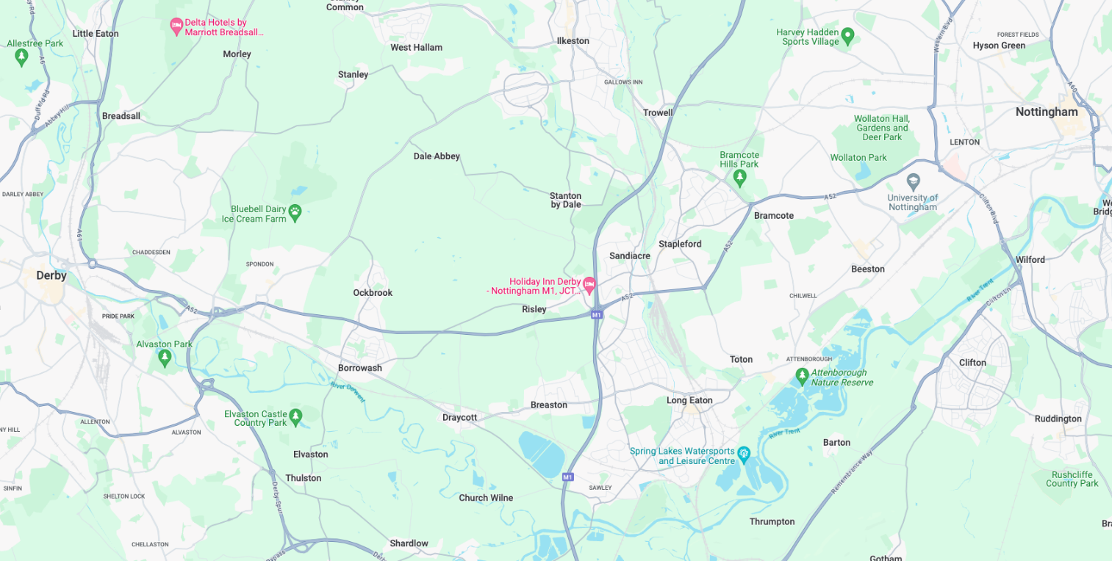
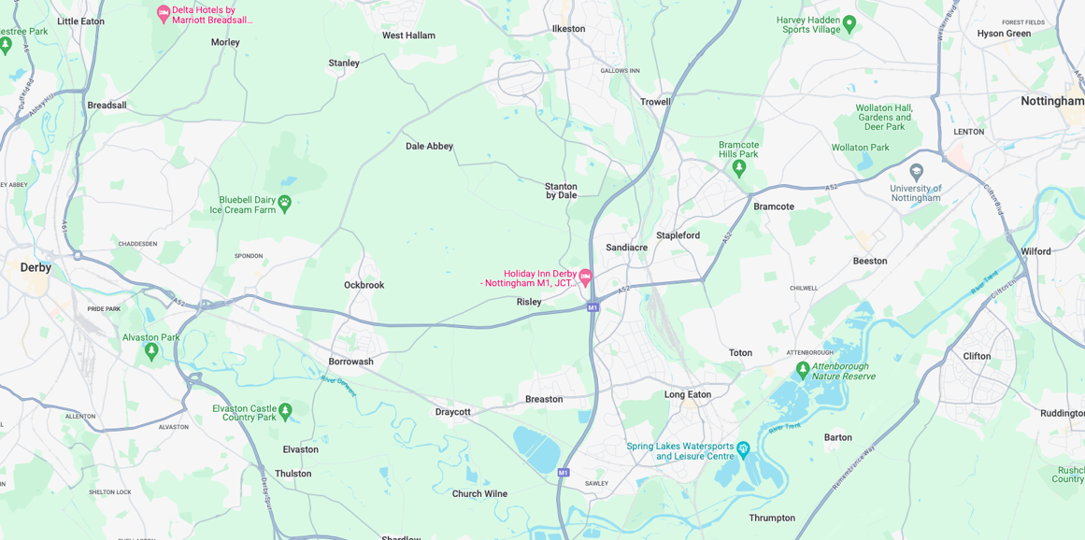


Our Location
Trent College and The Elms are conveniently situated on the border of Nottinghamshire and Derbyshire.
Ideally located at the heart of the UK’s motorway system, we are only 2 miles from junction 25 of the M1, which provides easy access to the M42 and A1.
Reaching Trent College by rail couldn’t be easier. Long Eaton boasts its own train station, located 1.5 miles from the schools. Rail routes through Long Eaton run along the Midlands Main
Line route, with direct routes to London, Loughborough, Leicester, Birmingham, Nottingham, Derby, Chesterfield and Sheffield.

Our Local Community
Working in partnership and serving the community are natural and very important values at Trent College and The Elms. We work with many local schools in Long Eaton and the wider Erewash borough to increase opportunities and aspirations, and to share the school’s excellent grounds, facilities and specialist staff.



Food and Nutrition Technician

Job Description
You will be a key member of our state-of-the-art Food and Nutrition suite, providing general support to staff and students, to ensure the smooth operation of the facility, including ordering ingredients, preparation and cleaning of materials and resources for the department and in giving practical support in the classroom to teachers and students.
Core Duties

You will provide the following support for the department:

- Support learning by assisting students and teaching staff during all practical classes including demonstrations of skills, techniques and equipment.
- Be responsible for calculating ingredients, booking deliveries and ordering from suppliers.
- Help to ensure that statutory safety and hygiene levels are maintained.
- Ensure the maintenance of a clean and orderly working environment. Clear away and clean / launder equipment and materials used for practical purposes, daily.
- Prepare, operate and setup equipment, ingredients and materials required for demonstrations and class practical work. (This will include the preparation of class sets of equipment, weighing ingredients, etc.)
- Ensure all materials and equipment are stored safely.
- To ensure the regular upkeep of the food store, refrigerators and freezers.
- Create displays in class/exhibitions/school.


- Undertake stock control and inventory checks as appropriate including the upkeep of appropriate records and filing systems, using computerised systems where necessary.
- Assist the teacher with learning activities ensuring health and safety and good behaviour of students.
- General administration within the department including photocopying, printing, display, taking photographs of student work, etc.
- Monitor and arrange orderly and secure storage of supplies.
- To consult with suppliers regarding equipment and supplies.
- Ensure the organisation, maintenance, ordering and collection of supplies of both food and equipment.
- Maintenance of everyday equipment, check for quality/safety.
- Report and record any damages.
- Operate and maintain equipment in accordance with instructions.
- Attend relevant meetings as required.
- Participate in training and other learning activities.
- Assist with the supervision of students out of lesson times e.g. clubs, extra-curricular activities as appropriate.
- Be available to administer basic first aid as necessary (training will be given where necessary).
- To assist in planning for visits and visiting speakers.
- To update departmental information resources (recipe cards, leaflets, fact sheets etc.)
- To undertake any other reasonable duties which might from time to time be requested by the Head teacher or any person delegated by them.

The above list is not exhaustive and other duties may be attached to the post from time to time.



Person Specification
 |  | Essential | Desirable
Qualification and Training | GCSE Maths and English |  | X
Qualification and Training | Evidence of further professional development |  | X
Qualification and Training | First-Aid Certificate |  | X
Qualification and Training | Food Hygiene training (training can be given) |  | X
Professional Skills and Experience | Specific Training in Food and Nutrition practical area |  | X
Professional Skills and Experience | Knowledge of safeguarding procedures | X
Knowledge and Understanding | Experience of using ICT (excel, word) | X
Knowledge and Understanding | Experience of Budget/Stock management |  | X
Knowledge and Understanding | Experience in a Food practical environment | X
Knowledge and Understanding | Experience of working with a wide range of young people | X
Knowledge and Understanding | Experience or working in an educational environment with children / young people of a relevant age | X
Abilities | Effective use of ICT and other specialist equipment/resources | X
Abilities | Ability to relate well to children and adults | X
Abilities | Basic food hygiene knowledge and the willingness to undertake further training | X
Abilities | First-aid knowledge or willingness to undertake training | X
Attributes | To be able to work calmly under pressure | X
Attributes | To be an effective team member | X
Attributes | To be flexible and able to manage time effectively | X
Attributes | Be prepared to work flexibly to meet the needs of the school | X
Attributes | To work independently and collaboratively | X
Attributes | Committed to the principals of equality and diversity | X
Attributes | Be willing to undertake training | X





Benefits
- Staff can enjoy complimentary lunches in the Obolensky Dining Hall during term time. Free car parking is available on site and staff have access to a cycle to work scheme.
- Staff are able to make free use of the school gym and leisure facilities at designated times.
- A flexible retirement plan run by TPT Solutions (formerly The Pensions Trust), including Death in Service benefit.
- Enhanced sick pay and maternity pay is available to staff.
- Staff are entitled to a fee remission for children attending the school, in line with our policy.
- We provide a range of benefits to support staff, including counselling, an employee assistance programme and 24/7 online GP consultations.

Terms and Conditions
- Actual salary £19,318
- Fixed Term – End date 2 July 2027
- 35 hours per week (8.30am – 4.30pm with 1-hour unpaid lunch break)
- Term time only


Making an Application
Candidates who wish to apply for this post should apply via our website.
If you have any questions about the role please email recruitment@trentcollege.net or telephone 0115 949 4949 (during term time).
The closing date for applications is included in the advert.
Interviews will take place w/c 5 October 2026.
We reserve the right to close this advertisement early if we receive a volume of strong and suitable applications.

The school is committed to safeguarding and promoting the welfare of children and young people and expects all staff and volunteers to share this commitment.
Applicants will be required to undergo child protection screening appropriate to the post, including checks with past employers and the Disclosure and Barring Service (DBS). The school may carry out online searches on shortlisted applicants and all applicants will be required to provide details of their online profile, including social media account names/handles, as part of their application
The post is exempt from the Rehabilitation of Offenders Act 1974. The school is therefore permitted to ask job applicants to declare all convictions and cautions on a self-declaration form in advance of attending an interview (including those which are "spent" unless they are "protected" under the DBS filtering rules) in order to assess their suitability to work with children.



