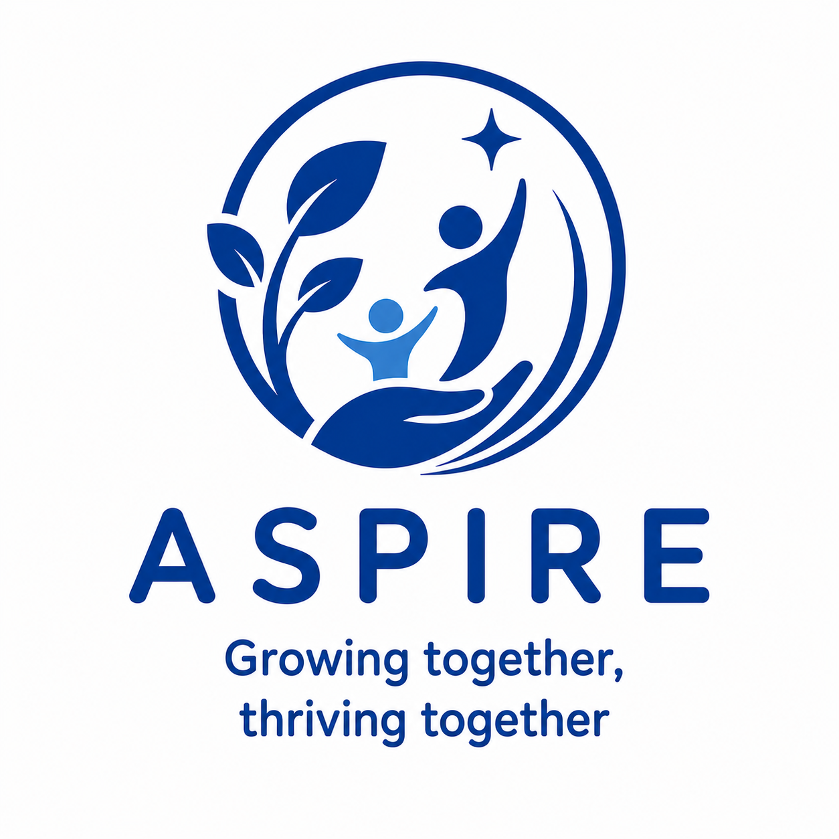
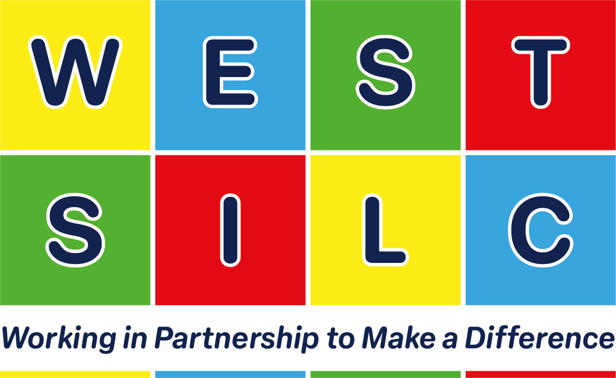

Teaching in Aspire at West SILC
An introduction to the pathway for prospective teachers
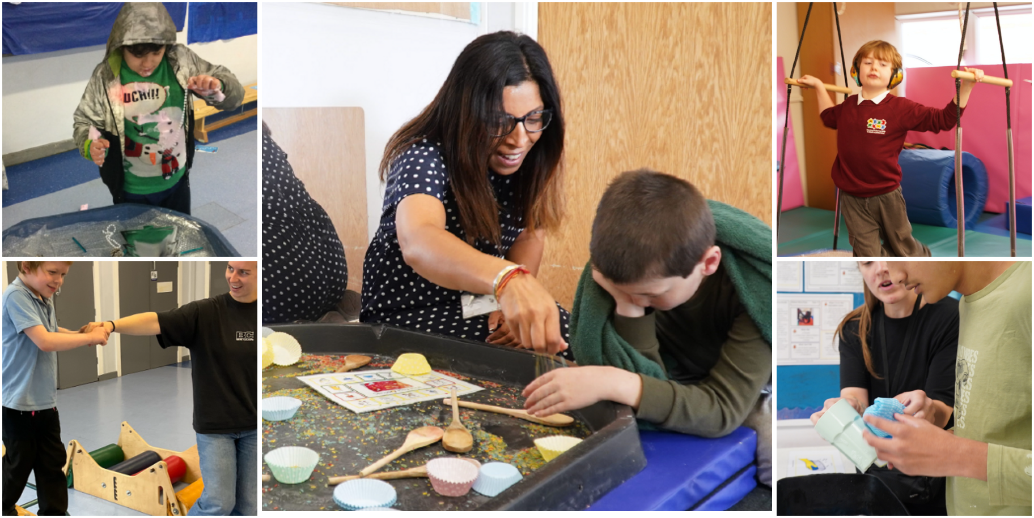

Aspire is a highly personalised pathway for learners in Key Stages 2 to 5 with complex communication needs and autism. Engagement, communication, regulation and growing independence are woven through every part of the day.

A curriculum built around the learner
Topics provide a meaningful context for learning, while each learner's Education Health and Care Plan outcomes and developmental profile determine the next steps. Planning gives balanced attention to communication and interaction, cognition and learning, physical and sensory development, and social emotional and mental health.
Play, experiential learning and carefully planned continuous provision allow learners to explore at their own pace. Skilled adults notice interests, open up possibilities and support participation, while making space for learners to initiate and lead their own learning.

Engagement is the foundation of learning
Area of engagement | What we notice and develop
Exploration | Curiosity and interaction with rich sensory experiences
Realisation | Connections between actions and outcomes
Anticipation | Recognition of routines and what happens next
Persistence | Sustained attention and repeated attempts
Initiation | Self-expression and an active role in learning

Individualisation does not limit challenge. Where a learner shows an emerging strength in early literacy, numeracy or enquiry, carefully selected and adapted learning from the Connect curriculum can enrich the Aspire offer without replacing it.

Planning assessment and progress
Every half term, five small-step outcomes keep learning focused and measurable: one linked to the learner's SCERTS profile and one for each of the four areas of need in their EHCP. Progress is recorded as Emerging, Developing or Secure. Small changes in attention, communication, regulation, choice and independence are treated as meaningful evidence and used to shape the next opportunity.

What teaching looks like in Aspire
Responsive practice that makes participation and progress possible

Aspire teaching starts with close observation and a detailed understanding of how each learner communicates, regulates and engages. The teacher shapes the environment, adults and learning experiences around that profile, adapting in the moment while keeping long-term outcomes in view.

Teaching feature | How the approach works
Learning experiences | Adult-directed sessions are short, visual and motivating. Attention Time and Sensory Stories develop shared attention and curiosity, followed by independent exploration through play and continuous provision.
Communication | Each learner has a personalised Total Communication approach. Intensive Interaction, visual supports, AAC and responsive strategies develop turn-taking, joint attention, choice-making and the ability to express wants, needs and feelings.
Regulation and sensory needs | A holistic timetable helps learners remain calm and ready to engage. This may include sensory integration, hydrotherapy, rebound therapy and individual programmes planned with occupational therapy colleagues.
Relationships and behaviour | Secure, positive relationships are the starting point for learning. Behaviour is understood as communication; staff respond with empathy, adapt the environment and teach more functional ways to communicate rather than relying on punishment.
SCERTS | Social Communication, Emotional Regulation and Transactional Support are embedded across the day so learning remains accessible, motivating and responsive to each learner's communication and regulation profile.

The teacher's role
- Plan motivating experiences that connect EHCP outcomes with learners' interests, sensory profiles and communication systems.
- Lead a consistent class team, modelling interaction, observation, co-regulation and the careful reduction of adult support.
- Work with families, therapists and other professionals so approaches remain joined up across learning, health and care.
- Maintain ambitious expectations while recognising that progress may be shown through very small but significant changes.

Preparing for the future
From Key Stage 2 through Post 16, learning builds towards a good adult life. Communication, relationships, health and wellbeing, community inclusion and practical independence are developed through meaningful real-world experiences. Transition planning is personalised and carried out with families and future providers so that learners move on with continuity and confidence.

This guide accompanies the Aspire teacher advert | www.westsilc.co.uk | recruitment@westsilc.org | 0113 3862450

Safeguarding West SILC is committed to safeguarding and promoting the welfare of children and young people and expects all staff and volunteers to share this commitment. The successful candidate will be subject to an enhanced DBS check and all other relevant safer recruitment checks.

