




Teacher
Burton upon Stather Primary Academy
Candidate
Information Pack
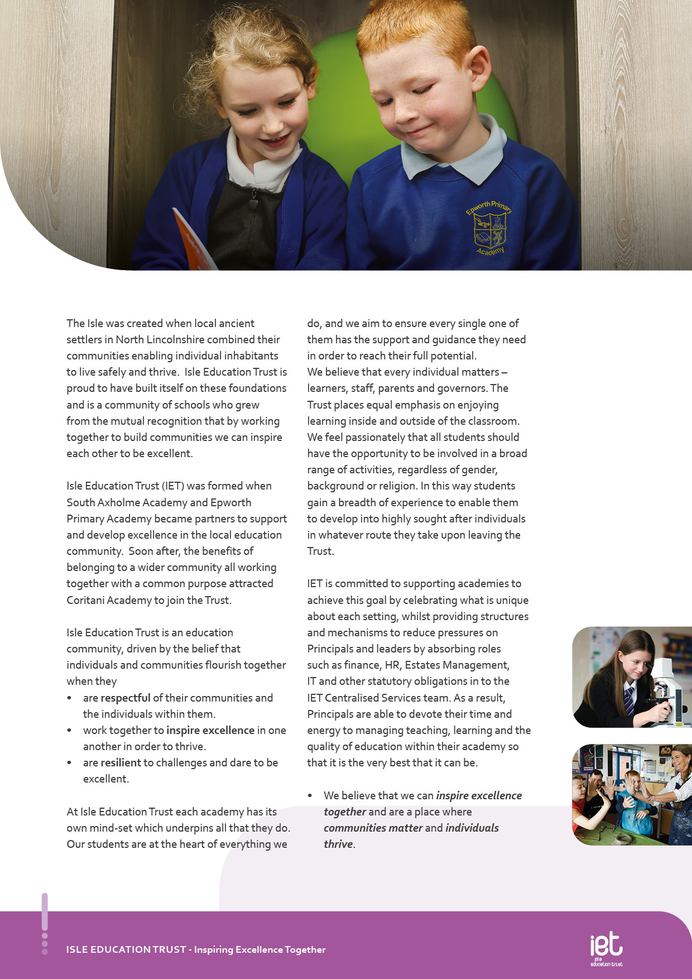
About IET

Dear Prospective Colleague,

Thank you for your interest in joining Isle Education Trust. Whether you are at the start of your teaching journey or bringing a wealth of experience, I’m delighted that you’re considering becoming part of our community.

At Isle Education Trust, our vision is simple yet powerful: Inspiring Excellence Together. We believe in creating environments where individuals thrive and communities flourish. Across our 6 academies- South Axholme Academy, Coritani Academy, Epworth Primary Academy, Alkborough Primary Academy, Kirton Lindsey Primary Academy and Burton upon Stather Primary Academy - we are united by a shared commitment to high standards, inclusive practice, and a deep sense of belonging.

Our values are not just words on a page—they shape how we work, how we support one another, and how we grow. We ask every member of our team to:

Be respectful – acting with honesty, consistency, and care.
Be resilient – embracing challenges and daring to be excellent.
Be inspirational – leading by example and lifting others through our actions.

We know that great teachers change lives. That’s why we invest in your development, champion your wellbeing, and celebrate your successes. Whether it’s through high-quality CPD, collaborative networks across the Trust, or leadership pathways, we are committed to helping you thrive professionally and personally.

Our academies are vibrant, welcoming places to work—where innovation is encouraged, support is ever-present, and every voice matters. If you share our belief in the power of education to transform lives, I warmly invite you to explore the opportunities within our Trust.

We look forward to the possibility of welcoming you to our team.

Warm regards,



Sarah Sprack
CEO, Isle Education Trust

Welcome from the CEO


Dear Candidate,

Thank you for your interest in the teaching position at Burton- upon- Stather Primary Academy.

The academy is located in our charming village in North Lincolnshire, our academy prides itself on being a place ‘where every child can shine’.

This is a particularly exciting time to join our team as we have recently become part of the Isle Education Trust (IET). This partnership allows us to maintain our unique village identity while benefiting from the Trust’s mission of ‘inspiring excellence together’. As an IET academy we are committed to being respectful, resilient and inspirational in everything we do.

Our school offers a vibrant environment where we make full use of our wonderful surroundings, including our dedicated forest school curriculum. We are looking for a dedicated professional who shares our passion for creative and inclusive education and who will thrive in our collaborative community.

I encourage you to explore our website at Burton upon Stather Primary to learn more about our team and values. We welcome visits to the school to see our modern facilities and meet our enthusiastic pupils first hand.

I look forward to receiving your application.

Warm regards
Mr Sean Woolley
Principal, Burton -upon-Stather Primary Academy

.

Andy Marshall
Head teacher

Welcome from the Head Teacher


Burton upon Stather Primary Academy - Where Roots Run Deep and Futures Grow Bright

Set in the heart of the historic village of Burton upon Stather - perched above the River Trent and steeped in centuries of local life - our academy is proud to be part of a community shaped by heritage, resilience, and connection. From the village’s Saxon origins and medieval church to its role in shipbuilding and agriculture, Burton’s story is one of craftsmanship, courage, and close-knit community.

We carry that legacy into our classrooms every day.

At Burton upon Stather Primary Academy, we cherish a culture built on care, curiosity, and high aspirations. Our values - respect, ready and resilience - aren’t just words on a wall; they’re woven through the life of the school, guiding our actions and inspiring our learning.

Here, every child is known and valued. We foster not only academic achievement but also confidence, creativity, and compassion. Staff, families, and pupils work together to create a nurturing and stimulating environment where learning is meaningful and children feel they belong.

In a place where history speaks through the land and its people, Burton upon Stather Primary Academy stands proudly shaping young minds to carry that spirit forward with pride and purpose.



About the Academy

Job Title Teacher

Salary | MPS 1-6/UPS
Job Details | 0.6 FTE (3 days) or fulltime (5days) to be confirmed with successful candidate.
Location | Burton- upon - Stather Primary Academy
Required | 20 April 2026 to 31 August 2026, 1 term
Application Close | 12pm 6 March 2026
Interview Date | Week commencing 9 March 2026

Job Purpose
Class teacher responsible for the development of pupils’ academic, social and emotional development within the Academy. The role has come about to provide cover for class teachers who have taken on additional leadership roles in the academy.

Job Description


Teaching and learning
Meet the expectations as laid out in the STPCD including:
- Carry out teaching duties in accordance with the curriculum
- Liaise with colleagues to plan and deliver work in a collaborative way.
- To ensure a high-quality learning experience by using a range of teaching methods that are appropriate to pupils’ individual learning needs and curriculum requirements.
- Set targets for student attainment levels.
- Demonstrate good practice in the teaching areas of responsibility.
- Work effectively as part of the teaching team to provide an inspiring role model for children and colleagues, and work to ensure every child can flourish.
- To work individually and collaboratively to explore and implement the academy’s vision, values and aims.
- Maintain accurate records to monitor and report on student learning.
- Establish and develop a safe and purposeful learning environment.
- To contribute to the care and holistic wellbeing and development of all children.
- To foster positive relationships and model effective communication with all members of the academy community
Assessment, Recoding and Reporting
- Record pupils’ work
- Keep class registers showing student achievement.
- Maintain lesson evaluations.
- Mark and return work within the agreed time span, providing feedback and targets in line with policy
- Provide assessment reports to monitor student progress.
- Liaise with parents and attend consultation evenings.
- Work within the code of practice relating to Special Educational Needs.
Teamwork
- Work within a team of teachers.
- Understand issues relating to the organisation and support structures within the academy.
- Support and uphold the academy’s policies on behaviour, discipline and bullying.
- Take part in target setting and subject based work.
- Contribute to staff development activities.
- Manage the performance of students and teaching assistants.
Standards and Quality Assurance
- Support the aims and ethos of the academy
- Set a good example in terms of dress, punctuality and attendance.
- Participate in staff training.
- Attend team and staff meetings.
- Develop links with governors.
- Perform any other teaching tasks, as deemed appropriate by your Line Manager

Key Responsibilities and Accountabilities:



INTERVIEWS:
Thursday 13th June 2024
CLOSING DATE:
Tuesday 11th June 2024 at 9:00am
- Work with all students ensuring equality of opportunity for all.
- Take responsibility for Safety and Welfare of all students, raising any concerns following the Academy/Trust protocols and procedures.
- Work proactively and effectively in partnership with all stakeholders.
- Carry out a share of statutory supervisory duties.
- Treat students with dignity and build relationships rooted in mutual respect and at all times observing proper boundaries appropriate to the professional position.
- Participate in CPD relevant to the role.
- Accompany teaching staff and students on visits, trips and out of school activities as required.
- Demonstrate an understanding of and take responsibility for promoting high standards of literacy including the correct use of spoken English and numeracy.
- Participate in arrangements for examinations and assessments.
- Take an active role in promoting good behaviour in and around the Academy/Trust.
- Ensure that students adhere to the uniform code and apply sanctions when this code is breached.
- Develop an academy learner mind-set – the attitudes, skills and learning habits needed to become an inspired, confident and independent learner.
- Be a positive role model and demonstrate consistently and effectively the positive attitudes, values and behaviour which are expected of students.
- Ensure compliance with data protection laws and safeguarding procedures.
- Work as a team member and identify opportunities for working with colleagues and sharing the development of effective practice with them.
- Regularly review the impact of their work and its impact on students’ progress, attainment and well-being, refining approaches where necessary and responding to advice and feedback from colleagues.
- Proactively participate with arrangements made in accordance with the Professional Learning and Growth Policy.
- Have professional regard for the practice, ethos and policies of the Academy/Trust and maintain high standards in your own attendance and punctuality.
- Operate at all times within the stated policies and practices of the Academy/Trust.
- Contribute positively and effectively to the whole Academy/Trust ethos.
- Cooperate with other staff members to ensure a sharing and effective use of resources to the benefit of the Academy, individual departments and students.
- Attend and participate in appropriate calendared meetings.
- Take responsibility for own professional development and duties in relation to Academy policies and practices.
- Ensure compliance with data protection laws and safeguarding procedures.
- Carry out any other duties as directed by your Line Manager as may from time to time be agreed in accordance with the nature of the job described above.
- Liaise effectively with staff, students, parents and governors.
- Ensure compliance with Health and Safety at Work Act 1974 and all other policies related to health and safety, and to ensure compliance with the Data Protection Act 1988.

We expect all Trust staff to:
This is not an exhaustive list of tasks and job descriptions will be continually reviewed and changed according to the needs of the Trust.

Post holders will be expected to be flexible in undertaking duties and responsibilities attached to their post and may be asked to perform duties, which reasonably correspond to the general character of the post and are commensurate with its level of responsibility. This job description is provided for guidance only and does not form part of the contract of employment.


Qualifications | Essential | Desirable
Qualified Teacher Status | AI
Professional development relevant to the post | A
Qualified to degree level or relevant qualification | A
Personal Qualities | Essential | Desirable
passionate about making sure that all pupils succeed in life | AI
is positive with pupils and staff despite any challenges or adversity | A
believes all pupils can succeed given a safe and nurturing environment | I
believes in a small school approach | I
is a champion of diversity | AI
wants all pupils to receive the best quality curriculum and teaching and learning | AI
can develop close partnerships with pupils and parents | AI
puts pupil voice at the heart of development | A
is capable of delivering differentiated learning | A
good understanding of child development and learning | I
is flexible in their approach to the delivery of an inspiring curriculum | I
experience of working in an educational setting or similar environment | A
A sense of humour and a good sense of wellbeing | AI
Professional knowledge, skills and understanding
Demonstrate success in raising achievement | AI
The ability to create an outstanding learning and teaching environment for students, including disabled students and students from under-represented groups | A
Knowledge of the National Curriculum and appropriate interventions for students to achieve success | AI
Knowledge of the key role that attendance plays in attainment | AI
Strong behaviour management skills | AI
Confident user of data, able to provide analysis and measure impact of interventions | AI

Person Specification:

High expectations of self and others | Essential | Desirable
A flexible and adaptable approach | AI
An innovator with the desire to continue to learn | AI
Resilience and the determination to be successful within this role and ambitious for the Academy and its pupils | I
Safeguarding Students | Essential | Desirable
Committed to safeguarding and promoting the welfare of children and young people | I
Equal Opportunity | Essential | Desirable
The ability to ensure that there is equality of access to educational attainment and that all aspects of equal opportunities are adhered to | I

KEY
A = assessed through the application process
I = assessed through the interview process


c
 Pension Scheme
All staff are enrolled in either the Teachers’ Pension Scheme or Local Government Pension Scheme, whichever is relevant.
 Continuous Professional Development
IET offers numerous opportunities for continued CPD for all staff including NPQs and apprenticeships

 Cycle to Work Scheme
Eligible staff may apply to purchase a new bike, e-bike or cycling accessories through this salary sacrifice scheme, making significant savings.

 Staff Wellbeing
This is a priority for the Trust. All staff have access to a free Employee Support Package, including 24/7, 365 days a year online and telephone support covering areas such as mental health, bereavement, financial advice and counselling.

 Healthcare
All staff have free access, 24/7, 365 days a year to an online doctor.

 Flu Vaccinations
All staff are able to request a free voucher for a flu vaccination in the Autumn term.

 Discounts
Through our employee benefits platform, staff can make significant savings through discounts and vouchers in a range of areas including restaurants, supermarkets, retail and holidays.

Trust Benefits:


Appointment Process
How to apply
To apply for this post, visit the IET website:

Isle Education Trust - Vacancies

Please note that the personal statement you provide as part of this process must be no longer than 1000 words.

Receipt of early applications from candidates with the appropriate experience, qualifications and personal qualities may result in an early interview being offered.

Isle Education Trust promotes equality of opportunity and welcomes applications from all sectors of society.

Isle Education Trust is committed to safeguarding and promoting the welfare of children and expects all staff and volunteers to share this commitment. All posts at Isle Education Trust are subject to an Enhanced Disclosure and Barring check.

