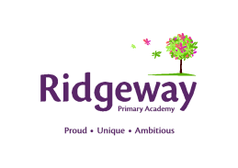
Ridgeway Primary Academy
HLTA Specification Personal
July 2026
SCP: 12

 | ESSENTIAL | DESIRABLE | METHOD OF ASSESSMENT
Educational Attainment | - NVQ Level 3 or equivalent qualification or experience in relevant discipline  - HLTA status | - Evidence of further training/Development | - Application form  - Certificates
Work Experience | - Substantial experience in a support environment relevant to the post | - Experience of whole class teaching  - Experience of working across all key stages | - Application form  - Interview  - References
Knowledge/  Skills/  Aptitudes | - Effective use of ICT to support learning  - Use of other technology equipment – photocopier etc.  - Understanding of relevant polices/codes of practice and awareness of relevant legislation  - Understanding of national/foundation stage curriculum and other basic learning programmes/ strategies  - Understanding of child development and learning  - Excellent numeracy/literacy skills  - Knowledge of training in the relevant learning strategies e.g. literacy |  | - Interview  - References
Disposition | - Able to self-evaluate learning needs and actively seek learning opportunities  - Able to work constructively as part of a team, understanding classroom roles and responsibilities and your own position within these  - Able to relate well to children and adults  - Committed to the principles of equality and diversity  - Flexible approach to work |  | - Interview  - References
Circumstances | - Enhanced clearance from the Disclosure and Barring Service |  | - DBS check

