

Introduction
Welcome to Notre Dame Preparatory School (NDPS).
Notre Dame Preparatory School offers a nurturing and inclusive environment where every child is encouraged to thrive. Situated in Norwich, NDPS has served its community since 1864, building a reputation for excellence and maintaining the highest standards across all aspects of school life. We are delighted that you are considering joining our dedicated team, who work collaboratively to create a safe, nurturing and stimulating atmosphere for pupils and staff alike.
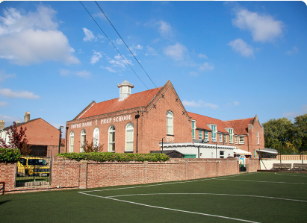
The History
Notre Dame Prep School was founded in 1971 as a Charitable Trust in its own right having been part of Notre Dame School (an Independent Convent School for Children from 5 – 18) based at Surrey Street, Norwich. The original Notre Dame School changed its status to become a Voluntary Aided High School. A group of parents set up Notre Dame Preparatory School, (Norwich) Ltd and the school moved to 147, Dereham Road, Norwich. The premises are leased from the Catholic Diocese of East Anglia. Having originally been an all-Girls’ School, the school has developed into a co-educational Preparatory School for children aged 2 – 11 years of age.
The School Today
As a Catholic independent school, we uphold a strong Christian ethos whilst warmly welcoming families from all faiths or none. There are no entrance examinations or religious requirements for admission, reflecting our commitment to inclusivity. Our provision extends from nursery (aged 2) through to the main school (aged 11), offering a well-rounded, forward-looking education that prepares children for their futures beyond primary education. The school currently has a roll of approximately 115 pupils and is known for its well-mannered and friendly children, families from diverse backgrounds and excellent academic achievements.
Mission Statement & Aims
As a Catholic school we endeavour to nurture a love of God through Jesus Christ in all our children. The school has an ethos of love and care and embraces children of all faiths. Children are treated as individuals, respected, nurtured and encouraged to embrace and fulfil their potential in all areas of school life.
We foster positive relationships with peers and adults, looking for mutual respect.
We provide a wide-range of extra-curricular activities in order to develop the talents of each child.
In order to achieve the above the following statements are of paramount importance:
- We must value everyone; children, colleagues and parents for the unique people that they are.

- We must develop compassion, tolerance, empathy and co-operation in our children.
- We must encourage our children to look beyond themselves in order to develop spiritually and creatively.
- We must first believe in ourselves and encourage children to believe in themselves.
- Learning means growing and acknowledging our strengths and weaknesses.
- We must encourage our children to set goals, take risks, make decisions and develop their confidence to change their thinking, when necessary, in order to achieve goals.
- We must believe that all things are possible.
- We must encourage children to give of their best at all times and not to be content to give less.
- We must praise our children for their efforts.
- We must acknowledge that the quality of education that we give to our children will be a determining factor in how their lives unfold.
- To acquire knowledge and to use it wisely is a powerful force.

Structure of the School
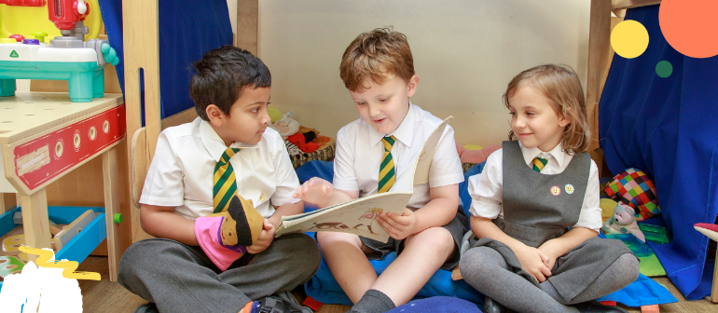
Our school consists of a Nursery and the Main School. Our Minibeast Nursery caters for 2- to 4-year-olds. Our main school pupils are aged from 4 to 11 years from Pre-Prep to Prep 6. The school has spaces available in almost all classes. The school is single form entry.
The school has four houses, Acutis, Francis, Clare and John. The children value participating in inter-house competitions and earning rewards for good work and excellent behaviour.
Lessons are challenging, inspiring and creative. Our recent Independent Schools inspection report 2025 confirmed that all relevant standards were met and can be accessed here - Regulatory Information - Notre Dame Prep School
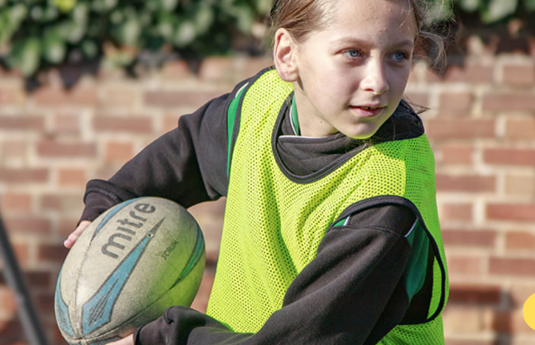
There is a strong support for those children with SEN and for those children that need a boost. The Deputy Headteacher(academic), is also the SENCo and liaises closely with the staff to ensure that the children’s needs are met. The other Deputy Headteacher is responsible for the EYFS and Pastoral Care including safeguarding throughout the whole school.
The school offers a wide variety of extra-curricular clubs each term which the children enjoy from Pre-Prep to Prep 6. Clubs vary from term to term but include activities such as drama, story-telling, art and craft, multi-sports, dodgeball, netball, football and musical theatre.
Notre Dame Prep is a vibrant community where pupils develop confidence, happiness and a strong sense of self-worth, knowing they are valued and loved. Staff are guided by the commandment ‘Love one another as I have loved you’, fostering a culture of kindness and respect throughout the school. Opportunities for creative expression and religious understanding are woven into our curriculum, including art and drama. Our Catholic identity is central to school life, permeating the daily experience for all members of the community. 
Our mission extends beyond the school gates, with staff and pupils actively supporting charitable initiatives locally, nationally and internationally, striving to ‘make the world a better place for everyone’. We are confident that NDPS is an exceptional learning environment—where children are encouraged to be the best they can be, and where staff are valued for their commitment and passion.
We invite you to join us and contribute to the ongoing success and ethos of Notre Dame Preparatory School.

HOW TO APPLY
If you wish to discover more about this exciting opportunity and would like to have an informal discussion or arrange a visit to the school, please contact our Chair of Governors - Kevin Long via the clerk to the governors - alliwarne@notredameprepschool.co.uk
- COMPLETE AN ONLINE APPLICATION FORM - Here
Please follow the link above to visit the main vacancies page on our school website. Search for the vacancy you wish to apply for and complete the online application form in full and submit it to us before the closing date .
Closing Date: Noon 13th April 2026
Return applications to the Clerk to the Governors Alli Warne: alliwarne@notredameprepschool.co.uk

- INVITED TO INTERVIEW
Candidates will be notified if selected for interview by 17th April 2026.
- Child Protection
NDPS is committed to safe-guarding and promoting the welfare of children and young people and expects all staff to share this commitment. All applicants should read the School’s Safeguarding & Child Protection policy, which is available on the website, and are required to declare any criminal convictions or cautions, or disciplinary proceedings related to young people. The successful candidate will be required to complete an application for Enhanced Disclosure, to initiate a Criminal Records Check (working with children) and an Open Source check will be undertaken.
Applicants must be willing to undergo child protection screening appropriate to the post, including, but not limited to, checks with past employers and the Disclosure and Barring Service (DBS). Identity will be checked for shortlisted candidates conforming to the School’s Safeguarding Policy.

- GDPR
NDPS is also registered for the processing of personal data in accordance with UK General Data Protection Regulations (GDPR) Act 2018. Such checks are required in accordance with the school’s policy on Disclosure Information, data protection policy and policy for handling Disclosure information received from the Criminal Records Bureau. Copies of these policies may be obtained from the school’s website.

- References
Short-listed Candidates must also agree to references being taken up at that stage and checks made with past employers. The appointment is subject to robust safer-recruitment procedures, including but not limited to, satisfactory references, satisfactory clearance from the DBS, proof of identity, section 128 check, prohibition from teaching and qualifications.
A formal contract, detailing terms and conditions, will be drawn up on appointment in accordance with ISA guidelines. The following notes provide guidance, without prejudice, on the likely main provisions:
General Notes:
- A highly competitive remuneration package will be available.
- There is a 50% discount on fees for the children of staff
- The appointment will be subject to two terms’ notice.
- Holidays are by arrangement with the chair of governors and to be taken during the school holiday period
- the Head Teacher should expect to be available for some periods outside term-time to attend calendared strategic planning days, attend INSET or attend school events and activities.
- The Head Teacher’s performance will be subject to a regular appraisal, conducted by the governing body.
- The successful applicant will be required to complete a self-disclosure Medical Questionnaire.
- Please note for this role 3 referees will be required. One referee must be your Parish Priest. Referees will not be contacted until after candidates are notified that they have been selected for interview.
DATES FOR THE SELECTION PROCESS
Closing date: Noon on Monday 13th April 2026.
Candidates notified if selected for interview: Wednesday 18th April 2026.
Interviews: will take place during week commencing Monday 20th April 2026.
Job Description
Post Title - Headteacher
Responsible to
The Governing Body of Notre Dame Preparatory School
Context and Catholic Ethos
Notre Dame Preparatory School is a Catholic school within the Diocese of East Anglia. The Headteacher is a reserved post and must therefore be filled by a practising Catholic in good standing with the Church. The Headteacher is expected to provide visible, authentic and inspirational Catholic leadership, ensuring that the Catholic ethos and mission of the school permeate all aspects of school life.
The Headteacher will work in close partnership with the Governing Body, the Diocesan Director of Schools’ Service, and the School Chaplain to ensure that the school’s strategic direction, standards, and Catholic identity are maintained and strengthened.
Purpose of the Role
The Headteacher has overall responsibility for the leadership, management and development of Notre Dame Preparatory School. The role combines strategic leadership with operational oversight, ensuring high standards of education, strong safeguarding practice, financial sustainability, and a positive, inclusive culture rooted in Catholic values.
Key Responsibilities
Catholic Life and Mission
- Lead the school as a practising Catholic, modelling Gospel values and the teachings of the Catholic Church.
- Sustain and further develop the Catholic ethos of the school in worship, curriculum, relationships and behaviour.
- Work closely with the School Chaplain to provide high-quality spiritual provision for pupils and staff.
- Ensure the school maintains and improves its Catholic inspection outcomes.
- Lead assemblies and whole-school prayer that reflect Catholic tradition and values.
Strategic Leadership and Governance
- Provide clear, strategic leadership and vision for the school, working with the Governing Body to deliver the strategic priorities of the school as set out in the School Development Plan.
- To produce, monitor and review the annual School Development Plan in consultation with the SLT and governing body.
- Advise and support the Governing Body in the effective discharge of its statutory and strategic responsibilities.
- Report formally and regularly to the Governing Body on:
  - Progress against strategic priorities as set out in the School Development Plan.
  - Educational standards and pupil outcomes in compliance with the Independent Schools Standards Regulations (ISSRs).
  - Safeguarding and welfare.
  - Staffing and performance.
  - Present and projected pupil numbers.
  - Financial performance and risks.
- Inform the Governing Body in advance of any decisions with financial or strategic impact, including all remuneration decisions for staff.
Culture, Behaviour and Inclusion
- Establish and sustain a positive, inclusive culture aligned with Catholic values and high expectations for behaviour.
- Promote equality, dignity and respect for all, while showing tolerance and understanding of other faiths and beliefs.
- Ensure the needs of all pupils are met, including those with SEND, and that statutory duties are fulfilled.
Teaching, Learning and Curriculum
- Lead and monitor the quality of teaching and learning across all key stages, including the Early Years Foundation Stage.
- Ensure the curriculum is broad, balanced and ambitious, and that the Religious Education Directory is fully implemented across all year groups.
- Promote effective use of formative and summative assessment to raise standards and improve outcomes.
- Participate annually in set examinations, as appropriate to the role.
- To oversee the pastoral and spiritual development of pupils.
- To be familiar with the work being done by members of the school and EYFS, through regular lesson observations, pupil work scrutiny and the annual staff appraisal system.
Staff Leadership and Development
- Lead and manage all teaching and non-teaching staff, fostering a culture of high performance and professional growth.
- Ensure robust safer recruitment, retention and performance management processes are in place.
- Implement an annual appraisal process for all staff, clearly linked to professional development and remuneration.
- Ensure all staff receive appropriate safeguarding training and ongoing development.
- Ensure awareness and adherence to all relevant school policies and assist with the development and review of the same.
- To monitor the completion of records on pupils.
- To appoint and induct new staff to the school and EYFS and organise a subject mentor for ETCs and PGCE students in accordance with school policy.
- To be involved in the appointment and induction of ancillary staff, including classroom assistants and lunchtime supervisors.
- To identify and develop skills of Class Teachers, including recommendations for staff Inset as part of a coordinated programme of continuing professional development.
- To participate in the appraisal of teachers within the school, and agree follow up action.
- To ensure the security of the school buildings in conjunction with the Estates Manager.
- To ensure that a suitable school Health & Safety Policy exists and is followed by members of the school.
- To be responsible for the conduct of fire drills.
- To produce twice termly reports for Governors as required and attend all Governors’ meetings
- To oversee the construction of the termly academic and co-curricular programme, including the managing and staffing of the after-school care provision.
Safeguarding and Compliance
- Take overall responsibility for safeguarding and safer recruitment, ensuring statutory requirements and best practice are met.
- Ensure the school complies with all relevant legislation, including Keeping Children Safe in Education 2025, Equality Act 2010, Health and Safety regulations 1974, and Independent School Standards Regulations.
- To ensure that the school remains “inspection ready” ahead of any ISI and CSI scheduled inspections
- Ensure safeguarding training is up to date for the Headteacher and all staff.
Financial and Operational Leadership
- Work with the school’s accountants to ensure sound financial management and long-term sustainability.
- Develop and implement a sustainable growth plan, including a clear marketing strategy to promote the school.
- Oversee budgeting and targeted spending across all departments.
- Ensure the school estate is maintained within available resources.
- Promote and develop nursery provision and wraparound care to support growth in early years.
- To plan, allocate and monitor the school budget, including bidding for extra resources for planned future developments as part of the Strategic Development Plan.
Recruitment, Admissions, External Relations and Marketing
- Act as an ambassador for the school, promoting its vision and achievements to parents, prospective families and the wider community.
- To be the “face” of the school and EYFS setting to current and prospective parents
- To meet parents of prospective pupils and arrange for tours of the school as required
- Foster strong relationships with other schools, external agencies and educational bodies.
- To review annually all literature relating to the school, both hard copy and electronic, and amend as necessary. To ensure that the school website and social media platforms are up to date with current news.
- To develop positive and lasting relationships with ISA, CISC and local primary schools to raise awareness of NDPS as a leading independent co-educational Catholic prep school.
Operational
- To oversee the organisation of the weekly assembly programme and staff duty rotas.
- To calendar and oversee the arrangement of Parent/Teacher Consultation Evenings (in conjunction with the SLT) and to deal with any queries from parents relating to pupils’ educational progress and welfare.
- To organise special events and functions within the school (e.g. Harvest Thanksgiving Service, Christmas and Easter Services, etc.) in conjunction with the Chaplain and SLT.
- To fully support the wider life of the school by attending evening and weekend concerts, drama productions, sports fixtures, Masses and other set-piece events such as Open Mornings, Sports Day, PTA events and other school events.
- To undertake any other reasonable duties as required by the governing body.

Person Specification – add source of evidence
The following table sets out the selection criteria for the post. All criteria under Essential must be met. Desirable criteria will be used to differentiate between candidates who meet all essential requirements.
Person Specification Table
Category | Specification | Essential | Desirable | Source of Evidence
Catholic Faith and Mission | Practising Catholic in good standing with the Church | ✓ |  | Reference from Parish Priest
Catholic Faith and Mission | Clear commitment to the Catholic mission and witness of the school | ✓ |  | Interview
Catholic Faith and Mission | Ability to lead Catholic worship and prayer | ✓ |  | Personal Statement and Interview
Catholic Faith and Mission | Active involvement in parish life |  | ✓ | Interview
Qualifications | Qualified Teacher Status (DfE recognised teaching qualification) | ✓ |  | Copies of Certificates
Qualifications | Bachelor’s degree | ✓ |  | Copies of Certificates
Qualifications | Up-to-date safeguarding training | ✓ |  | Copies of Certificates
Qualifications | Catholic Certificate in Religious Studies (CCRS) |  | ✓ | Copies of Certificates
Qualifications | Master’s degree or master’s-level qualification |  | ✓ | Copies of Certificates
Experience | Successful leadership experience as a Deputy or Assistant Headteacher | ✓ |  | Employment History
Experience | Experience as a Headteacher |  | ✓ | Employment History
Experience | Significant and recent teaching experience in primary education | ✓ |  | Employment History
Experience | Experience of leadership across at least two primary key stages | ✓ |  | Interview
Experience | Experience of teaching across all three primary key stages, including Early Years |  | ✓ | Employment History
Experience | Experience in a preparatory or independent school setting |  | ✓ | Employment History
Experience | Proven track record of raising attainment and sustaining high standards | ✓ |  | Interview
Experience | Experience of recruitment, retention and performance management of teaching and non-teaching staff | ✓ |  | Interview
Experience | Proven experience of managing a school or departmental budget | ✓ |  | Interview
Experience | Experience of policy development, implementation and evaluation | ✓ |  | Personal Statement & Interview
Experience | Strong understanding of safeguarding and pupil welfare | ✓ |  | Personal Statement & Interview
Experience | Strong strategic thinking and leadership skills | ✓ |  | Interview
Skills and Knowledge | Excellent communication skills with pupils, staff, governors, parents and external stakeholders | ✓ |  | Interview
Skills and Knowledge | Ability to analyse data to inform improvement | ✓ |  | Personal Statement & Interview
Skills and Knowledge | Knowledge of current educational developments, including curriculum and assessment requirements | ✓ |  | Personal Statement & Interview
Skills and Knowledge | Understanding of Independent School Standards and regulatory requirements |  | ✓ | Personal Statement & Interview
Skills and Knowledge | Integrity, energy and resilience | ✓ |  | Personal Statement & Interview
Personal Qualities | Commitment to continuous professional development | ✓ |  | Personal Statement & Interview
 | Ability to inspire, motivate and lead others | ✓ |  | Personal Statement & Interview
Governance | Prior membership of a governing body |  | ✓ | Personal Statement & Interview

