

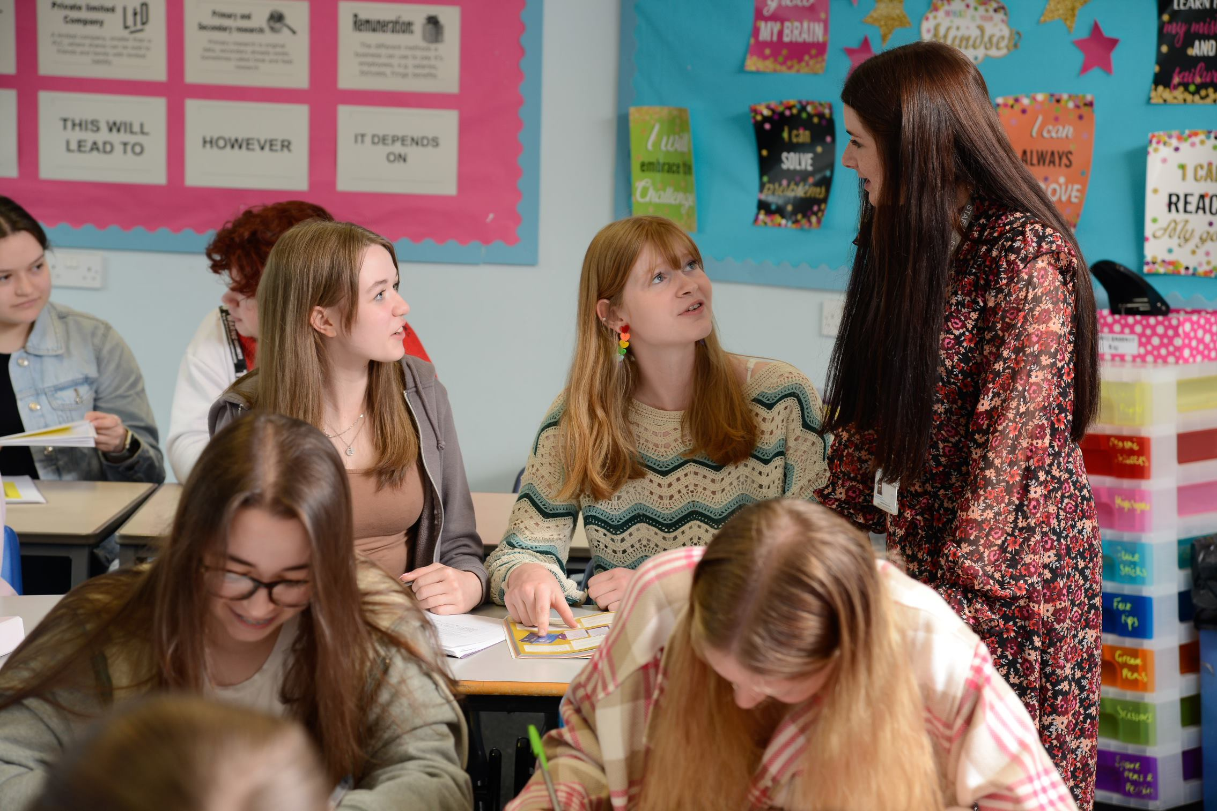

WELCOME TO BUXTON COMMUNITY SCHOOL

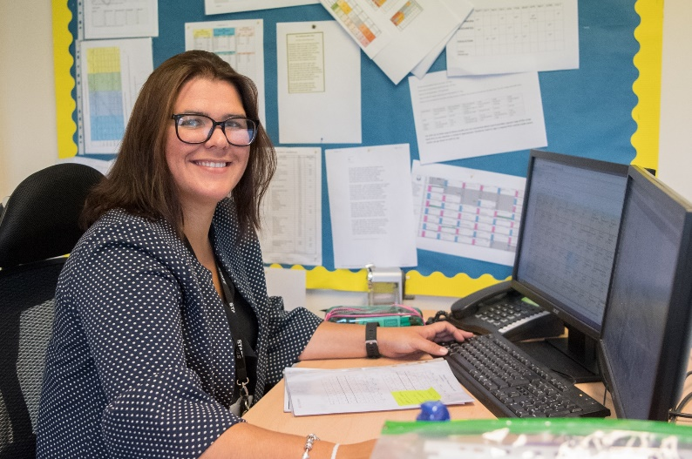

Welcome to our school which is part of the Embark Federation. We are proud to be part of a family of 25 schools across Derbyshire who believe that by working together as a team we can create schools that ‘stand out’ at the heart of their communities. Our trust has four core beliefs; Family, Integrity, Teamwork and Success, which are integral to everything we do.
We have high standards across our schools but want to ensure that the school experience for our children is a magical time. Our purpose is to enable everyone in our Embark family to be able to ‘Love Learning, Love Life.’
We are a successful, supportive and high achieving secondary school based in the heart of the Peak District with just under 1,000 students on roll. As an 11-18 provider, we play a key part in providing the highest quality education and support for our students across a broad range of subjects at KS3, KS4 and KS5.
Our approach with the students involves acknowledging and rewarding positive behaviours and achievements whilst challenging and supporting students to be the best version of themselves. Our values, Ready, Respectful and Safe are instrumental in achieving our vision.
Our principles for learning are focused on learning for the long term and developing deep understanding. We have developed a clear strategy that underpins what happens in our classrooms. Teachers who join our school will find well-resourced and planned schemes of learning. However, they are not prescriptive, we believe the professional in the classroom is the subject expert and the champion of the needs of the children in their classes. Staff wellbeing is of utmost importance to me, and we have adopted a number of approaches in order to support in this area of school life. For example, we support all our staff by providing additional non-contact time above that of most schools to allow them the chance to prepare and assess effectively.
I am keen to appoint subject specialists who are passionate and demonstrate true excitement for their subject. We want staff who are positive, energetic, enthusiastic and deeply committed to supporting our young people, and who are prepared to go that extra mile to contribute to our whole school improvement.
We want the best for our staff and young people, and we will not let it get more complicated than that.
Joining a new school will be a huge decision for you, I am sure you will have worked through our website, read our inspection report and looked at our data but you need to know what more there is to our school. I would be happy to talk with you as a prospective candidate before or after you submit an application and talk with you about our ethos and values, our priorities and answer any questions you might have. Please contact DeniseLowe@buxton.derbyshire.sch.uk to arrange a call. The recruitment process will also give you every opportunity to learn more about our school. I would like to take the opportunity to thank you for your interest in this post.

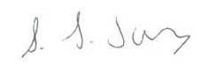
Samantha Jones
Headteacher

The Role

Buxton Community School is seeking to appoint a well-qualified and enthusiastic teacher to join the Music Department on a temporary basis to cover maternity leave.

We are seeking a Teacher of Music for our Music Department. The post offered is a temporary part time contract working two days per week – Wednesday and Thursday.

This is a fantastic opportunity for an enthusiastic, inspirational and highly motivated professional. This post is suitable for unqualified teachers, NQTs and experienced teachers and the successful candidate will be a highly committed team player, with a passion for music and understanding of the strategies required to motivate and inspire students.

Salary: Unqualified Teacher or Main/Upper Pay Scale
Contract Type and Term: Maternity Cover, temporary and part time
Start date: 6th May 2026

The Department

The Music Department at Buxton Community School has one full time member of staff and we are looking to recruit a part time teacher to work two days per week to meet our music lesson timetable for this academic year. This is a temporary post to cover maternity leave for an existing member of staff from November 2021.
At Key Stage 3 students cover a number of topics through keyboard skills, singing, rhythm (Rhythm Cups, Djembe drumming and Samba drumming), ICT and ukulele skills. They begin to compose music fit for particular occasions and start to develop crucial performance skills.
The department has 15 music workstations running Mixcraft and Musescore software. Students explore this software throughout KS3 and KS4 for composition and recording.
GCSE Music (Eduqas) is offered as an option choice for Year 10 and 11 students.
A number of extracurricular clubs run at lunch times and after school including two choirs, an instrumental ensemble, keyboard club, Band Academy and Musical Theatre Club.

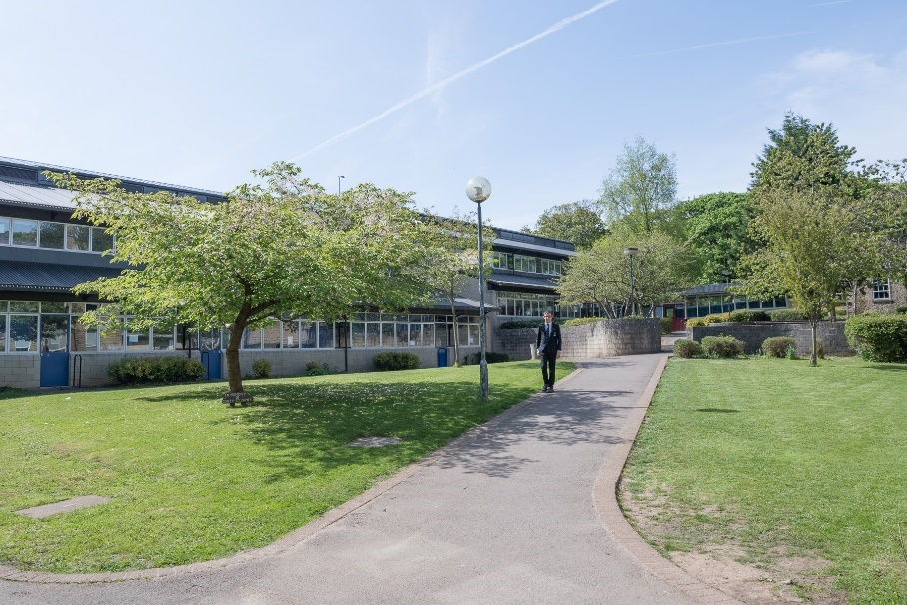

Job Description

Post Title: Teacher of Music – Maternity Cover

Grade: MPS/UPR

TLR: N/A

Responsible to: Head of Music

Post Objectives: The post-holder will work together with the other members of the department to help students learn to their full potential.

Duties and Responsibilities:

Classroom Management
Students learn best in an orderly environment where work is sufficiently challenging to motivate and stimulate them. They also need to be given clear objectives for their learning and regular feedback. All teachers should promote the school’s Aims and Values and implement school policies and procedures in order to establish a sound learning environment. They should aim for the highest possible standards of work and behaviour at all times. This will involve:
- preparing and teaching lessons which are appropriate, challenging and stimulating
- employing procedures for encouraging good behaviour and dealing with poor behaviour
- assessing students’ work in line with department and school policies
- implementing the school system for rewards
- setting and marking homework.

Assessment
The teacher will fulfil all requirements of the school policy on Assessment, Recording and Reporting. They will assess regularly as a means of monitoring progress, diagnosing weakness, informing future teaching and as a basis for target setting.
This will involve working within department and school policies to:
- establish record keeping procedures
- complete all reports
- carry out such assessments as required by the National Curriculum
- pass on to other staff who may teach the students, appropriate assessment data, (e.g. at end of year)
- carry out end of Key Stage assessments
- prepare students for internal and external tests and examinations
- report to more senior staff and parents as required.

Special Educational Needs
The postholder will be aware of the range of student abilities within each class and endeavour to ensure that all students can, and do, make progress. This will involve:
- being aware of the individual needs of the students in the teaching group
- ensuring that teaching materials are appropriate and allow students access to the learning
- employing a range of activities so that students have the opportunity to succeed
- liaising with Special Needs staff over individual students
- planning with support staff to clarify roles and responsibilities
- contributing to Individual Education Plans

Curriculum
This will involve:
- sharing in the production of resources with others in the department and in the school
- keeping abreast of current developments in the subject and related areas
- sharing in the development of teaching strategies and approaches
- developing a good classroom environment through display

General
All teachers will:
- be expected to keep themselves up to date with recent education developments and to participate in Inset
- take part in break duty rotas and cover
- participate in the school system of lesson observations

Please note that this document should be read in conjunction with the Conditions of Employment of School Teachers as outlined in the current DfE School Teacher’s Pay and Conditions Document.



Person Specification

(To be read in conjunction with the National Standards for Classroom Teachers)

Post Title: Teacher of Music – Maternity Cover

Grade: MPS/UPR

 | Essential Criteria
Qualifications | QTS (when taking up post)
Qualifications | Relevant Degree
 | Relevant practical experience
 | You are committed to teaching and learning in a comprehensive school
 | You have high expectations of all the students you work with
 | You are able to articulate clear educational values and apply these to your teaching
 | You understand the barriers that can affect students’ learning and show commitment to overcoming these
 | You are able to develop and maintain positive relationships with all students
 | You actively encourage all students to develop and maintain positive relationships with each other
 | You approach problem-solving positively and creatively
 | You are well-organised in your planning and use of classroom resources
 | You work effectively with colleagues to develop and improve learning
 | You use good communication skills (speaking, writing and listening) with the whole school community
 | You are committed to the personal development of the young people you work with
 | You constantly strive to analyse, refine and develop the learning in your classroom
 | You demonstrate high levels of commitment, enthusiasm and motivation
 | You are hard-working and dependable
 | You have an excellent record of attendance and punctuality
 | Outline of clear educational philosophy linked to post requirements
 | You have effective and positive behaviour management skills.
 | You are an effective team worker with a ‘can do’ attitude that embraces change and creativity.
 | You show clear evidence of on-going professional development.

A Great Place to Work

We care passionately about our staff, their well-being and their professional development and this is reflected in the fact that we are an enthusiastic team, committed to working collaboratively and sharing the very best practice.

We can offer:
- a strong team environment that takes staff well-being seriously
- a dedicated Senior Leadership Team who want to see their staff progress
and flourish in their career
- an active teaching and learning research and development group
- very supportive parents and a high standing in the community
close and successful working relationships with other schools within the High Peak area

Diversity & Inclusion

At Buxton Community School we hire the best, give them first-class training and if you are driven to perform, you’ll fit right in. We approach our work fearlessly, learn quickly, improve constantly, and celebrate our wins at every turn.

We are passionate about creating an inclusive workplace which promotes and values diversity in age, gender identity, race, sexual orientation, physical or mental ability and ethnicity. More importantly, creating an environment where everyone, from any background, can do their best work is the right thing to do. Everyone is welcome—as an inclusive workplace, our employees are comfortable bringing their authentic whole selves to work.

The Town of Buxton
Buxton Community School is a school truly at the heart of the town and the area is a beautiful part of the country.
At 1,030ft above sea level, Buxton is said to be the highest market town in England. Tourists have been coming to Buxton and the Peak District since the 14th Century and it’s not surprising that Buxton is today one of the most popular tourist destinations in the Peak District. Within an hour’s drive of Manchester, Sheffield, Derby and Stoke, its famous Georgian and Victorian architecture with buildings such as The Crescent, The Pavilion Gardens and The Opera House it provides an impressive backdrop to a rich and vibrant range of music, theatre and festivals.
The Buxton Festival of World Cinema takes place around March/April, with the Big Session Festival of folk music in April/May. July brings the Buxton Festival of Opera, Music and Literature, the Buxton Well-Dressing Festival, Buxton Fringe Festival and the Buxton Military Tattoo. In August the Family Festival provides fun for all the family.

The Application Process

Applicants should complete the online application form on My New Term. If you have any questions please do not hesitate to contact The Headteachers PA, Denise Lowe at DeniseLowe@buxton.derbyshire.sch.uk

Closing date for applications is 17th April 2026
Interviews will take place 22nd April 2026

If you are short-listed for interview, you will be contacted in advance to discuss arrangements for the interview. Unfortunately, if you have not been contacted prior to the interview day, your application has not been successful on this occasion.

Buxton Community School is committed to safeguarding and the process of safer recruitment. As a result, this post is subject to an enhanced Disclosure and Barring Service check, and all shortlisted candidates will be expected to prove their identity at interview. The successful candidate will be expected to show original copies of qualifications and further proof of their identity.



