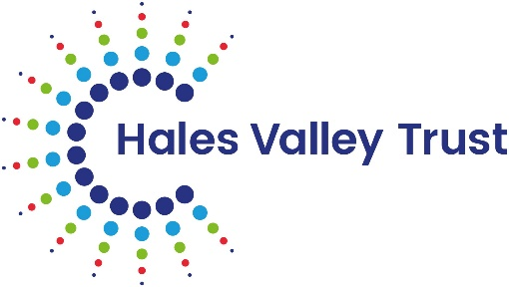

Job title: | EYFS Leader – Gig Mill Primary School
Hours of work: | See advert for details
Salary: | Teachers Main Pay Scale and TLR 2a

This EYFS leader’s job description is in line with the statutory requirement as laid out in the ‘Pay and Conditions Document’, and is subject to annual review.

Main Purpose of the Post
- This leadership post is class based with dedicated leadership time provided each week to undertake duties in addition to PPA.
- To lead a phase of the school, being responsible for the day to day management of the classes within that phase. To be aware of the standards of learning and teaching in all areas across the phase
- To develop high quality teaching and learning and the effective use of resources ensuring all pupils make progress
- To provide leadership which will enable a shared commitment to excellence

To whom the postholder reports
The postholder is responsible to the Executive Headteacher/Head of School in all matters.

Professional Responsibilities of the Phase Leader

School Leadership
- Provide support to the Headteacher in the management of all aspects of the day to day running of the school, ensuring that the aims, policies and values are upheld
- Actively encourage and support all staff within the phase, providing advice, praise and assistance to maintain the school’s high standards
- Foster and develop good relationships within school and between parents and Trust Board
- Foster and develop an atmosphere of trust and care within school in order to generate a healthy team approach and a climate of security.
- To promote the image of the school within the local community.
- Be mindful of Health & Safety regulations, carrying out regular checks of accommodations and equipment as necessary
- Play a role in formulating, implementing, monitoring and reviewing the school self review process
- Play a role in formulating, implementing, monitoring and reviewing the school improvement plan – SIP

Phase Leadership
- To lead the phase, being responsible for the day to day management
- Be responsible for the behaviour of the pupils within the phase, liaising with parents as necessary
- Liaise with the other Phase Leaders to ensure effective transition for pupils from one year to another
- Liaise with other Phase Leaders to ensure effective communication across the school
- Welcome and brief all students and visitors to the team
- Oversee an effective induction programme for new members of staff to the phase
- Be responsible for effective display in all areas of the phase
- Be responsible for the effective use of space within the phase, creating a warm and pleasant indoor environment

Appraisal
- Implement and support the appraisal process as an appraiser
- Carry out teaching observations and monitoring across the school to ensure quality of delivery, effective classroom organisation, behaviour management, use of support staff and learning outcomes
- Lead, develop and enhance the teaching practice of others through monitoring the quality of teaching and learning and sharing judgements with teachers and support staff as appropriate
- Identifying key professional development needs

Curriculum
- To lead a core curriculum area effectively through school
- Work with the SLT to lead, develop and enhance the teaching of strategies which support the development of all aspects of the curriculum
- Create a climate, which enables all staff to develop and maintain positive values and attitudes towards cross-curricula work
- Ensure that the phase curriculum is engaging, exciting and relevant and reflects all aspects of PSHE and our school values
- Ensure that key professional development needs are addressed through the provision of high quality coaching and mentoring
- Monitor and evaluate planning as part of school self review —assessment for learning, progression, adaptive teaching, effective use of resources, SEND provision. Feedback outcomes to the SLT and implement necessary actions as a result

Assessment
- Working with the SLT to be aware of standards across the phase
- Carry out moderation of work across the phase, linked to SIP. Feedback outcomes to the SLT and implement necessary actions as a result.
- To oversee the effectiveness of intervention across the phase
- Use data and pupil outcomes to monitor progress of children across the school, action planning where necessary and with a view to setting and getting targets for further school improvement.
- Evaluate standards of achievement and progress for the EYFS cohort (ensuring that progress is at least age related and that progress is on track)
- Embed the use of the e-profile, monitoring progress in the EYFS profiles, ensuring consistency of approach by all practitioners and liaising with external agencies as required

Monitoring and Evaluation
- To be aware of standards throughout the phase through the monitoring and evaluation of children’s work, lesson observations, assessment data and planning
- Take a lead role in supporting the monitoring and evaluation of teaching and learning across the school and contributing to the completion of the SEF and the development of improvement plans.
- Observe delivery, working alongside colleagues in the classroom
- To produce annual action plans that have specific, time related targets with success criteria

Resources
- To identify resources needed to meet the needs of the curriculum
- Oversee the ordering and use of stock, ensuring that the curriculum is effectively resourced
- To advise the Executive Headteacher/Headteacher and Trust Board of priorities for expenditure.
- To manage the audit of all resources, including suitability for the phase
- To audit, order and monitor and control the use of these resources.

Leading and Managing Staff:
- Organise and lead staff meetings where appropriate
- Provide direction for teaching assistants when working with identified groups and individuals.
- Make effective use of staff expertise
- Plan, delegate and evaluate work carried out by team(s) and individuals, and ensure a consistent approach across the school

Specific to role

Lead the EYFS curriculum, developing creativity, innovation and continuity
- Ensure a successful phonics programme is being implemented in EYFS that addresses the needs of the children, the Letters & Sounds programme and builds upon existing good practice
- Promote stimulating learning environments both inside and outside the classroom and create opportunities for the development of independent learning in EYFS, building upon the play-based curriculum and children and adult initiated learning
- Play a major role in the raising of standards in EYFS.
- Ensure the smooth and effective transition from: Home to Preschool, Preschool to EYFS and EYFS to Year 1
- Support early identification of children with SEND or vulnerable needs
- Be mindful of Health & Safety regulations, carrying out regular checks of accommodations and equipment as necessary

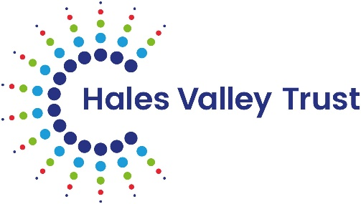
Phase Leader Person Specification

Qualifications and Training
- Degree or equivalent
- Qualified teacher status
- Evidence of ongoing CPD
- Professional development relevant to the post

Experience
Applicants should be able to demonstrate recent and relevant experience of:
- Proven exemplary classroom practice in a primary school
- Demonstrable impact on school improvement
- Ability to analyse and apply data to support intervention strategies

Practical Skills
- Able to organise, lead and motivate a team
- Able to work constructively as part of a team, understanding classroom roles and own position within these
- Able to constantly improve own practice/knowledge through self-evaluation and learning from others
- Able to use ICT to support learning
- The ability to implement assessment for learning
- The ability to plan and teach lessons, ensuring high standards and continuity and progression

Personal Qualities and Attributes
- An ability to establish and develop positive relationships throughout the school
- Ability to be calm under pressure
- The ability and motivation to constantly improve own practice and knowledge through self-evaluation and learning from others
- Have excellent written and verbal communication skills.
- Have good time management skills and an ability to plan and prioritise work and tasks for you and your phase team.
- Willingness to devote time to this important post and the extracurricular life of the school
- Demonstrate enthusiasm, adaptability, commitment and a sense of humour
- Be loyal and committed to the school and promote the ethos of the school.

Equality
- Demonstrate commitment to inclusive practise and equal opportunities.
- Demonstrable commitment to inclusive teaching and learning
- Awareness of the effects of discrimination on pupils, parents, colleagues and policy

Additional Information:
Hales Valley Trust is committed to safeguarding and promoting the welfare of children and expects all staff and volunteers to share this commitment. All offers of employment are subject to an Enhanced DBS check, and where applicable, a prohibition from teaching check will be completed for all applicants.

This post is exempt from the Rehabilitation of Offenders Act 1974 (Exceptions) Order 1975 (2013 and 2020). This means that certain convictions and cautions are considered ‘protected’ and do not need to be disclosed to employers, and if they are disclosed, employers cannot take them into account. Guidance about whether a conviction or caution should be disclosed can be found on the Ministry of Justice website:

https://www.gov.uk/government/publications/new-guidance-on-the-rehabilitation-of-offenders-act-1974

