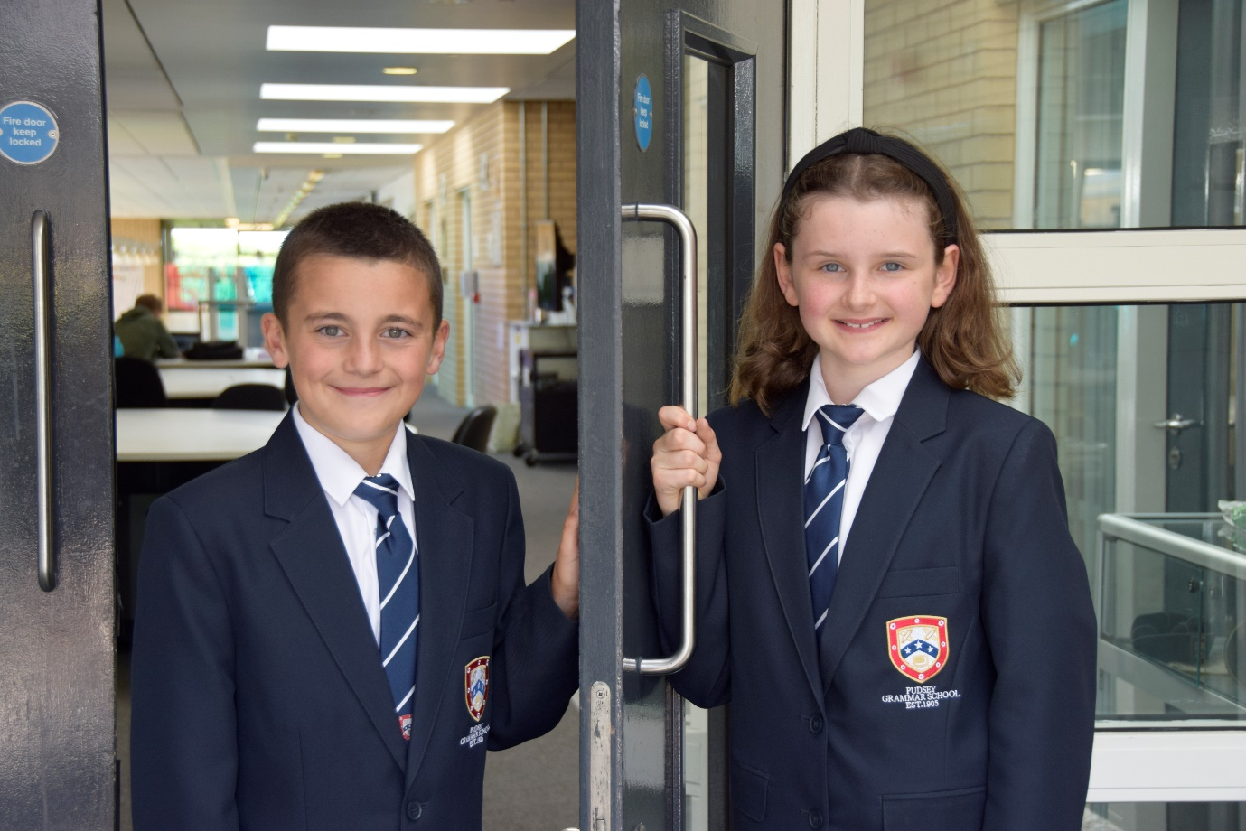

TEACHER OF
ENGLISH

APPLICATION PACK

Apprentice -
Academic Support Tutor
Expected duration: 18 Months
A1 £24,413 - £24,796
(Actual salary £20,977 - £21,327)

Term-time + 5 days / 37 hours per week
Start date: January 2026

Working pattern to be confirmed (the school will operate an early finish on Fridays)

Contents

- Introduction from the Headteacher
- Information on the post
- Job description
- Person specification
- Enhanced disclosure
- School Location and Travel Information

Introduction from the Headteacher

Thank you for the interest you have shown in the post of Apprentice (Academic Support Tutor) at our school. This is an excellent opportunity to join our dynamic SEND team.

Pudsey Grammar School is a heavily oversubscribed mixed comprehensive secondary school located in the heart of the market town of Pudsey. Situated between Leeds and Bradford the town has always valued its independence from its two larger neighbours. The school has a long and proud history stretching back to 1905. The school has 1200 students with a thriving and expanding Sixth Form of over 250 students all taught in a state of the art building. The innovative and unique style of the building creates a calm atmosphere very different to many secondary schools.

I was appointed in 2014 and since then we have received a letter from Amanda Spielman (HMCI Ofsted) which stated we ‘have transformed all aspects of the school.’ This assertion was further underlined in 2018 when the increase in our exam results resulted in the school being the most improved school in Leeds and one of the most improved in the country (we were delighted to follow these achievements up with our best ever GCSE exam results in 2019 which were above the national average). The pattern of improvement continued in 2020 with our Year 11 students achieving grades, which were outstanding. The school had a highly successful Ofsted inspection in April 2019 and was judged as good in all areas including our sixth form. The school underwent an ungraded inspection in April 2024 which saw, for the first time in the school’s history, a second successive Ofsted judgement of being a good school. This is testament to the consistently high quality of education which the school provides for all of our students and is one of the reasons why we remain one of the most popular schools across the city of Leeds with over 900 applications received for 215 Year 7 places for September 2024.

In 2022, the school was selected to be a national Behaviour Hub school. This is a Department for Education programme led by the Governments’ School Behaviour Advisor, Tom Bennett, which identifies schools who have ‘an exemplary behaviour culture’. We are one of only 20 secondary schools out of 4000 who have achieved this prestigious accolade and we are working with other schools across the north of England to improve their behaviour cultures.
We have a comprehensive House system which runs across all year groups with over 30 diverse competitions across the year for students and one each half term for staff too. House assemblies take place once every three weeks lead by our eight House Leaders. At the end of each academic year, the winning House is awarded our 80-year-old Victor Ludorum Cup.
We are aiming to be a centre of excellence and every indicator we have, we are on track to achieve this goal. Continuing to recruit high calibre staff is a key priority of our strategy.

The following quotes are taken from the latest Ofsted report:

- The school is welcoming and pupils respect the differences in other people.
- Safeguarding is very well led and pupils feel safe
- Pupils get on very well with each other
- Teachers have strong subject knowledge
- Pupils behave well in lessons and the vast majority focus on their work
- The school has developed an ambitious curriculum for pupils
- Staff have high expectations of all pupils. The vast majority of pupils rise to these expectations and work hard
- Pupils benefit from the curriculum and are well prepared for their next steps
- The House system plays a central role in the school and provides a sense of belonging. Pupils who earn House ties for their dedication to House competitions wear them with pride
- If bullying happens, pupils are confident that staff will deal with it quickly
The school has a long tradition in the town, being established as Pudsey Grammar School in 1905. Although the school is taught in a state of the art building, our core values of respect, resilience, integrity, compassion and ambition are highly traditional and are based on the goal of ensuring that every student reaches their true potential.

Our school is not just about the students gaining knowledge and qualifications, although these are extremely important. We believe in teaching young people core values of decency, social skills and how to be a good citizen in an ever changing world. We want their character to develop and grow and for them to leave us with an inquiring and independent mind. We want our students to gain the best qualifications they are capable of whilst experiencing a range of opportunities which are second to none. As a result, the school is extremely popular with our community and is significantly over-subscribed every year.

Our Sixth Form, which is rated as good by Ofsted, has grown in recent years and we now have over 250 Post-16 students studying at Pudsey Grammar. We have a strong tradition of ensuring students access the best universities including Oxford and Cambridge.

Our staff show exceptional dedication and commitment to our students. Relationships in the school are extremely strong and this underpins the ethos of the school. We pride ourselves in the care and support that we give our staff and as a result there is a real team spirit in the school where people enjoy being part of our school community. Teaching and learning is the key focus of the organisation and everything that we do is designed to ensure that the classroom experience for the students is excellent. We are currently redesigning our curriculum to ensure that the education we offer is second to none.

We offer fantastic support and professional development to staff which ensures that everyone is equipped with all the necessary skills to be an excellent practitioner and deliver a first class education to all students.

The school is a foundation Trust school and our partners include global companies such as Asda, HSBC bank alongside leading local business and training provider, Appris. These high quality links allow our school to offer excellent careers
opportunities to students across the ability range. As a result the school has 0% NEETs at Year 11.

We are currently part of The Leeds Teaching HUB, which is providing outstanding opportunities and CPD for all of our staff. Subject Leaders attend their Collaborative Learning Groups, which allows them to network and share best practice. This is further disseminated through the school via regular Department meetings and weekly Teaching & Learning briefings.

This clearly is an exciting time to join our school as we continue to build on our high standards and aspirations.

If you have a desire to be part of one of the most exciting and rewarding schools to work in, which will also provide you with excellent development opportunities, please complete the application form. Any further details can be obtained directly from the school’s HR Team: recruitment@pudseygrammar.co.uk) or our website www.pudseygrammar.co.uk vacancies – My New Term link

Mark McKelvie
Headteacher
Pudsey Grammar School

Pudsey Grammar School
Pudsey Grammar School is a thriving secondary school and sixth form educating students aged 11-18. Established in 1905, our school boasts a long and proud history combined with a modern, state-of-the-art building designed to inspire learning and achievement. We are heavily oversubscribed with 1,350 students in the main school and 250 in the sixth form.
Rated Good by Ofsted in 2024, we were proudly selected as a National Behaviour Hub School in 2022. As part of the Leeds Teaching Hubs, we offer outstanding opportunities for continuing professional development (CPD), enabling our staff to grow and thrive in their careers. At Pudsey Grammar, we are committed to fostering a supportive and dynamic environment where both students and staff succeed.
Job Title: Apprenticeship – Academic Support Tutor – Fixed term (18 months)
Hours and working pattern: 37 hpw, plus 5 training days 8.00am-4.15pm Monday to Thursday and 8.00am to 2.30pm Fridays)
Grade: A1 point 2
Salary: £24,413 - £24,796 FTE (£20,997 £21,327 Actual)
Start date: ASAP
This an exciting opportunity for you to start your career as an Academic Support Tutor, gaining experience in a forward-thinking and exciting organisation, supporting our students with a range of learning needs to achieve their goals and targets whilst working towards your level 3 Teaching Assistant Apprenticeship standard qualification. The successful candidate will play a key role in promoting self-belief, social inclusion and a high self-esteem amongst our SEND students, which is an integral part to their well-being. You will need to be a highly motivated team player and have the ability to relate well to young people and build positive relationships.
Candidates need to demonstrate
- A commitment to:
  - Working in line with statutory safeguarding guidance (e.g. Keeping Children Safe in Education, prevent and our safeguarding and child protection policies)
  - Working with the designated safeguarding lead (DSL) to promote the best interests of students, including sharing concerns where necessary
  - Promoting the safeguarding of all students in the school
Why work at Pudsey Grammar School?

- Be part of a rapidly improving school
- Work for an organisation which has staff wellbeing as its core
- Embrace the opportunity to play a key part in the continuing transformation of the school
- Be part of a dynamic and enthusiastic team of staff who are ensuring our students are successful in every way
- Work alongside hub-schools in the Yorkshire and Humber region and University College London, with access to high quality Teaching and Learning training, networking events, CPD
- Belong to a supportive organisation which prides itself on high standards for staff and students
- Work in an award-winning state of art building

Our school is committed to safeguarding and promoting the welfare of children and expects all staff and volunteers to share this commitment. Appointments will be subject to an enhanced DBS disclosure. If shortlisted, you will be required to disclose relevant information regarding criminal history and an on-line search will be conducted. This includes only information publicly available on-line.

We promote diversity and want a workforce that reflects the population of Leeds.

Employment is conditional on confirmation of the right to work in the UK – either as a UK or Irish citizen, under the EU Settlement scheme or having secured any other relevant work visa. If you do not have the right to work in the UK and the role does not meet eligibility for sponsorship, please consider carefully whether you meet the eligibility to apply for this position.

Application Process
Should you wish to apply for this position, please see below:
- Please be aware that we do not accept Curriculum Vitaes.
- In support of your application, you may include a covering letter. This should be in addition to the completed application form.
- Application form and full job description can be found on the school website: www.pudseygrammar.co.uk vacancies – My New Term link

Closing date for applications: Tuesday 6th January 2026 at 8.00am
Successful candidates will be contacted direct with details of the interview.
Interview date: TBC

Job Description
Post Title: | Apprentice – Academic Support Tutor
Reporting to: | Assistant Headteacher
Working time: | 37 hours per week, term time plus 5 days  8.00am-4.15pm Monday to Thursday  8.00am to 2.30pm Fridays  There will be a requirement to attend staff training and departmental meetings as required which may fall outside of the set hours.
Salary/Grade: | A1, point 2 FTE £24,413 - £24,796  Actual salary (£20,977 - £21,327)
Main (Core) Duties:
With organised, robust and targeted support and training throughout the apprenticeship programme, development of the following tasks and responsibilities:

- Assist students individually and in groups with their work following the direction and guidance of the Teacher to enable them to complete the work to their full ability. •
- Work with pupils both inside the classroom and elsewhere to encourage independence, maintain personal confidence and enable full potential to be reached ultimately with the minimum of supervision.
- Support and assist students with social integration advising them on strategies to deal with problems they encounter, seek appropriate professional help when necessary referring to appropriate teaching staff for advice.
- Help the teaching staff in the preparation of lessons in advance to identify necessary preparation for the lesson, to gain familiarity with the work to be covered and design appropriate teaching
- Create learning materials as agreed with the teacher following guidance to ensure maximum access to the lesson material for students.
- Identify issues of concern and positive feedback to be shared with teaching staff.
- Liaise with teaching staff, therapy staff and parents/carers creating an effective team who share knowledge and information.
- Keep a record of events and progress, bringing issues of concern to the class teacher to ensure full pupil data is available to inform pupils’ assessment and future planning.
- Develop an understanding of EHCPs/Provision maps/relevant policies and other documentation to understand how this supports students within school and how to work within the guidelines of these key documents.
- Support with one-to-one/small group support for students under the direction of the SENCo and or Deputy Director of SEND
- Provide support and cover where necessary to students who may have complex medical needs, ensuring that a sound understanding of management of such students is developed through shadowing and working alongside other members of the team as well as the SENCo/Deputy Director of SEND
- To support with the administration of medication as required under the guidance of the SENCo/Deputy Director of SEND.
- Assist students to use equipment and resources effectively.
- Support basic administrative duties such as photocopying, filing, arranging and management of resources, routine marking, display work, record keeping and collation of basic data.
- Supervise students when required during non-teaching times of the day to ensure their health and safety. •
- Undertake other reasonable duties of a similar level and nature to the post as requested.

Manage Own Performance and Professional Development | - To share responsibility for student welfare.  - To contribute to the overall ethos, work and aims of the school supporting, where necessary, out of school events.  - To comply with, and assist with, the development of policies and procedures relating to Child Protection, Health and Safety, confidentiality and data protection, reporting all concerns to the appropriate person.
Wider responsibilities: | - Develop effective professional relationships with others.  - Be aware of and support difference and ensure equal opportunities for all stakeholders accepting the principles underlying the school’s equal opportunities policies and practice.  - Maintain the confidential nature of information relating to the school, its students, parents and carers acting in accordance with the principles of the GDPR and the Data Protection Act 2018 at all times.  - Contribute to and support the overall life, work/aims and ethos of the school.  - Attend and participate in relevant meetings as required.  - Undertake additional duties as reasonably requested by senior staff.  - Assist with promoting the school with occasional evening events such as Open Evenings.
Safeguarding | - To work in line with statutory safeguarding guidance (e.g. Keeping Children Safe in Education, prevent and our safeguarding and child protection policies)  - To work with the designated safeguarding lead (DSL) to promote the best interests of students, including sharing concerns where necessary  - To promote the safeguarding of all students in the school.
Physical conditions | - The post is based at Pudsey Grammar School  - The school is accessible by stairs and lift and is available by disabled persons to the ground floor by a portable ramp on request  - This post is subject to an enhanced Disclose and Barring Service check  - The school operates a non-smoking policy
Training | The school encourages training both “in house” and external to meet the needs of the individual post holder
Any Special Conditions of Service: No smoking policy

This job description is to assist staff joining Pudsey Grammar School to understand and appreciate the work content of their post and the role they are to play in the organisation.

Whilst every endeavor has been made to outline the main duties and responsibilities of the post, a documentation such as this does not permit every item to be specified in detail. The job description is not a definite list of responsibilities but identifies the key components of the role. The post holder will, therefore, be required to undertake other reasonable duties commensurate with the purpose and salary level of the post.

Employees should not refuse to undertake work, which is not specified on this form, but they should record any additional duties they are required to perform, and these will be taken into account when the post is reviewed.

All new appointments of support staff are made subject to the satisfactory completion of a six-month probationary period.

Statement:

This school is committed to safeguarding and promoting the welfare of children and expects all staff and volunteers to share this commitment. Appointments will be subject to an enhanced DBS disclosure. If shortlisted, you will be required to disclose relevant information regarding criminal history and an on-line search will be conducted. This includes only information publicly available on-line. The employee may be subject to rechecking as required from time to time.

All appointments are subject to satisfactory references.

Pudsey Grammar School is an equal opportunities employer and requires its employees to comply with all current equality policies both in terms of equal opportunity for employment and access to the school’s services.
We promote diversity and want a workforce which reflects the population of Leeds.
Dated: 15th December 2025

Person Specification
KNOWLEDGE/QUALIFICATIONS | Ess | Des
GCSE English and Maths (A to C/9 to 4) | *
Knowledge of relevant IT eg MS Office, google. | *
Willingness to pursue further professional development through training. | *

EXPERIENCE | Ess | Des
Experience of working within a team and contributing to a shared outcome |  | *
Experience of learning new skills and working to deadlines |  | *

SKILLS |  | Ess | Des
A passion for your work and positive outlook |  | *
Resilience to cope with multiple requests and demands on your time in a busy work environment |  | *
Determination to be successful and contribute to the work of the organisation | *
Ability to communicate with a range of different people. | *
Willingness to learn new skills and seek/accept constructive advice from your mentor and other line managers to enable continuous development | *
Ability to work autonomously | *
Ability and willingness to work cooperatively as part of a team. | *
Maintain confidentially with both written and verbal communication. | *

BEHAVIOURAL AND OTHER RELATED CHARACTERISTICS | Ess | Des
Willing to abide by the school’s Equal Opportunities Policy in the duties of the post, and as an employee of the school. | *
Willing to carry out all duties having regard to an employee’s responsibility under the school’s Health and Safety Policies. | *
To display a responsible and co-operative attitude to working towards the achievement of the school’s aims and objectives. | *
An ability to respect sensitive and confidential work. | *
Commitment to own personal development and learning. | *

School Location and Travel Information

Pudsey Grammar School
Mount Pleasant Road
Pudsey
Leeds
LS28 7ND

Tel: 0113 2558277

www.pudseygrammar.co.uk
Instagram/Twitter/Facebook - @PudseyGS

