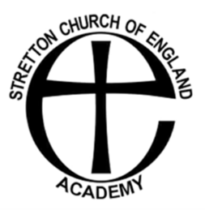


1:1 TEACHING ASSISTANT STRETTON C OF E ACADEMY

Salary: £26,403 FTE
Grade: F 7-10
Contract Type: Fixed Term until 31/08/2027
Basis: 32.5 hours
Closing Date: 1st February 2026
Interview Date: Week Commencing 2nd February 2026
The Diocese of Coventry Multi Academy Trust is on an aspirational journey to achieve educational excellence for all. The Trust seeks to build a better future for all within our academies who in turn will positively impact their communities. People within the Trust work as part of the broader Trust family, benefitting from peer support and wide opportunities for personal development.

A fantastic opportunity has arisen for a motivated and positive teaching assistant to support children with their learning and emotional well-being.
Stretton Academy is a friendly, supportive and enthusiastic school, which is part of The Diocese of Coventry Multi Academy Trust.

Are you:
- Passionate about supporting children?
- Caring and reliable?
- An excellent team member?

Do you:
- Have high expectations of yourself, colleagues and children?
- Hold a recognised NVQ Level 2/equivalent qualification?
- Have experience of working with children in small groups supporting learning and emotional well-being?

If so please apply.

We are happy for prospective candidates to visit the school to see the passion and ethos of Stretton Academy.

In line with our commitment to Safeguarding, all posts are subject to a safer recruitment process which includes enhanced with barred list Disclosure and Barring Services (DBS) and other vetting checks.

For an appointment to visit the school please contact the school on 024 76303 582 / school.office@stretton.covmat.org

