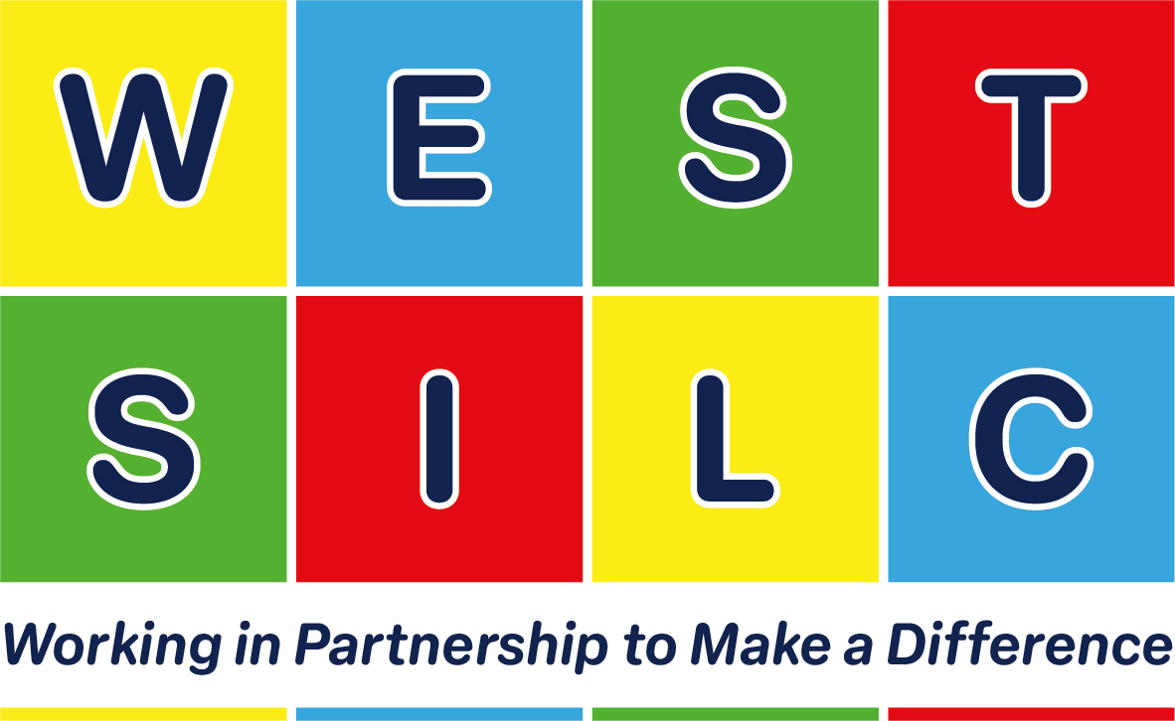
Principal Michelle Wilman | Milestone Site 4 Town Street Stanningley Leeds LS28 6HL | 0113 3862450
info@westsilc.org | www.westsilc.co.uk

Class Teacher Aspire Pathway
3 Days+ (Wed-Fri) or Full time
Severe Learning Difficulties - Complex Communication - Autism
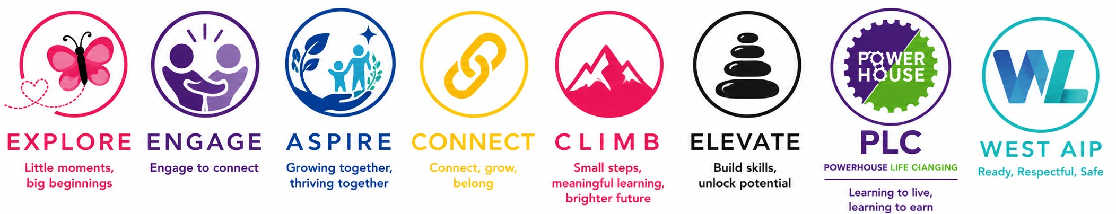
M1 to UPR3 plus minimum SEN allowance | Permanent position from January 2027 | NOR 326

West SILC is seeking an inspirational and creative teacher to lead a class in our Aspire Pathway. We are an all-age special school working across several sites in West Leeds. Each pathway provides a curriculum designed around the needs, strengths and aspirations of its learners.
Aspire supports learners with autism, severe learning difficulties and complex communication needs. Its highly individualised curriculum uses the Engagement Model, play-based and experiential learning, Total Communication and carefully planned sensory support. We are looking for a teacher who can build secure relationships, recognise progress in small steps and promote communication, regulation and independence throughout the day.
What you will bring | What we offer
- Effective, specialised teaching for learners with complex SEND.  - Engaging, personalised and multi-sensory teaching with high expectations.  - Confidence using Total Communication and the Engagement Model.  - Strong relationships and clear communication with learners, families and colleagues.  - A reflective approach and commitment to professional development.  - Creativity, calmness, confidence and enthusiasm. | - A welcoming and inclusive school where children and young people enjoy learning.  - A genuine opportunity to improve learners' experiences and outcomes.  - Dedicated class, pathway and multidisciplinary colleagues.  - A school community guided by respect, inclusion, independence, aspiration and partnership.

Visit Aspire - Aspire is based at our Milestone site. To learn more, watch the Aspire Pathway video on our website.
Visits are warmly encouraged:
- Friday 18 September at 10.00am;
- Thursday 24 September at 1.30pm;
- Friday 2 October at 10.00am.
Please call 0113 3862450 to book.

Safeguarding West SILC is committed to safeguarding and promoting the welfare of children and young people and expects all staff and volunteers to share this commitment. We are an equal opportunities employer. The successful candidate will be subject to an enhanced DBS check and all other relevant safer recruitment checks.

How to apply – Online via My New Term, West SILC, also includes further details. Any enquiries to: recruitment@westsilc.org. Early career teachers with relevant SEND experience are welcome to apply.
Closing date: Thursday 8th October

Interviews: week beginning 12th October

