Class Teacher
KS1

1 Year Fixed Term

Starting September 2026

RECRUITMENT pack
Class Teacher
Full-time 1 Year Fixed Term
Main Scale 1 – 6

We are seeking an enthusiastic and motivated Class Teacher to join our dedicated team, starting in September 2026.

At Northfield Road, we are on an exciting journey of improvement, recently achieving
the ‘Expected Standard’ in all areas of our Ofsted inspection and are committed to
providing a supportive, inclusive, and inspiring learning environment for all our pupils. This is a fantastic opportunity for a teacher who is passionate about helping children achieve their full potential and who is eager to contribute to the wider life of the school.

We welcome applications from both experienced teachers and Early Career Teachers who are committed to providing high-quality teaching and learning. You will work collaboratively with colleagues, parents, and the wider school community to create engaging and effective learning experiences that support every child’s development—academically, socially, and emotionally.

About Northfield Road Primary School
At Northfield Road Primary School, we are committed to fostering a nurturing and inclusive environment where every child is encouraged to reach their full potential.
Our vibrant two-form entry school is located in the heart of Netherton, proudly anchored in the area’s rich industrial and cultural heritage. As a key part of this close-knit community, we are passionate about offering an education that celebrates our past while preparing our pupils for a successful and fulfilling future.

Our school motto, ‘Anchoring our future’, is both a nod to where we come from and a promise to equip every child with the skills, knowledge and values they need for the wider world. We believe that every child is capable of success and happiness, and our dedicated staff go above and beyond—every single day—to ensure each child feels supported, inspired, and empowered to thrive. Through a broad and engaging curriculum, a rich variety of extracurricular activities, and strong pastoral care, we strive to create the conditions for our pupils to become confident, compassionate, and resilient individuals by teaching them that we are, ‘caring together, linked together, stronger together’.

Our staff are the heart of our success—a committed, enthusiastic, and supportive team who work collaboratively to provide the highest quality education. We are deeply invested in staff development, offering meaningful professional growth opportunities while also prioritising wellbeing and reflective practice.

The role offers the opportunity to:
- Be part of a professional, dedicated and friendly team.
- Work with amazing, diverse and enthusiastic pupils.
- Develop your career in teaching within a supportive, friendly, and vibrant school.
- Being part of a collaborative trust
- Be part of our journey to become the best school we can be for our children and families.
Visits to the school are encouraged and we welcome you to look around our school prior to shortlisting. Visits will be conducted by the headteacher.
For an informal conversation to discuss the role, please speak to:
Mr Gareth Ludlam
Headteacher
Northfield Road Primary School
Stour Vale Academy Trust

Please call the school to book an appointment:
Telephone Number: 01384 989027
Email: info@northfield.dudley.sch.uk

Closing date: Monday 11th May 2026 Midday
Interviews: Week Commencing 18th May 2026

Please Complete Your Application Form Via My New Term – CV’s Will Not Be Accepted

Northfield Road Primary School is committed to safeguarding and promoting the welfare of children and expects all staff and volunteers to share this commitment. We will carry out pre-appointment checks including DBS and will disqualify any applicant where we consider the outcomes to be unsatisfactory. This post is exempt from the Rehabilitation of Offenders Act (ROA) 1974.

We are equally committed to ensuring that no applicant will be disadvantaged or discriminated against because of their protected characteristics under the Equality Act 2010.

ABOUT STOUR VALE ACADEMY TRUST

Our multi-academy trust was founded in 2017 and developed from collaboration between schools, the significant positive impact of which convinced three schools, two secondary and one primary, that together we would have much greater capacity to continuously improve. Over time, Stour Vale has steadily grown. We began as a cross-phase multi-academy trust and as we have grown, both secondary and primary schools have joined us. There are currently thirteen member schools, six primary, one junior, one infant with day nursery and five secondary.

As a successful family of schools, delivering high-quality education for the communities we serve, Stour Vale values its diversity. Each school brings their own distinct character, community, history and identity. We celebrate the uniqueness of member schools, recognising that there is a great deal to learn from education in different contexts. This is also the reason why we remain outward-looking, committed to learning from research and excellent practice across the education system.

OUR VISION AND VALUES
Stour Vale Academy Trust holds children and young people at the heart of all that we do. We recognise that as a multi-academy trust we exist in order to advance education for the public good. Our mission, therefore, is to improve life opportunities for children and young people by both providing the best possible education and care to pupils in Stour Vale member schools and by having a positive impact across the wider education system. Our values are encapsulated in four words:

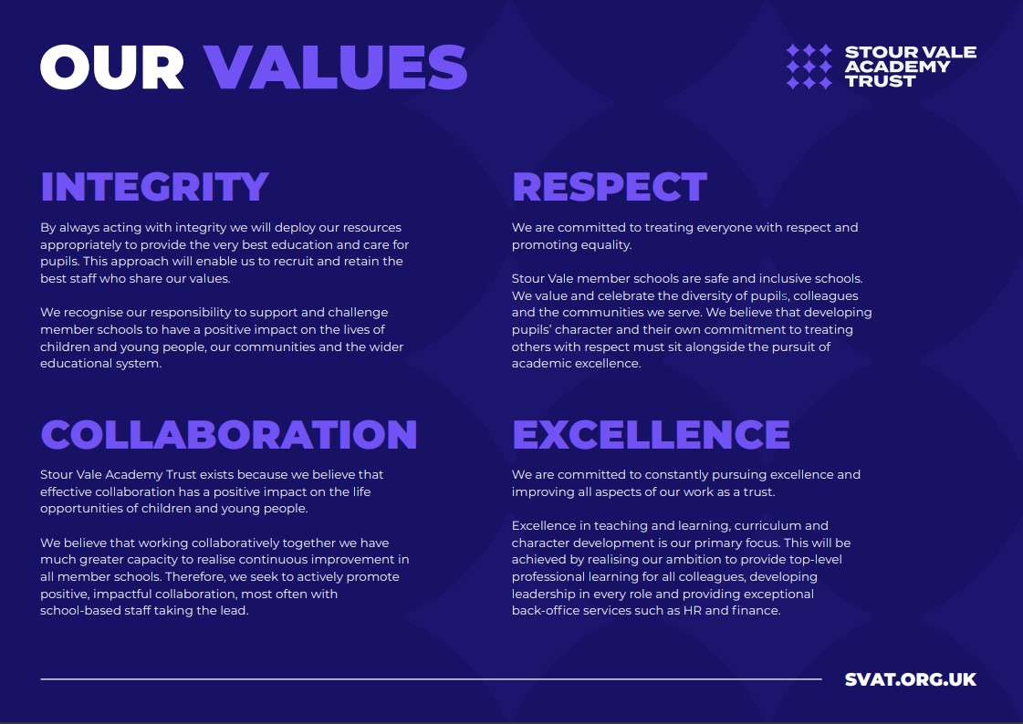
We describe our shared approach to school improvement as ‘secure autonomy’. Headteachers, with school leadership teams and staff, have autonomy to lead school improvement in their own schools, responsively and in collaboration with others within and beyond our trust. We believe that this approach enables us to grow, attract and retain excellent schoolteachers and to develop the most innovative and impactful school improvement strategies. We recognise that this autonomy must be secured within the structure of the multi-academy trust, and our model of challenge and support for impact, underpinned by our shared values, ensures sustained school improvement and a sharp focus on outcomes for pupils. This in turn realises our ambition that Stour Vale member schools will create the difference together.

Job Description
Class Teacher
Full time 1 Year Fixed Term
M1 -M6

Legal Requirements
The class teacher’s professional duties must be carried out in accordance with the subject to:
- The Stour Vale Academy Trust Scheme of Delegation
- The provisions of all applicable legislation
- The School Teachers’ Pay and Conditions Document
- The Funding Agreement of the School and the Academies Financial Handbook

Core Purpose
In line with the values, ethos and strategic direction of Stour Vale Academy Trust and under the overall direction of the Head Teacher, Deputy Head, the Assistant Head Teachers and teaching and learning responsibility holders, the Class Teacher will:
- Work collaboratively with all other staff to ensure high quality education and care for all pupils leading to academic achievement, character development and an embedded culture of safeguarding.
- Act professionally
- Uphold the values and ethos of the school and of Stour Vale Academy Trust
- Be supportive of the school and of Stour Vale Academy Trust, consistently seeking to present a positive image of the school and trust.
- Be a class teacher for a class of pupils within the school or be timetabled to teach a number of classes across the week.
- Set clear targets for all pupils, building on prior attainment, and setting high expectations.
- Plan and deliver lessons and sequences of lessons to achieve progression in learning; setting tasks that challenge pupils and ensure high levels of interest.
- Encourage pupils to think and talk about their learning and to develop independence.
- Make effective use of resources, so that they have a positive impact on learning.
- Teach responsively, assessing pupils in order to adjust teaching, give effective feedback, address misconceptions, plan future lessons and match teaching to individual needs.
- Record pupils’ progress systematically and keep appropriate records in line with school procedures.
- Provide accurate and up-to-date information on pupil progress to the school’s leadership team.
- Work effectively with school staff, other professionals, and parents to ensure that pupils make the best possible progress.
- In line with school policies and procedures, have a positive approach to pupils’ behaviour, creating a positive, purposeful, and productive learning environment

- Undertake professional learning and seek to continually improve the quality of teaching.
- Carry out teaching duties in accordance with Stour Vale and the member school’s policies and procedures.
- Contribute to the development, organisation, and implementation of the school’s curriculum.
- Attend and participate in team and staff meetings.
- Report to parents, attend and participate in parent teacher consultations and other meetings for parents.
- Make a positive contribution to the wider life of the school.
- Develop links with the community and partnership working with other schools.
- Undertake other duties and responsibilities identified by the headteacher and deputy headteacher commensurate with this role.

Person Specification
Class Teacher

No | Categories | Essential | Desirable
QUALIFICATIONS & EXPERIENCE
1. | A first degree or equivalent
2. | Qualified Teacher Status
3. | Successful teaching experience
4. | Recent relevant professional development
5. | Experience of managing behaviour positively and effectively as a class teacher or a trainee teacher
6. | Experience of developing the teaching skills of colleagues or trainee teachers
7. | Experience of communicating effectively with a range of audiences
KNOWLEDGE AND SKILLS
8. | Effective classroom practitioner
9. | Understanding of what makes ‘quality first’ teaching, and of effective intervention strategies
10. | Effective communication and interpersonal skills
11. | Knowledge of the primary curriculum
12. | Ability to build effective working relationships
13. | Knowledge of safeguarding
14. | Good record-keeping skills
15. | Ability to work under pressure and prioritise effectively
PERSONAL QUALITIES
16. | Committed to working collaboratively to improve outcomes for pupils and promoting the ethos and values of the school
17. | Commitment to safeguarding and promoting the welfare of children and young people
18. | Genuine respect for others and desire for equality of opportunity and diversity
19. | Ability to work as part of a team understanding Trust roles and responsibilities and your own position within these
20. | Can-do attitude and solution focused approach with an ability to manage expectations and not over promise
21. | Have a willingness to demonstrate commitment to the values and ethos of Stour Vale Academy Trust
22. | Be committed to innovation, learning from research and the best current practice
23. | Committed to building positive and effective relationships, based on trust and transparency, with children, staff, parents, governors, other schools and the wider community
24. | Commitment to maintaining confidentiality at all times

CONTACT US
For informal talks please contact:

Mr Gareth Ludlam
Headteacher
Telephone: 01384 989027

Please visit our website: https://www.northfield.dudley.sch.uk/

