

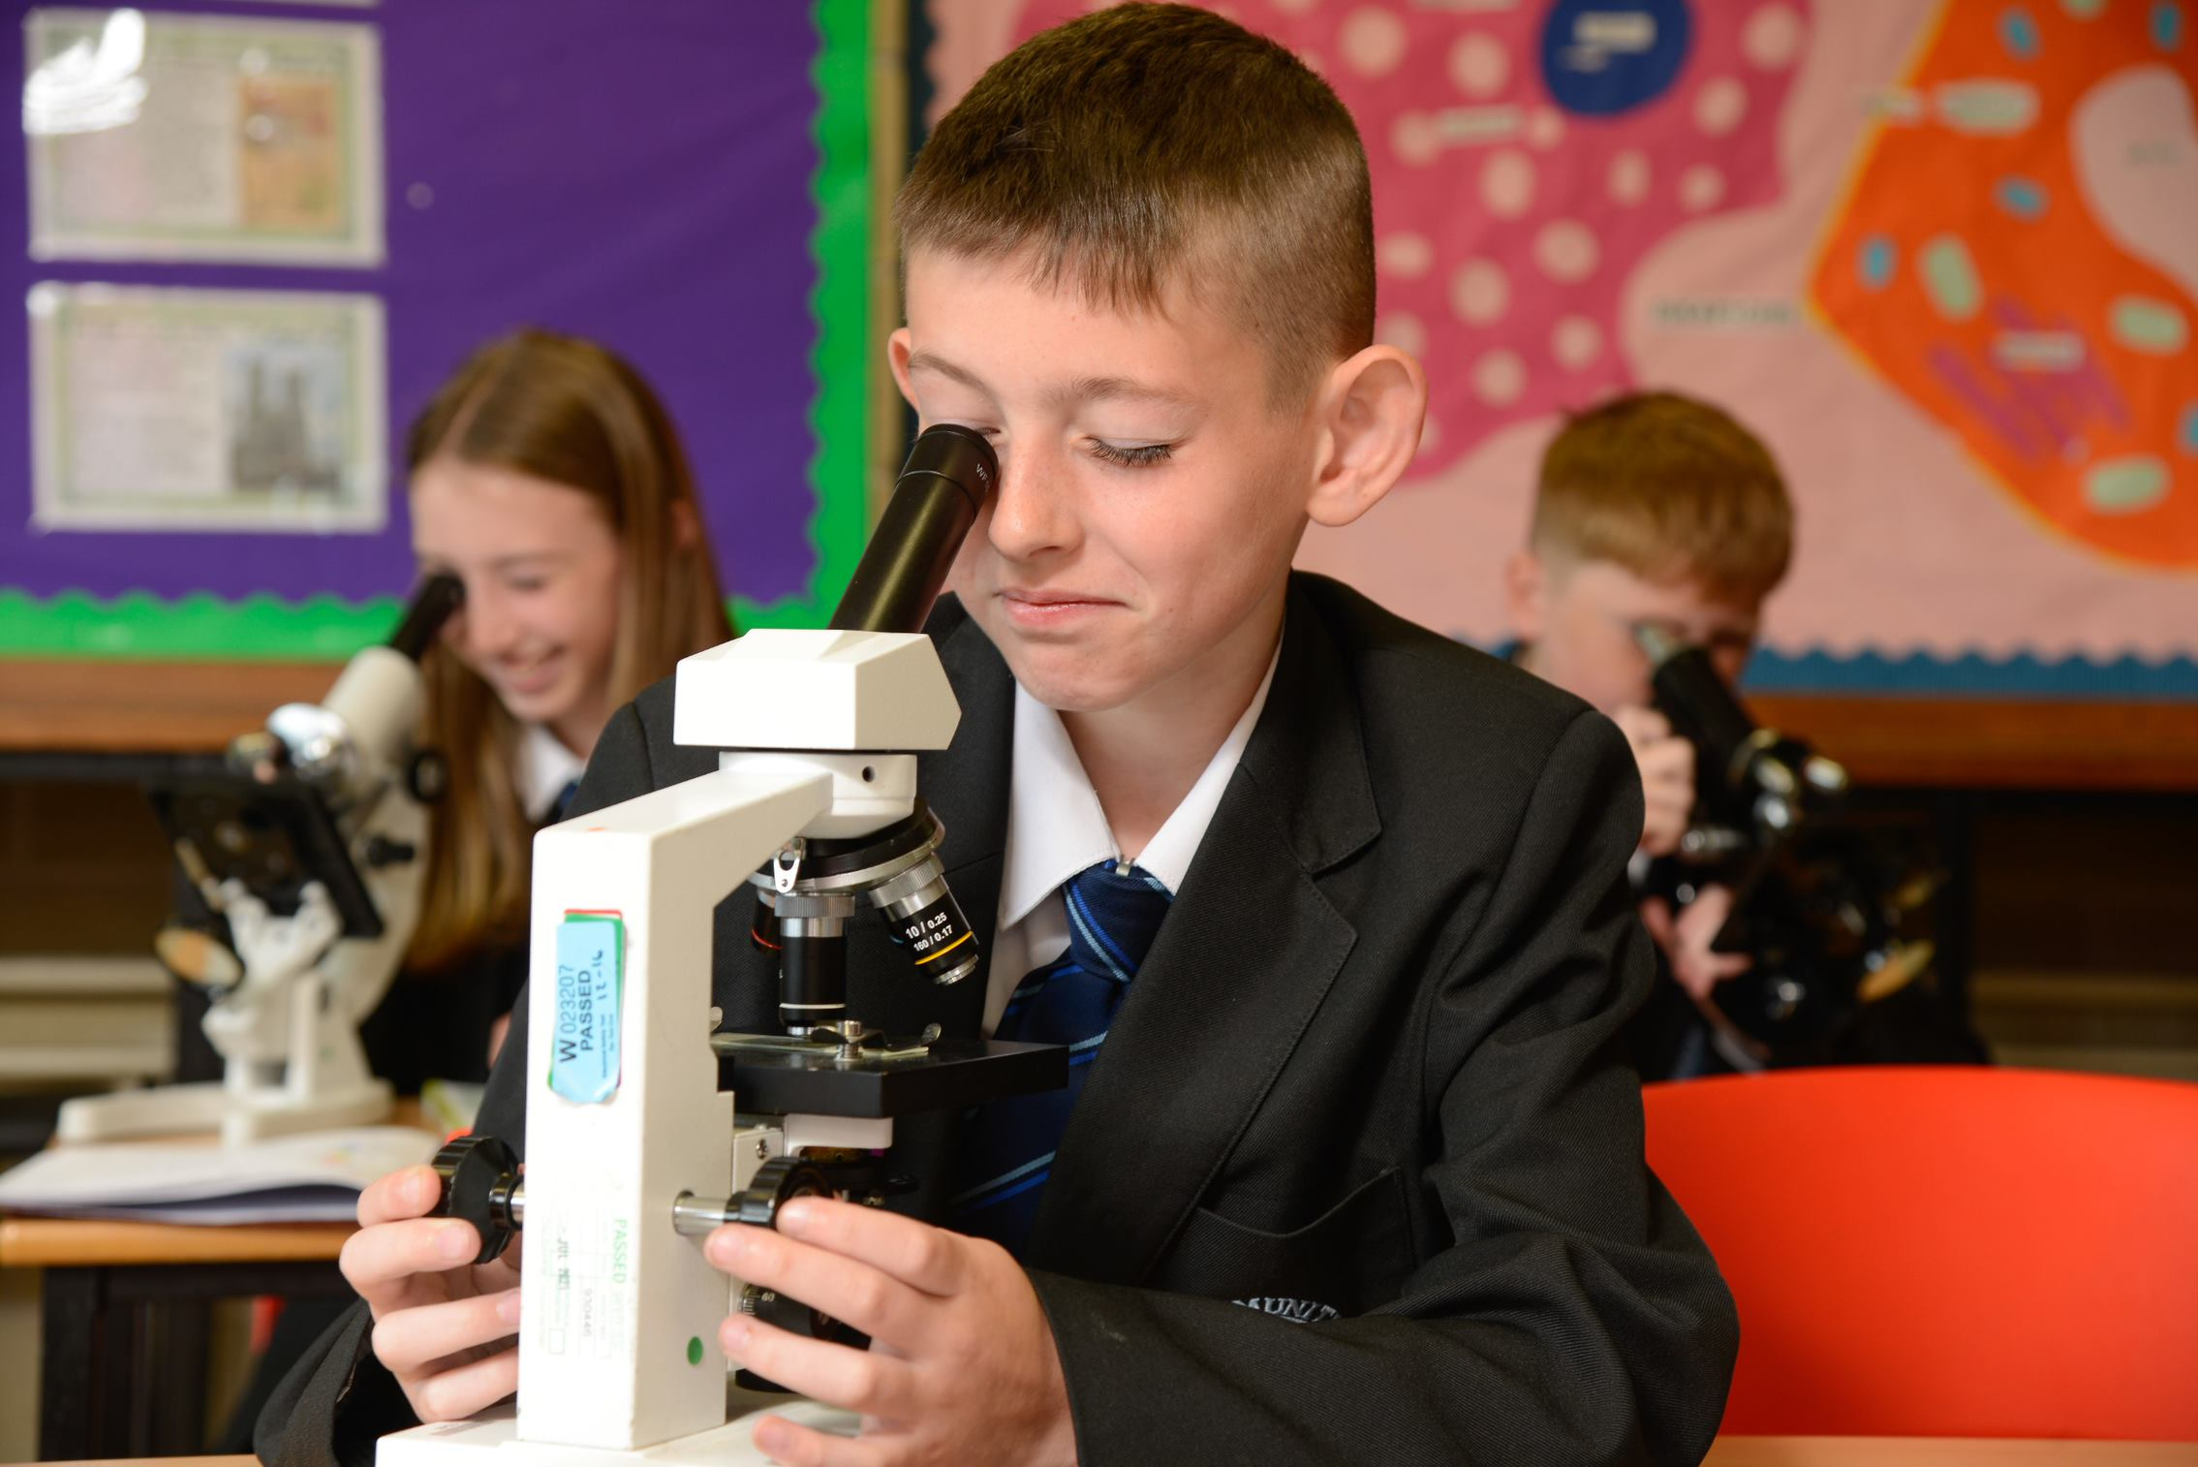

WELCOME TO BUXTON COMMUNITY SCHOOL
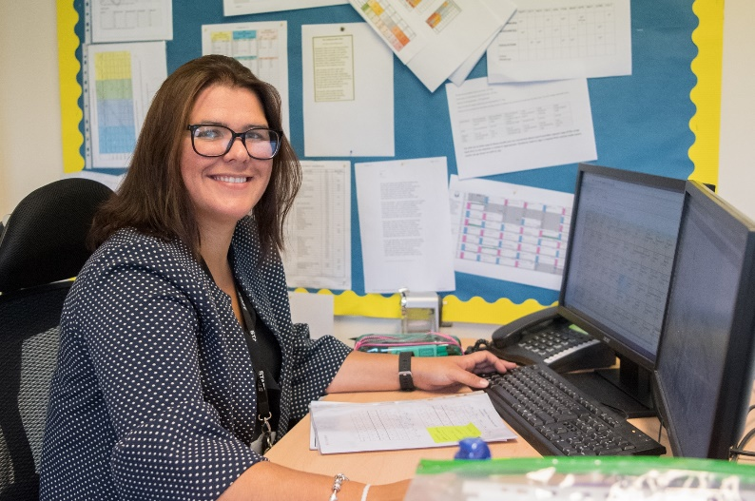

Welcome to Buxton Community School and thank you for your interest in this post. We are a successful, supportive and high achieving secondary school based in the heart of the Peak District with over 1,000 students on roll. As an 11-18 provider, we play a key part in providing the highest quality education and support for our students across a broad range of subjects at KS3, KS4 and KS5.
Our approach with the students involves acknowledging and rewarding positive behaviours and achievements whilst challenging and supporting students to be the best version of themselves. Our values, Ready, Respectful and Safe are instrumental in achieving our vision.
We have a clearly defined plan and commitment to improving learning and support for students. Our outcomes have shown significant improvement over several years as our developments to teaching and learning have taken hold.
Our principles for learning are focused on learning for the long term and developing deep understanding. We have developed a clear strategy that underpins what happens in our classrooms. Teachers who join our school will find well-resourced and planned schemes of learning. However, they are not prescriptive, we believe the professional in the classroom is the subject expert and the champion of the needs of the children in their classes. Staff wellbeing is of utmost importance to me, and we have adopted a number of approaches in order to support in this area of school life. For example, we support all our staff by providing additional non-contact time above that of most schools to allow them the chance to prepare and assess effectively.
I am keen to appoint subject specialists who are passionate and demonstrate true excitement for their subject. We want staff who are positive, energetic, enthusiastic and deeply committed to supporting our young people, and who are prepared to go that extra mile to contribute to our whole school improvement.
You will be joining the school at an exciting time as we are about to join an academy – The Embark Federation. We are excited by the opportunities that this partnership will bring in terms of developmental opportunities for both the staff and students. We want the best for our staff and young people, and we will not let it get more complicated than that.
Joining a new school will be a huge decision for you, I am sure you will have worked through our website, read our recent inspection report and looked at our data but you need to know what more there is to our school. I would be happy to talk with you as a prospective candidate before or after you submit an application and talk with you about our ethos and values, our priorities and answer any questions you might have. Please contact dawn.garrett@buxton.derbyshire.sch.uk to arrange a call. The recruitment process will also give you every opportunity to learn more about our school.


Samantha Jones
Headteacher

The Role

Buxton Community School is seeking to appoint a well-qualified and enthusiastic Teacher of Science to join the team on a permanent basis.

We are seeking an outstanding classroom teacher with proven success and suitable experience of delivering high quality teaching and learning to students across all key stages. Experience of KS5 teaching is desirable however, not essential provided that the candidate has suitable ambition to teach to this level should the opportunity arise. The role is suitable for ECTs to apply.

Applicants for the role must have a strong Science background as evidenced by excellent qualifications and an intrinsic desire to keep abreast of key developments in the subject. We are looking for an enthusiastic and dynamic individual who is a team player and happy to work collegiately to continue to drive forward our success. You will work closely and collaboratively with the Science team; be receptive to innovative practices and be an inspirational and motivational practitioner.

The ideal candidate will:

- Have a tangible passion for teaching Science and be able to share evidence of enabling students to meet and exceed expectations.
- Have experience in teaching Science at Key Stages 3 & 4 with experience or ambition to teach to A Level.
- Have excellent understanding of the curriculum and specifically how lesson design can help to deliver this successfully. They will have a keen interest in evidenced based research to inform their teaching.
- Be someone who understands the value of high-quality assessment and feedback to inform lesson design.
What you will get from us.
- The chance to join a forward thinking and ambitious department who are committed to providing the best education to students at BCS.
- Support with regard to your own needs whether they be teaching and learning based or leadership.
- A supportive, collegiate and sociable working environment.
This is a fantastic opportunity for a teacher at any stage of their career and our priority is to appoint someone who is committed to education and being the best teacher they can be. We are looking for someone who can spark an interest in students and fully support them in achieving success in the subject.

Salary: Main/Upper Pay Scale
TLR : N/A
Contract Type and Term: Full time, Temporary with a view to becoming permanent.
Start date: Immediate start but the latest Easter 2026.

The Department

The Science department at Buxton Community School is a large and very successful department offering the full range of subjects across Key Stages 3, 4 and 5.

The Science team work well together and are always supportive of its staff and students; enthusiastic and committed to providing engaging lessons to all year groups and all abilities. The successful candidate will teach alongside a hardworking team of 9 teaching staff and 2 technicians, with a range of experience and responsibilities, both in the department and across the school.

We are passionate about providing a rich and valuable learning experience for all of our students and use educational research to guide us in what we do. We have a strong ethos of collaboration and support for one another within the department and work together very closely as a team on all aspects of planning, assessment and teaching.

We have a policy of tolerance, fairness, empathy and respect which is embedded into all lessons.

In Year 7 students are taught in mixed ability teaching groups, in Year 8 and 9 they are broadly set. We follow the Activate scheme of learning, with adaptations to best support our learners. All students take the GCSE (AQA) 6 hours a week, following either the Combined (Trilogy or Synergy) course or the Triple Science one. We offer all 3 sciences at A level as well as the Level 3 Extended Certificate in Applied Human Biology.

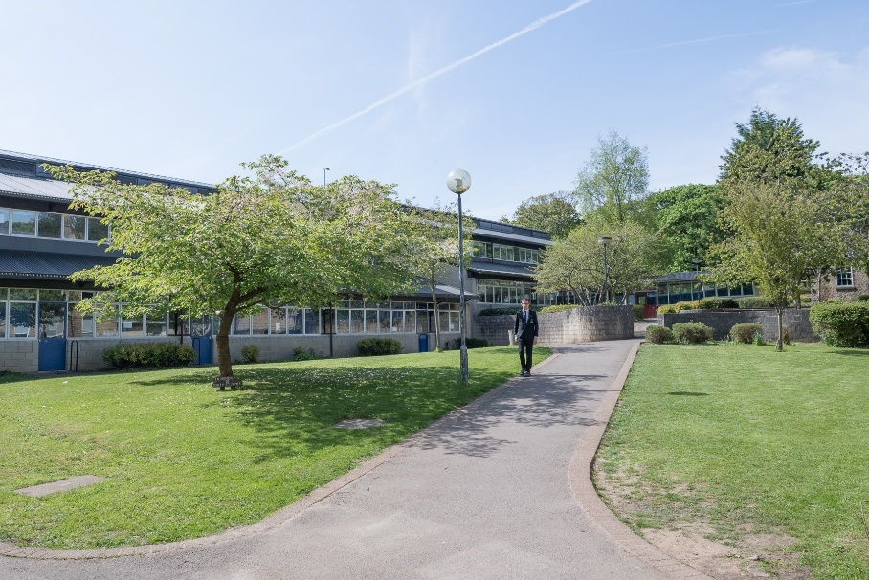

Job Description

Post Title: Teacher of Science (chemistry specialist preferred)

Grade: MPS/UPR

TLR: N/A

Responsible to: Head of Science

Post Objectives: The post-holder will work together with the other members of the department to help students learn to their full potential.

Duties and Responsibilities:

Classroom Management
Students learn best in an orderly environment where work is sufficiently challenging to motivate and stimulate them. They also need to be given clear objectives for their learning and regular feedback. All teachers should promote the school’s Aims and Values and implement school policies and procedures in order to establish a sound learning environment. They should aim for the highest possible standards of work and behaviour at all times. This will involve:
- preparing and teaching lessons which are appropriate, challenging and stimulating
- employing procedures for encouraging good behaviour and dealing with poor behaviour
- assessing students’ work in line with department and school policies
- implementing the school system for rewards
- setting and marking homework.

Assessment
The teacher will fulfil all requirements of the school policy on Assessment, Recording and Reporting. They will assess regularly as a means of monitoring progress, diagnosing weakness, informing future teaching and as a basis for target setting.
This will involve working within department and school policies to:
- establish record keeping procedures
- complete all reports
- carry out such assessments as required by the National Curriculum
- pass on to other staff who may teach the students, appropriate assessment data, (e.g. at end of year)
- carry out end of Key Stage assessments
- prepare students for internal and external tests and examinations
- report to more senior staff and parents as required.

Special Educational Needs
The postholder will be aware of the range of student abilities within each class and endeavour to ensure that all students can, and do, make progress. This will involve:
- being aware of the individual needs of the students in the teaching group
- ensuring that teaching materials are appropriate and allow students access to the learning
- employing a range of activities so that students have the opportunity to succeed
- liaising with Special Needs staff over individual students
- planning with support staff to clarify roles and responsibilities
- contributing to Individual Education Plans

Curriculum
This will involve:
- sharing in the production of resources with others in the department and in the school
- keeping abreast of current developments in the subject and related areas
- sharing in the development of teaching strategies and approaches
- developing a good classroom environment through display

General
All teachers will:
- be expected to keep themselves up to date with recent education developments and to participate in Inset
- take part in break duty rotas and cover
- participate in the school system of lesson observations

Please note that this document should be read in conjunction with the Conditions of Employment of School Teachers as outlined in the current DfE School Teacher’s Pay and Conditions Document.

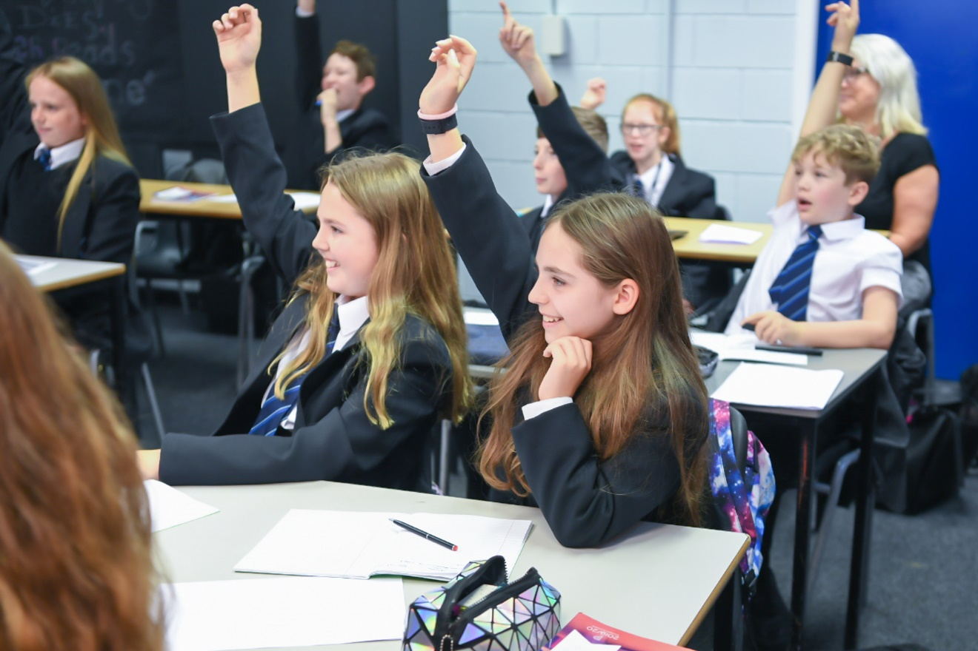

Person Specification

(To be read in conjunction with the National Standards for Classroom Teachers)

Post Title: Teacher of Science (chemistry specialist preferred)

Grade: MPS/UPR

 | Essential Criteria
Qualifications | QTS (when taking up post)
Qualifications | Relevant Degree
 | Relevant practical experience
 | You are committed to teaching and learning in a comprehensive school
 | You have high expectations of all the students you work with
 | You are able to articulate clear educational values and apply these to your teaching
 | You understand the barriers that can affect students’ learning and show commitment to overcoming these
 | You are able to develop and maintain positive relationships with all students
 | You actively encourage all students to develop and maintain positive relationships with each other
 | You approach problem-solving positively and creatively
 | You are well-organised in your planning and use of classroom resources
 | You work effectively with colleagues to develop and improve learning
 | You use good communication skills (speaking, writing and listening) with the whole school community
 | You are committed to the personal development of the young people you work with
 | You constantly strive to analyse, refine and develop the learning in your classroom
 | You demonstrate high levels of commitment, enthusiasm and motivation
 | You are hard-working and dependable
 | You have an excellent record of attendance and punctuality
 | Outline of clear educational philosophy linked to post requirements
 | You have effective and positive behaviour management skills.
 | You are an effective team worker with a ‘can do’ attitude that embraces change and creativity.
 | You show clear evidence of on-going professional development.

A Great Place to Work

We care passionately about our staff, their well-being and their professional development and this is reflected in the fact that we are an enthusiastic team, committed to working collaboratively and sharing the very best practice.

We can offer:
- a strong team environment that takes staff well-being seriously
- a dedicated Senior Leadership Team who want to see their staff progress
and flourish in their career
- an active teaching and learning research and development group
- very supportive parents and a high standing in the community
close and successful working relationships with other schools within the High Peak area

Diversity & Inclusion

At Buxton Community School we hire the best, give them first-class training and if you are driven to perform, you’ll fit right in. We approach our work fearlessly, learn quickly, improve constantly, and celebrate our wins at every turn.

We are passionate about creating an inclusive workplace which promotes and values diversity in age, gender identity, race, sexual orientation, physical or mental ability and ethnicity. More importantly, creating an environment where everyone, from any background, can do their best work is the right thing to do. Everyone is welcome—as an inclusive workplace, our employees are comfortable bringing their authentic whole selves to work.

The Town of Buxton
Buxton Community School is a school truly at the heart of the town and the area is a beautiful part of the country.
At 1,030ft above sea level, Buxton is said to be the highest market town in England. Tourists have been coming to Buxton and the Peak District since the 14th Century and it’s not surprising that Buxton is today one of the most popular tourist destinations in the Peak District. Within an hour’s drive of Manchester, Sheffield, Derby and Stoke, its famous Georgian and Victorian architecture with buildings such as The Crescent, The Pavilion Gardens and The Opera House it provides an impressive backdrop to a rich and vibrant range of music, theatre and festivals.
The Buxton Festival of World Cinema takes place around March/April, with the Big Session Festival of folk music in April/May. July brings the Buxton Festival of Opera, Music and Literature, the Buxton Well-Dressing Festival, Buxton Fringe Festival and the Buxton Military Tattoo. In August the Family Festival provides fun for all the family.

The Application Process

Applicants should apply on My New Term.

Closing date for applications is Wednesday 28th January 12pm
Interviews will be held the following week.

If you are short-listed for interview, you will be contacted in advance to discuss arrangements for the interview. Unfortunately, if you have not been contacted prior to the interview day, your application has not been successful on this occasion.

Buxton Community School is committed to safeguarding and the process of safer recruitment. As a result, this post is subject to an enhanced Disclosure and Barring Service check, and all shortlisted candidates will be expected to prove their identity at interview. The successful candidate will be expected to show original copies of qualifications and further proof of their identity.



