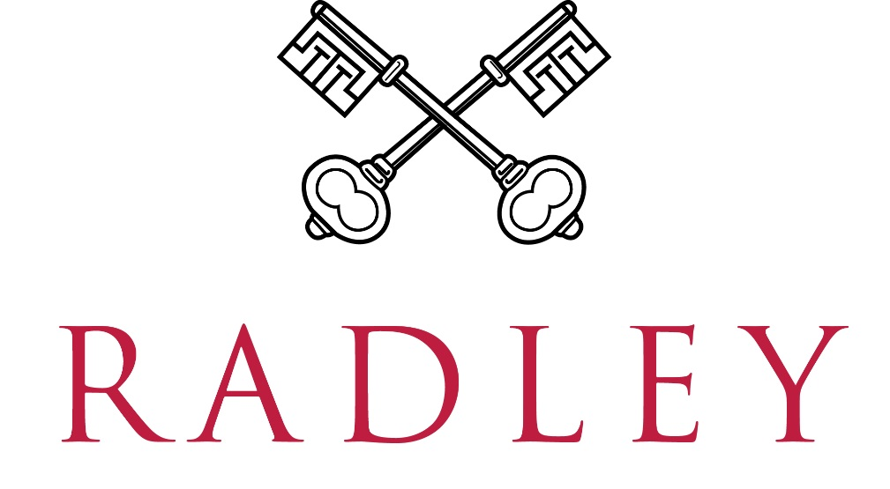

JOB DESCRIPTION
Job Title: IT Systems Engineer
Reports to: Head of IT Services
Location: Radley College, Abingdon, Oxon
Responsible for: The administration, support, governance and continuous improvement of key College systems and cloud services, including Microsoft 365, Microsoft Entra ID, Apple device management platforms and other business-critical technologies. The role provides advanced technical support, platform ownership and engineering expertise across the wider IT environment.

KEY RESPONSIBILITIES

Service Ownership and Technical Leadership
- Take ownership of designated systems and services, ensuring they remain secure, reliable, well-governed and aligned to the needs of the College.
- Proactively identify opportunities to improve service performance, security, automation and user experience.
- Act as a subject matter expert for assigned technologies, providing technical guidance and support to colleagues and stakeholders.
- Contribute to the strategic development and continuous improvement of the College's cloud, identity and end-user technology environments.

Microsoft 365, Identity and Collaboration Services
- Administer and support Microsoft 365 services including Exchange Online, Teams, SharePoint Online and OneDrive.
- Administer Microsoft Entra ID, including users, groups, guest accounts, authentication methods and access controls.
- Own the technical identity lifecycle processes supporting joiners, movers and leavers, working closely with HR and the Service Desk.
- Maintain governance of Microsoft 365 resources, including users, groups, guest accounts, Teams, shared mailboxes and SharePoint sites, ensuring services remain secure, compliant and aligned to business need.
- Support the ongoing development, optimisation and adoption of Microsoft 365 services across the College.

Governance, Security and Compliance
- Support the implementation and administration of Microsoft 365 security and compliance controls, including Multi-Factor Authentication, Conditional Access, secure sharing and information protection technologies.
- Work collaboratively with the Network Manager / IT Security Officer and Infrastructure Engineer to maintain and strengthen the security posture of supported services.
- Participate in access reviews, security audits and governance activities as required.

Systems Engineering and Platform Ownership
- Act as technical owner for designated platforms and services, ensuring their effective administration and support.
- Provide administration and support for the College's JAMF environments and other cloud-based business systems.
- Administer the College's cloud telephony platform and associated services.
- Work with suppliers and service providers to resolve issues and deliver service improvements.

Automation and Continuous Improvement
- Provide advanced second and third-line technical support across cloud services, applications and end-user technologies.
- Investigate, diagnose and resolve complex technical issues, acting as an escalation point for the Service Desk where required.
- Use PowerShell and other administration tools for reporting, automation, troubleshooting and service improvement activities.
- Develop and maintain technical documentation, procedures and knowledge resources.
- Identify opportunities to improve efficiency, resilience and service quality across supported systems.

Technical Support and Continuous Improvement
- Provide advanced second and third-line support across cloud services, systems, applications, user technologies and SaaS platforms.
- Investigate, diagnose and resolve complex technical issues, identifying root causes and implementing appropriate solutions.
- Support the Service Desk with escalated incidents, requests and problem investigations.
- Act as a technical escalation point for supported systems and services.
- Provide technical guidance, knowledge transfer and mentoring to colleagues where appropriate.
- Assist with the resolution of issues spanning multiple technical disciplines and service areas.

Technical Support and Continuous Improvement
- Provide advanced second and third-line technical support across cloud services, applications and end-user technologies.
- Investigate, diagnose and resolve complex technical issues, acting as an escalation point for the Service Desk where required.
- Use PowerShell and other administration tools for reporting, automation, troubleshooting and service improvement activities.
- Develop and maintain technical documentation, operational procedures and knowledge resources.
- Identify opportunities to improve efficiency, resilience and service quality across supported systems.
- Maintain appropriate records of system configurations, technical changes and service activities.
Projects and Collaboration
- Contribute to technology projects, upgrades, migrations and service improvement initiatives.
- Work collaboratively with colleagues across IT Services to deliver effective and joined-up support.
- Follow agreed change-control, security and service-management processes when implementing technical changes.
- Support the development of operational standards, best practice and continual service improvement across IT Services.
- Support wider Group IT activities and future technology developments as required.
- Provide reasonable cross-team support and technical cover where required.
- Participate in the on-call rota and provide emergency support as necessary.
- Undertake any other duties commensurate with the nature and level of the post.

OTHER DUTIES
- Such other duties which may reasonably be required.
- To attend necessary training as required by the College.
- Radley College is committed to safeguarding and promoting the welfare of its pupils and expects all employees to share this commitment. Employees must, at all times, have regard to the need to safeguard and promote the welfare of children in line with the provisions of the Children Act 2004 (as amended) and Keeping Children Safe in Education (as amended) and be fully aware of, and understand, the duties and responsibilities that apply to their role in relation to these requirements. All employees must attend appropriate training in accordance with College and local Safeguarding Board stipulations.

HOURS OF WORK
- Term Time + 3 weeks, on site
- Monday to Friday, 9 am to 5 pm (some flexibility may be possible).
- Saturday mornings 8 am to 1 pm on a rota basis (approx. one in every six weeks during term time).

PERSON SPECIFICATION
- Demonstrable experience administering Microsoft 365 services, including Exchange Online, Teams, SharePoint Online and OneDrive.
- Strong working knowledge of Microsoft Entra ID and identity and access management principles.
- Experience managing users, groups, authentication methods and access controls within Microsoft cloud environments.
- Strong PowerShell skills with the ability to use scripting for administration, reporting, troubleshooting and automation.
- Experience supporting cloud-based and SaaS platforms.
- Strong troubleshooting and problem-solving skills across a broad range of technologies.
- Good understanding of Microsoft 365 security features including Multi-Factor Authentication, Conditional Access and access governance.
- Ability to investigate and resolve technical issues independently.
- Excellent communication and interpersonal skills with the ability to work effectively with both technical and non-technical users.
- Strong organisational skills with the ability to manage competing priorities.
- Ability to produce clear technical documentation and follow change-control processes.
- A collaborative and flexible approach, with a willingness to support colleagues across a small IT team.
Desirable
- Experience with Microsoft Purview, Data Loss Prevention and information protection technologies.
- Experience administering JAMF and Apple device management platforms.
- Experience supporting iOS, iPadOS and macOS devices.
- Experience working within hybrid Active Directory and Entra ID environments.
- Experience with Single Sign-On (SSO), federation and identity integrations.
- Experience developing automation solutions beyond PowerShell.
- Experience of working within the education sector.
- Relevant Microsoft certifications.
- Experience working within an ITIL-aligned service management environment

