

Recruitment Pack
Teacher of Humanities
Start date: September 2026
Permanent / Full Time

Vision



Values


Responsibility Kindness Resilience

Curriculum Intent

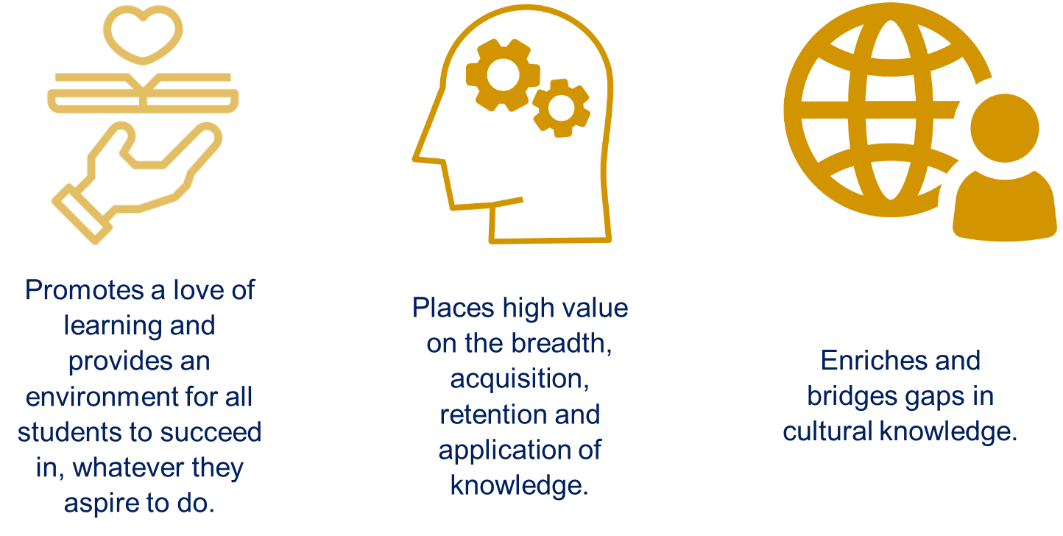

Teacher of Humanities

Contract: Permanent
Closing Date: 8am on Monday 22nd June 2026
Salary Range: MPS/UPS

This is an exciting opportunity for a talented colleague to join our vibrant and ambitious school as a Teacher of Humanities. We welcome applications from teachers who can deliver one or more Humanities subjects, with particular interest in candidates who are able to teach RSP.

Benton Park School is a thriving, inclusive comprehensive school located in Rawdon, on the outskirts of Leeds. With over 1,500 students—including a vibrant Sixth Form of over 200—we are proud to serve a diverse and supportive local community. Our recent move into a £28.5 million state-of-the-art building has created an inspiring environment for learning and working, underpinned by cutting-edge classroom technologies.

As part of the Moorlands Learning Trust, we are committed to delivering a truly aspirational education for all. Our school vision—“Together we belong, develop character and achieve excellence”—captures our belief in the power of community, personal growth, and high achievement. We are proud to be a school that goes from strength to strength, with good behaviour and attendance and strong outcomes and destinations for our students.

Our values—Kindness, Resilience, and Responsibility—shape our culture and guide every interaction. They underpin our commitment to developing confident, compassionate, and capable young people who are ready to make a positive contribution to society.

We celebrate the importance of community through a rich calendar of events that bring our school to life. Highlights such as Live in LS19 music festival, Enterprise Day, Sports Day, and our school performances provide students with opportunities to showcase their talents, develop leadership and teamwork skills, and build lasting memories. These events unite students, staff, families, and the wider community, reinforcing our ethos and strengthening the sense of belonging that defines Benton Park.

Our curriculum is broad, balanced, and enriched by opportunities for personal development, leadership, and community engagement—including strong partnerships with local primary schools through the Aireborough Learning Partnership Trust. We also take pride in our unique morning meeting structure, our strong pastoral care, and our relentless focus on effective teaching and mentoring, which together ensure excellent outcomes and a strong sense of connection for every student.

Benton Park is more than a school—it’s a place where students grow, belong, and flourish.

About Benton Park School

Benton Park School is a popular and oversubscribed comprehensive school located to the north-west of the vibrant and diverse city of Leeds. We are proud to serve a wide catchment area including Rawdon, Yeadon, Calverley and Farsley as well as areas further into Leeds and Bradford. Our families are incredibly supportive, and we work closely with a number of local primary schools through strong partnerships, including our work with the Aireborough Learning Partnership Trust.

We are fortunate to have benefited from a £28.5 million investment in our premises, resulting in a state-of-the-art learning environment that inspires both students and staff. Our bespoke Sixth Form centre has been extensively refurbished to create a welcoming and aspirational space for post-16 study, and our Sixth Form continues to grow in strength and popularity.

Our vision—“Together we belong, develop character and achieve excellence”—drives every aspect of our work. It is supported by our core values of Kindness, Resilience, and Responsibility, which underpin our inclusive ethos and commitment to developing well-rounded, confident young people. Our Personal Development Curriculum places a strong emphasis on mental health and wellbeing, helping students to build the skills and character needed for success in life beyond school.

We believe in celebrating success and fostering a culture of inclusivity and positivity. Our rewards system recognises students who go above and beyond, and our philosophy—a busy student is a successful student—is reflected in the wide range of enrichment opportunities we offer. These include lunchtime and after-school clubs, educational visits both in the UK and abroad, and a thriving Duke of Edinburgh Award programme.

Community events are central to our school identity. Annual highlights such as Live in LS19 music festival, Enterprise Day, Sports Day, and our school performances bring our community together, showcase student talent, and reinforce our values in action. These events help build character, confidence, and a strong sense of belonging—making Benton Park not just a place to learn, but a place to grow and thrive.

Welcome from the Headteacher

Thank you for your interest in joining Benton Park School.

As a Teacher of Humanities, you would play a vital role in supporting our vibrant school community and helping to shape a strong, positive, and successful learning experience for all students. Your contribution would be part of a wider team effort that ensures every child feels safe, supported, and ready to thrive.

We are looking for a highly motivated, positive colleague who can contribute to maintaining excellent standards in all areas of school life. A team player, you will have the ability to form high-quality relationships with staff, students, and families alike.

Benton Park is a thriving, inclusive and oversubscribed comprehensive school located in Rawdon, on the outskirts of Leeds. We serve a diverse and supportive community and we are proud to recognise and celebrate this. Our school is proud to be part of the Moorlands Learning Trust, and we continue to go from strength to strength—with excellent behaviour, great attendance and strong outcomes and destinations for our students.

Our vision—“Together we belong, develop character and achieve excellence”—drives every aspect of our work. It is underpinned by our core values of Kindness, Resilience, and Responsibility, which shape our culture and guide every interaction. We are proud to have received national recognition for our inclusive and values-driven approach, including the RED Award for Diversity and Inclusion and the UK Gold Feminista Award for promoting gender equality and student voice.

We take an evidence-informed approach to school improvement. There are no gimmicks or silver bullets—just a relentless focus on doing the simple things well, every day. Our ‘warm-strict’ approach instils strong learning habits and helps students become better qualified, more successful, and happier. We expect students to follow routines, wear their uniform with pride, and be fully engaged in their learning.

Our curriculum is designed to ensure students know and remember more as they progress, with clear Learning Journeys and Progression Models that promote mastery and a love of learning. We place high value on the breadth, retention, and application of knowledge, and actively work to enrich and bridge gaps in cultural capital.

We also celebrate success at every opportunity. Our positive rewards culture recognises students who go above and beyond, and our philosophy—a busy student is a successful student—is reflected in our wide range of enrichment opportunities. These include lunchtime and after-school clubs, educational visits in the UK and abroad, and a thriving Duke of Edinburgh Award programme.

Community events are central to our identity. Annual highlights such as our music events including our Live in LS19 festival, Enterprise Day, Sports Day, and our school performances bring our community together, showcase student talent, and reinforce our values in action. These events help build character, confidence, and a strong sense of belonging.
Our Personal Development Curriculum places a strong emphasis on mental health and wellbeing—ensuring students are equipped not only for academic success but for life beyond school.

Joining Benton Park means becoming part of a school that is ambitious, inclusive, and deeply committed to making a difference. We look forward to welcoming a new colleague who shares our values and wants to contribute to our continued success.

Mr N Skilton
Headteacher

Teaching and Learning at Benton Park

I Do, We Do, You Do
Our teaching model is built around Rosenshine’s Principles of Instruction and follows I Do, We Do, You Do. Teachers ensure that they model excellence before scaffolding and guiding students to produce the best quality work possible. This enables students to then produce outstanding work during their independent practice.

Learning Journeys and Progression Models
All of our teaching is built around our Learning Journeys and Progression Models. We believe that students should ‘master’ their learning and, in doing so, know and remember more. Our subject areas have developed high-quality and effective Learning Journeys and Progression Models to support this and ensure there are opportunities for immediate and effective feedback.
Subject Specialism

We use every opportunity to connect students with subject specialists both inside and outside the school. The through-school approach helps us to offer students the chance to see their learning through the eyes of experts and to experience learning which has been developed and delivered by specialists.

Professional Development
Developing our staff is incredibly important to use. All staff have access to professional development across the school calendar. We believe that the best professional development is not a one-off event but a process. To support the development of teaching across the school we use Teaching Walkthrus. Many of our staff also access external courses including NPQs.

Benton Park Fundamentals
At Benton Park, we build our teaching around some crafted fundamentals to support teaching and learning. We explicitly teach these to our students to ensure that learning time is maximised and that transitions are effective. We pride ourselves on support all learners, including our most vulnerable, having access to the highest quality support through these fundamentals

Reading
Reading, and literacy, form central pillars of our approach with students. Students have the opportunity to be read every morning to develop their reading and also their cultural capital. We expect every member of our School community to talk in full sentences at all times to support our drive for improved oracy and, subsequently, literacy levels.

Job Description

Role | Teacher of Humanities
Allowances: | MPS/UPS
Responsible to: | Leader of Humanities
Line Manage: | N/A
Review Date: | Annually

Purpose of the Job
As a classroom teacher at Benton Park School, you ensure every pupil experiences a high‑quality, ambitious curriculum and achieves excellent outcomes, with strong character and a strong sense of belonging—aligned to our vision: “Together we belong, develop character and achieve excellence.” You fulfil the responsibilities of a teacher as set out in the STPCD and the Teachers’ Standards, acting with professionalism, integrity and high expectations at all times.
Main Purpose
Under the direction of the Leader of Humanities (and working closely with pastoral and inclusion teams), you will:
- Plan and deliver expertly sequenced lessons so pupils know more and remember more over time.
- Assess learning formatively and summatively, give actionable feedback, and use assessment to adapt teaching.
- Create a calm, purposeful climate for learning with consistent routines and high expectations.
- Remove barriers to learning through adaptive teaching and effective deployment of support.
- Communicate effectively with parents/carers and contribute to wider school life and continuous improvement.
Duties and Responsibilities:

Curriculum, teaching and classroom practice
- Deliver a coherent, well‑sequenced curriculum that secures progression of knowledge and skills.
- Use explicit instruction, modelling and guided practice; embed retrieval and checks for understanding.
- Plan adaptations for diverse needs (SEND, EAL, disadvantaged) that raise rather than lower challenge.
- Ensure full coverage of relevant specifications and programmes of study.
Assessment, feedback and reporting
- Use in‑lesson AfL, hinge questions and periodic assessments to diagnose misconceptions.
- Provide efficient, specific feedback and ensure pupils act on it; keep accurate records.
- Report clearly to parents/carers and use comparative data appropriately to inform next steps.
Behaviour, culture and relationships
- Establish consistent routines and positive norms; apply rewards/sanctions fairly.
- Build strong relationships with pupils; restore and maintain them following incidents.
- Promote excellent attendance, punctuality and readiness to learn in every lesson.

Safeguarding, inclusion and wellbeing
- Keep children safe: notice concerns, record factually, and report to the DSL immediately; follow up as required.
- Uphold inclusion; collaborate with SENCO and pastoral colleagues to remove barriers and monitor impact.
Professional development and collaboration
- Engage in instructional coaching/CPD; act on feedback and share practice.
- Work effectively with colleagues, including supporting non‑specialists where appropriate.
Data, intervention and exam readiness (where applicable)
- Analyse class attainment/progress; identify pupils/groups for support or stretch.
- Implement and evaluate targeted interventions; prepare pupils for assessments and examinations.
Wider contribution and enrichment
- Contribute to clubs, trips and enrichment that widen participation and develop character.
- Represent the department/school positively in the community and with families.
Communication with parents/carers
- Communicate professionally, promptly and constructively to support pupil progress and wellbeing.
Additional Duties
- Be (or become) First Aid and Mental Health First Aid trained and respond in line with school policy.
- Support whole‑school events and promote equality, diversity and inclusion.
- Comply with all school/Trust policies (including data protection and confidentiality) and report concerns promptly.

Variation in Role
Given the dynamic nature of the role and structure of Benton Park School, it must be accepted that, as the school’s work develops and changes, there will be a need for adjustments to the role and responsibilities of the post. The duties specified above are, therefore, not to be regarded as either exclusive or exhaustive. They may change from time to time, commensurate with the grading level of the post and following consultation with the post holder.
The post‑holder will be familiar with and uphold the school’s Safeguarding, Health & Safety, Equality, Inclusion, and Data Protection policies.

Health and Safety
The post holder will make themselves familiar with the requirements of the Health and Safety Policy which are relevant to their work.

Safeguarding

Benton Park School is committed to safeguarding and promoting the welfare of children and young people and expects all staff and volunteers to share this commitment. All appointments are subject to an enhanced DBS disclosure.
We promote diversity and want a workforce which reflects the population of Leeds.

Person Specification

Attributes | Essential | Desirable | How Identified
Qualifications | - Degree and QTS; evidence of recent, relevant CPD. | - Postgraduate study and/or subject-specific accreditation; First Aid/MHFA certification (or willingness to gain). | - Application  - Certification
Experience | - Sustained record of good or better classroom teaching  - Effective use of assessment to plan learning; experience teaching across KS3–KS4  - Contribution to enrichment. | - Experience teaching KS5  - Track record of raising attainment/progress  - Supporting non-specialists/mentoring ECTs.  - Ability to teach RSP | - Application  - Interview  - References
Knowledge and skills | - Strong subject knowledge and up-to-date pedagogy  - Coherent unit/lesson sequencing  - High-quality explanations and modelling  - Routines that secure behaviour  - Adaptive teaching for SEND/EAL/disadvantaged  - Efficient feedback  - Clear oral/written communication  - Effective use of educational technology where appropriate. | - Understanding of assessment validity/reliability  - Confident analysis of class data and reporting  - Experience with standardisation/moderation. | - Application  - Interview  - References
Character | - Unwavering commitment to inclusive education, high expectations and pupil dignity.  - Professional integrity, resilience, and visible optimism; models Benton Park values.  - Organised, calm under pressure; able to meet deadlines and adapt to changing priorities.  - Work effectively as a member of a team  - Good sense of humour  - Ability to receive and act on feedback  - Strong attention to detail  - Ability to work under pressure  - Commitment to the full life of the school  - Secures strong parent/carer engagement. |  | - Application  - Interview  - References

We are actively committed to safeguarding and promoting the welfare of our pupils and expect all staff and volunteers to share this commitment. All appointments will be made subject to an enhanced DBS disclosure.
We promote diversity and want a workforce which reflects the population of Leeds.

