THE RESPECT DEPARTMENT

Our departmental mission statement is:

“The RESPECT Department’s purpose is to develop pupils’ understanding of different worldviews and equip young people to make moral, ethical and social choices as they move from childhood to adulthood.”

As a subject, RESPECT comprises of the following:

KS3 (Year 7 – Year 9)
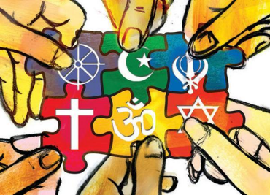
Religion and Worldviews (Religious Education)

- Examining the beliefs, practices and influence of different religious and non-religious worldviews

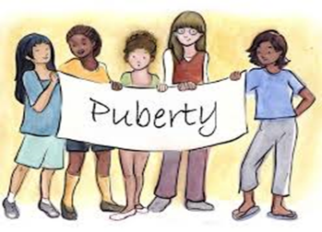
Personal, Social, Health and Economic Education

- Supporting the students’ understanding of ‘Growing Up’
- Helping the students to develop social maturity and make informed decisions about a range of PSHE topics
- Understanding issues such as drugs, sex and relationships and how to develop a healthy lifestyle

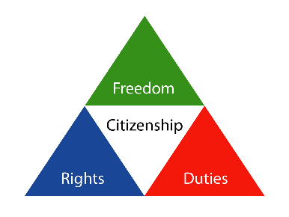
Citizenship

- Supporting the students’ understanding of Government and Community-related issues
- Help the students to understand their social responsibility and develop participation in their local and international community

The link to the KS3 curriculum map can be found here:

https://fallibroome.academy/department/respect/?template=ks3cmap

KS4 (Year 10 – Year 11)
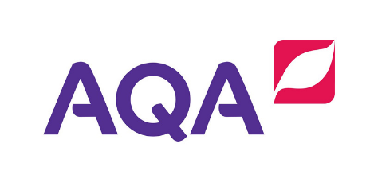
GCSE Religious Education (Full Course & Short Course)

- Teach Christianity and Buddhism AQA A
- Teach the non-textual themes paper

RESPECT is a compulsory subject at GCSE. Students follow a programme of study that allows them to gain a Religious Education GCSE as well as studying PSHE modules alongside their GCSE course. This is delivered in three lessons per fortnight. The majority of our students complete the full course, from Buddhist and Christian points of view. All GCSE classes are mixed ability; students are only set by the qualification that they are working towards. The department have achieved excellent exam results in recent years.

The link to the KS4 curriculum map can be found here:

https://fallibroome.academy/ks4course/respect/

KS4 (Year 10 – Year 11)


GCSE Child Development

- Teach Child Development including a written exam and coursework entry

Child Development is taught by RESPECT teachers at Fallibroome Academy. This is an optional GCSE subject which includes exam and coursework. We have one class per year group (of approximately 25 mixed-ability students) and the subject is taught over five lessons per fortnight. The department have improved the provision of Child Development through the introduction of a trip to a nursery, which provides practical knowledge and experience to support the students’ understanding of the coursework. The department have achieved positive exam results in recent years.

The link to the Child Development curriculum map can be found here:

https://fallibroome.academy/ks4course/child-development/?template=ks4cmap

KS5 (Year 12 – Year 13)
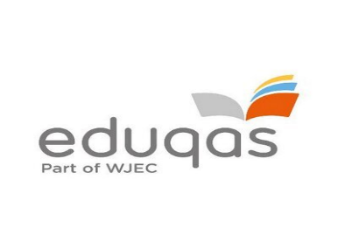
Religion, Philosophy and Ethics (A-level)

- Teach Christianity as the religion option
- Includes teaching of Philosophy of Religion and Ethics

Philosophy, Ethics and Religion is a popular A Level choice. The course runs annually with an average class size of 14 in Year 12 and the department use the Eduqas exam board. The course is split into the three components of Ethics, Philosophy and Religion and students are currently taught the components separately by subject specialist teachers. At A Level, students study Christianity for the religious component. As with GCSE, the department have achieved excellent exam results in recent years.

The link to the KS5 curriculum map can be found here:

https://fallibroome.academy/ks5course/religion-philosophy-ethics/

Extra-Curricular: Students have the opportunity to extend their learning through a range of trips that are arranged annually. These include:
Y7 – Trip to the Islam Centre and Sikh Gurdwara
Y8 – Trip to Parliament
Y10 – Trip to the Buddhist Samatha Centre
Y10 – Nursery visit for Child Development (Bright Horizons Nursery)
Y12 – KS5 Ethics Conference and Candle Conference
KS5 - RESPECT & Art Trip to Rome (2019)

Accommodation: We have four designated teaching classrooms, grouped together and we share a fifth room. The department is very well resourced, in terms of books and audio-visual materials and all teaching rooms are equipped with ICT facilities including interactive whiteboards. As our classrooms are designated RESPECT rooms all rooms have relevant, informative and eye-catching displays which highlight different aspects of the curriculum.

