

ROLE PROFILE

*Red Kite Learning Trust is committed to supporting work–life balance and recognise the benefits of flexible working. We welcome requests for flexible working arrangements as part of the recruitment process. While flexibility may be possible for many roles, each request will be considered on an individual basis.
Job Title: | Cook | School: |  | Harrogate Grammar School
Salary Grade: | Salary Band 7 SCP 8-12 | Working Hours: |  | 37 hours per week, Monday
Contract Type: | Permanent, Term time plus 2 weeks (including Training Days) | Location: |  | Harrogate
Responsible to: Catering Manager
Role Summary: This is a hands-on role to work alongside the catering management team producing a fantastic product & service and enhancing team performance.
Special conditions of service: No smoking policy, including e-cigarettes/vaping. Requirement to work outside of school hours and off school premises, as required by the school.
Role specific responsibilities:

- Act as a role model for colleagues through professionalism, presentation and a strong work ethic.
- Support the management team by providing guidance, training and advice to colleagues.
- Ensure the effective delivery of a high-volume catering service within tight break and lunchtime schedules.
- Share culinary skills and knowledge with team members, encouraging creativity and keeping up to date with food trends.
- Attend and contribute to team meetings as required.
- Promote a positive team culture and a supportive working environment.
- Demonstrate integrity and a hands-on approach while understanding wider service objectives.
- Take responsibility for planning, preparing, cooking and serving meals in line with menus, dietary requirements and nutritional standards.
- Ensure consistently high standards of food quality, portion control and presentation while minimising food waste.
- Manage stock control and ordering processes effectively.
- Be willing to work flexibly to meet the needs of the school.
- Engage positively with the school's CPD programme and appraisal process.
- Participate in networks within and beyond the school to support continuous improvement.
- Ensure health and safety regulations are strictly followed.
- Support the school's sustainability objectives and ensure sustainable practices are embedded within the catering service.
All colleagues, regardless of career stage, will make a positive contribution to the wider life and community of our school, for example through sport, music, hobbies etc.
RK People responsibilities:
- Contribute to the overall aims and values of our Trust, appreciate and support the roles of other members of the wider team and attend and participate in relevant meetings as required
- Comply with all Trust policies and procedures including child protection, health, safety, welfare, security, confidentiality and data protection etc., reporting any concerns to the appropriate person
- Contribute to ensuring safeguarding procedures are in place and used effectively at all times.
The role holder must demonstrate a flexible approach to the delivery of the role. Consequently, the role holder may be required to perform work not specifically identified in the role profile, but which is in line with the general scope, grade and responsibilities of the role.
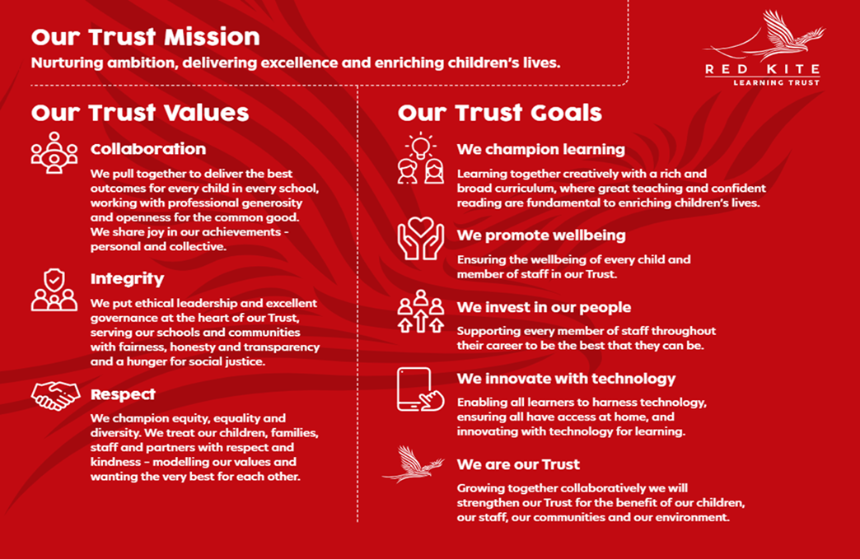
PEOPLE PROFILE
Aptitudes and Characteristics |  |  | Essential |  | Desirable
Polite, courteous and friendly towards customers and colleagues |  |  | *
Good organisational skills, high levels of self-motivation and able to take the initiative |  |  | *
Highly effective communication and interpersonal skills |  |  | *
Energy, self-confidence and ability to ‘give more’ when the occasion demands it |  |  | *
Excellent attention to detail |  |  | *
Good level of numeracy skills |  |  | *
Reliability in all aspects of work and conduct |  |  | *
Ability to lead and inspire colleagues |  |  | *
Ability to relate well to children and adults |  |  | *
Ability to work under pressure and to meet deadlines |  |  | *
Capacity to evaluate and improve. |  |  | *
Able to plan, organise and oversea meal production |  |  | *
Able to follow instructions, i.e. menus, recipes, allergies, guidelines, Codes of Practice |  |  | *
Able to use general catering equipment, safely and correctly |  |  | *
Able to adhere to the required personal hygiene standards |  |  | *
Flexible approach to working out-of-hours on occasion including evenings and occasional weekends |  |  | *
Qualifications, Knowledge and Experience |  |  | Essential |  | Desirable
Food safety qualification and thorough knowledge of all aspects of Food Safety |  |  | *
Knowledge of Health and Safety regulations and Food Based Standards |  |  | *
Awareness of nutritional standard applying of schools and the importance of providing healthy food to young people. |  |  | *
Willing and able to undertake further training |  |  | *
Capable of moderate physical activity, i.e. lifting saucepans, standing for long periods of time |  |  | *
Experience of maintaining high standards of food hygiene, food safety and allergen management. |  |  | *
Experience dealing/communicating with different stakeholders |  |  | *
Experience of preparing, cooking and serving meals in a busy catering environment. |  |  | *
Experience of working independently and managing workload to meet service deadlines. |  |  | *
Experience of leading, motivating and managing others within a kitchen |  |  | *
High degree of catering craft skills |  |  | *
Safeguarding and Promoting the Welfare of Students |  |  | Essential |  | Desirable
An appropriate motivation to work with children and young people |  |  | *
Ability to maintain appropriate relationships and personal boundaries with children and young people |  |  | *
Emotional resilience in working with challenging behaviours and appropriate attitudes to the use of authority and maintaining discipline |  |  | *

