

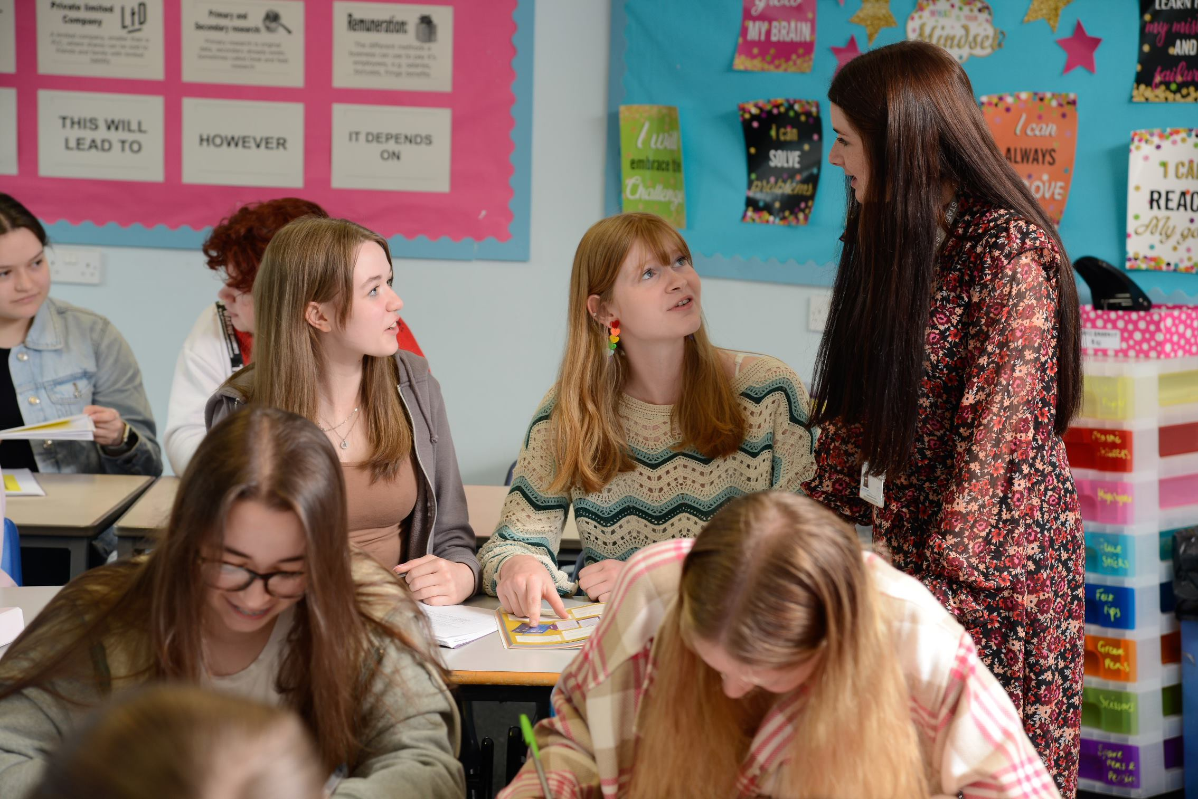


WELCOME TO BUXTON COMMUNITY SCHOOL

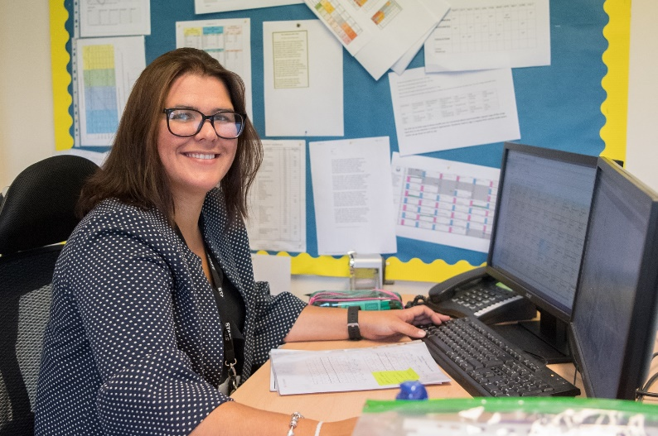

Welcome to our school which is part of the Embark Federation. We are proud to be part of a family of 19 schools across Derbyshire who believe that by working together as a team we can create schools that ‘stand out’ at the heart of their communities. Our trust has four core beliefs; Family, Integrity, Teamwork and Success, which are integral to everything we do.
We have high standards across our schools but want to ensure that the school experience for our children is a magical time. Our purpose is to enable everyone in our Embark family to be able to ‘Love Learning, Love Life.’
We are a successful, supportive and high achieving secondary school based in the heart of the Peak District with over 1,000 students on roll. Student numbers are rising; applications for Year 7 have risen by 25% over the last 5 years as more families want to send their children to us. As an 11-18 provider, we play a key part in providing the highest quality education and support for our students across a broad range of subjects at KS3, KS4 and KS5.
Our approach with the students involves acknowledging and rewarding positive behaviours and achievements whilst challenging and supporting students to be the best version of themselves. Our values, Ready, Respectful and Safe are instrumental in achieving our vision.
We have a clearly defined plan and commitment to improving learning and support for students. Our outcomes have shown significant improvement over several years as our developments to teaching and learning have taken hold.
Our principles for learning are focused on learning for the long term and developing deep understanding. We have developed a clear strategy that underpins what happens in our classrooms. Teachers who join our school will find well-resourced and planned schemes of learning. However, they are not prescriptive, we believe the professional in the classroom is the subject expert and the champion of the needs of the children in their classes. Staff wellbeing is of utmost importance to me, and we have adopted a number of approaches in order to support in this area of school life. For example, we support all our staff by providing additional non-contact time above that of most schools to allow them the chance to prepare and assess effectively.
We are keen to appoint subject specialists who are passionate and demonstrate true excitement for their subject. We want staff who are positive, energetic, enthusiastic and deeply committed to supporting our young people, and who are prepared to go that extra mile to contribute to our whole school improvement.
We want the best for our staff and young people, and we will not let it get more complicated than that.
Joining a new school will be a huge decision for you, I am sure you will have worked through our website, read our recent inspection report and looked at our data but you need to know what more there is to our school. I would be happy to talk with you as a prospective candidate before or after you submit an application and talk with you about our ethos and values, our priorities and answer any questions you might have. Please contact denise.lowe@buxton.derbyshire.sch.uk to arrange a call. The recruitment process will also give you every opportunity to learn more about our school. I would like to take the opportunity to thank you for your interest in this post.

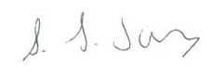
Samantha Jones
Headteacher

The Role

Buxton Community School is seeking to appoint an outstanding, passionate and ambitious Teacher of Modern Foreign Languages (French and Spanish) to join our team on a full-time basis from September 2026.

We are looking for an inspiring and dedicated classroom practitioner with a genuine love of languages, who can enthuse, engage and motivate students across all key stages. You will join a forward-thinking and supportive department that values creativity, collaboration and innovative approaches to teaching and learning.

Applicants should demonstrate a strong commitment to delivering consistently high-quality lessons and securing excellent outcomes for all learners. The successful candidate will be able to teach French and/or Spanish to GCSE, with opportunities to contribute to our A-Level French provision.

You will work closely with the MFL team, playing an active role in the continued development of our curriculum. This includes delivering the AQA 2024 GCSE specifications and contributing to a refreshed and ambitious Key Stage 3 curriculum in both French and Spanish. We are seeking a professional who brings energy, enthusiasm and high expectations to every lesson, alongside a clear commitment to continuous improvement and a passion for language learning.

The ideal candidate will:

- Have a tangible passion for teaching French and/or Spanish, inspiring students to achieve their full potential.
- Be confident in delivering lessons to GCSE standard, with experience or ambition to teach to A Level.
- Have excellent subject knowledge and an understanding of how effective lesson design can support deep learning.
- Value evidence-based practice, high-quality assessment and meaningful feedback to drive progress.
- Be a reflective practitioner, keen to develop professionally and share best practice within a supportive team.
What you will get from us.
• The opportunity to join a thriving, ambitious department committed to providing the best possible education to all students.

• Support for your professional growth, whether your focus is on classroom practice or leadership development.

• A positive, collegiate and supportive working environment where wellbeing is prioritised.

This is a fantastic opportunity for a teacher at any stage of their career to join a progressive school community. We are seeking someone who can spark curiosity, foster a love of languages, and make a real difference to the lives of young people.

Salary: Main/Upper Pay Scale
TLR: N/A
Contract Type and Term: Full Time. Permanent.
Start date: September 2026

The Department
The Modern Foreign Languages department at Buxton Community School is a vibrant, collaborative and forward-looking team dedicated to fostering students’ passion for languages and cultures.
We deliver French and Spanish across Key Stages 3, 4 and 5, offering AQA GCSE and A Level qualifications. Our curriculum is designed to engage, challenge and inspire students through a focus on communication, cultural awareness and lifelong learning.
The department has recently introduced a new Key Stage 3 curriculum for both French and Spanish, aligning with the AQA 2024 GCSE specification, ensuring clear progression and depth of learning. At Key Stage 5, we currently offer AQA A Level French, with growing interest in continuing language study beyond GCSE.
Our classrooms are well-resourced, supported by digital technology and interactive resources. Beyond the classroom, we are proud of our commitment to enrichment and global experience, with regular overseas visits yearly such as Madrid in 2026 and France in 2027, alongside local and national cultural events.
You will join a talented and supportive team that values collaboration and professional growth. The department works closely with the wider school community and with colleagues across the Embark Federation to share expertise and develop outstanding practice.
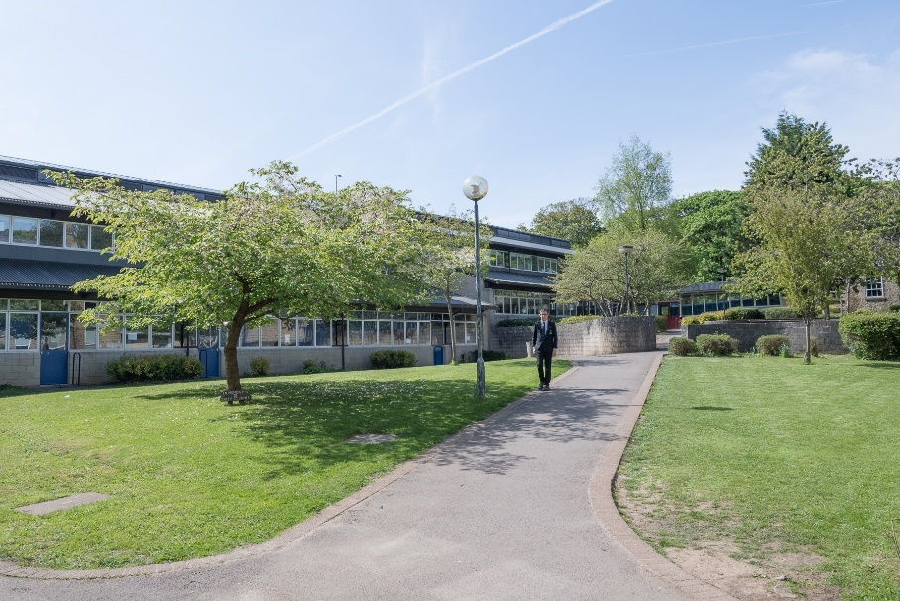

Job Description

Post Title: Teacher of MFL (French/Spanish)

Grade: MPS/UPR

TLR: N/A

Responsible to: Head of MFL

Post Objectives: To deliver high-quality teaching and learning in Modern Foreign Languages, enabling all students to achieve their full potential. The post-holder will contribute to the wider aims and ethos of Buxton Community School by promoting a culture of high expectations, respect, and a love of learning.

Duties and Responsibilities:

Teaching and Classroom Practice
Students learn best in an environment that is structured, supportive and inspiring. Teachers are expected to create an engaging and purposeful classroom where every student can thrive. This includes:
- Planning, preparing and delivering well-structured lessons that are challenging, creative and differentiated to meet the needs of all learners.
- Using a variety of teaching strategies to promote curiosity, independence and confidence in language learning.
- Establishing high standards of behaviour and consistently applying school policies to promote a safe and positive learning environment.
- Providing clear learning objectives and success criteria, ensuring students understand how to make progress.
- Setting meaningful homework that supports and extends classroom learning.
- Celebrating achievement and maintaining high levels of motivation through the school’s rewards and recognition systems.
Assessment and Feedback
Regular assessment and constructive feedback are essential to student progress. Teachers are expected to:
- Use formative and summative assessment to monitor progress and inform lesson planning.
- Provide timely, specific and actionable feedback that helps students to reflect and improve.
- Maintain accurate records of student attainment and progress in line with departmental and school policies.
- Analyse assessment data to identify gaps, inform intervention, and support improvement.
- Prepare students thoroughly for internal and external examinations.
- Report effectively to parents, carers and senior leaders on student progress and achievement.
Curriculum and Professional Development
- Contribute to the ongoing development of the MFL curriculum, ensuring alignment with the AQA 2024 GCSE specifications and the new Key Stage 3 programmes of study.
- Collaborate with colleagues to share resources, strategies and best practice across the department and school.
- Keep up to date with national developments in language education, pedagogy and assessment.
- Engage fully in professional learning and CPD opportunities to enhance classroom practice and student outcomes.
- Participate in school-wide quality assurance, performance management and curriculum review processes.
Inclusion and Student Support
- Adapt teaching to support the needs of all learners, including those with SEND and EAL.
- Work collaboratively with the SEND team and support staff to plan and deliver inclusive lessons.
- Contribute to the creation and implementation of Individual Education Plans (IEPs) or student passports where required.
- Promote equality, diversity and inclusion through classroom practice and curriculum content.

General Responsibilities

- Uphold the school’s aims, values and policies, including those on behaviour, safeguarding, and staff conduct.
- Undertake supervisory duties, cover and wider professional responsibilities as required.
- Participate in assemblies, meetings and events that contribute to the life of the school.
- Model professionalism and integrity in all interactions with students, colleagues and parents.

Please note that this document should be read in conjunction with the Conditions of Employment of School Teachers as outlined in the current DfE School Teacher’s Pay and Conditions Document.


Person Specification

(To be read in conjunction with the National Standards for Classroom Teachers)

Post Title: Teacher of MFL

Grade: MPS/UPR

 | Essential Criteria
Qualifications | QTS (when taking up post)
Qualifications | Relevant Degree
 | Relevant practical experience
 | Ability to teach French and/or Spanish to GCSE level, with ambition or experience of teaching to A Level.
 | Secure knowledge of the AQA 2024 GCSE specifications and a clear understanding of the progression from Key Stage 3 to Key Stage 5.
 | Understanding of effective assessment, feedback and differentiation to support progress for all learners.
 | Awareness of current educational developments and strategies for improving teaching and learning.
 | Understanding of how to remove barriers to learning and support students with diverse needs, including SEND and EAL.
 | Knowledge of safeguarding principles and commitment to promoting the welfare of all students.
 | Demonstrates high expectations of all students and a commitment to achievement for every learner.
 | Reflects regularly on teaching practice to refine and improve learning experiences.
 | You are well-organised in your planning and use of classroom resources
 | You work effectively with colleagues to develop and improve learning
 | You use good communication skills (speaking, writing and listening) with the whole school community
 | You are committed to the personal development of the young people you work with
 | You constantly strive to analyse, refine and develop the learning in your classroom
 | You demonstrate high levels of commitment, enthusiasm and motivation
 | You are hard-working and dependable
 | You have an excellent record of attendance and punctuality
 | Outline of clear educational philosophy linked to post requirements
 | You have effective and positive behaviour management skills.
 | You are an effective team worker with a ‘can do’ attitude that embraces change and creativity.
 | You show clear evidence of on-going professional development.

A Great Place to Work

We care passionately about our staff, their well-being and their professional development and this is reflected in the fact that we are an enthusiastic team, committed to working collaboratively and sharing the very best practice.

We can offer:
- a strong team environment that takes staff well-being seriously
- a dedicated Senior Leadership Team who want to see their staff progress
and flourish in their career
- an active teaching and learning research and development group
- very supportive parents and a high standing in the community
close and successful working relationships with other schools within the High Peak area

Diversity & Inclusion

At Buxton Community School we hire the best, give them first-class training and if you are driven to perform, you’ll fit right in. We approach our work fearlessly, learn quickly, improve constantly, and celebrate our wins at every turn.

We are passionate about creating an inclusive workplace which promotes and values diversity in age, gender identity, race, sexual orientation, physical or mental ability and ethnicity. More importantly, creating an environment where everyone, from any background, can do their best work is the right thing to do. Everyone is welcome—as an inclusive workplace, our employees are comfortable bringing their authentic whole selves to work.

The Town of Buxton
Buxton Community School is a school truly at the heart of the town and the area is a beautiful part of the country.
At 1,030ft above sea level, Buxton is said to be the highest market town in England. Tourists have been coming to Buxton and the Peak District since the 14th Century and it’s not surprising that Buxton is today one of the most popular tourist destinations in the Peak District. Within an hour’s drive of Manchester, Sheffield, Derby and Stoke, its famous Georgian and Victorian architecture with buildings such as The Crescent, The Pavilion Gardens and The Opera House it provides an impressive backdrop to a rich and vibrant range of music, theatre and festivals.
The Buxton Festival of World Cinema takes place around March/April, with the Big Session Festival of folk music in April/May. July brings the Buxton Festival of Opera, Music and Literature, the Buxton Well-Dressing Festival, Buxton Fringe Festival and the Buxton Military Tattoo. In August the Family Festival provides fun for all the family.

The Application Process

All applications should be made visa My New Term

Closing date for applications is Friday 8th May at 9am. Interviews will take place the following week.

If you are short-listed for interview, you will be contacted in advance to discuss arrangements for the interview. Unfortunately, if you have not been contacted prior to the interview day, your application has not been successful on this occasion.

Buxton Community School is committed to safeguarding and the process of safer recruitment. As a result, this post is subject to an enhanced Disclosure and Barring Service check, and all shortlisted candidates will be expected to prove their identity at interview. The successful candidate will be expected to show original copies of qualifications and further proof of their identity.


