
Key Stage 4 Centre
Barncroft Campus
Washington Avenue
Hemel Hempstead
HP2 6NG
T: 01442 247476
E: admin@desc.herts.sch.uk

KS4 Learning Support Assistant

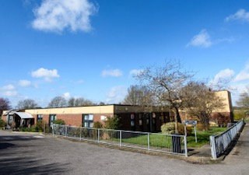 | 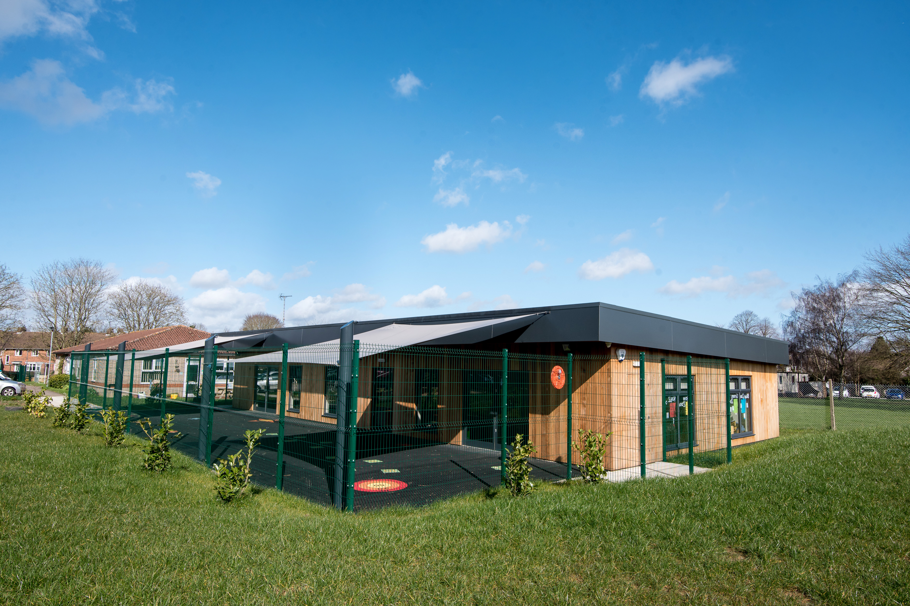

KS4 Learning Support Assistant
Recruitment Information Pack

Contents | Page No.
Letter from the Headteacher | 3
Application Process | 4
Vacancy Advert | 5
Job Description  Person Specification | 6  8



Dear Candidate,

Thank you very much for your enquiry regarding the position of Learning Support Assistant (LSA) at DESC. The Management Committee, together with the learners, parents and staff are seeking a talented individual who has the qualities to “Ignite a Passion for Learning”.

Dacorum Education Support Centre is a unique organisation that works with young people who, for one reason or another, are not in mainstream education. We support the individual and their family and work together to achieve appropriate outcomes and secure a positive way forward for the future. We firmly believe effective relationships are the key to great learning outcomes.

Our innovative and responsive curriculum enhances the learning experience of all our learners. Our offer is linked to the passions, interests and aspirations of our learners. It enables them to combine the broad range of core subjects with significant specialist option choices, as well as practical skills for life and work.

Our mantra, Be the best you can be, is echoed in all our work with young people, working with them to overcome their barriers to learning, re-engage with their education, and take confident steps, while fostering our core values of Respect, Aspiration and Integrity.

We believe that this post provides an excellent opportunity for a talented individual to be part of a Centre willing to take risks, pushes the boundaries in developing an innovative approach and, as a result, is viewed as an evolving success story.

We very much look forward to receiving your application.

Yours sincerely,
“At DESC the young people are treated like adults and not kids, they are respected by staff”
Parent at DESC

Naomi Walker Clare Winter
Co-Headteacher Co-Headteacher





Co-Headteachers: Clare Winter and Naomi Walker
KS3 and The Haven: 30 Tenzing Road, Hemel Hempstead, HP2 4HS
KS4 Centre: Barncroft Campus, Washington Avenue, Hemel Hempstead HP2 6NG
Email: admin@desc.herts.sch.uk | Tel: 01442 247476 | www.desc.herts.sch.uk



The Application Process

We hope that this application pack and our website www.desc.herts.sch.uk ignites a desire to apply for this post.

Applications can be made by completing the application form through My New Term, via our website www.desc.herts.sch.uk.

Visits/discussions are most welcome. Please contact Kathryn Girdlestone on 01442 247476, Option 1, to arrange a visit.

Closing date for applications is midnight on Sunday 11th July 2026.

We encourage candidates to apply promptly, as the Centre reserves the right to close the advert should we feel able to appoint an appropriate candidate sooner.

DESC is committed to safeguarding and promoting the welfare of our learners and expects all staff and volunteers to share this commitment. This post is subject to satisfactory references, medical clearance and enhanced checks carried out by the Disclosure and Barring Service.

We are required to conduct online searches about all shortlisted candidates in accordance with Keeping Children Safe in Education guidance, in order to identify any incidents or concerns which are publicly available online. By submitting and signing your application, you acknowledge that such searches will be conducted as part of the shortlisting process.

We are committed to promoting equality and respecting diversity and welcome applications from all sections of the community.

“I can say from the bottom of my heart if it was not for all of you I would not have been able to make all the progress I had made”
Learner at DESC

“The school is outstanding – my son’s mental health has really improved and this has had a positive impact on family life”
Parent at DESC



KS4 Learning Support Assistant
Grade: H4 rising H5
Required September 2026
34 hours/week Term Time Only plus 5 INSET Days

Dacorum Education Support Centre is a vibrant and unique Pupil Referral Unit based on 2 sites in Hemel Hempstead working with learners across our 9 Dacorum secondary schools and 60 primary schools. We are seeking to appoint an enthusiastic individual to join our friendly and supportive team of dedicated professionals. This post will support learners by providing in-class support to focus on learning and behavior and helping the team to promote the importance of reading and literacy across the Centre

Do you have:
Experience of and a passion for working in a unique educational environment?
- The ability to form excellent professional relationships with learners, staff, parents and all stakeholders?
- Good literacy and numeracy skills?
- Excellent communication skills?
- Excellent administrative skills?
Are you able to:
- Be an effective team player?
- Use your own initiative?
- Be adaptable?
Hours of Work:
The normal hours of work will be 34 hours per week and typically the working pattern will be similarly to below:

Monday 8:30-3:30
Tuesday 8:30-3:30
Wednesday 8:30-5:00
Thursday 8:30-3:30
Friday 8:30-3:30

Probationary Period:
New employees to the Centre will be required to satisfactorily complete a six month probationary period of service.

DESC is committed to safeguarding and promoting the welfare of our learners and expects all staff and volunteers to share this commitment. This post is subject to satisfactory references, medical clearance and enhanced checks carried out by the Disclosure and Barring Service

Job Description: KS4 Learning Support Assistant

DESC is committed to creating a diverse workforce. We’ll consider all qualified applicants for employment without regard to sex, race, religion, belief, sexual orientation, gender reassignment, pregnancy, maternity, age, marriage or civil partnership.

Responsible to: KS4 Centre Co-Ordinator
Grade: H4 rising H5 with experience and subject to performance appraisal

Core Purpose of the Job:

- Provide support to teachers in the management of learners’ learning and behaviour
Duties and Responsibilities

- Supervise and provide individual support for pupils, including those with identified special educational needs and those experiencing emotional or behavioural difficulties
- Assist with the development of individual education & behaviour plans
- Administer and assess routine tests and undertake routine marking of pupils’ work
- Use ICT for learning activities and support pupils to develop competence and independence in the use of ICT
- Use specialist curricular knowledge or experience to support pupils’ learning and liaise with subject staff accordingly
- Supervise whole classes during the short-term absence of a teacher
- Within an agreed system of supervision, plan, deliver and evaluate programmes of work that meet teaching and learning objectives
- Undertake administrative responsibilities for specific areas of the provision
- Support and prepare pupils for reintegration into mainstream school
- Work alongside staff in schools, INCo and other professionals to facilitate the successful re-integration into mainstream school
- Work and liaise with personnel from other support services and external agencies
- This role will work across both campus’
Equalities
- Be aware of and support difference and ensure that the Centre’s equalities and diversity policies are followed

Policies and Procedures
- Be aware of and comply with policies and procedures relating to Child Protection, Health and Safety, Confidentiality and Data Protection and report all concerns to an appropriate person

Disclosure and Barring Service
- This post is classed as having a high degree of contact with children or vulnerable adults and is exempt from the Rehabilitation of Offenders Act 1974. An enhanced disclosure will be sought through the Disclosure and Barring Service as part of Hertfordshire County Council’s pre-employment checks. Please note that additional information referring to the Disclosure Barring Service is in the guidance notes to the application form.

Additional Information
- The jobholder is required to contribute to and support the overall aims and ethos of the Centre
- All staff are required to participate in training and other learning activities, and in Professional Growth and development as required by the Centre’s policies and practices
- All staff may be required to work across both DESC sites
- The duties and responsibilities listed here describe the post as it is at present. It is not always possible to define completely the duties and responsibilities attached to posts and some variations may be necessary from time to time. The post holder is expected to accept any reasonable alterations that may from time to time be necessary

Organisation Chart

Co-Headteachers

KS4 Co-Ordinator Subject Leads

Learning Support Assistants

Supervision
- The jobholder is managed by the School Business Manager. The frequency of meetings is determined by the Centre’s Professional Growth Policy

Contacts
- The postholder works directly with all members of Centre staff and learners and has routine and regular contact with parents and carers as well as with visitors, external agencies and other professionals

KS4 Learning Support Assistant

Please state, on the application form, in numerical order, how you meet the following selection criteria. Candidates will be shortlisted entirely on the basis of the extent to which they meet the criteria in their application form. Please ensure that you address every aspect, in turn, and number them under each heading. All elements are essential unless otherwise stated. Where ‘desirable’ is stated, only comment if you have the appropriate skills or experience.

Professional Experience, Abilities and Qualifications | Essential (E)  Desirable (D)
Experience of working with hard to reach Young People | E
Experience of working within an education setting | D
Good numeracy / literacy skills (minimum of grade C at GCSE or equivalent) in both English and Maths | E
An ability to manage learners’ behaviour effectively | E
Good organisational skills, including the ability to organise a workload with conflicting demands when under pressure | E
An ability to work with accuracy when recording, sharing or reporting information | E
An ability to use resources effectively and with flexibility to develop a programme of learning for learners | E
An ability to understand and respect the need for discretion, sensitivity and confidentiality | E
Great team player | E
Ability to self-reflect and willingness to participate in development and training opportunities | E
Ability to adhere to policies, procedures and relevant legislation relating to child protection, health and safety, security, confidentiality, data protection and equal opportunities | E
An ability to work effectively with individual learners or small groups and forge good working relationships with them | E
Personal Qualities
Enthusiastic, hard-working, creative, flexibility and resilient | E
Be an excellent role model for learners, staff and parents | E
Be able to form positive professional relationships with both learners and colleagues | E
Good communication skills, interpersonal skills and good send of humour | E

